**Computer Network Lab By Abhay NY**

**Week-02**

**Configure a DHCP within a LAN and Outside LAN**

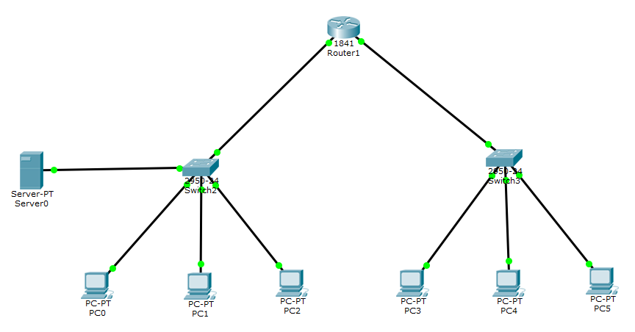

Output :

