**Week 3**

**Configure web server and DNS within a LAN**

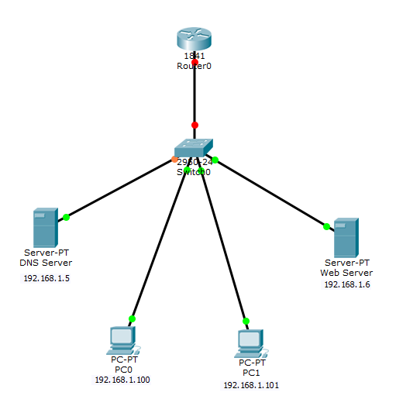

Create the above topology

Configure the PC 0 with the given ip address, default gateway and dns server

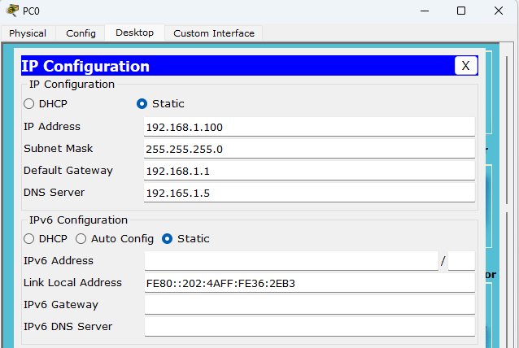

Configure the PC 1 with the given ip address, default gateway and dns server

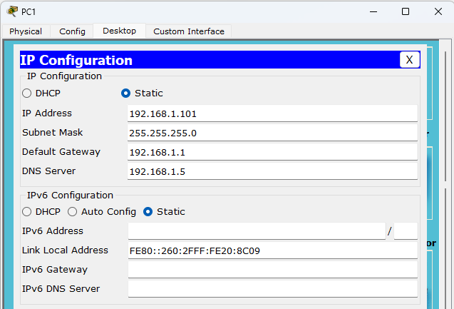

Configure the DNS Server with the given ip address, default gateway and dns server

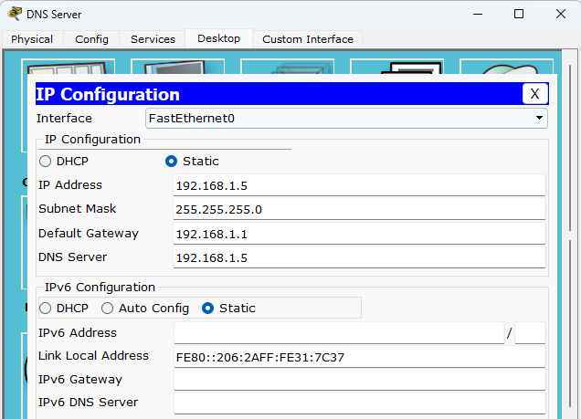

Configure the Web Server with the given ip address, default gateway and dns server

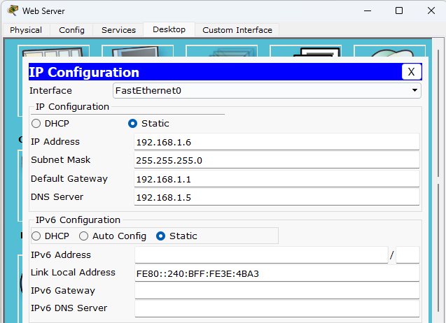

Click on web server -> services -> HTTP -> turn them ON -> helloworld.html -> edit accordingly

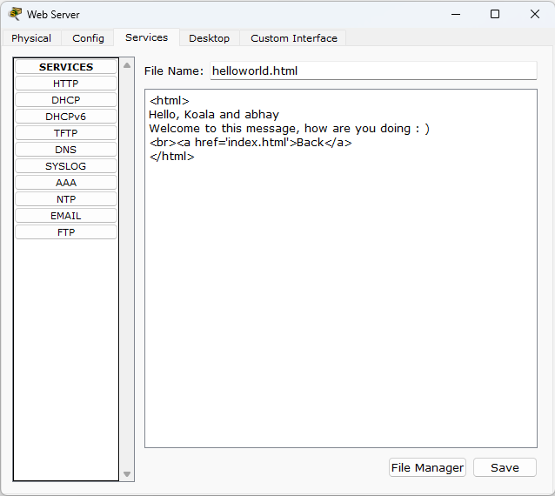

Click on DNS server -> services -> DNS -> turn on -> add name, type and the address accordingly & save

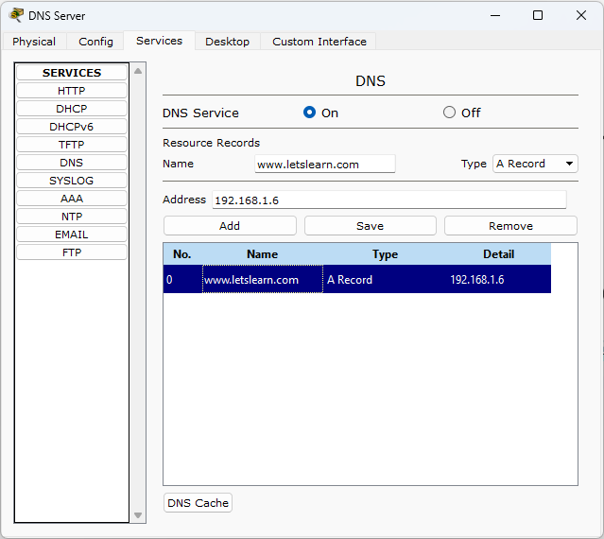

Go to any PC -> Desktop -> web browser -> type in the URL ie [www.letslearn.com](http://www.letslearn.com) -> go

