**Computer Network Lab By Abhay NY**

**Week 4**

**Configure default route, static route to the Router**

Drag all the required components

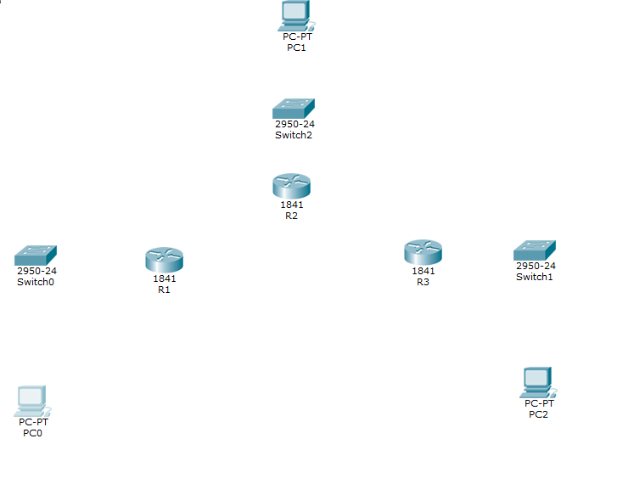

Connect the topology accordingly

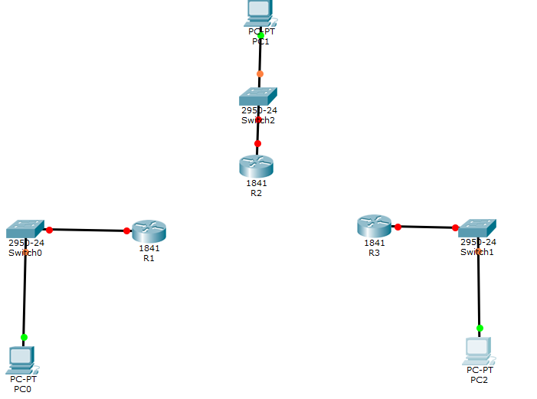

Check if router has serial interface port

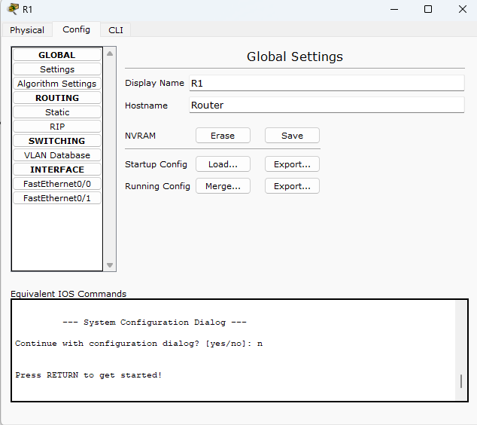

Since the router doesn’t have serial port. Click on router -> physical -> turn off the router -> drag and drop HWIC-2T and place it there -> turn on the router. Do the same for all 3 routers

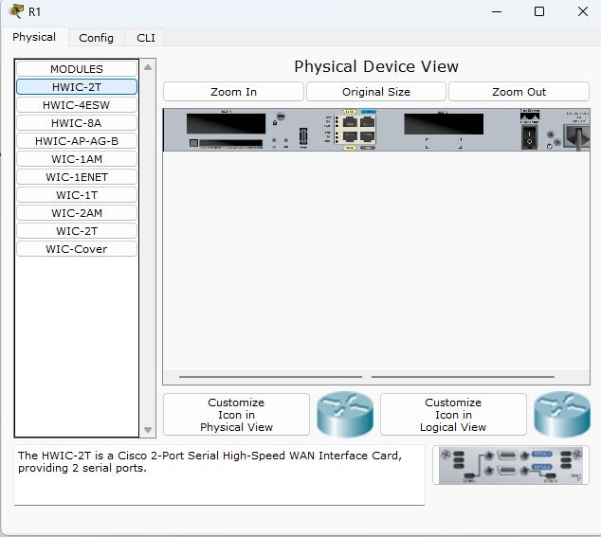

Turn on the router after

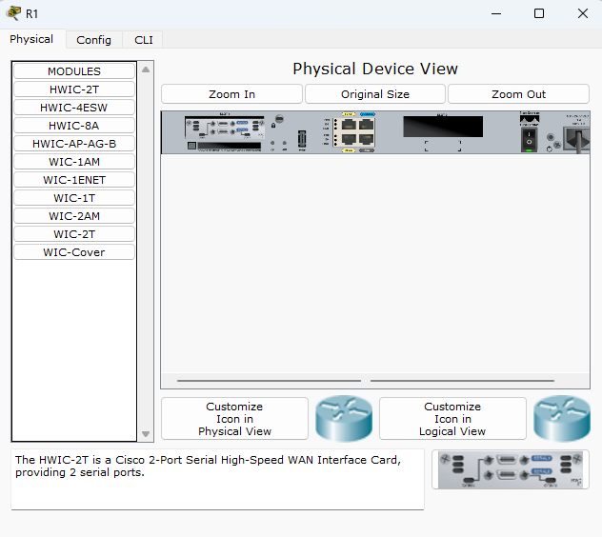

As you can see at the left Serial0/1/0 and Serial0/1/1 has been added

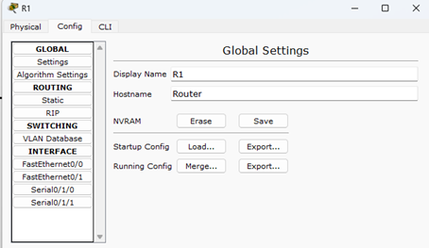

Connect the routers with Serial DCE cables to the serial ports accordingly

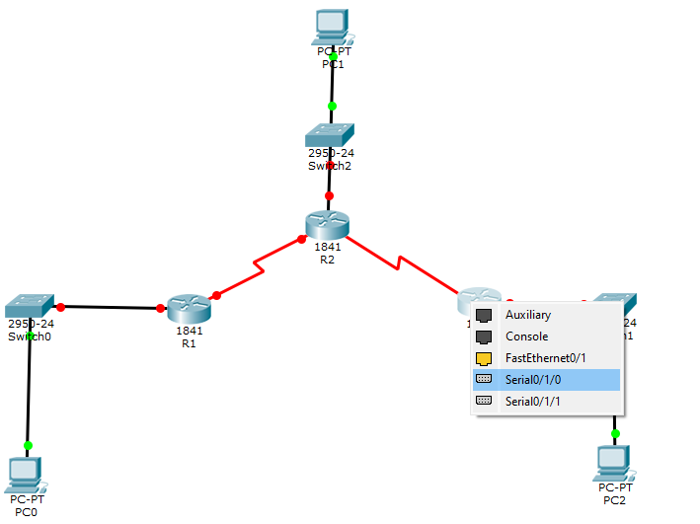

Configure the router 1 accordingly :

Click on R1 go to cli . type the following commands

No -> Conf t -> Int Se0/0/1 -> Ip address 192.16.1.1 255.255.255.252 -> No shutdown -> Exit

-> interface Fa0/0 -> ip address 192.168.10.1 255.255.255.0 -> no shutdown -> exit -> write memory

Configuring Router 2 as below:

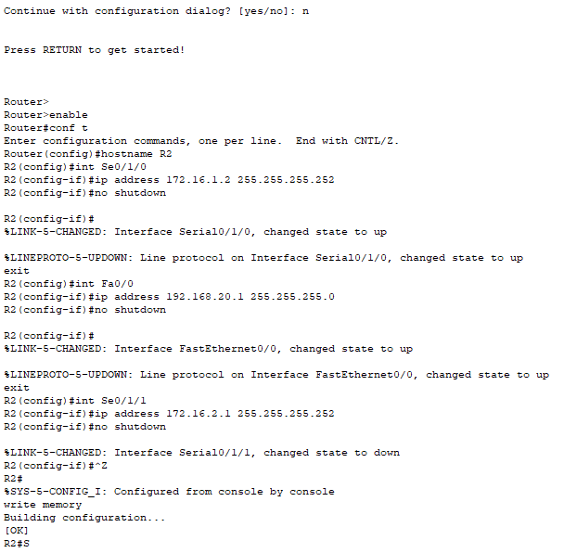

Configuring Router 3 as below:

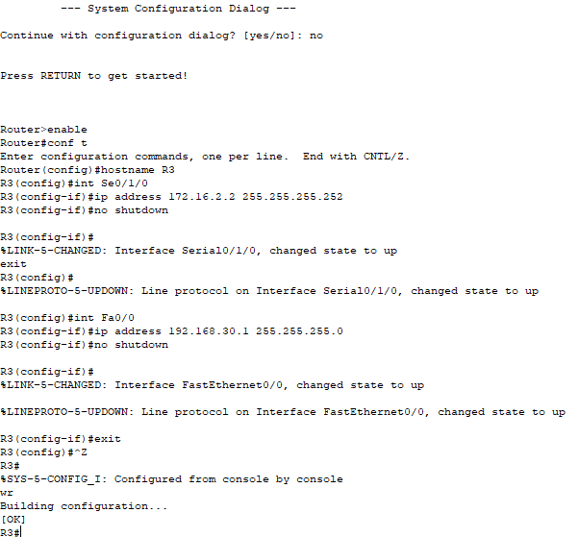

Configure each PC’S ip address and default gateway accordingly.

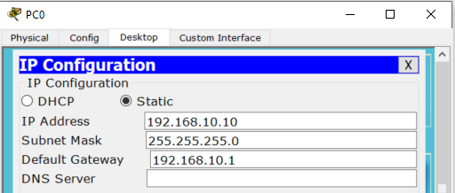

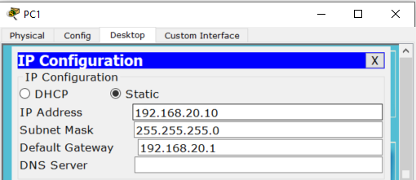

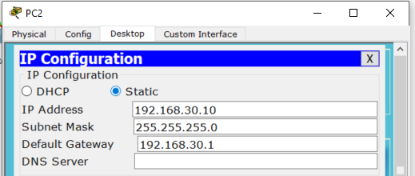

Go to Router 1 ie R1 click on it go to cli and enter the commands which are below.

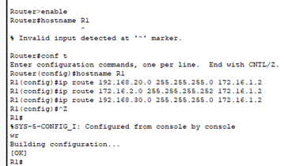

Go to Router 2 ie R2 click on it go to cli and enter the commands which are below.

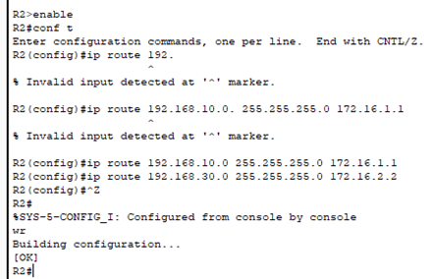

Go to Router 3 ie R3 click on it go to cli and enter the commands which are below.

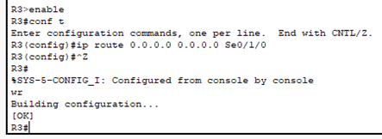

Click on Router 1 -> cli and type in “ show ip route “ and check all the connections are successful

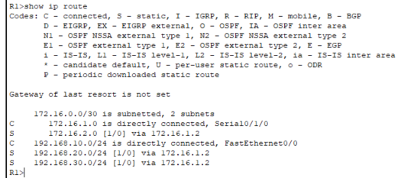

Click on Router 2 -> cli and type in “ show ip route “ and check all the connections are successful

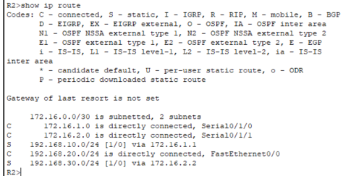

Click on Router 3 -> cli and type in “ show ip route “ and check all the connections are successful

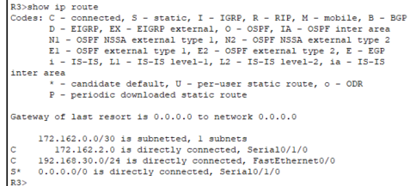

Go to PC0 -> desktop -> command prompt -> and ping 192.168.10.10, 192.168.20.10, 192.168.30.10 and check if the packets are being sent and received.

Pinging 192.168.10.10

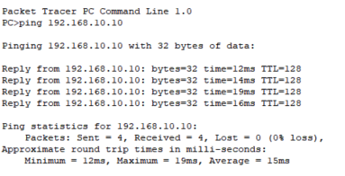

Pinging 192.168.20.10

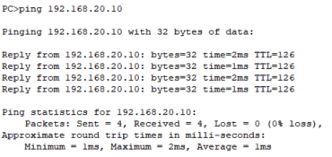

Pinging 192.168.30.10

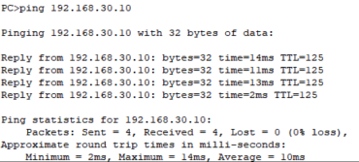

Here you can see that the message is successfully send from PC0 to PC1.

