**Computer Network Lab By Abhay NY**

**Week 5**

**Configure TELNET to access router remotely**

Connect the topology accordingly

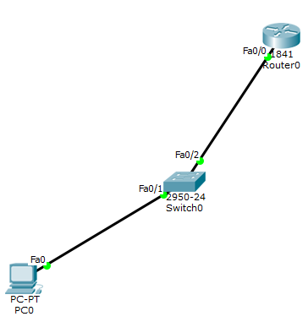

Configure the PC0 with the ip address, subnet mask and the default gateway.

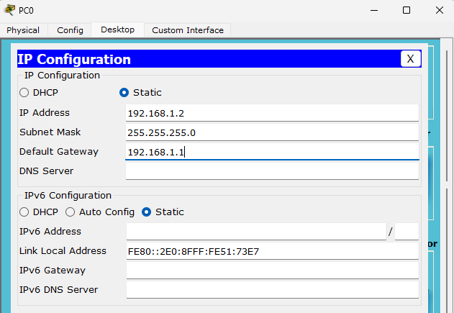

Now click on router->cli and type down the below commands

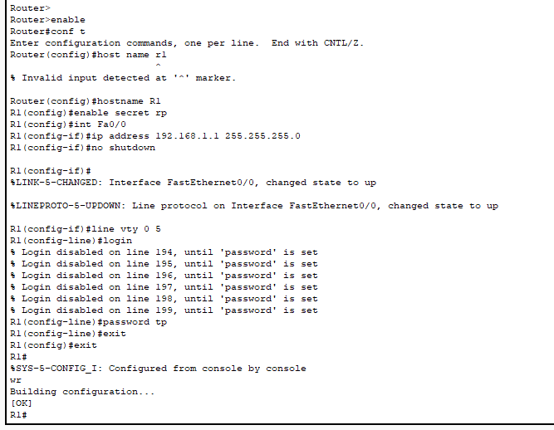

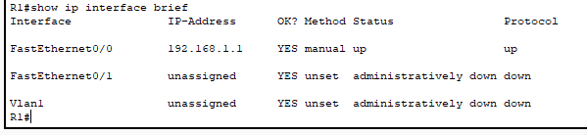

Click on PC0 -> desktop-> ping 192.168.1.1

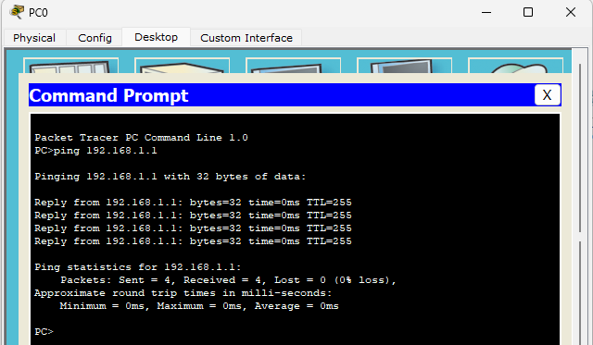

In the same cli type in the below commands. The first password as tp and the second as rp. Since the FastEthernet0/1 has a new ip address as 192.168.1.4 the telnet connection has successfully connected

