**Computer Network Lab By Abhay NY**

**Week 6**

**Configure RIP routing Protocol in Routers**

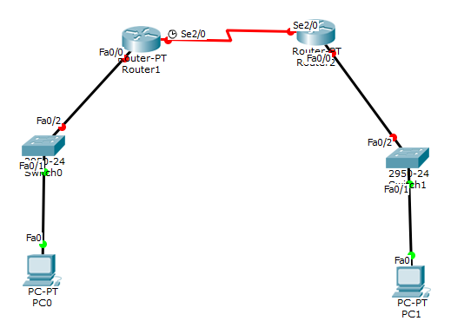

Drag all the components required and connect the topology accordingly. Connect R1 with R2 Serial DCE.

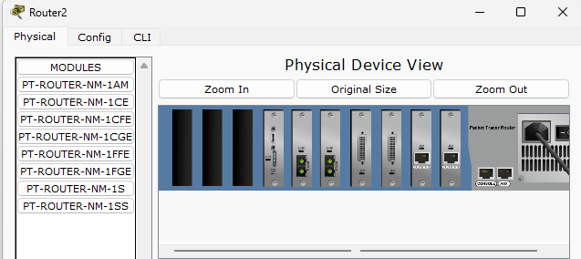

Turn of the router 1 and router 2 -> drag the PT-ROUTER-NM-1SS and place it in an empty slot -> turn it back on

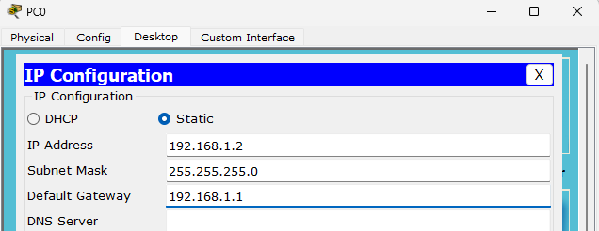

Click on PC0 -> desktop -> ip configuration -> enter the ip address as 192.168.1.2 and default gateway as 192.168.1.1

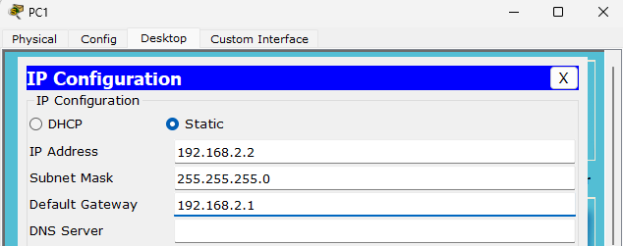

Click on PC1 -> desktop -> ip configuration -> enter the ip address as 192.168.2.2 and default gateway as 192.168.2.1

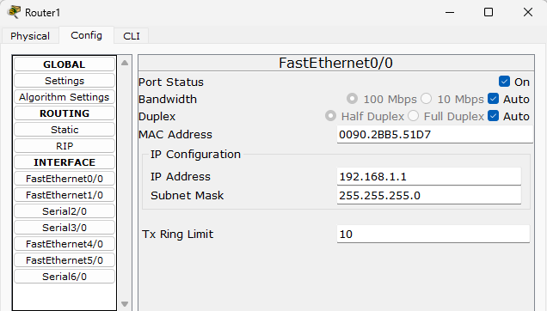

Go to router 1 -> config -> FastEthernet 0/0-> enter the ip address 192.168.1.1 and turn it ON.

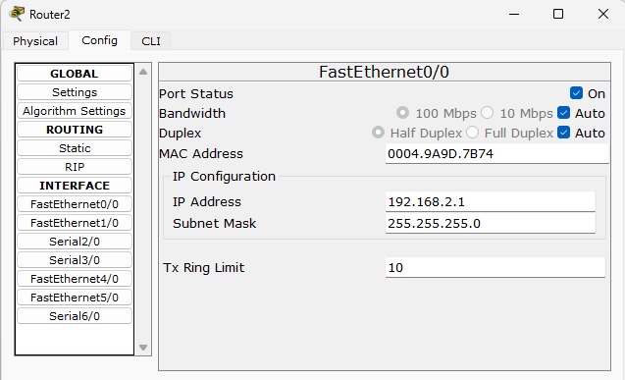

Go to router 2 -> config -> FastEthernet 0/0-> enter the ip address 192.168.2.1 and turn it ON.

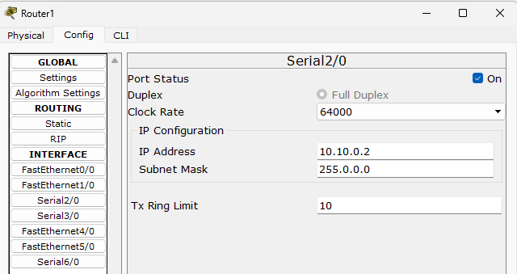

Go to router 1 -> config -> Serial 2/0-> Set the clock rate : 64000 and enter the ip address 10.10.0.2 and turn it ON.

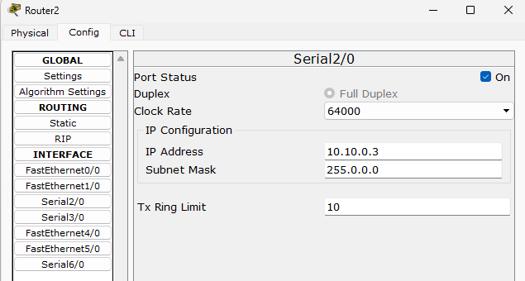

Go to router 2 -> config -> Serial 2/0-> Set the clock rate : 64000 and enter the ip address 10.10.0.3 and turn it ON.



Check if the packets are send successfully.

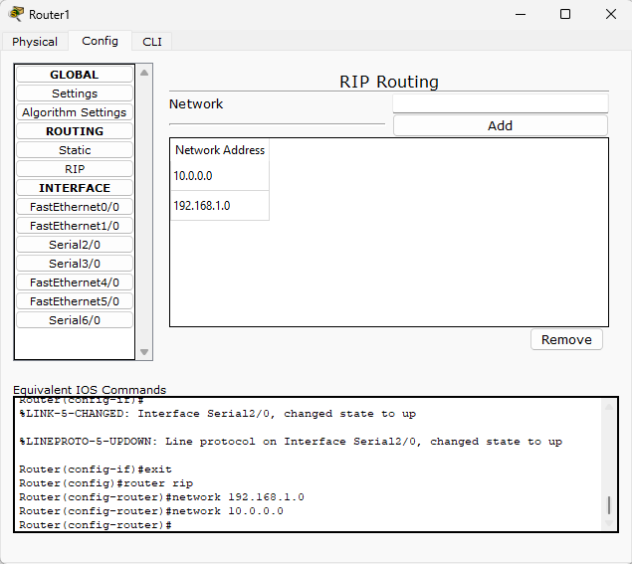

Go to router 1 -> config -> in the network section add the network addresses that are 192.168.1.0 and 10.0.0.0

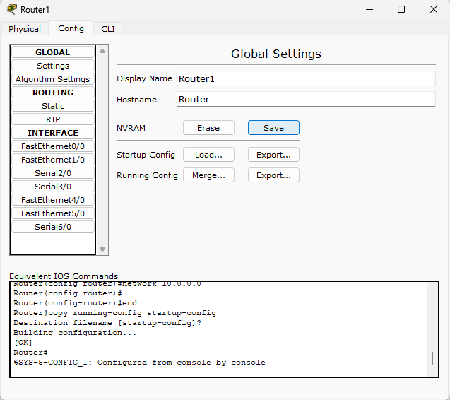

In router 1 -> config -> global setting -> Go to NVRAM and click on save.

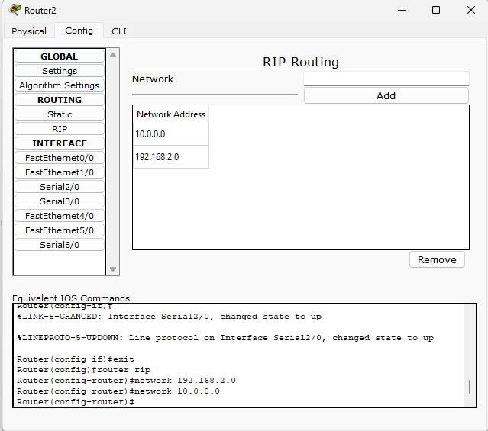

Go to router 2 -> config -> in the network section add the network addresses that are 192.168.2.0 and 10.0.0.0

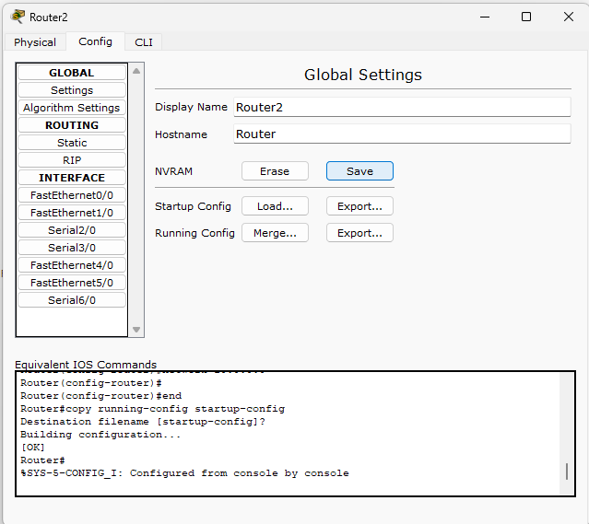

In router 2 -> config -> global setting -> Go to NVRAM and click on save.



Once done. Check if the packet is being send from PC0 TO PC1 and the status should be successful for the program to be successful.