**Computer Network Lab By Abhay NY**

**Week 7**

**To construct a WLAN and make the nodes communicate wirelessly**

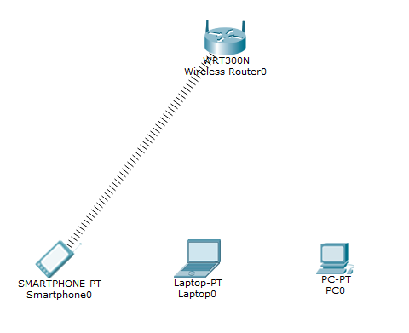

Drag all the above components smart phone, laptop, PC0 and wireless router WTT300N

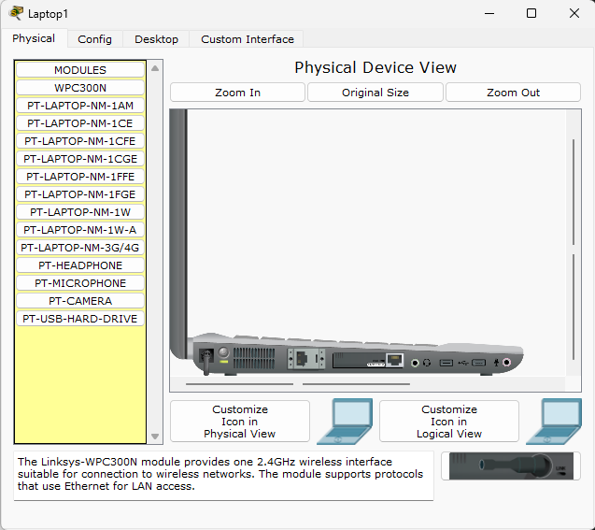

Go the the laptop click on it -> physical -> turn off the laptop and drag out the Ethernet port and place the wireless one.

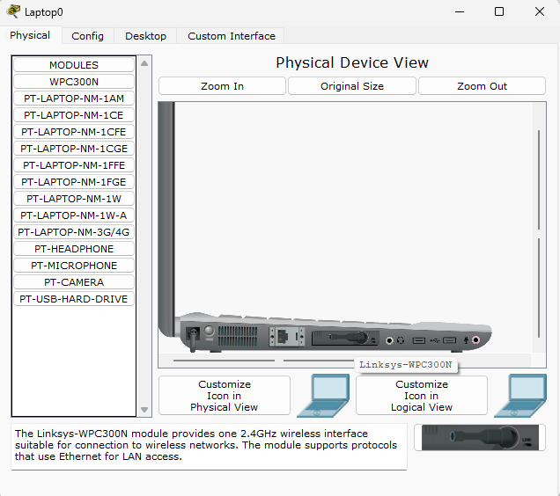

Once done turn on the laptop

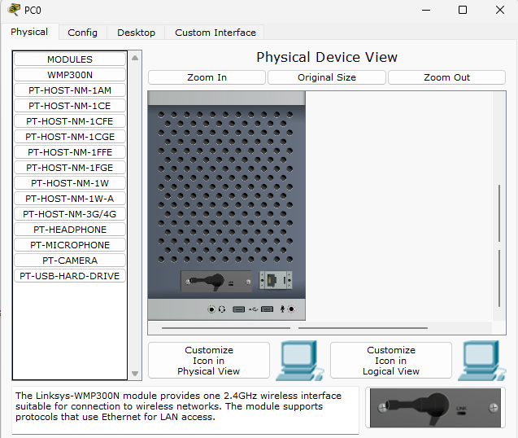

Go the PC0 click on it -> physical -> turn off the PC0 and drag out the Ethernet port and place the wireless one which is in the bottom right.

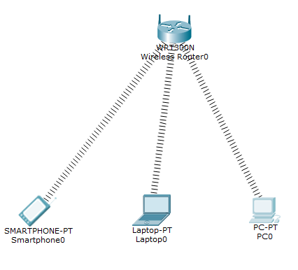

As you can see the wireless connection is successful.

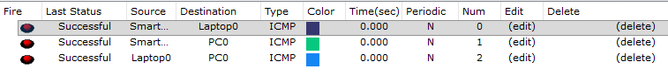

You can check by sending the packets from one component to the other component. If it says successful the configurations are successful.

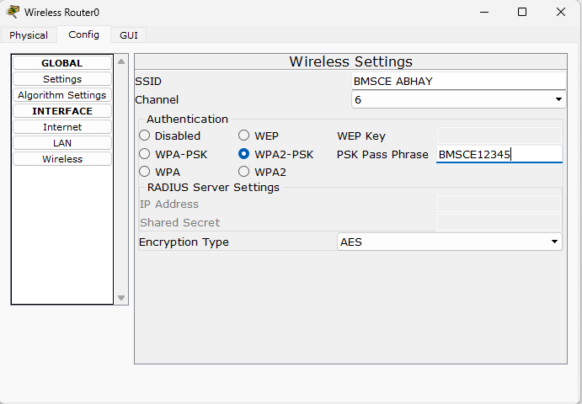

In the wireless router -> config -> settings -> enter the SSID and turn on WPA1-PSK and enter the pass phrase : BMSCE12345.

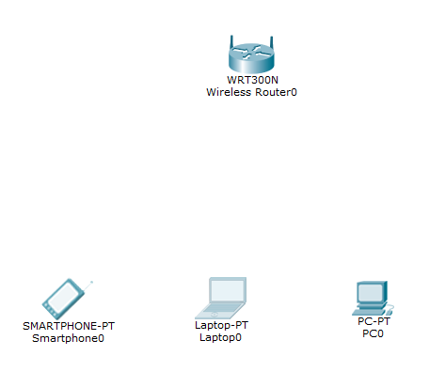

Since the smart phone, laptop and PC are not configured. The connections will not be established.

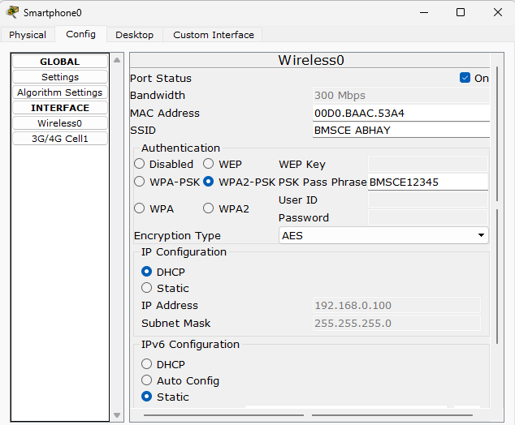

Click on smartphone -> config -> Wireless0 -> enter the SSID and the authentication type and pass phrase NOTE the SSID and the pass phrase should be same as the Wireless one.

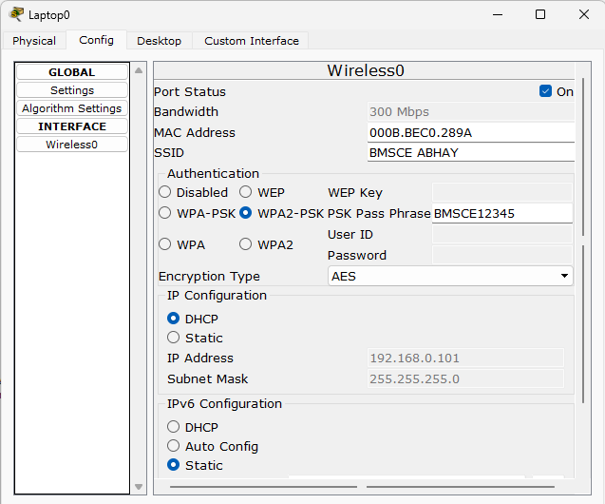

Click on Laptop0 -> config -> Wireless0 -> enter the SSID and the authentication type and pass phrase NOTE the SSID and the pass phrase should be same as the Wireless one.

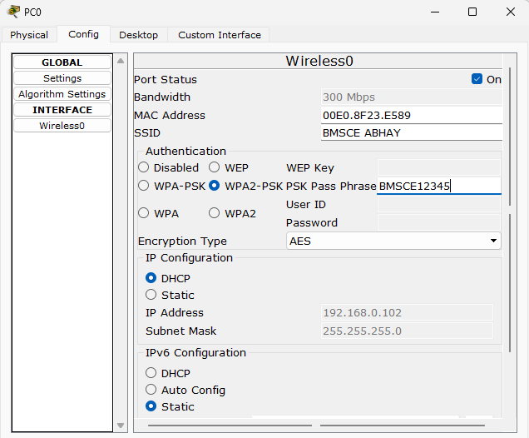

Click on PC0 -> config -> Wireless0 -> enter the SSID and the authentication type and pass phrase NOTE the SSID and the pass phrase should be same as the Wireless one.

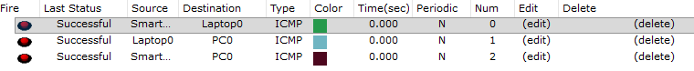

Once the connections are done send the packet from one component to the other to check if the connections are successful.