**Computer Network Lab By Abhay NY**

**Week 8**

**To construct simple LAN and understand the concept and operation of Address Resolution Protocol (ARP)**

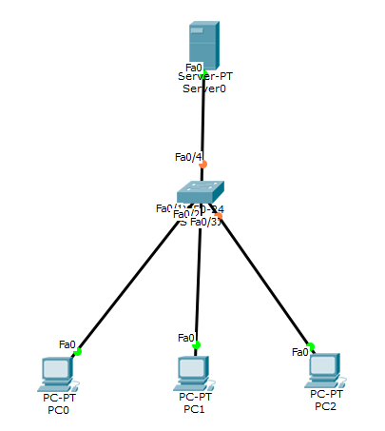

Drag all the components from the above image.

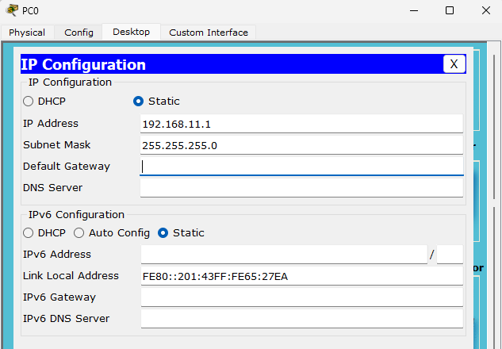

Click on PC0 -> Desktop -> IP configuration and configure the IP address as 192.168.11.1

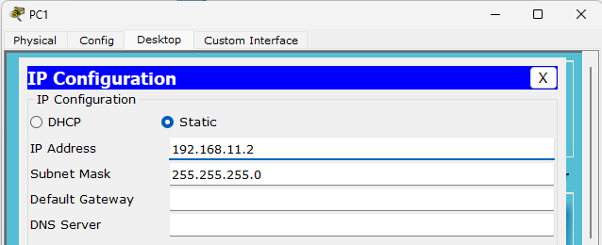

Click on PC2 -> Desktop -> IP configuration and configure the IP address as 192.168.11.2

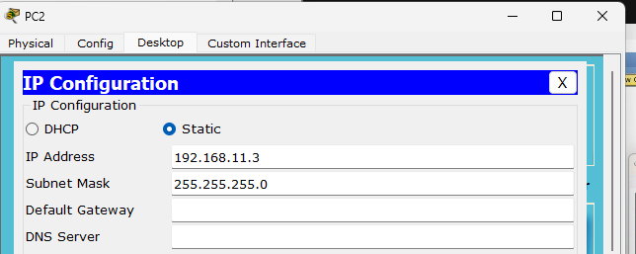

Click on PC2 -> Desktop -> IP configuration and configure the IP address as 192.168.11.3

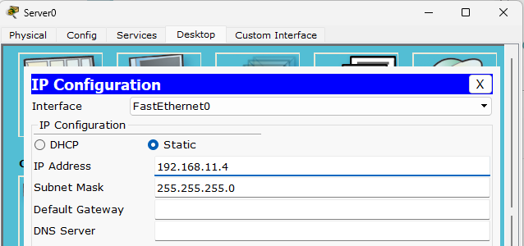

Click on Server0 -> Desktop -> IP configuration and configure the IP address as 192.168.11.4

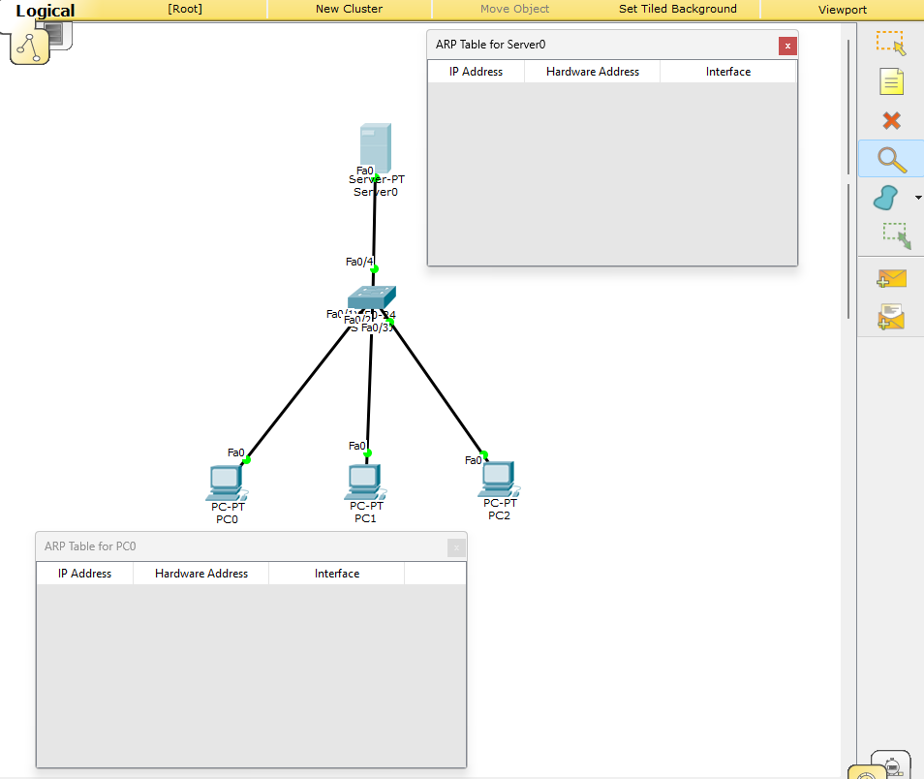

Click on the optical glasses in the right side -> right click on PC0 and select ARP table, do the same for server0 as well

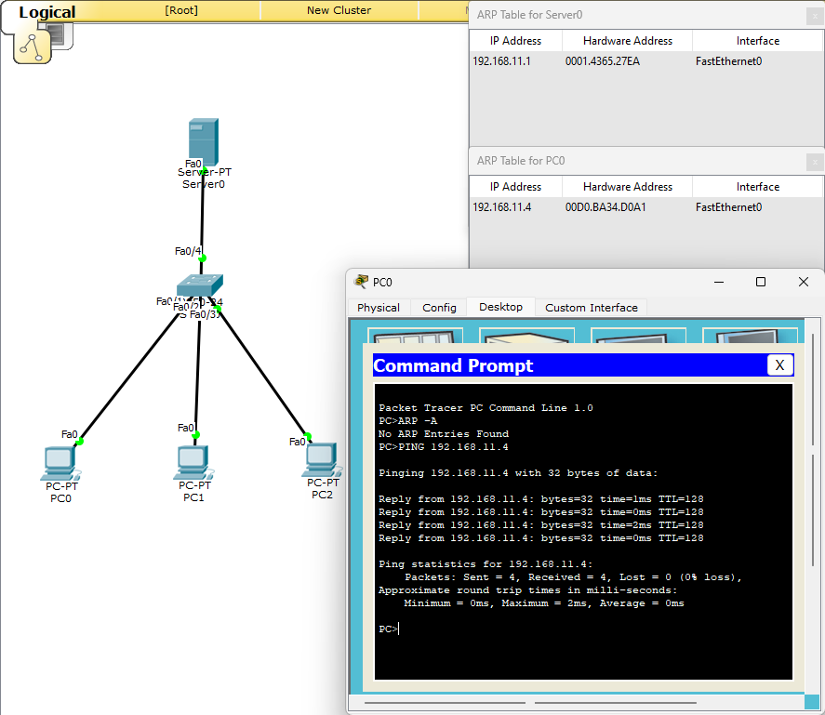

Click on PC0 -> desktop -> command prompt -> ping 192.168.11.4 and check if the values are generated in the ARP tables which you have selected earlier.



Send packets from one PC0 to any other PC to check if the connections are successfully connected.