**Computer Network Lab By Abhay NY**

**Week 9**

**To construct a VLAN and make the PC’s communicate among a VLAN**

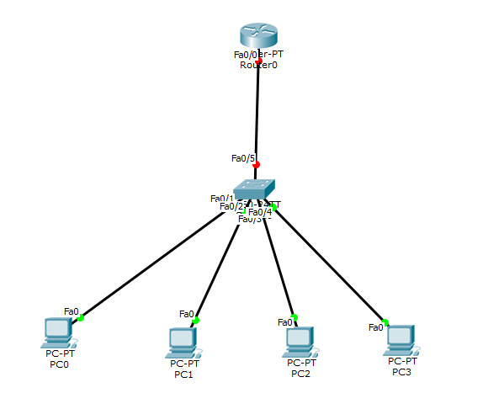

Create the above topology accordingly, and connect through copper straight through.

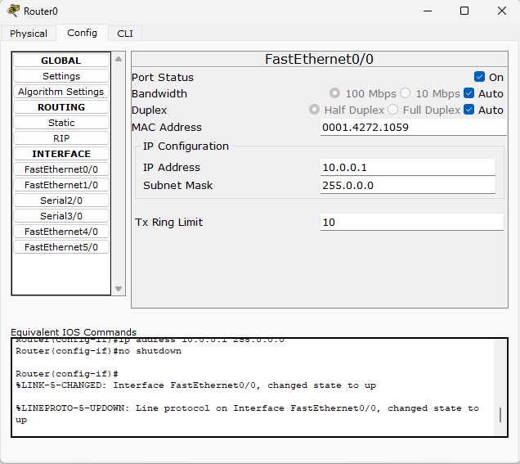

Go to router -> config -> fast ethernet 0/0 , IP address 10.0.0.1 and port status ON.

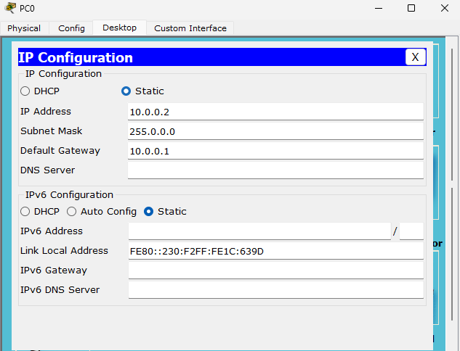

Click on PC0 -> desktop -> IP address 10.0.0.2 and default gateway 10.0.0.1

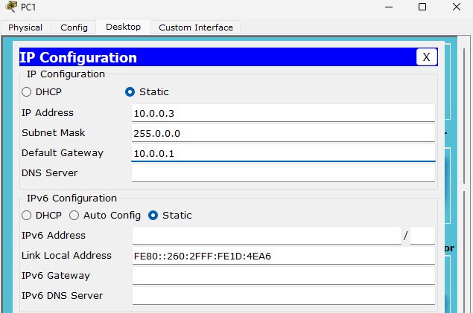

Click on PC1 -> desktop -> IP address 10.0.0.3 and default gateway 10.0.0.1

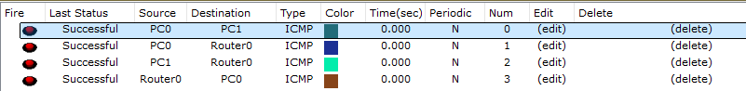

Check if the connections are successful by send in packets from PC0 to PC1, PC0 to ROUTER 0, PC1 to ROUTER 0, ROUTER 0 to PC0.

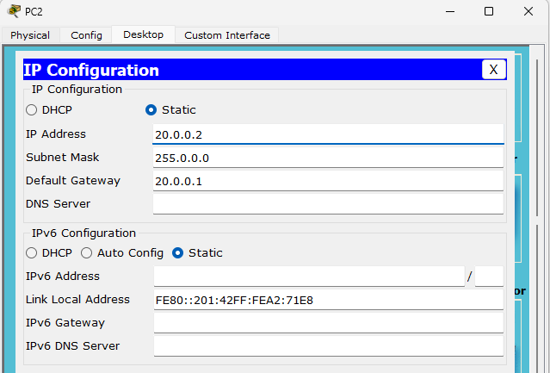

Click on PC2 -> desktop -> IP address 20.0.0.2 and default gateway 20.0.0.1

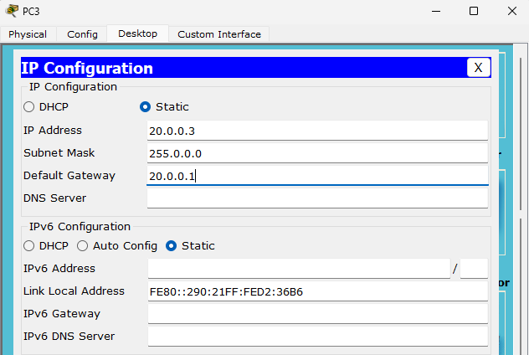

Click on PC3 -> desktop -> IP address 20.0.0.3 and default gateway 20.0.0.1

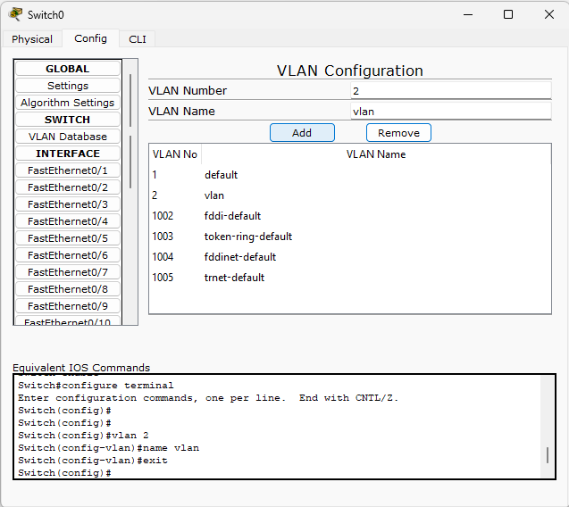

Click on switch0 -> config -> VLAN Database -> VLAN NUMBER : 2 , VLAN Name : vlan and press add.

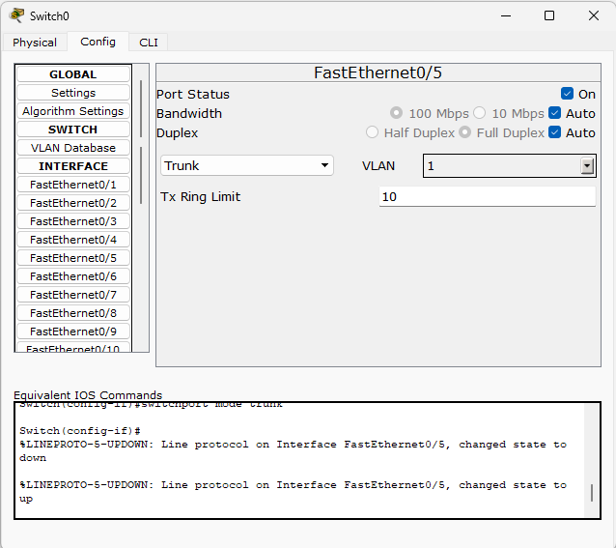

Click on Switch0 -> config -> FastEthernet 0/5 change from access to “Trunk”

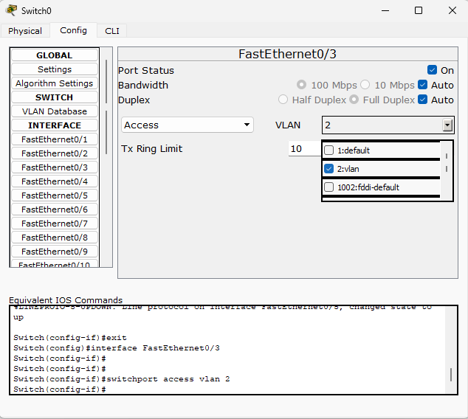

Click on Switch0 -> config -> FastEthernet 0/3 change the VLAN to “2”

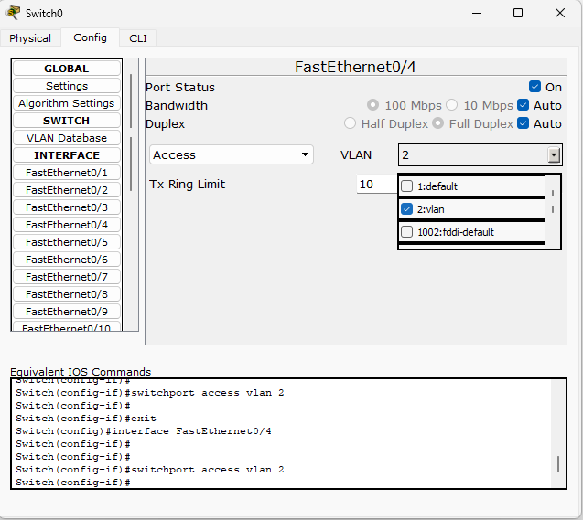

Click on Switch0 -> config -> FastEthernet 0/4 change the VLAN to “2”

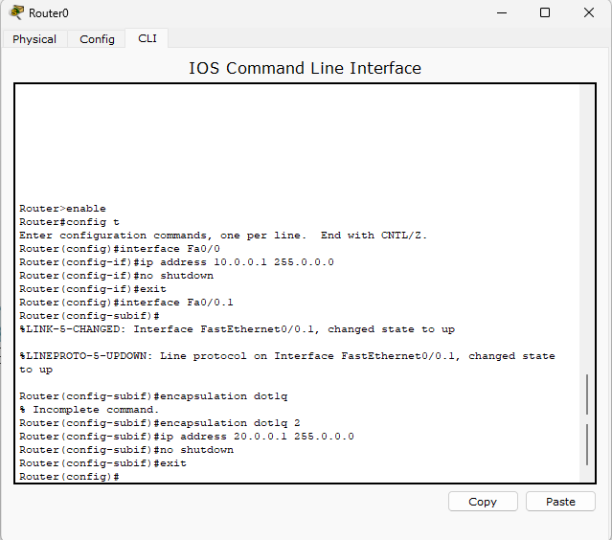

Click on Router0 -> CLI and type in the above commands accordingly.

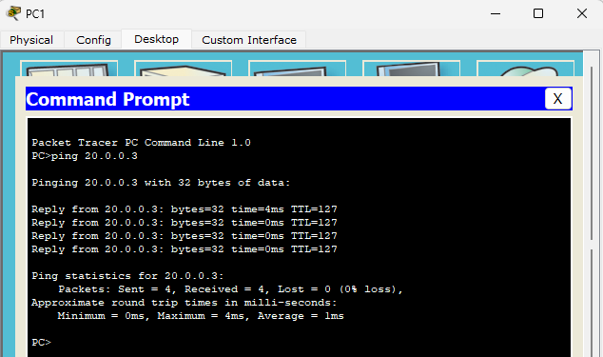

Now click on PC1 -> command prompt -> ping 20.0.0.3 and check if the ping is successful.