Computer Network Lab By Abhay NY
Week 10
Configure OSPF routing protocol
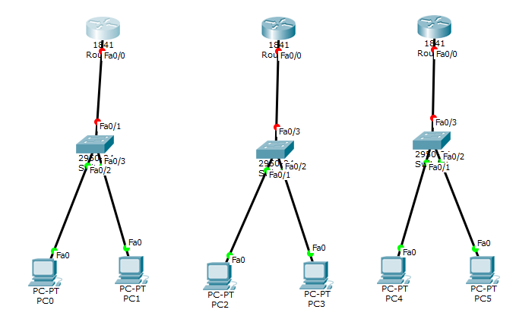
Drag all the components accordingly.

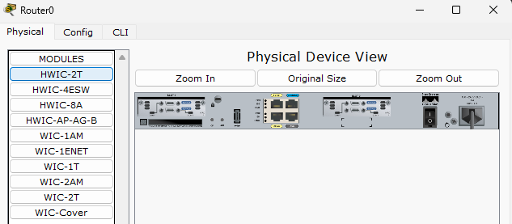
Click on router 0 -> physical -> Turn off the device -> Drag and drop HWIC-2T and place it.
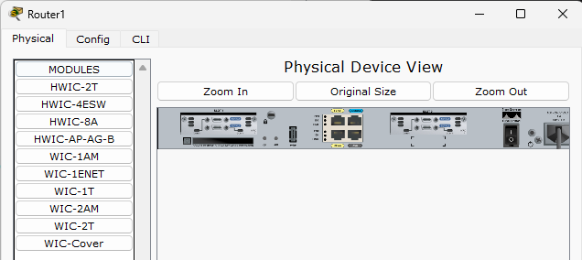
Click on router 1 -> physical -> Turn off the device -> Drag and drop HWIC-2T and place it.

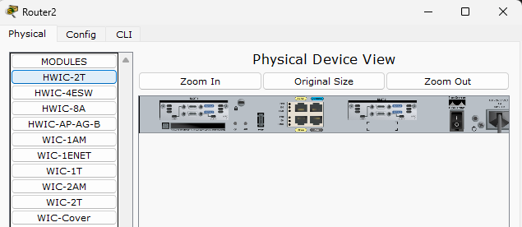
Click on router 2 -> physical -> Turn off the device -> Drag and drop HWIC-2T and place it.
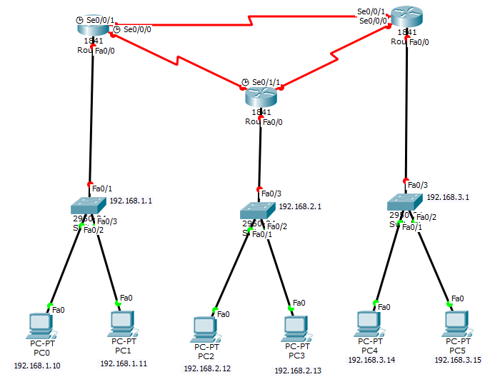
Label the components accordingly.

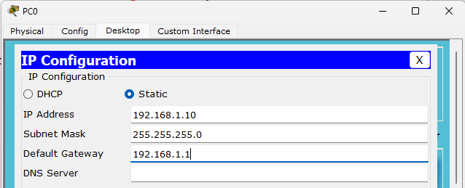
Click on PC0 -> Desktop -> IP configuration, IP Address: 192.168.1.10, Default gateway: 192.168.1.1
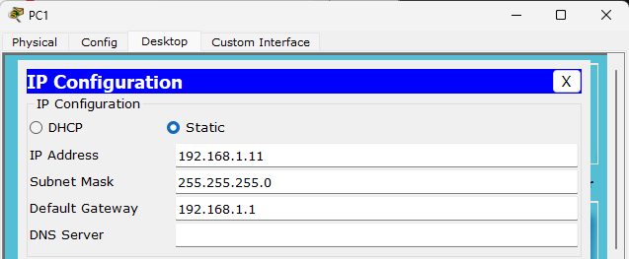
Click on PC1 -> Desktop -> IP configuration, IP Address: 192.168.1.11, Default gateway: 192.168.1.1

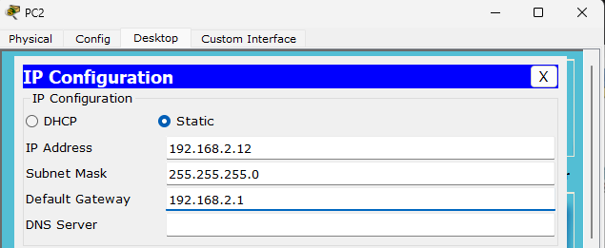
Click on PC2 -> Desktop -> IP configuration, IP Address: 192.168.2.12, Default gateway: 192.168.2.1
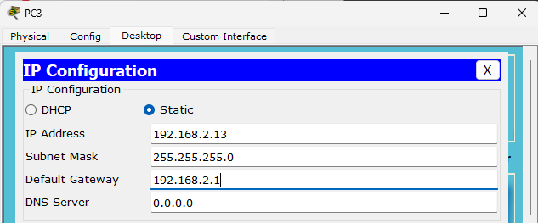
Click on PC3 -> Desktop -> IP configuration, IP Address: 192.168.2.13, Default gateway: 192.168.2.1

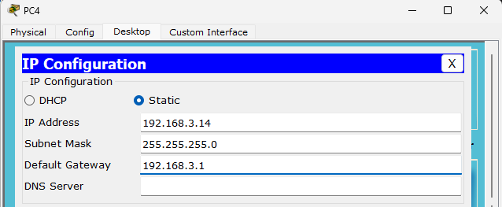
Click on PC4 -> Desktop -> IP configuration, IP Address: 192.168.3.14, Default gateway: 192.168.3.1
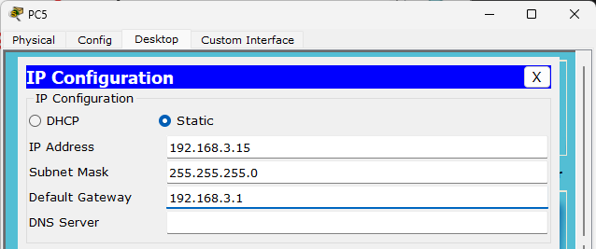
Click on PC5 -> Desktop -> IP configuration, IP Address: 192.168.3.15, Default gateway: 192.168.3.1

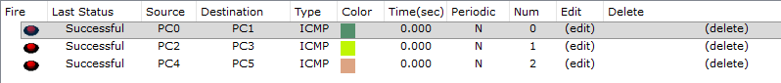
Send packets from PC0 to PC1, PC2 to PC3, PC4 to PC5 and check if the packets are sent successful.
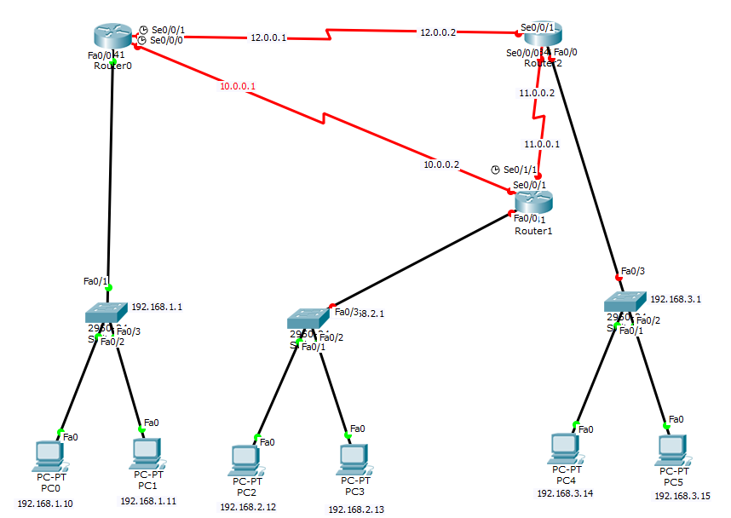
Note the IP addresses accordingly and note them.
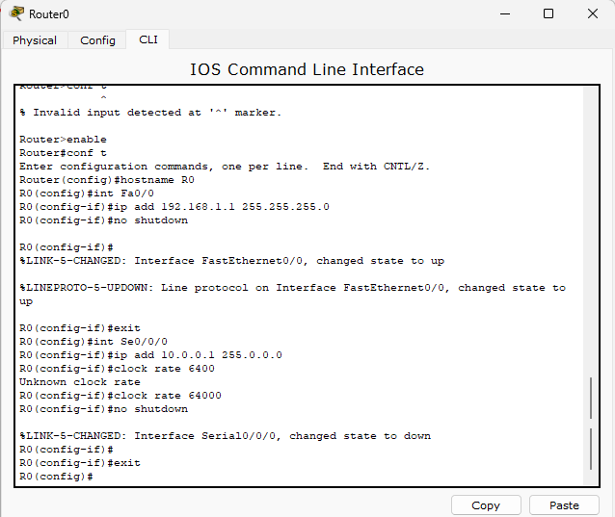
Click on Router0 -> CLI -> and type in the above commands accordingly.
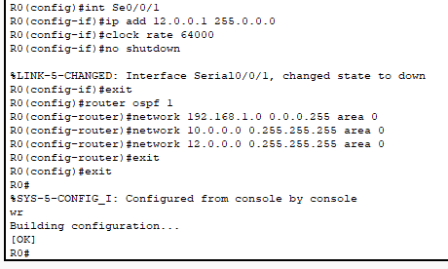
Complete the above commands in the same CLI of Router0
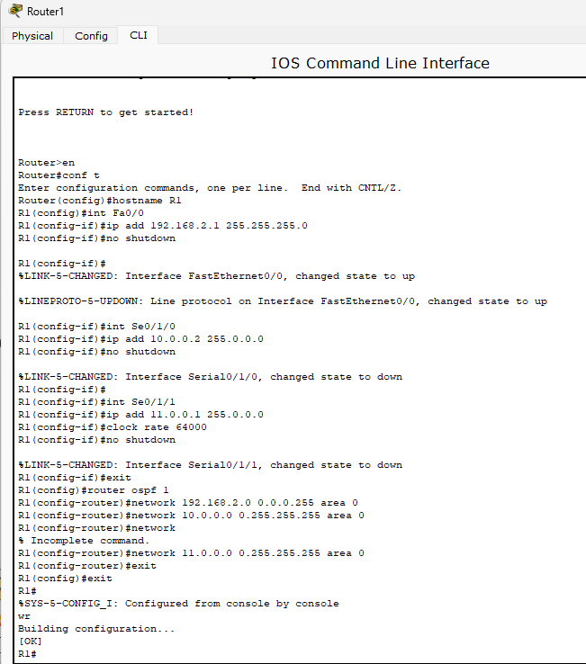
Click on Router1 -> CLI -> and type in the above commands accordingly.
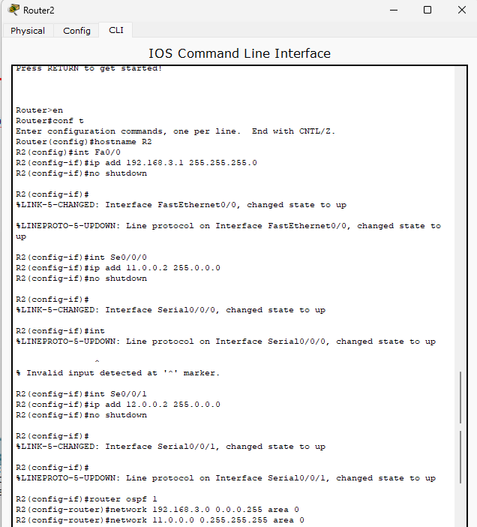
Click on Router2 -> CLI -> and type in the above commands accordingly.

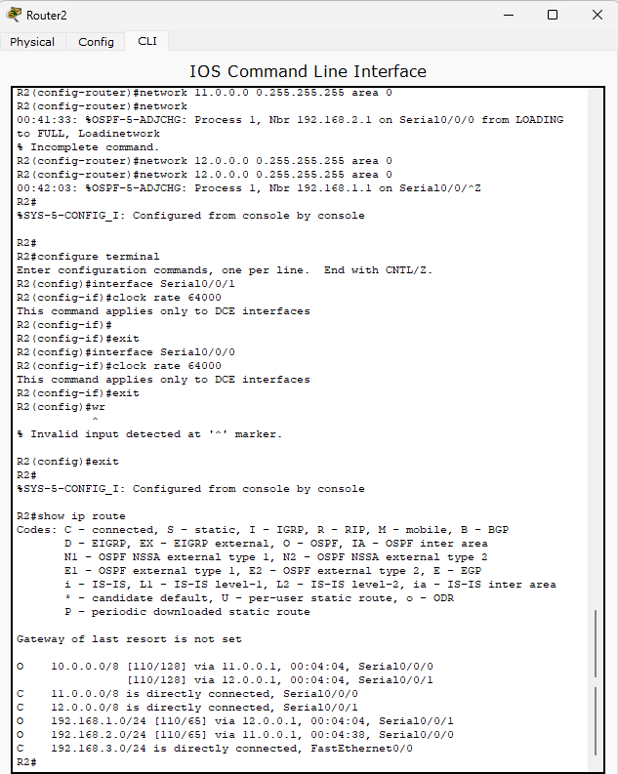
Complete the above commands in the same CLI of Router2

Send packets from PC0 to PC2, PC0 to PC5 and check if the packets are sent successful.

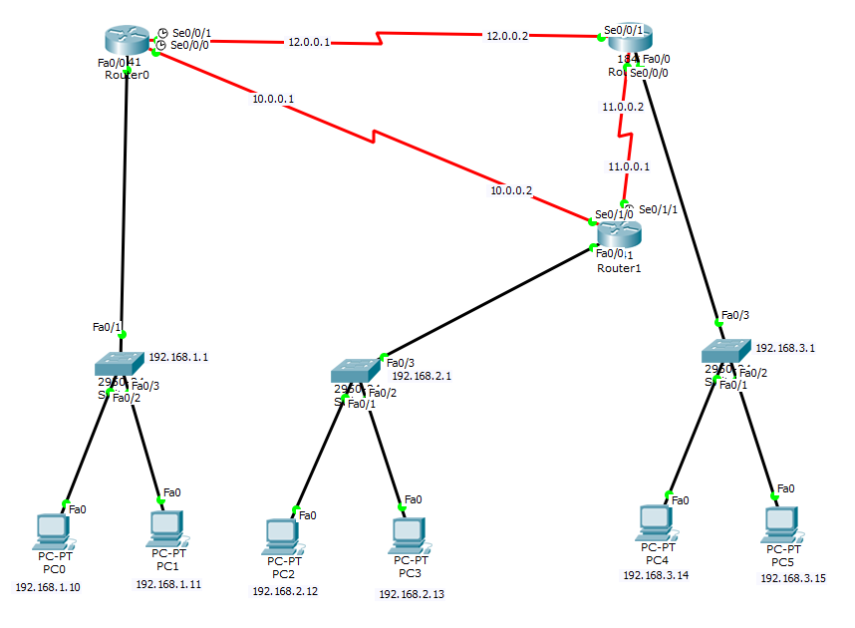
This is the final connections that is to be done. For your reference.

