**Part 1**

drop database newdatabase;

show databases;

create database IF NOT exists newdatabase;

show databases;

use newdatabase;

create table uno

(

name varchar(20)

);

insert into uno values("abhay");

insert into uno values("jam");

select * from uno;

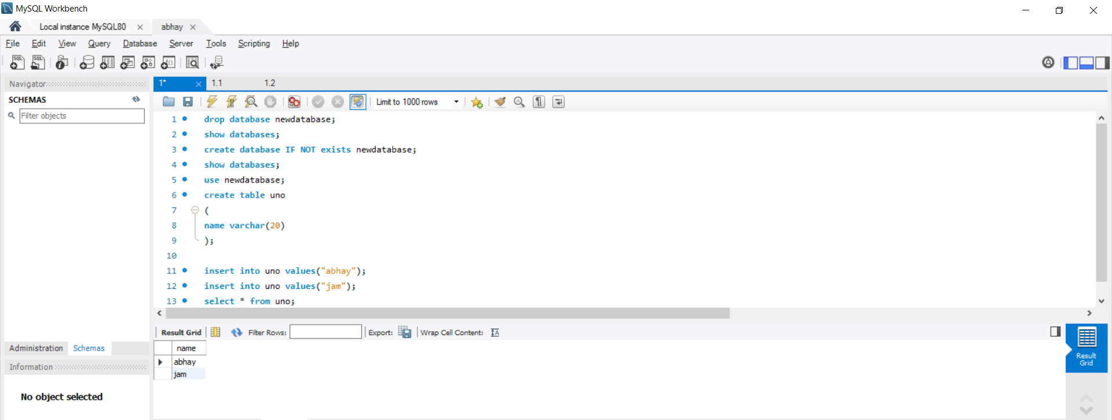

**Part 1.1**

drop database abhay;

create database abhay;

use abhay;

create table student(std_id int(5), std_name varchar(20), dob_date DATE, doj_date DATE, fee int(5), gender char(7));

insert into student values (1,"ABHAY",'2005-03-11','2005-01-05',10000,"M");

insert into student values (2,"KOALA",'2005-01-12','2005-11-07',11000,"F");

insert into student values (3,"PUGGY",'2005-01-15','2005-10-09',12000,"M");

alter table student add PHONE_NO varchar (10);

alter table student rename column PHONE_NO to STUDENT_NO ;

-- alter table student rename to STUDENT_INFO;

-- alter table student drop column gender;

-- delete from student where std_id = 2 ;

select * from student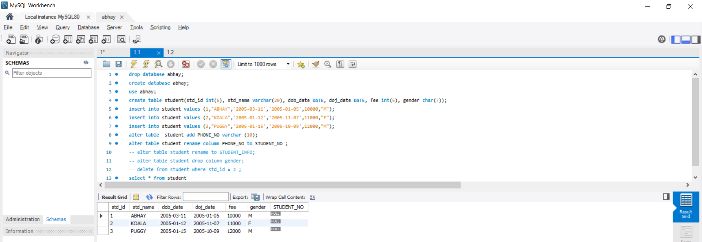

**PART 1.2**

drop database Product;

create database Product;

use Product;

create table Product(product_ID int(5), product_code varchar(50), name varchar(100), quantity int(10), price float(10));

insert into Product values (1001,"PEN","Pen Red",5000,1.23);

insert into Product values (1002,"PEN","Pen BLUE",8000,1.25);

insert into Product values (1003,"PEN","Pen Black",2000,1.25);

insert into Product values (1004,"PEC","Pencil 2B",10000,0.48);

insert into Product values (1005,"PEC","Pencil 2H",8000,0.49);

insert into Product values (1006,"PEC","Pencil HB",0,9999999.99);

alter table Product add Product_cost varchar (10);

alter table Product rename column Product_cost to Product_sales ;

-- alter table Product rename to Product_INFO;

-- alter table Product drop column quantity;

-- delete from Product where product_id = 1002 ;

select * from Product

