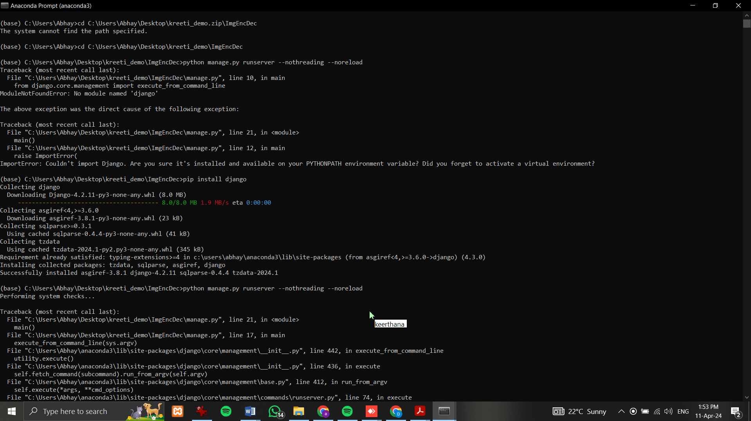

pip install django

pip install opencv-python==4.5.5.64

python manage.py runserver --nothreading --noreload

