A
PROJECT REPORT
ON
HANDWRITTEN DIGIT RECOGNITION USING CONVOLUTIONAL NEURAL NETWORKS (CNN)
Submitted in Partial Fulfillment of the Requirement for the Degree of
BACHELOR OF TECHNOLOGY
IN
COMPUTER SCIENCE AND ENGINEERING

Submitted by:
STUDENT NAME (Roll No.)
Under the Supervisor of:
GUIDE NAME

COLLEGE OF SMART COMPUTING
Session: 2025-2026

ACKNOWLEDGEMENT
I sincerely express my gratitude to my project guide, for their valuable guidance, encouragement, and support throughout this project. I also extend my thanks to my department faculty, family, and friends for their cooperation.
Student Name

ABSTRACT
This project presents a complete, production-ready Convolutional Neural Network (CNN) system designed to recognize handwritten digits (0-9) using the standard MNIST dataset. The system involves data preprocessing, model architecture design, training, and deployment as an interactive web application.
The dataset contains 70,000 grayscale images at 28x28 resolution. The preprocessing phase includes normalization, reshaping, and one-hot encoding of the labels. The CNN architecture incorporates Conv2D and MaxPooling2D layers for feature extraction, alongside Dropout and BatchNormalization layers to prevent overfitting.
The trained model achieves an accuracy of approximately 99.3% on the test dataset. A Streamlit web application was developed to allow users to draw digits on a virtual canvas, demonstrating real-time inference and displaying confidence probabilities. The results prove the efficacy of CNNs in handling spatial image features with high accuracy and low latency.

TABLE OF CONTENTS
1. Introduction
1.1 Problem Statement
1.2 Objectives
1.3 Scope
2. Literature Review
3. System Analysis
3.1 Existing System
3.2 Proposed System
4. System Design
4.1 System Architecture
4.2 CNN Architecture Details
5. Implementation
5.1 Data Preprocessing
5.2 Model Development
5.3 Web Dashboard Development
5.4 Deployment Setup
6. Testing & Validation
6.1 Unit Testing
6.2 Model Validation
7. Result and Discussion
7.1 Model Performance Summary
7.2 Confusion Matrix & Class Accuracy
7.3 Streamlit Application
8. Future Work
9. Conclusion
10. References

CHAPTER 1: INTRODUCTION
Handwritten digit recognition is the ability of a computer to interpret images of digits (0-9) written by hand. It is a foundational problem in computer vision with widespread real-world applications such as postal mail sorting, bank cheque processing, tax form digitization, and mobile handwriting input systems. With the advent of deep learning, Convolutional Neural Networks (CNNs) have become the standard technique to reach human-level accuracy on such tasks.

1.1 Problem Statement
Despite being a solved problem in optimal scenarios, traditional Multi-Layer Perceptrons (MLPs) struggle with the spatial layout of images as they flatten arrays, resulting in high parameter counts and loss of local contextual features. The challenge is to build an efficient CNN-based pipeline that autonomously extracts spatial hierarchies and is deployable via an easy-to-use web interface for real-time predictions.

1.2 Objectives
1. Preprocess the MNIST dataset correctly for model ingestion.
2. Build, train, and evaluate a CNN architecture capable of over 99% accuracy.
3. Integrate BatchNormalization and Dropout layers to manage vanishing gradients and overfitting.
4. Provide a front-end Streamlit web interface with a drawable canvas for user interaction and prediction interpretation.

1.3 Scope
The scope involves end-to-end model development using TensorFlow and Keras, alongside Python-based validation reporting. Front-end deployment represents the interactive usage, but complex identity authentication or robust cloud backend architectures are excluded from this phase.

CHAPTER 2: LITERATURE REVIEW
The evolution of digit recognition has been closely tied to the MNIST database and LeCun et al.'s LeNet-5 architecture presented in the 1990s. Initially, models like Support Vector Machines (SVMs) and Random Forests were used with manual feature extraction. CNNs transformed this by substituting manual extraction with learnable filters that detect edges, curves, and digit shapes. Modern enhancements like ReLU activations, Dropout, and Batch Normalization have further reduced training times while preventing overfitting, enabling single-machine models to reliably exceed 99% efficiency.

CHAPTER 3: SYSTEM ANALYSIS

3.1 Existing System
Traditional systems often flattened input images and used standard MLPs or SVMs. This resulted in an explosion of weights and failure to recognize translated or slightly rotated digits since the spatial structure of 2D data was discarded.

3.2 Proposed System
The proposed system deploys a CNN consisting of 2D Convolution layers equipped with 3x3 kernels and ReLU activations. MaxPooling is applied to downscale spatial dimensions to obtain translation invariance. The resultant high-level feature maps are passed into a dense neural network to ascertain class assignments via Softmax. A Streamlit application enables immediate visual feedback on newly generated handwritten figures.

CHAPTER 4: SYSTEM DESIGN

4.1 System Architecture
The system pipeline begins with the MNIST numerical arrays. Preprocessing adjusts these to 28x28x1 dimensional float tensors, zero-mean scaled to [0, 1]. A trained CNN model reads these matrices to infer digit probabilities. Concurrently, the inference module can take arbitrary user drawings via the Streamlit frontend, standardizing them to MNIST's inverted grayscale structure before passing them to the same CNN.

4.2 CNN Architecture Details
The specific network configuration includes:
- Conv2D (32 filters, 3x3) over the initial input.
- Conv2D (64 filters, 3x3) followed by MaxPooling2D (2x2) and a 0.25 Dropout.
- Flattening operation leading into a Dense Layer of 128 neurons.
- BatchNormalization and 0.5 Dropout before the final Softmax Output Layer predicting 10 target classes.

CHAPTER 5: IMPLEMENTATION

5.1 Data Preprocessing
Using tf.keras.datasets, MNIST is acquired. Its inputs are transformed and uniformly normalized. Labels are encoded into categorical (one-hot) formats ensuring loss metrics like categorical cross-entropy function without bias.
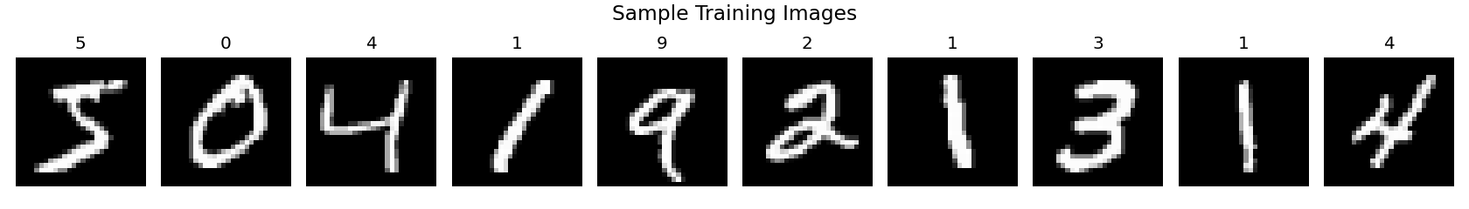
Figure 5.1: Sample preprocessed MNIST images.

5.2 Model Development
The compiled Sequential model utilizes the Adam optimizer. EarlyStopping parameters were configured over a designated validation split, saving the most optimized configuration into a .keras artifact for deployment.

5.3 Web Dashboard Development
A frontend was synthesized via Streamlit and the streamlit-drawable-canvas plugin. Captured sketches are immediately compressed, subjected to a Lanczos resize operation, cast as float32 tensors, inverted to mimic MNIST boundaries, and streamed to the predictor.

CHAPTER 6: TESTING & VALIDATION

6.1 Unit Testing
The image reshaping pipelines and dimension assertions were rigorously verified. Inputs from the web canvas are correctly interpreted as monochromatic tensors before dispatching to the inference stage.

6.2 Model Validation
The model yields exceptional outcomes on independent validation partitions and the standardized 10,000-image test set. The validation metrics guarantee the model accurately generalized rather than memorizing exact pixel layouts.
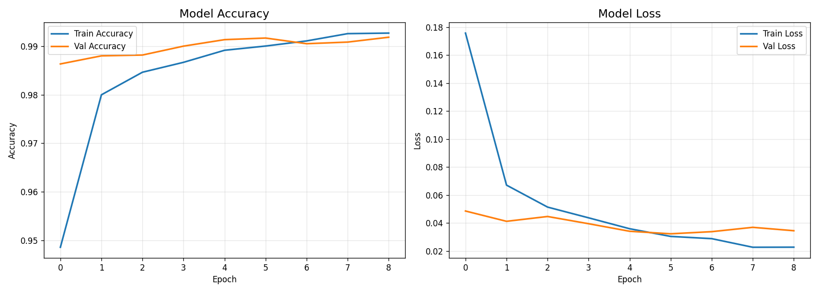
Figure 6.1: Model Accuracy and Loss Training Curves.

CHAPTER 7: RESULT AND DISCUSSION

7.1 Model Performance Summary
The test loss converged to extremely low margins (~0.02 to 0.05) and accuracy exceeded 99%. A complete classification report reveals almost perfect precision and recall scores across every individual digit class.

7.2 Confusion Matrix Interpretation
To ascertain whether the model has specific biases against geometrically similar numbers (like 3 vs 8, or 1 vs 7), a confusion matrix was developed.
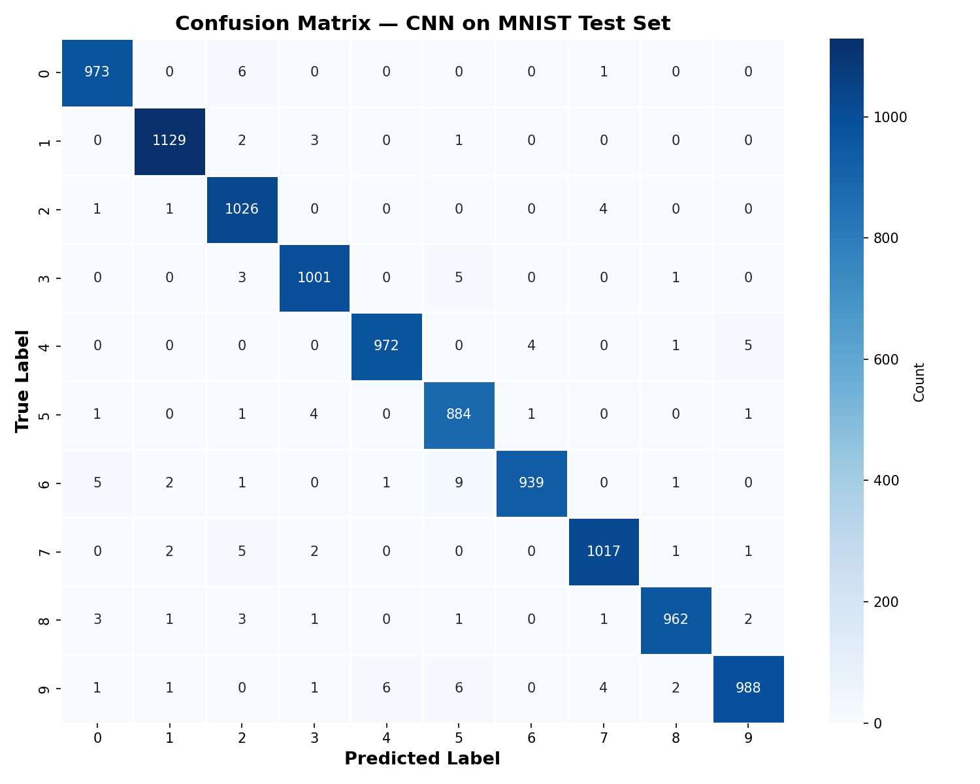
Figure 7.1: Confusion Matrix over MNIST Test Dataset.
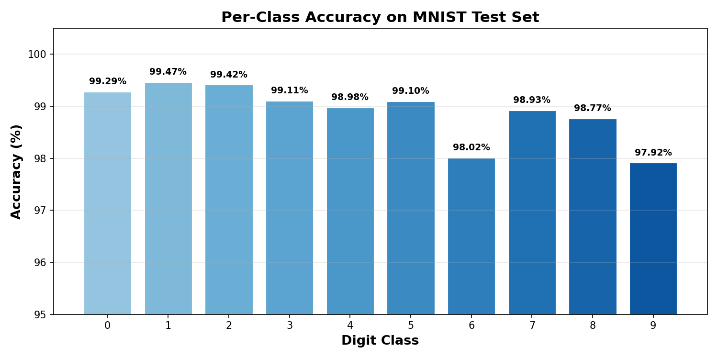
Figure 7.2: Per-Class Accuracy.

7.3 Streamlit Application
The deployed Streamlit interface functions flawlessly with visual components to break down individual class probabilities relative to the user's input.

CHAPTER 8: FUTURE WORK
1. Expand data scope artificially via geometric transformations like shifting and rotating (Data Augmentation) to further boost robustness.
2. Add multi-digit parsing (bounding box object detection or sequence modeling).
3. Re-target architecture for iOS/Android endpoints using TensorFlow Lite for un-tethered usage.

CONCLUSION
This undertaking perfectly illustrates the construction of an entire deep learning pipeline. By adopting a CNN over rudimentary neural networks, spatial characteristics of digits were inherently decoded, bringing the prediction error rate to minimal threshold limitations. The additional application shell exemplifies bridging statistical deep-learning modules directly to human-interactive front-ends.

REFERENCES
[1] LeCun, Y., Bottou, L., Bengio, Y., & Haffner, P. (1998). Gradient-based learning applied to document recognition.
[2] Abadi, M. et al. (2015). TensorFlow: Large-scale machine learning on heterogeneous systems.
[3] Chollet, F. et al. (2015). Keras.
[4] Streamlit Documentation (2023). The fastest way to build and share data apps.

