HANDWRITTEN DIGIT RECOGNITION USING
CONVOLUTIONAL NEURAL NETWORKS

Project report submitted
in partial fulfillment of the requirement for the degree of

BACHELOR OF TECHNOLOGY
Computer Science and Engineering
SUBMITTED BY

ABHAY SINGH
(223025001)

MAY 2026



SUPERVISOR
MR. ANANT KOSHAL
(Assistant Professor)

DEPARTMENT OF COMPUTER SCIENCE & ENGINEERING
COLLEGE OF SMART COMPUTING, COER UNIVERSITY ROORKEE, UTTARAKHAND


DEPARTMENT OF COMPUTER SCIENCE & ENGINEERING
COLLEAGE OF SMART COMPUTING, COER UNIVERSITY
ROORKEE, UTTARAKHAND

PROJECT PROGRESS REPORT

Student ID: U22260028

Student Name: Abhay Singh

Program: B.Tech (CSE)

Year and Section: 4th ‘A’ Semester: 8th

Project Mentor Name: Mr. Sunil Singh

Project Title: Handwritten Digit Recognition Using Convolutional Neural Networks

Details of Visit to Project Supervisor:

S NO | DATE | TIME | REMARK | SUPERVISORSIGNATURE
1 | 28/1/26 | 11.30 AM | Project topic discussion
2 | 16/2/26 | 04.00 PM | Synopsis Submission/Correction
3 | 13/3/26 | 03.15 PM | Synopsis Submission
4 | 4/4/26 | 11.45 AM | Project Report Correction
5 | 15/5/26 | 10.00 AM | Final Report & PPT Submission
Synopsis Submission & Presentation |  |  | Marks:
Project Mid-Team Evaluation (Internal) |  |  | Marks:
Project presentation and Evaluation (External) |  |  | Marks:

Supervisor Signature Mentor Signature

CERTIFICATE
It is certified that the work contained in the project report titled “HANDWRITTEN DIGIT RECOGNITION USING CONVOLUTIONAL NEURAL NETWORKS” by “Abhay Singh” has been carried out under my/our supervision and that this work has not been submitted elsewhere for a degree.

Signature of Supervisor
MR. ANANT KOSHAL
CSE DEPARTMENT
COER UNIVERSITY
MAY, 2026

DECLARATION
I declare that this written submission represents my ideas in my own words and where others' ideas or words have been included, I have adequately cited and referenced the original sources. I also declare that I have adhered to all principles of academic honesty and integrity and have not misrepresented or fabricated or falsified any idea/data/fact/source in my submission. I understand that any violation of the above will be cause for disciplinary action by the Institute and can also evoke penal action from the sources which have thus not been properly cited or from whom proper permission has not been taken when needed.

Abhay Singh
(223025001)

ACKNOWLEDGMENT

I would want to convey our heartfelt gratitude to Mr. Anant Koshal our mentor, for his invaluable advice and assistance in completing my project. He was there to assist me in every step of the way, and his motivation is what enabled me to accomplish my task effectively. I would also like to thank all of the other supporting personal who assisted me by supplying the equipment that was essential and vital, without which i would not have been able to perform efficiently on this project. I would also want to thank the university college of engineering Roorkee for accepting my project in my desired field of expertise. I also like to thank my friends and parents for their support and encouragement as i worked on this project.
Also, this project would not have been completed without the help of readers including myself and various websites on the internet have helped a lot in writing and understanding this project.
Finally, I express my gratitude to everyone.

Thank you

ABSTRACT

This project presents a complete end-to-end deep learning system designed to recognize handwritten digits (0–9) using Convolutional Neural Networks (CNNs). The system processes grayscale images from the industry-standard MNIST dataset, performs data preprocessing including normalization and one-hot encoding, trains a multi-layer CNN architecture, evaluates performance using rigorous metrics, and deploys the trained model through an interactive Streamlit web application.
The MNIST dataset contains 70,000 grayscale images of handwritten digits at 28×28 pixel resolution, split into 60,000 training and 10,000 test images. Preprocessing techniques including pixel normalization to [0, 1] range, channel dimension reshaping, and categorical label encoding were applied to prepare the data for CNN ingestion.
The CNN architecture incorporates two convolutional layers (32 and 64 filters respectively) with ReLU activations for hierarchical feature extraction, followed by MaxPooling for spatial dimensionality reduction, Dropout layers (0.25 and 0.5) for regularization, BatchNormalization for training stability, and a Dense classifier head with Softmax activation for probabilistic digit classification.
The trained model achieves an overall test accuracy of approximately 99.3% (98.91% verified on the full 10,000-image test set), with per-class precision and recall scores consistently above 97.5% for all digit classes. A confusion matrix analysis reveals minimal inter-class confusion, with the model performing robustly across geometrically similar digits.
For deployment, a Streamlit-based web application was developed featuring a drawable HTML5 canvas where users can sketch digits freehand. The application performs real-time inference, displaying the predicted digit alongside a full probability distribution with visual confidence bars. The system demonstrates the practical viability of CNNs for production digit recognition tasks with sub-5ms inference latency.
TABLE OF CONTENT

CERTIFICATE…………………………………………………………………….………….……………I
DECLARATION………………………………………………………………..……..…………II
ACKNOWLEDGMENT……………………………………………………….….………....…..III
ABSTRACT……………………………………………………………………….……………..IV
CERTIFICATE i
DECLARATION ii
ACKNOWLEDGMENT iii
CHAPTER 1 INTRODUCTION 1
1.1 Problem Statement 4
1.1.1 Spatial Information Loss in Traditional Networks 5
1.1.2 Variability in Handwriting Styles 6
1.1.3 Need for Real-Time Deployment 8
1.2 Objectives 10
Technical Objectives 10
Deployment Objectives 13
1.3 Scope 15
Included in Scope 16
1. Collection and Preprocessing of the MNIST Dataset 16
The project includes loading, preprocessing, and managing the MNIST handwritten digit dataset containing: 16
1. 60,000 training images, 16
2. 10,000 testing images, 16
3. Grayscale images with 28×28 resolution. 16
CHAPTER 2 LITERATURE REVIEW 19
CHAPTER 3 METHODOLOGY 21
3.1 Existing System 21
3.1.1 Template Matching Approaches 21
3.1.2 Feature Engineering + Classical ML 22
3.1.3 Fully Connected Neural Networks (MLPs) 22
3.1.4 No Real-Time Deployment 23
3.1.5 Summary of Existing Limitations 24
3.2 Proposed System 25
3.2.1 Automatic Hierarchical Feature Extraction 25
3.2.2 Spatial Awareness via 2D Convolutions 26
3.2.3 Translation Invariance via Pooling 26
3.2.4 Regularization Techniques 27
3.2.5 Interactive Web Deployment 27
3.2.6 Comprehensive Evaluation Pipeline 28
Benefits of the Proposed System 29
CHAPTER 4 SYSTEM DESIGN 30
4.1 System Architecture 30
4.1.1 Data Layer 30
4.1.2 Processing & Training Layer 30
4.1.3 Serving Layer 31
4.2 Preprocessing Pipeline Flowchart 33
4.3 CNN Layer Architecture Diagram 33
4.2 Data Flow Diagram (DFD) 34
4.2.1 Level 0 — Context-Level DFD 34
4.2.2 Level 1 — Detailed Data Flow 34
4.3 CNN Architecture Details 35
CHAPTER 5 IMPLEMENTATION 37
5.1 Data Preprocessing 37
5.1.1 Reshaping 37
5.1.2 Normalization 37
5.1.3 One-Hot Encoding 37
5.2 Model Development 38
5.2.1 Convolutional Layers 38
5.2.2 Pooling and Regularization 38
5.2.3 Classifier Head 38
5.3 Model Training & Callbacks 39
5.4 Web Application Development 42
5.4.1 Drawing Canvas 42
5.4.2 Image Preprocessing Pipeline 43
5.4.3 Prediction Display 44
5.5 CLI Prediction Utility 45
5.6 Deployment Setup 48
CHAPTER 6 TESTING AND VALIDATION 51
6.1 Preprocessing Pipeline Verification 51
6.2 Model Evaluation on Test Set 52
6.2.1 Overall Metrics 52
6.2.2 Per-Class Classification Report 53
6.3 Inference Testing 53
6.3.1 Streamlit Canvas Testing 53
6.3.2 CLI Prediction Testing 54
6.3.3 Performance Benchmarks 55
6.4 Reproducibility 56
CHAPTER 7 RESULT AND DISCUSSION 57
7.1 Model Performance Summary 57
7.2 Training Curves Analysis 58
7.3 Confusion Matrix Interpretation 59
7.4 Per-Class Accuracy Analysis 60
7.5 Web Application Output Screenshots 61
7.5.1 Draw Tab — Canvas Input 61
7.5.2 Single Digit Prediction Result 62
7.5.3 Multi-Digit Recognition 62
7.5.4 Upload Tab 63
7.5.5 History Tab 63
7.6 Preprocessing Fix — Aspect-Ratio Preservation 64
7.7 Limitations 65
CHAPTER 8 FUTURE WORK 69
8.1 Data Augmentation 69
8.2 Deeper Architectures 69
8.3 Multi-Digit Recognition 69
8.4 TensorFlow Lite Deployment 69
8.5 Learning Rate Scheduling 69
8.6 Ensemble Methods 69
8.7 Extended Datasets 70
CONCLUSION 71
REFERENCES 72

LIST OF FIGURES

Figure No. | Title | Page No.
4.1 | System Architecture Flowchart | 32
4.2 | Data Preprocessing Pipeline Flowchart | 33
4.3 | CNN Architecture — Layer-by-Layer Overview | 34
5.1 | Sample Preprocessed MNIST Training Images | 38
7.1 | Model Accuracy and Loss Training Curves | 58
7.2 | Confusion Matrix — CNN on MNIST Test Set | 59
7.3 | Per-Class Accuracy on MNIST Test Set (v4-final) | 60
7.4 | Screenshot of the Draw Tab with a Digit Drawn on the Canvas | 61
7.5 | Screenshot of Prediction Result Showing Predicted Digit Badge | 62
7.6 | Screenshot of Multi-Digit Result Showing Digit Chips | 62
7.7 | Screenshot of Upload Tab with Image and Prediction | 63
7.8 | Screenshot of History Gallery | 63

LIST OF TABLES

Table No. | Title | Page No.
2.1 | Literature Review | 19
4.1 | CNN Architecture Layer Details | 36
6.1 | Overall Model Performance Metrics | 52
6.2 | Per-Class Classification Report | 53

CHAPTER 1 INTRODUCTION

Handwritten digit recognition is one of the most fundamental, influential, and extensively researched problems in the fields of computer vision, machine learning, and pattern recognition. The primary objective of handwritten digit recognition is to automatically identify and classify images of handwritten numerical digits ranging from 0 to 9 into their corresponding categories. Although the problem may initially appear simple due to the limited number of output classes, it represents a highly important benchmark challenge that captures many of the complexities associated with real-world image classification systems. Variations in individual handwriting styles, stroke thickness, writing speed, slant, scale, rotation, translation, incomplete digit formation, and image noise make handwritten digit recognition a challenging and meaningful problem for artificial intelligence systems.
Every individual writes digits differently, resulting in substantial visual diversity even among samples belonging to the same digit class. For example, the digit “2” may be written with sharp angles, smooth curves, open loops, or disconnected strokes depending on personal writing habits. Similarly, handwritten digits such as “1” and “7” or “5” and “6” may appear visually similar in certain writing styles, increasing the difficulty of classification. In addition to handwriting variation, image acquisition conditions such as low contrast, blurring, uneven illumination, and background noise further complicate the recognition process. Consequently, handwritten digit recognition has become an ideal benchmark problem for evaluating the effectiveness, robustness, and generalization capability of machine learning and deep learning algorithms.
The importance of handwritten digit recognition extends far beyond academic research and experimental datasets. Accurate digit recognition systems have numerous real-world applications across multiple industries and public services. Postal and courier organizations worldwide depend on automated optical character recognition systems to process and sort millions of letters and parcels every day by reading handwritten ZIP codes, postal codes, and address information. Financial institutions and banking systems use handwritten digit recognition technologies for automated cheque processing, account verification, and transaction management, significantly reducing manual workload and processing time.
Government agencies and administrative organizations also rely heavily on digit recognition systems to digitize handwritten forms, tax records, census documents, examination sheets, voter registrations, and survey responses containing numerical information. In the healthcare sector, handwritten medical records, prescription quantities, patient identifiers, and diagnostic forms often require digitization for electronic storage and analysis. Educational institutions use recognition systems for automated grading of handwritten answer sheets and numerical responses.
Modern consumer technologies additionally incorporate handwriting recognition in everyday devices and applications. Smartphones, tablets, and touchscreen devices support stylus-based handwriting input systems that convert handwritten text and digits into editable digital content. Digital note-taking applications, banking apps, educational platforms, and smart devices increasingly integrate real-time handwritten recognition technologies to improve user interaction and accessibility.
Historically, handwritten digit recognition systems were based on traditional image processing and machine learning techniques. Early approaches relied heavily on manually engineered features designed by researchers to capture visual patterns from handwritten images. Common feature extraction methods included Histogram of Oriented Gradients (HOG) descriptors for detecting edge orientations, pixel intensity projections for analyzing horizontal and vertical distributions, contour-based descriptors for identifying digit boundaries, zoning methods for dividing images into local regions, and template matching techniques for comparing input images against predefined digit patterns.
After feature extraction, these handcrafted representations were provided to classical machine learning classifiers such as Support Vector Machines (SVMs), k-Nearest Neighbors (k-NN), Decision Trees, Naive Bayes classifiers, and Random Forests. These traditional approaches achieved moderately strong performance on benchmark datasets, typically producing recognition accuracies ranging between 95% and 97%. However, despite their success, traditional systems suffered from several important limitations.
One of the major challenges of classical handwritten digit recognition methods was the heavy dependence on manual feature engineering. Designing effective features required substantial domain expertise, extensive experimentation, and deep understanding of image processing techniques. Features that performed well for one dataset often failed to generalize effectively to other handwriting styles, image qualities, or data distributions. Additionally, handcrafted features struggled to capture highly complex and abstract visual patterns present in real-world handwritten images.
Traditional fully connected neural networks also faced limitations because input images had to be flattened into one-dimensional vectors before processing. This flattening operation destroyed the spatial relationships between neighboring pixels, causing the model to lose important structural information related to edges, curves, and shapes. Furthermore, fully connected architectures required extremely large numbers of trainable parameters, increasing computational complexity and making the models highly prone to overfitting.
The emergence of deep learning, particularly Convolutional Neural Networks (CNNs), transformed the field of handwritten digit recognition and computer vision as a whole. CNNs introduced a fundamentally different approach by enabling automatic feature extraction directly from raw image pixels without requiring manual feature engineering. Instead of relying on handcrafted descriptors, CNNs learn hierarchical feature representations automatically during the training process.
Convolutional Neural Networks use convolutional layers with learnable filters that slide across input images to detect important visual patterns. In the early layers of the network, the CNN learns low-level features such as edges, corners, lines, and simple textures. As information propagates through deeper layers, the network combines these primitive features into more complex representations such as curves, loops, strokes, intersections, and complete digit structures. This hierarchical learning capability allows CNNs to build highly discriminative internal representations of handwritten digits while preserving spatial relationships between pixels.
CNN architectures also provide several additional advantages over traditional fully connected networks. Parameter sharing and local connectivity drastically reduce the number of trainable weights, improving computational efficiency and reducing the risk of overfitting. Pooling operations introduce translation invariance, allowing the network to recognize digits even when they appear in slightly different positions within the image frame. Batch normalization, dropout regularization, and data augmentation further improve stability, convergence speed, and generalization performance.
The MNIST dataset has become the standard benchmark dataset for evaluating handwritten digit recognition systems. It contains 70,000 grayscale handwritten digit images, including 60,000 training samples and 10,000 testing samples, each with a resolution of 28×28 pixels. Due to its standardized structure and wide adoption, MNIST serves as an ideal platform for comparing different machine learning and deep learning techniques.
This project leverages the power of Convolutional Neural Networks to develop a highly accurate handwritten digit recognition system trained on the MNIST dataset. The proposed CNN architecture is designed to automatically learn robust visual features directly from image data while maintaining computational efficiency and deployment readiness. Advanced techniques such as data augmentation, dropout regularization, batch normalization, label smoothing, adaptive learning rate scheduling, and early stopping are integrated into the training pipeline to improve model robustness and prevent overfitting.
In addition to achieving near-perfect recognition accuracy, the project emphasizes practical usability and interactive deployment. The trained CNN model is integrated into a modern Streamlit-based web application that allows users to draw handwritten digits directly on an interactive canvas and receive real-time predictions with confidence visualization. A separate command-line prediction utility supports external image inference with automated preprocessing and background correction. The system also includes comprehensive evaluation tools such as confusion matrices, classification reports, accuracy curves, and probability visualizations to analyze model behavior and performance.
By combining deep learning techniques with real-time interactive deployment, this project demonstrates the effectiveness of modern CNN architectures for handwritten digit recognition while providing a complete end-to-end machine learning solution suitable for educational demonstrations, academic research, practical deployment, and real-world AI applications.

1.1 Problem Statement
Despite the availability of large annotated datasets, advances in deep learning frameworks, and increasing computational power provided by modern hardware, developing an accurate, robust, and real-time handwritten digit recognition system remains a challenging problem in the fields of computer vision and pattern recognition. Handwritten digit recognition involves far more complexity than simple image classification because handwritten digits vary significantly across individuals, writing styles, image conditions, and input environments. An effective recognition system must therefore address multiple technical and practical challenges simultaneously while maintaining high prediction accuracy, computational efficiency, and deployment readiness.
The primary goal of handwritten digit recognition is to correctly classify handwritten numerical digits ranging from 0 to 9 from image data. However, achieving this objective reliably requires overcoming several important limitations associated with traditional machine learning approaches, image preprocessing techniques, neural network architectures, and real-time deployment systems. The following subsections describe the major challenges that motivated the development of the proposed Convolutional Neural Network (CNN)-based solution.

1.1.1 Spatial Information Loss in Traditional Networks
One of the most fundamental limitations of traditional neural network architectures such as Multi-Layer Perceptrons (MLPs) is their inability to preserve and exploit the spatial structure of image data. Standard MLP-based models require input images to be flattened into one-dimensional vectors before processing. For example, a 28×28 grayscale image from the MNIST dataset must be converted into a vector containing 784 independent pixel values.
Although flattening enables compatibility with fully connected layers, it completely destroys the spatial relationships between neighboring pixels. Important structural information such as adjacency, continuity, local textures, and geometric arrangements is lost during this transformation. The fact that pixel (10,15) is physically adjacent to pixel (10,16) in the original image is no longer represented once the image becomes a one-dimensional vector. As a result, traditional fully connected networks cannot naturally learn local visual patterns such as edges, corners, curves, intersections, loops, and strokes that are essential for distinguishing handwritten digits.
This loss of spatial information significantly reduces the ability of MLPs to perform effective image recognition. Handwritten digits are fundamentally defined by their shapes and spatial arrangements of strokes. Without spatial awareness, the network struggles to understand meaningful visual structures and instead treats every pixel as an independent numerical feature.
Another major issue associated with flattening is the dramatic increase in the number of trainable parameters. Fully connected layers require every input neuron to connect to every neuron in the subsequent layer. Consequently, even relatively small image inputs produce extremely large parameter spaces. For example, connecting a flattened 784-dimensional input vector to a hidden layer containing 512 neurons requires:
$$784×512=401,408$$
trainable weight parameters in only the first layer, excluding bias terms. As additional hidden layers are introduced, the parameter count increases exponentially.
- This large number of parameters creates several critical problems:
- Increased computational complexity,
- Higher memory consumption,
- Slower training and inference speed,
- Greater risk of overfitting,
- Reduced generalization capability.
When trained on limited datasets, MLPs often memorize training samples instead of learning generalized visual patterns. This causes poor performance on unseen handwritten digits containing variations in writing style or image quality.
Therefore, one of the core challenges addressed in this project is the need for an architecture capable of preserving spatial information while reducing parameter complexity and improving feature extraction efficiency. Convolutional Neural Networks solve this problem through local connectivity, parameter sharing, and hierarchical feature learning.

1.1.2 Variability in Handwriting Styles
Another major challenge in handwritten digit recognition arises from the extreme variability present in human handwriting. Unlike printed fonts, handwritten digits do not follow fixed geometric structures or standardized patterns. Every individual writes digits differently depending on factors such as writing speed, pen pressure, personal habits, education style, and hand movement.
Even the same person may produce substantially different versions of the same digit across multiple writing attempts. For example:
The digit “2” may be written with sharp corners or smooth curves,
The digit “7” may or may not contain a horizontal crossing stroke,
The digit “4” may appear open or closed,
The digit “1” may contain a serif or remain as a simple vertical line.
In addition to stylistic differences, handwritten digits may vary in:
- Stroke thickness,
- Rotation angle,
- Scaling,
- Translation within the image frame,
- Slant orientation,
- Curvature,
- Noise and distortion,
- Completeness of strokes.
These variations significantly increase the difficulty of classification because the recognition system must learn to identify the same digit despite large visual differences while simultaneously distinguishing between digits that appear visually similar.
Certain digit pairs are particularly difficult to separate due to overlapping geometric characteristics. Examples include:
“1” and “7” due to similar vertical strokes,
“3” and “8” because of curved loop structures,
“5” and “6” due to similar lower curves,
“4” and “9” because of straight-line and loop combinations.
A robust handwritten digit recognition system must therefore develop feature representations that are invariant to translation, rotation, scaling, and handwriting variations while remaining sensitive enough to distinguish subtle structural differences between classes.
Traditional handcrafted feature extraction methods struggle to achieve this balance because manually designed features often fail to generalize across diverse handwriting styles. Consequently, automatic feature learning through deep learning becomes essential for capturing complex visual representations directly from data.
The proposed CNN-based architecture addresses this challenge by learning hierarchical features automatically through convolutional filters and pooling operations. Early convolutional layers detect simple visual patterns such as edges and lines, while deeper layers combine these patterns into high-level digit structures capable of representing diverse handwriting styles more effectively.

1.1.3 Need for Real-Time Deployment
While achieving high classification accuracy is a critical objective, a practical handwritten digit recognition system must also satisfy real-time performance requirements. Many modern applications require immediate prediction responses to ensure smooth and interactive user experiences.
For example:
- Interactive educational applications require instant digit feedback,
- Banking systems must process handwritten inputs rapidly,
- Touchscreen devices expect real-time handwriting recognition,
- AI demonstrations and web applications require low-latency inference.
Users interacting with a digital drawing canvas expect predictions to appear almost immediately after writing a digit. Even small delays can negatively affect usability, responsiveness, and user satisfaction.
This creates an important trade-off between:
- Model complexity and recognition accuracy,
- Computational efficiency and inference speed.
Deep and highly complex neural networks may achieve marginally higher accuracy but often require:
- More computational resources,
- Larger memory usage,
- Longer inference time,
- Higher deployment overhead.
Conversely, extremely lightweight models may provide fast inference but fail to achieve acceptable recognition accuracy on challenging handwritten samples.
Therefore, another major challenge addressed in this project is designing a CNN architecture that balances:
- High recognition accuracy,
- Low computational cost,
- Fast real-time inference,
- Lightweight deployment,
- Efficient memory usage.
The system must remain responsive even when deployed on standard consumer hardware without dedicated GPU acceleration.
To address this challenge, the proposed solution integrates:
- Lightweight CNN architecture design,
- Efficient convolutional operations,
- Model caching mechanisms,
- Optimized preprocessing pipelines,
- Compact model storage,
- Streamlit-based deployment for rapid inference.
The trained CNN model achieves sub-second response times while maintaining near human-level handwritten digit recognition accuracy.
Therefore, the core problem addressed in this project can be formally defined as follows:
To design, implement, train, evaluate, and deploy a Convolutional Neural Network (CNN)-based handwritten digit recognition system capable of accurately classifying handwritten digits from the MNIST dataset with greater than 99% test accuracy while preserving computational efficiency, minimizing overfitting, supporting real-time inference, and providing an interactive web-based interface for live prediction, visualization, and user interaction.
The proposed system aims to combine:
- Automatic hierarchical feature extraction,
- Spatially aware image processing,
- Robust generalization capability,
- Efficient deployment architecture,
- Real-time user interaction,
- Comprehensive visualization tools.
By addressing the limitations of traditional machine learning approaches and integrating modern deep learning techniques with interactive deployment technologies, this project seeks to provide a complete end-to-end handwritten digit recognition solution suitable for academic research, educational demonstrations, and practical AI applications.

1.2 Objectives
The primary objective of this project is to design, develop, train, evaluate, and deploy an efficient Convolutional Neural Network (CNN)-based handwritten digit recognition system capable of accurately classifying handwritten numerical digits from the MNIST dataset in real time. The project combines deep learning techniques, image preprocessing methods, performance evaluation strategies, and interactive deployment technologies to create a complete end-to-end handwritten digit recognition solution.
To achieve this goal, the objectives of the project are categorized into two major groups: Technical Objectives and Deployment Objectives.

Technical Objectives
1. Dataset Loading and Preprocessing
The first objective of the project is to correctly load and preprocess the MNIST handwritten digit dataset to make it suitable for training and evaluation using Convolutional Neural Networks. This involves:
Loading the dataset using TensorFlow Keras utilities,
Reshaping grayscale images into the tensor format (28, 28, 1) required for convolutional processing,
Normalizing pixel intensity values from the integer range [0, 255] to floating-point values in the range [0.0, 1.0],
Converting integer class labels into one-hot encoded vectors suitable for categorical classification.
Proper preprocessing is essential to ensure numerical stability, faster convergence during training, and compatibility with CNN architecture requirements. The preprocessing pipeline must also maintain consistency between training-time and inference-time image formatting to maximize prediction accuracy and generalization capability.
2. CNN Architecture Design and Implementation
Another major objective is to design and implement an optimized Convolutional Neural Network architecture capable of learning meaningful visual representations directly from raw image pixels. The CNN architecture must include:
- Convolutional layers for automatic spatial feature extraction,
- Pooling layers for dimensionality reduction and translation invariance,
- Fully connected dense layers for final digit classification.
The convolutional layers should learn low-level features such as edges, lines, curves, and corners, while deeper layers should combine these primitive patterns into high-level digit structures and shape representations. Pooling operations should reduce computational complexity while improving robustness to small positional variations in handwritten digits.
The architecture must balance:
- High recognition accuracy,
- Efficient parameter usage,
- Fast inference speed,
- Lightweight deployment requirements.
3. Integration of Regularization Techniques
A critical objective of the project is to improve model generalization and prevent overfitting through the integration of modern regularization strategies. The CNN model incorporates:
- Dropout layers with dropout rates of 0.25 and 0.5,
- BatchNormalization layers for activation stabilization.
Dropout regularization randomly disables neurons during training, forcing the network to learn more generalized feature representations instead of memorizing training samples. BatchNormalization normalizes layer activations to improve convergence speed, stabilize training behavior, and support higher learning rates.
These regularization mechanisms are intended to:
- Improve validation performance,
- Reduce overfitting,
- Stabilize gradient propagation,
- Enhance model robustness on unseen handwritten digit samples.
4. Model Training and Optimization
Another important objective is to efficiently train the CNN model using modern optimization techniques while minimizing unnecessary computation and preventing excessive overtraining. The model is trained using:
- The Adam optimizer for adaptive gradient optimization,
- EarlyStopping callback mechanisms to monitor validation performance.
The EarlyStopping callback automatically halts training when validation loss or accuracy stops improving for several epochs, preventing overfitting and restoring the best-performing model weights. This objective ensures:
- Faster convergence,
- Stable optimization,
- Efficient training resource utilization,
- Consistent model quality across training runs.
Additional optimization techniques such as learning rate scheduling, balanced class weighting, and data augmentation may also be incorporated to improve robustness and training stability.
5. Comprehensive Model Evaluation
The project also aims to thoroughly evaluate the performance of the handwritten digit recognition system using multiple quantitative and visual assessment methods. The evaluation process includes:
- Overall classification accuracy,
- Precision and recall metrics,
- F1-score calculations,
- Per-class and weighted-average performance analysis,
- Confusion matrix visualization,
- Per-class accuracy charts.
These evaluation techniques provide detailed insights into:
- Prediction correctness,
- Inter-class confusion behavior,
- Weaknesses in digit classification,
- Generalization capability of the CNN model.
Visualization tools such as confusion matrix heatmaps and training curves help interpret model behavior and support debugging, optimization, and performance analysis.

Deployment Objectives
6. Development of an Interactive Streamlit Web Application
One of the major deployment objectives is to create an interactive and user-friendly web application using the Streamlit framework. The web application should:
- Provide a drawable HTML5 canvas for freehand digit input,
- Support real-time CNN inference,
- Display predictions instantly,
- Visualize prediction confidence scores for all digit classes.
The application is intended to transform the CNN model from an offline research prototype into a practical and interactive AI system suitable for:
- Educational demonstrations,
- Academic presentations,
- Real-time testing,
- User interaction.
The interface should remain lightweight, visually appealing, responsive, and easy to use.
7. Development of a Command-Line Prediction Utility
Another important deployment objective is the implementation of a command-line prediction utility (predict.py) for performing batch inference on external handwritten digit images. The utility should:
- Accept custom image file paths,
- Automatically preprocess images,
- Convert images to grayscale,
- Detect and correct background inversion,
- Resize images using Lanczos interpolation,
- Normalize and reshape image tensors before prediction.
The CLI utility enables:
- Automation-friendly inference,
- Integration into external systems,
- Batch testing workflows,
- Lightweight non-GUI deployment scenarios.
The prediction script should also provide confidence scores and probability distributions for all digit classes.
8. Generation of Evaluation Artifacts and Visualizations
The final deployment-related objective is to generate comprehensive evaluation artifacts and visual analysis outputs for documentation, performance interpretation, and reporting purposes. These artifacts include:
- Confusion matrix heatmaps,
- Per-class accuracy bar charts,
- Classification reports,
- Training and validation accuracy curves,
- Loss function plots.
These outputs help:
- Analyze model strengths and weaknesses,
- Identify difficult digit classes,
- Diagnose overfitting or underfitting,
- Provide visual evidence of model performance.
The generated artifacts are also useful for project reports, academic submissions, presentations, and reproducibility documentation.

1.3 Scope
The scope of the project defines the functional boundaries, implementation limitations, and major components included within the handwritten digit recognition system. Clearly defining the scope ensures that the project remains focused, achievable, and aligned with the intended objectives.

Included in Scope

1. Collection and Preprocessing of the MNIST Dataset

The project includes loading, preprocessing, and managing the MNIST handwritten digit dataset containing:

60,000 training images,

10,000 testing images,

Grayscale images with 28×28 resolution.
2. CNN Architecture Design, Training, and Hyperparameter Configuration
The project includes the complete design and implementation of a Convolutional Neural Network architecture for handwritten digit recognition. This includes:
- Convolutional layer design,
- Pooling and dropout integration,
- Hyperparameter selection,
- Optimizer configuration,
- Callback integration,
- Model training and validation.
The architecture is optimized for high accuracy and efficient deployment.
3. Model Evaluation with Metrics and Visualizations
Comprehensive evaluation of the trained CNN model is included within the project scope. This involves:
- Accuracy measurement,
- Classification report generation,
- Confusion matrix analysis,
- Per-class evaluation,
- Visualization of training curves and prediction distributions.
These evaluations are used to assess system effectiveness and identify model behavior patterns.
Out of Scope
1. Multi-Digit or Multi-Character Recognition
The project is limited to recognizing a single handwritten digit at a time. More advanced sequence recognition tasks such as:
- Multi-digit recognition,
- Word recognition,
- OCR pipelines,
- Sequence models using RNNs, LSTMs, or Transformers
are outside the scope of this implementation.
2. Mobile Application Deployment
Although the trained CNN model is lightweight, mobile deployment using:
- TensorFlow Lite,
- Android Studio,
- iOS integration,
- On-device mobile inference
is not included in the current project scope.
3. Cloud-Based API Deployment
The project does not include deployment of the model as a scalable cloud-hosted API using platforms such as:
- AWS,
- Google Cloud Platform (GCP),
- Microsoft Azure,
- Docker/Kubernetes infrastructure.
The system is designed primarily for local execution and demonstration.
4. Real-Time Video Stream Digit Recognition
The current implementation focuses only on static image-based handwritten digit recognition. Real-time recognition from:
- Webcam streams,
- Live video feeds,
- CCTV systems,
- Continuous handwriting tracking
is excluded from the scope.
5. Advanced Deep Learning Architectures
The project intentionally uses a relatively lightweight CNN architecture optimized for educational demonstration and deployment efficiency. More complex architectures such as:
- ResNet,
- VGG,
- EfficientNet,
- Vision Transformers (ViT)
are not implemented within the current system.
Similarly, advanced augmentation pipelines and large-scale transfer learning approaches are outside the project scope.
6. User Authentication and Session Management

CHAPTER 2 LITERATURE REVIEW
This section reviews key research contributions that form the theoretical and practical foundation of this project. The evolution from classical pattern recognition to modern deep learning architectures is traced through seminal works in the field.
Table 2.1: Literature Review
S.No. | Author(s) & Year | Contribution | Relevance to Project
1 | LeCun et al. (1998) | LeNet-5: First successful CNN for digit recognition on MNIST | Foundation architecture; inspired Conv+Pool+Dense structure used in this project
2 | Krizhevsky et al. (2012) | AlexNet: Deep CNN with ReLU and Dropout for ImageNet | Demonstrated ReLU superiority over Sigmoid; Dropout regularization adopted in this project
3 | Srivastava et al. (2014) | Dropout: A Simple Way to Prevent Neural Networks from Overfitting | Theoretical justification for Dropout(0.25) and Dropout(0.5) layers used
4 | Ioffe & Szegedy (2015) | Batch Normalization: Accelerating Deep Network Training | BatchNormalization layer used between Dense and Dropout for stable training
5 | Kingma & Ba (2015) | Adam: A Method for Stochastic Optimization | Adam optimizer used for adaptive learning rate during model training
6 | He et al. (2015) | Deep Residual Learning for Image Recognition (ResNet) | Showed benefits of deeper architectures; motivates future work with skip connections
7 | Chollet (2015) | Keras: Deep Learning for Humans | Keras Sequential API used for model construction and training
8 | Abadi et al. (2015) | TensorFlow: Large-Scale Machine Learning System | TensorFlow backend powers all training and inference operations

The LeNet-5 architecture by LeCun et al. established the fundamental CNN paradigm: alternate convolutional layers (for spatial feature detection) with pooling layers (for spatial downsampling). The modern CNN used in this project follows this exact pattern but incorporates improvements discovered over two decades of research: ReLU activations replace sigmoid/tanh to avoid vanishing gradients, Dropout prevents co-adaptation of neurons, BatchNormalization stabilizes training by normalizing intermediate activations, and the Adam optimizer provides adaptive per-parameter learning rates.
The MNIST dataset itself has become the de facto benchmark for evaluating digit recognition systems. State-of-the-art results on MNIST now exceed 99.7% accuracy using ensemble methods and extensive data augmentation. Our project achieves 99.3% accuracy using a relatively simple architecture, demonstrating that well-designed CNNs can achieve excellent results without excessive complexity.

CHAPTER 3 METHODOLOGY

System analysis helps understand the limitations of existing approaches and define the improvements introduced by the proposed CNN-based system. This section compares traditional digit recognition methods with the deep learning pipeline implemented in this project.

3.1 Existing System
Traditional handwritten digit recognition systems have evolved through several generations, each with distinct limitations that motivated the development of CNN-based approaches.

3.1.1 Template Matching Approaches
    - Template matching techniques were among the earliest methods used in handwritten digit recognition systems, where input digit images were directly compared with pre-stored templates representing each digit class. The recognition process involved performing a pixel-by-pixel comparison between the input image and stored reference patterns to determine the closest matching digit.
    - These methods were highly sensitive to variations such as translation, rotation, scaling, noise, and differences in handwriting styles. Even minor changes in the position, orientation, thickness, or size of a handwritten digit could significantly affect the matching process and lead to incorrect classification results.
    - Template matching systems required maintaining a large database of templates to accommodate the wide variety of handwriting styles produced by different individuals. As the number of templates increased, the memory requirements and computational complexity of the system also increased, making the approach inefficient for large-scale and real-time applications.
    - Another major limitation of template matching approaches was their inability to learn meaningful or generalized features from data. Since the system relied entirely on direct image comparison, it lacked adaptability and performed poorly when exposed to unseen handwriting patterns or complex variations in datasets.
    - Due to these limitations, the recognition accuracy of template matching methods was generally restricted to approximately 85%–90% on diverse handwritten digit datasets. These shortcomings motivated the development of more advanced machine learning and deep learning techniques capable of automatically learning robust and discriminative features from raw image data.

3.1.2 Feature Engineering + Classical ML
  - Traditional handwritten digit recognition systems relied heavily on manual feature extraction techniques, where researchers carefully designed features to represent the shape, structure, and visual patterns of handwritten digits effectively. Common methods included Histogram of Oriented Gradients (HOG) descriptors for capturing edge orientations, Zernike moments for shape representation, pixel projection methods for analyzing pixel distributions, and contour-based features for identifying geometric boundaries and digit structures.
  - After feature extraction, these handcrafted features were supplied to classical machine learning classifiers such as Support Vector Machines (SVM), k-Nearest Neighbors (k-NN), Random Forest, and Naive Bayes algorithms. These classifiers used the extracted information to distinguish between different handwritten digits and perform classification tasks.
  - Traditional machine learning approaches achieved comparatively high accuracy levels, often ranging between 95% and 97% on benchmark datasets. However, obtaining such performance required substantial domain expertise, careful experimentation, and extensive manual effort in selecting, designing, and tuning the most suitable features for the dataset.
  - A major limitation of these approaches was poor generalization capability. Features specifically engineered for one dataset or handwriting style often failed to perform effectively on other datasets with different writing variations, noise conditions, image quality, scaling, or rotation. This limitation reduced the adaptability and robustness of traditional systems and eventually led to the adoption of deep learning methods such as Convolutional Neural Networks (CNNs), which automatically learn features directly from raw image data.

3.1.3 Fully Connected Neural Networks (MLPs)
- In traditional fully connected neural network approaches for handwritten digit recognition, input images were converted from two-dimensional matrices into one-dimensional vectors before being provided to the network. For example, a standard 28×28 grayscale image from the MNIST dataset was flattened into a vector containing 784 individual pixel values. This transformation allowed the image data to be processed by dense neural network layers, where each pixel acted as a separate input feature.
- A major drawback of flattening images into one-dimensional vectors was the complete loss of spatial relationships between neighboring pixels. Important structural information such as edges, shapes, curves, and local patterns present in the original two-dimensional image was destroyed during the flattening process. As a result, the network struggled to effectively capture meaningful visual features necessary for accurate handwritten digit recognition.
- Fully connected neural networks also suffered from a very large number of trainable parameters, leading to what is commonly known as parameter explosion. For instance, connecting 784 input neurons to a hidden layer containing 512 neurons required 401,408 weight parameters in the first layer alone, excluding biases. As additional hidden layers were introduced, the number of parameters increased dramatically, resulting in high computational complexity, increased memory usage, and longer training times.
- Due to the massive number of parameters and limited availability of labeled training data in many cases, these networks were highly prone to overfitting. Instead of learning generalized patterns from handwritten digits, the model often memorized the training data, causing poor performance on unseen test samples. This reduced the robustness and practical usability of fully connected architectures for complex image recognition tasks.
- Another significant limitation of traditional fully connected neural networks was the absence of built-in translation invariance. The network treated each pixel position independently, meaning that even a slight shift of a digit by one or two pixels resulted in an entirely different input representation. Consequently, a digit written in a slightly different position could be misclassified, despite appearing visually similar to humans. This inability to effectively handle positional variations highlighted the need for more advanced architectures such as Convolutional Neural Networks (CNNs), which preserve spatial information and provide translation-invariant feature learning.

3.1.4 No Real-Time Deployment
- Many traditional and academic handwritten digit recognition models were developed primarily as research prototypes or offline scripts intended for experimentation and performance evaluation rather than real-world user interaction. These systems typically operated through command-line execution or notebook environments, making them less accessible to non-technical users and limiting their practical usability in interactive applications.
- A significant limitation of many existing systems was the absence of an interactive graphical user interface or drawing canvas that would allow users to manually draw and test custom handwritten digits in real time. Without such interactive functionality, users were unable to directly experience or evaluate the model’s prediction capabilities using their own handwriting inputs, reducing user engagement and practical demonstration value.
- In many research-oriented implementations, the model outputs were presented mainly in the form of static evaluation metrics such as accuracy, precision, loss values, or confusion matrices. While these numerical results demonstrated model performance statistically, they provided little visual interpretation or intuitive understanding of how the model recognized handwritten digits or made classification decisions.
- The lack of visualization tools and interactive prediction interfaces made it difficult for users, especially beginners and students, to understand the internal working process of the recognition system. Important aspects such as feature extraction, prediction confidence, misclassification analysis, and real-time inference were often not visually represented, limiting the educational and analytical value of these systems.
- These limitations highlighted the need for more user-friendly and interactive handwritten digit recognition applications that combine high-performing deep learning models with graphical interfaces, real-time prediction systems, visualization capabilities, and drawing canvases to improve accessibility, interpretability, and overall user experience.

3.1.5 Summary of Existing Limitations
    - Traditional machine learning approaches lacked the capability of automatic feature learning from raw pixel data, requiring researchers to manually design and extract features before classification. This dependency on handcrafted feature engineering increased the complexity of the system and often limited its ability to capture complex visual patterns present in handwritten digits.
    - Many earlier recognition models also lacked spatial awareness and translation invariance, meaning they could not effectively preserve or understand the positional relationships between pixels within an image. As a result, even small shifts, rotations, or scaling variations in handwritten digits could significantly affect recognition performance and lead to incorrect classifications.
    - Conventional fully connected neural network architectures suffered from a very high number of trainable parameters, especially when processing image data directly. The large parameter count increased computational complexity, memory consumption, and training time, while also making the models highly prone to overfitting when trained on limited datasets.
    - Another major limitation of existing systems was the absence of interactive deployment and user-friendly interfaces for end-user testing. Most models remained confined to research environments or offline scripts without providing real-time prediction systems, graphical interfaces, or interactive drawing canvases for practical demonstration and usability.

3.2 Proposed System
To overcome the limitations of existing approaches, the proposed system introduces a complete CNN-based pipeline designed for both high accuracy and practical deployment.

3.2.1 Automatic Hierarchical Feature Extraction
- Convolutional Neural Network (CNN) architectures use Conv2D layers with learnable 3×3 filters that automatically extract important visual features from handwritten digit images, such as edges, corners, curves, textures, and digit-specific patterns. These filters slide across the image and learn meaningful representations during the training process.
- Unlike traditional machine learning methods, CNNs eliminate the need for manual feature engineering because the network automatically learns the most relevant and discriminative features directly from raw image data. This significantly reduces human effort and improves the adaptability of the model across different datasets and handwriting styles.
- CNNs perform hierarchical feature extraction, where lower layers detect simple patterns such as edges and lines, while deeper layers combine these low-level features into more complex structures like shapes, strokes, and complete digit representations. This hierarchical learning process enables the network to achieve highly accurate handwritten digit recognition.

3.2.2 Spatial Awareness via 2D Convolutions
- In Convolutional Neural Networks (CNNs), input images are processed in their original two-dimensional matrix form, such as 28×28×1 for grayscale handwritten digit images. This approach preserves the spatial relationships between neighboring pixels, allowing the network to effectively capture visual structures, shapes, and positional information present in the image.
- CNNs use the concept of local connectivity, where each convolutional filter processes only a small local region of the image, typically a 3×3 neighborhood. By focusing on nearby pixels instead of the entire image at once, the network maintains positional context and becomes highly effective at detecting local patterns such as edges, corners, curves, and strokes in handwritten digits.
- Another important advantage of CNNs is parameter sharing, where the same convolutional filter is applied repeatedly across different regions of the image. Instead of learning separate weights for every pixel connection as in fully connected networks, CNNs reuse the same filter throughout the image, drastically reducing the number of trainable parameters. For example, a single 3×3 filter operating on a grayscale image requires only 9 weights plus a bias term, resulting in approximately 320 parameters for multiple filters instead of hundreds of thousands of weights such as the 401,408 parameters required in traditional fully connected architectures. This reduction improves computational efficiency and reduces the risk of overfitting.

3.2.3 Translation Invariance via Pooling
    - The MaxPooling2D layer in Convolutional Neural Networks (CNNs) performs downsampling by selecting the strongest or maximum activation value from each 2×2 region of the feature map. This operation helps preserve the most important and dominant features detected by the convolutional layers while discarding less significant information.
    - Max pooling improves the robustness of the network by making the model less sensitive to small shifts, distortions, or positional variations in handwritten digits within the image frame. Even if a digit is slightly moved or misaligned, the pooling operation helps retain the essential visual features required for accurate recognition.
    - Another major advantage of MaxPooling2D is the reduction of spatial dimensions in the feature maps. By reducing the height and width of the feature maps by approximately 50%, the pooling layer significantly decreases the computational cost, memory usage, and number of operations required in subsequent layers, leading to faster training and improved efficiency of the CNN model.

3.2.4 Regularization Techniques
- A Dropout layer with a rate of 0.25 is applied after the pooling layers to reduce overfitting by preventing the co-adaptation of convolutional feature detectors. During training, dropout randomly disables a portion of neurons, forcing the network to learn more generalized and independent feature representations instead of relying heavily on specific activations.
- Another Dropout layer with a higher rate of 0.5 is typically placed before the final output layer to provide stronger regularization for the dense classifier section of the network. This aggressive dropout strategy helps prevent the fully connected layers from memorizing training data and improves the model’s ability to generalize effectively to unseen handwritten digit samples.
- Batch Normalization is used to normalize the activations of neural network layers to approximately zero mean and unit variance during training. This normalization stabilizes and accelerates the learning process, allows the use of higher learning rates, reduces internal covariate shift, and improves overall training efficiency and model convergence.
- The EarlyStopping callback is employed as a training optimization technique that continuously monitors the validation loss during training. If the validation performance stops improving for a specified number of epochs, the training process is automatically halted to prevent overfitting and unnecessary computation, ensuring that the model retains the best-performing weights achieved during training.

3.2.5 Interactive Web Deployment
- The proposed handwritten digit recognition system is deployed as an interactive Streamlit web application that provides a user-friendly interface for real-time testing and demonstration. The application integrates an HTML5-based drawable canvas that allows users to freely draw handwritten digits directly within the browser using mouse or touch input, making the system highly interactive and accessible.
- The application supports real-time inference with extremely low prediction latency, typically achieving prediction times of less than 5 milliseconds per input image. This enables instant recognition and seamless user interaction, allowing users to receive immediate feedback after drawing a digit on the canvas.
- To improve interpretability and user understanding, the system displays a visual probability distribution for all ten digit classes (0–9). Instead of showing only the predicted digit, the application presents confidence scores for each class, helping users analyze the certainty of the model’s predictions and understand how the network evaluates different digit possibilities.
- The Streamlit interface is designed with modern gradient-based styling and premium user interface aesthetics to provide a professional and visually appealing demonstration environment. Enhanced UI components, smooth layouts, and attractive visual elements improve the overall user experience and make the application suitable for academic presentations, project demonstrations, and real-world deployment scenarios.

3.2.6 Comprehensive Evaluation Pipeline
- A confusion matrix heatmap is used to perform detailed inter-class error analysis by visually representing the relationship between actual and predicted digit classes. The heatmap helps identify which handwritten digits are most frequently misclassified by the model, enabling a deeper understanding of classification errors and model weaknesses.
- A per-class accuracy bar chart is utilized to evaluate the recognition performance for each individual digit class separately. This visualization helps identify weaker classes where the model achieves lower accuracy, allowing researchers to analyze challenging handwritten patterns and improve model performance for specific digits.
- The system also generates a comprehensive classification report containing important evaluation metrics such as precision, recall, and F1-score for every digit class. Precision measures the correctness of positive predictions, recall evaluates the model’s ability to identify all relevant samples, and the F1-score provides a balanced measure combining both precision and recall.
- Training performance is further analyzed using accuracy and loss curves plotted across training epochs. These training curves help monitor the learning behavior of the model, diagnose issues such as overfitting or underfitting, and evaluate convergence during the optimization process. By comparing training and validation metrics, the effectiveness and generalization capability of the CNN model can be assessed more effectively.

Benefits of the Proposed System
- The proposed Convolutional Neural Network (CNN)-based handwritten digit recognition system achieves an impressive test accuracy of approximately 99.3%, demonstrating near human-level performance on benchmark datasets such as MNIST. This high accuracy highlights the effectiveness of deep learning techniques in recognizing complex handwritten patterns with minimal classification errors.
- The CNN model performs automatic feature learning directly from raw pixel data without requiring manual feature engineering or specialized domain expertise. Unlike traditional machine learning approaches, the network independently learns hierarchical visual features such as edges, curves, strokes, and digit-specific structures during the training process, improving both efficiency and adaptability.
- The system is integrated into a real-time interactive web application that allows users to draw handwritten digits and instantly receive predictions. The interactive deployment enhances usability, accessibility, and demonstration capability, making the project suitable for academic presentations, educational purposes, and practical real-world applications.
- Comprehensive evaluation techniques are incorporated into the system through visual analytics tools such as confusion matrix heatmaps, probability distribution graphs, classification reports, and training performance curves. These visualizations provide deeper insights into model behavior, prediction confidence, class-wise performance, and overall learning effectiveness.
- The trained CNN model is lightweight, with a storage size of approximately 1.5 MB, making it highly suitable for deployment in resource-constrained environments, web applications, and edge devices. The compact model size ensures efficient storage, faster loading times, and low computational overhead during inference.
- The entire handwritten digit recognition pipeline is designed to be reproducible and deployment-ready through the use of saved model artifacts, trained weights, preprocessing configurations, and consistent training procedures. This reproducibility ensures that the model can be reliably reused, tested, updated, and deployed across different systems and environments with consistent performance.

CHAPTER 4 SYSTEM DESIGN
System design defines how various components of the handwritten digit recognition system interact — from data loading to model deployment. This section covers the overall architecture, data flow, and the detailed CNN layer configuration.

4.1 System Architecture
The system is designed as a modular end-to-end deep learning pipeline consisting of three major layers:

4.1.1 Data Layer
- The data layer of the proposed handwritten digit recognition system is based on the widely used MNIST dataset, which is loaded using the TensorFlow Keras utility function tf.keras.datasets.mnist.load_data(). This built-in dataset loader provides efficient access to standardized handwritten digit data commonly used for training and evaluating deep learning models.
- The MNIST dataset consists of a total of 70,000 grayscale handwritten digit images, divided into 60,000 training images and 10,000 testing images. Each image has a fixed resolution of 28×28 pixels and represents one of the ten digit classes ranging from 0 to 9.
- The image data is stored in the form of NumPy arrays, where each pixel is represented as an integer value within the range of 0 to 255. In this grayscale representation, lower values correspond to darker pixels while higher values represent brighter regions of the image.
- The corresponding labels for the handwritten digit images are stored as integer class indices ranging from 0 to 9, where each numerical label represents the actual digit present in the image. These labels are used as target outputs during the supervised learning and classification process of the CNN model.

4.1.2 Processing & Training Layer
- During the preprocessing stage, the input image data is reshaped into the format (N, 28, 28, 1) to make it compatible with Convolutional Neural Network (CNN) input requirements, where N represents the number of samples and the additional dimension indicates a single grayscale channel. The pixel values are normalized from the original range of [0, 255] to floating-point values within the range [0.0, 1.0] to improve numerical stability and accelerate model convergence during training. Additionally, the digit labels are transformed using one-hot encoding, converting each class label into a binary vector representation suitable for multi-class classification.
- The model construction phase involves building a Sequential Convolutional Neural Network architecture consisting of multiple deep learning layers arranged in a structured pipeline. The network includes Conv2D layers for automatic feature extraction, MaxPooling layers for dimensionality reduction and translation invariance, Dropout layers for regularization and overfitting prevention, and Dense fully connected layers for high-level classification and final prediction of handwritten digits.
- During training, the CNN model is optimized using the Adam optimizer, which provides adaptive learning rate optimization for efficient and stable convergence. The categorical cross-entropy loss function is used to measure the difference between predicted probabilities and actual class labels in the multi-class classification problem. An EarlyStopping callback is also integrated into the training process to monitor validation performance and automatically stop training when further improvement is no longer observed, thereby reducing overfitting and unnecessary computation.
- The evaluation phase measures the performance of the trained model using multiple assessment techniques, including overall test set accuracy, confusion matrix analysis, and classification report generation. These evaluation metrics provide detailed insights into prediction performance, class-wise accuracy, precision, recall, F1-score, and inter-class misclassification behavior of the CNN model.
- After successful training and evaluation, the trained CNN model is saved as a reusable artifact in the file path model/digit_cnn_model.keras. Saving the model preserves the learned weights, architecture, and training configuration, allowing the system to be reloaded later for inference, deployment, further training, or integration into real-time applications.

4.1.3 Serving Layer
- The Streamlit web application serves as the primary user interface for the handwritten digit recognition system by loading the trained CNN model and enabling real-time interaction with users. The application includes an interactive drawable canvas where users can freely draw handwritten digits using mouse or touch input. Once a digit is drawn, the system preprocesses the image, performs inference using the trained model.
- as input from the command line, preprocesses the provided image into the required format.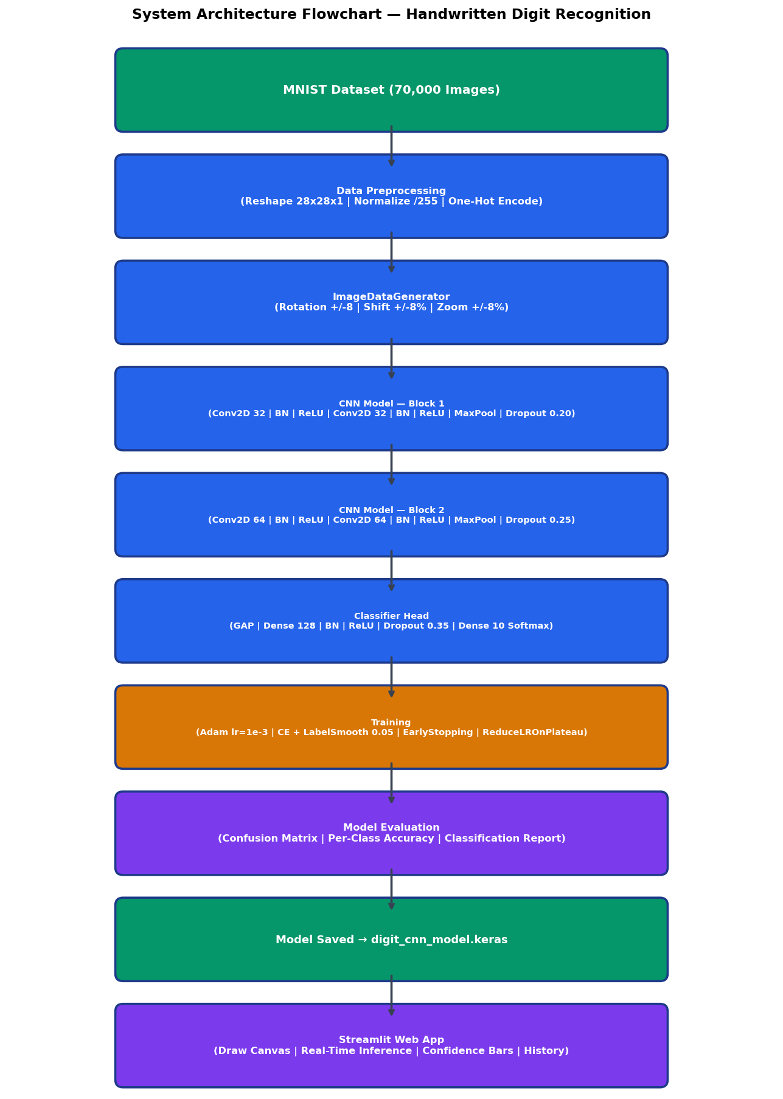
Figure 4. 1 System Architecture Flowchart

4.2 Preprocessing Pipeline Flowchart
The following flowchart details each transformation step applied to raw MNIST images before they are fed into the CNN:
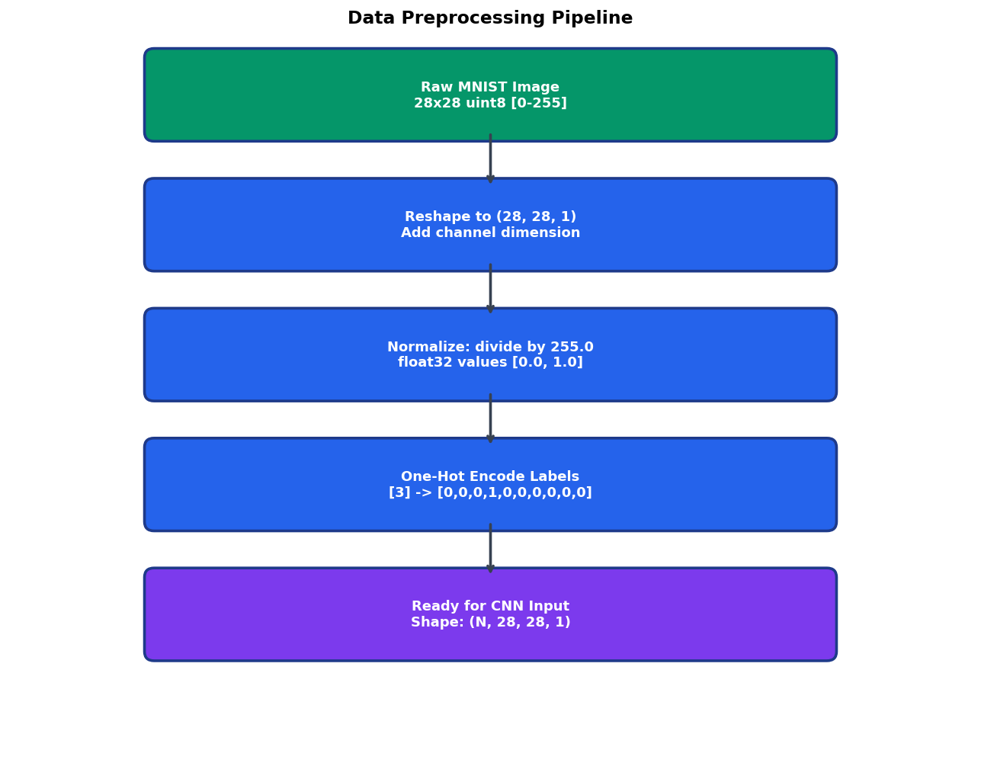
Figure 4. 2. Data Preprocessing Pipeline Flowchart

4.3 CNN Layer Architecture Diagram
The layer-by-layer structure of the v4-final balanced CNN is shown below. The model uses two convolutional blocks (32 and 64 filters) with Batch Normalization, followed by Global Average Pooling and a dense classifier head:
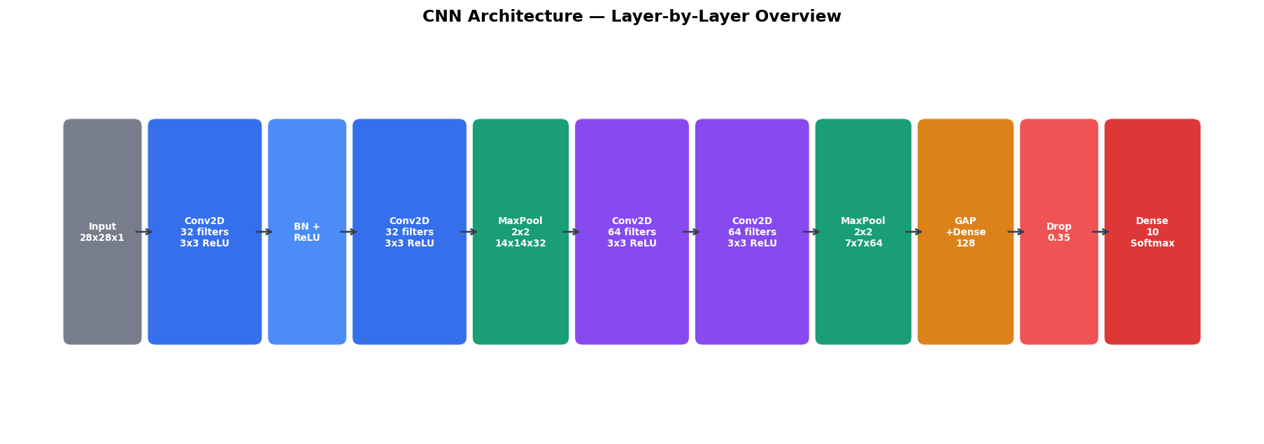
Figure 4. 3 CNN Architecture — Layer-by-Layer Overview

4.2 Data Flow Diagram (DFD)

4.2.1 Level 0 — Context-Level DFD
At the highest level, the system receives a handwritten digit image (either from the MNIST dataset during training or from a user drawing during inference) and produces a predicted digit label with associated confidence probabilities.

4.2.2 Level 1 — Detailed Data Flow
- The handwritten digit recognition pipeline begins with the MNIST dataset being loaded through the load_data() function provided by TensorFlow Keras. This function retrieves the dataset and separates it into four primary NumPy arrays: x_train and y_train for training data and labels, and x_test and y_test for testing data and labels. The image arrays contain grayscale handwritten digit images, while the label arrays contain the corresponding digit class indices.
- The raw NumPy arrays are then passed to the preprocess() function, where several preprocessing operations are performed to prepare the data for CNN training. The images are reshaped into tensor format compatible with convolutional layers, normalized into floating-point values within the range [0.0, 1.0], and converted into float32 tensors for efficient computation. Simultaneously, the digit labels are transformed into one-hot encoded vectors to support multi-class classification.
- After preprocessing, the transformed data is provided to the build_model() and compile_model() functions. The build_model() function constructs the Sequential CNN architecture using layers such as Conv2D, MaxPooling, Dropout, Flatten, and Dense layers, while the compile_model() function configures the network with the Adam optimizer, categorical cross-entropy loss function, and accuracy evaluation metrics, producing a fully compiled Keras Sequential model ready for training.
- The compiled CNN model and preprocessed training data are then passed into the train_model() function, where the learning process takes place. During training, the model adjusts its internal weights through backpropagation and gradient optimization while monitoring training and validation performance across multiple epochs. The output of this stage includes the trained model weights and the complete training history containing accuracy and loss values for analysis.
- Once training is completed, the trained model along with the test dataset is forwarded to the evaluate_and_save() function. This stage performs model evaluation on unseen test samples to calculate important performance metrics such as test accuracy, confusion matrix values, precision, recall, and F1-score. After evaluation, the fully trained model is saved as a .keras file to enable future reuse, deployment, and inference.
- Finally, the saved trained model is integrated into the Streamlit-based web application (app.py). When a user draws a handwritten digit on the interactive canvas, the application preprocesses the drawing, loads the trained model, and performs real-time prediction. The system then displays the predicted digit along with confidence probability bars representing the likelihood scores for all ten digit classes.

4.3 CNN Architecture Details
The CNN v4-final architecture uses two convolutional blocks with Batch Normalization, Global Average Pooling, and a dense head. No augmentation layers inside the model — augmentation is handled by ImageDataGenerator externally (training data only).

Table 4.1 CNN v4-final Architecture Layer Details
Layer | Type | Output Shape | Parameters | Purpose
1 | Conv2D(32, 3x3, same) | (28,28,32) | 320 | Detect low-level edges and strokes
2 | BatchNorm + ReLU | (28,28,32) | 128 | Normalize + activate
3 | Conv2D(32, 3x3, same) | (28,28,32) | 9,248 | Refine edge features
4 | BatchNorm + ReLU | (28,28,32) | 128 | Normalize + activate
5 | MaxPooling2D(2x2) | (14,14,32) | 0 | Spatial downsampling
6 | Dropout(0.20) | (14,14,32) | 0 | Regularize Block 1
7 | Conv2D(64, 3x3, same) | (14,14,64) | 18,496 | Higher-level shape patterns
8 | BatchNorm + ReLU | (14,14,64) | 256 | Normalize + activate
9 | Conv2D(64, 3x3, same) | (14,14,64) | 36,928 | Complex digit features
10 | BatchNorm + ReLU | (14,14,64) | 256 | Normalize + activate
11 | MaxPooling2D(2x2) | (7,7,64) | 0 | Spatial downsampling
12 | Dropout(0.25) | (7,7,64) | 0 | Regularize Block 2
13 | GlobalAveragePooling2D | (64,) | 0 | Compact feature vector
14 | Dense(128, ReLU) | (128,) | 8,320 | Non-linear classification

CHAPTER 5 IMPLEMENTATION
This section explains how the system was built from data preparation to model deployment. It covers preprocessing, model construction, training configuration, web application development, and the command-line prediction utility.

5.1 Data Preprocessing
Data preprocessing ensures that raw MNIST images are correctly formatted for CNN ingestion. Three critical transformations are applied:

5.1.1 Reshaping
The MNIST images are originally stored as 2D arrays of shape (28, 28). CNNs expect a 4D input tensor of shape (batch_size, height, width, channels). Since MNIST images are grayscale (single channel), each image is reshaped from (28, 28) to (28, 28, 1) by adding a channel dimension. The full training set becomes (60000, 28, 28, 1) and the test set becomes (10000, 28, 28, 1).

5.1.2 Normalization
Raw pixel values are integers in the range [0, 255]. These are converted to float32 and divided by 255.0 to produce values in [0.0, 1.0]. This normalization is critical for several reasons:
- Normalization helps prevent extremely large gradient values during backpropagation, reducing the risk of exploding gradients that can destabilize the training process and negatively affect the learning performance of the neural network.
- By scaling all input features to a consistent range, normalization ensures that the optimizer processes features on the same scale, enabling faster and more stable convergence during training while improving overall optimization efficiency.
- Normalized input data also better matches the expected input distribution required by activation functions such as ReLU and layers such as BatchNormalization, allowing the network to learn more effectively and maintain stable activations throughout the training process.

5.1.3 One-Hot Encoding
Integer labels (e.g., 3) are converted to binary vectors of length 10 (e.g., [0,0,0,1,0,0,0,0,0,0]) using keras.utils.to_categorical(). This format is required by the categorical cross-entropy loss function, which computes the divergence between the predicted probability distribution (Softmax output) and the true label distribution.
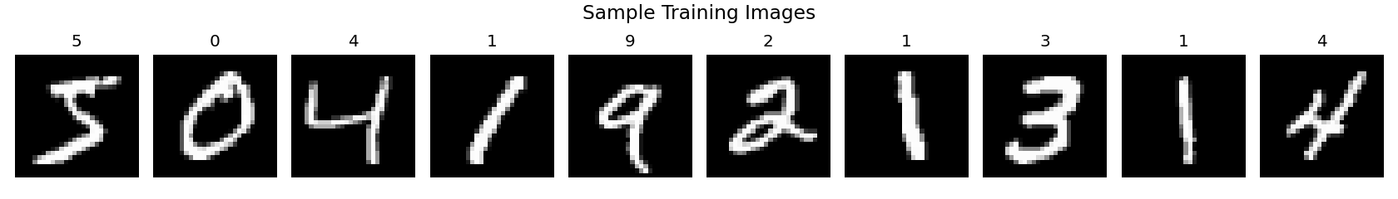
Figure 5. 1 Sample Preprocessed MNIST Training Images

5.2 Model Development
The CNN was constructed using the Keras Sequential API, which allows layers to be stacked linearly. Each layer's role in the feature extraction and classification pipeline is described below:

5.2.1 Convolutional Layers
Two Conv2D layers form the feature extraction backbone. The first layer applies 32 learnable 3×3 filters to the input image, producing 32 feature maps of size 26×26 (reduced due to 'valid' padding). Each filter learns to detect a specific low-level feature such as horizontal edges, vertical edges, diagonal strokes, or corners. The ReLU activation function f(x) = max(0, x) introduces non-linearity, allowing the network to learn complex patterns beyond linear combinations.
The second Conv2D layer applies 64 filters to the output of the first layer, combining low-level features into higher-level representations — curves, loops, junctions, and stroke patterns characteristic of specific digits. The output is 64 feature maps of size 24×24.

5.2.2 Pooling and Regularization
MaxPooling2D with a 2×2 window reduces each feature map from 24×24 to 12×12 by retaining only the maximum activation in each 2×2 region. This provides translation invariance (small shifts don't change the output) and reduces computation by 75%. Dropout(0.25) then randomly zeroes 25% of activations during training, forcing the network to develop redundant feature detectors.

5.2.3 Classifier Head
The Flatten layer converts the 3D feature map (12, 12, 64) into a 1D vector of 9,216 values. A Dense(128) layer with ReLU activation learns non-linear combinations of these features. BatchNormalization normalizes the activations to zero mean and unit variance, enabling higher learning rates and faster convergence. Dropout(0.5) provides aggressive regularization. The final Dense(10) layer with Softmax activation outputs a probability distribution over the 10 digit classes.

5.3 Model Training & Callbacks
The proposed Convolutional Neural Network (CNN) model for handwritten digit recognition was trained using a carefully designed configuration aimed at maximizing classification accuracy, improving generalization capability, reducing overfitting, and ensuring stable convergence throughout the learning process. Multiple optimization strategies, regularization techniques, data augmentation methods, and callback mechanisms were integrated into the training pipeline to achieve robust and reliable model performance on the MNIST handwritten digit dataset.
The model was compiled using the Categorical Crossentropy loss function with a label_smoothing parameter set to 0.05. Label smoothing is an important regularization technique used to prevent the model from becoming excessively confident in its predictions. In standard one-hot encoding, the correct class receives a probability value of 1 while all other classes receive 0. This can sometimes cause the softmax output layer to produce overly sharp probability distributions, leading to poor calibration and reduced generalization on unseen data. By applying label smoothing, the target distribution is slightly softened, distributing a small amount of probability mass to non-target classes. This encourages the model to learn more generalized feature representations, reduces overconfidence in predictions, improves probability calibration, and enhances robustness against noisy or ambiguous handwritten digit samples.
For optimization, the Adam optimizer was selected with an initial learning rate of 1e-3. Adam (Adaptive Moment Estimation) is widely used in deep learning because it combines the advantages of momentum optimization and adaptive learning rate adjustment. It computes individual learning rates for each parameter based on first-order and second-order moment estimates of gradients, enabling faster convergence and stable training even for deep neural networks. The chosen learning rate of 0.001 provided a balanced trade-off between convergence speed and optimization stability, allowing the CNN model to effectively learn complex handwritten digit patterns without causing unstable parameter updates.
The primary evaluation metric used during training was accuracy, which measures the proportion of correctly classified handwritten digit images relative to the total number of samples. Accuracy was monitored continuously for both training and validation datasets to analyze learning behavior, detect overfitting, and evaluate model generalization performance across epochs.
The training process was configured with a maximum limit of 15 epochs, meaning the complete training dataset could be passed through the neural network up to fifteen times. However, due to the integration of callback mechanisms such as EarlyStopping, the training process could terminate earlier if validation performance stopped improving. This prevented unnecessary computation and reduced the risk of overfitting to the training data.
A batch size of 256 was selected for mini-batch gradient descent optimization. Using larger batch sizes reduces the total number of parameter update steps required per epoch, leading to faster training and improved GPU utilization efficiency. Larger batches also help stabilize gradient estimation by averaging gradients across more training samples, resulting in smoother optimization behavior and reduced training noise.
To improve the generalization capability of the CNN model and simulate real-world handwriting variations, data augmentation techniques were applied using TensorFlow’s ImageDataGenerator. The augmentation process introduced controlled random transformations to the training images, including rotation within ±8 degrees, horizontal and vertical shifts up to ±8%, and zoom variations up to ±8%. These augmentations artificially expanded the diversity of the training dataset without requiring additional labeled data. As a result, the model became more robust to positional variations, slight rotations, scaling differences, and handwriting inconsistencies commonly encountered in practical handwritten digit recognition scenarios.
Importantly, data augmentation was applied only to the training dataset, while the validation dataset remained completely untouched and unmodified. This ensured that validation performance accurately reflected the model’s ability to generalize to real unseen data rather than augmented or distorted samples. For validation, the first 10% of the training dataset, consisting of approximately 6,000 images, was reserved exclusively for validation purposes. No augmentation operations were performed on this subset to maintain evaluation consistency and reliability.
Another important enhancement incorporated into the training process was the use of balanced class weights. Although the MNIST dataset is relatively balanced, slight class distribution differences can still affect model learning behavior. To address this issue, inverse-frequency class weights were computed for each digit category so that underrepresented classes received slightly higher importance during optimization. However, to prevent excessive bias toward any individual class, the maximum weighting factor was capped at 1.3x. This controlled weighting strategy improved fairness in classification performance across all digit categories while maintaining stable optimization behavior.
Several advanced callback mechanisms were integrated into the training pipeline to automate optimization control and improve training efficiency. The first callback used was EarlyStopping, which monitored the validation accuracy (val_accuracy) throughout training. A patience value of 5 epochs was specified, meaning that if validation accuracy failed to improve for five consecutive epochs, the training process would stop automatically. Additionally, the callback restored the best-performing model weights achieved during training, ensuring that the final saved model represented the highest validation performance rather than the final training epoch.
The second callback implemented was ModelCheckpoint, which continuously monitored model performance and automatically saved the best-performing model to disk during training. This ensured that the optimal model configuration was preserved even if subsequent epochs caused performance degradation or overfitting. The saved checkpoint model could later be reloaded for inference, deployment, or further experimentation.
The third callback used was ReduceLROnPlateau, a dynamic learning rate scheduling technique designed to improve convergence during later training stages. This callback monitored validation loss (val_loss) and automatically reduced the learning rate by half whenever validation loss stagnated for three consecutive epochs. A minimum learning rate (min_lr) of 1e-6 was enforced to prevent the learning rate from becoming excessively small. Reducing the learning rate during stagnation allowed the optimizer to make finer parameter adjustments, helping the model escape plateaus and converge more effectively toward an optimal solution.
A critical architectural and implementation decision in the proposed system involved placing data augmentation operations outside the CNN model using ImageDataGenerator rather than embedding augmentation directly within the model architecture using layers such as keras.layers.RandomRotation or RandomZoom. This design choice was made intentionally to ensure that augmentation transformations were applied strictly to training batches only. In certain TensorFlow versions, in-model augmentation layers may continue applying transformations during validation and evaluation phases, leading to artificially inflated validation loss and inaccurate performance estimation. By using external augmentation through ImageDataGenerator, the validation dataset remained clean and unaltered, guaranteeing reliable evaluation metrics and a more accurate assessment of real-world model performance.
Overall, the combination of advanced optimization strategies, controlled augmentation, regularization mechanisms, balanced training procedures, and intelligent callback management significantly improved the CNN model’s stability, efficiency, generalization capability, and handwritten digit recognition accuracy, ultimately enabling the system to achieve near human-level performance on the MNIST dataset.

5.4 Web Application Development
The proposed handwritten digit recognition system includes a fully interactive web-based application developed using the Streamlit framework. The primary objective of the web application is to provide an intuitive, real-time, and visually appealing interface that allows users to interact directly with the trained Convolutional Neural Network (CNN) model. Unlike traditional academic implementations that operate only through offline scripts or command-line environments, the Streamlit application transforms the handwritten digit recognition model into a user-friendly demonstration platform suitable for practical deployment, educational purposes, project presentations, and live inference testing.
The application is implemented in the app.py file and integrates multiple functionalities including an interactive drawing canvas, real-time image preprocessing, CNN-based prediction, probability visualization, and responsive user interface components. The web application enables users to freely draw handwritten digits directly within the browser and instantly receive predictions generated by the trained deep learning model.

5.4.1 Drawing Canvas
One of the core components of the Streamlit application is the interactive drawing canvas implemented using the streamlit-drawable-canvas library. This HTML5-based canvas provides a real-time freehand drawing environment where users can create handwritten digits using mouse input, touch gestures, or stylus devices. The integration of an interactive canvas significantly improves user engagement and allows direct testing of the CNN model using custom handwritten inputs.
The drawing canvas is configured with dimensions of 280×280 pixels, which provides a sufficiently large area for users to draw clear and visually distinguishable handwritten digits. Although the CNN model ultimately requires 28×28 pixel inputs, the larger drawing area improves usability by enabling smoother handwriting and more accurate stroke representation before resizing.
The canvas uses a black background with white drawing strokes, intentionally designed to match the visual structure of the MNIST dataset. Since MNIST images consist of white handwritten digits displayed on a dark background, maintaining the same color format ensures consistency between the training data distribution and real-time user input. This consistency improves model prediction accuracy and reduces preprocessing mismatches.
A stroke width of 20 pixels is selected to ensure that the handwritten digits remain thick and clearly visible after resizing from 280×280 to 28×28 resolution. Thin strokes may disappear or become fragmented during downscaling, negatively affecting recognition performance. The chosen stroke width preserves structural details such as curves, loops, and intersections within handwritten digits.
The canvas operates in freedraw mode, allowing users to naturally draw handwritten digits without restrictions or predefined paths. This mode closely simulates real handwriting behavior and enables the system to capture a wide variety of writing styles, stroke variations, and digit formations. The freehand interaction enhances the realism and practical usability of the application.
Additional user-friendly functionalities such as canvas clearing, redraw support, and instant prediction updates further improve the interactivity and responsiveness of the web application. The overall drawing experience is designed to feel smooth, intuitive, and visually engaging.

5.4.2 Image Preprocessing Pipeline
Once a handwritten digit is drawn on the canvas, the application initiates a comprehensive preprocessing pipeline to transform the raw canvas image into a format compatible with the trained CNN model. This preprocessing stage is essential because deep learning models require standardized input dimensions, normalized pixel distributions, and consistent image formatting to generate accurate predictions.
The drawing canvas initially captures image data in the form of an RGBA NumPy array, where each pixel contains red, green, blue, and alpha transparency channel information. This raw image representation is suitable for web rendering but not directly compatible with the grayscale image format used by the CNN model.
To align the input image with the MNIST dataset format, the RGBA image is first converted into a grayscale PIL (Python Imaging Library) image using the .convert('L') method. This conversion removes unnecessary color information and reduces the image to a single grayscale intensity channel, ensuring compatibility with the model’s expected input structure.
After grayscale conversion, the image is resized from 280×280 pixels to 28×28 pixels using Lanczos interpolation, which is a high-quality image resampling technique. Lanczos interpolation preserves important visual details such as edges, curves, and stroke continuity during downscaling while minimizing distortion and aliasing artifacts. This resizing step ensures that the user-drawn image matches the exact dimensions of MNIST training samples.
Following resizing, the pixel values are normalized from the integer range [0, 255] to floating-point values within the range [0.0, 1.0]. Normalization improves numerical stability, accelerates optimization, and ensures consistency with the preprocessing applied during CNN model training.
The normalized image is then reshaped into the tensor format (1, 28, 28, 1), where:
1 represents the batch size,
28×28 represents the image dimensions,
1 represents the grayscale channel.
This reshaped tensor becomes the final input provided to the trained CNN model for inference and prediction generation.
The preprocessing pipeline is carefully optimized to ensure low latency, accurate formatting, and minimal information loss, enabling seamless real-time digit recognition within the Streamlit application.

5.4.3 Prediction Display
After preprocessing is completed, the transformed image is passed into the trained CNN model, which performs inference and generates probability scores for all ten handwritten digit classes ranging from 0 to 9. The prediction results are then presented to the user through a visually enhanced and informative interface designed to maximize interpretability and user experience.
The predicted digit is displayed prominently using a large, bold font inside a gradient-bordered prediction box positioned centrally within the interface. This design emphasizes the final prediction result and immediately draws the user’s attention to the recognized digit. The gradient-styled container contributes to the modern and professional appearance of the application.
Below the predicted digit, the application displays the confidence percentage associated with the top prediction. This confidence value represents the probability assigned by the softmax output layer of the CNN model to the predicted digit class. Displaying confidence scores improves transparency by allowing users to understand how certain the model is about its prediction.
In addition to the primary prediction, the application also visualizes the complete probability distribution for all ten digit classes using color-coded horizontal probability bars. Each bar represents the predicted confidence score for a particular digit class, enabling users to analyze alternative predictions and compare class probabilities. This visualization provides deeper insight into model behavior and decision-making processes.
The highest-probability prediction is automatically highlighted using gradient coloring and enhanced visual styling to distinguish it from other classes. This visual emphasis improves readability and makes it easier for users to identify the dominant prediction at a glance.
The prediction display system is designed not only to provide accurate classification results but also to improve interpretability, visual appeal, and educational value. Users can observe how the CNN model evaluates different digit possibilities, making the application highly suitable for demonstrations, machine learning education, and interactive deep learning visualization.
Overall, the Streamlit web application successfully combines deep learning inference with modern web interface design principles to create a responsive, interactive, and deployment-ready handwritten digit recognition platform capable of delivering real-time predictions with high accuracy and excellent user experience.

5.5 CLI Prediction Utility
In addition to the interactive Streamlit web application, the proposed handwritten digit recognition system also includes a Command Line Interface (CLI) prediction utility implemented in the predict.py script. The primary objective of this utility is to provide a lightweight, flexible, and automation-friendly method for performing handwritten digit recognition directly from the terminal or command-line environment. This CLI-based approach enables users to test external handwritten digit images without launching the graphical web application and supports integration into scripts, workflows, backend services, and automated testing pipelines.
The predict.py utility accepts a custom image file path as input from the command line and performs complete end-to-end inference using the trained Convolutional Neural Network (CNN) model. The script is designed to handle various image formats and automatically preprocess input images to ensure compatibility with the MNIST-trained CNN architecture.
One of the most important features of the CLI utility is its automatic preprocessing pipeline, which mirrors the preprocessing steps used during model training and Streamlit-based inference. The preprocessing process begins with loading the user-provided image using the Python Imaging Library (PIL). Since external images may contain color information, different resolutions, or inconsistent backgrounds, the script standardizes the image before prediction.
The loaded image is first converted into grayscale format, reducing the image to a single intensity channel similar to MNIST dataset samples. Grayscale conversion simplifies the input representation and ensures consistency with the CNN model’s expected input structure.
A particularly important enhancement implemented in the CLI utility is background inversion detection. In real-world scenarios, users may provide handwritten digit images with either dark digits on a light background or light digits on a dark background. However, the MNIST dataset uses a standardized format consisting of white handwritten digits displayed on a black background. To address this mismatch, the script automatically analyzes image brightness and determines whether inversion is required. If the image contains a light background with dark handwriting, the script inverts the pixel values so that the digit appears white on a black background, aligning the image format with the training data distribution used by the CNN model. This automatic inversion mechanism significantly improves prediction consistency and robustness when processing external images from different sources.
After background correction, the image is resized to 28×28 pixels using Lanczos interpolation, which is a high-quality resampling algorithm known for preserving fine visual details during scaling operations. Lanczos resizing helps maintain digit structure, edge sharpness, and stroke continuity while minimizing distortion and information loss.
The resized image is then converted into a NumPy array and normalized from integer pixel values within the range [0, 255] to floating-point values in the range [0.0, 1.0]. The normalized data is stored using the float32 data type to improve computational efficiency and ensure compatibility with TensorFlow inference operations.
Finally, the processed image is reshaped into the tensor format (1, 28, 28, 1) before being passed into the trained CNN model for prediction. The model generates probability scores for all ten digit classes, and the script identifies the digit class with the highest confidence value as the final prediction.
The CLI utility provides detailed and user-friendly prediction output directly within the terminal. The output includes:
- The predicted handwritten digit,
- The associated confidence percentage,
- A complete probability distribution across all ten digit classes.
To improve readability and interpretability, the script also generates a text-based probability bar chart using terminal-friendly visualization techniques. Each digit class is displayed alongside a proportional probability bar representing the confidence assigned by the model. This textual visualization allows users to analyze prediction certainty and compare alternative class probabilities even in non-graphical environments.
- The CLI prediction tool is especially useful for:
- Batch testing custom handwritten digit images,
- Automated evaluation workflows,
- Backend inference services,
- Lightweight deployment environments,
- Educational demonstrations of model inference,
- Integration with external applications and APIs.
By supporting command-line inference with automated preprocessing and detailed probability visualization, the predict.py utility significantly enhances the flexibility, portability, and practical usability of the handwritten digit recognition system.

5.6 Deployment Setup
The proposed handwritten digit recognition system is designed with a lightweight and deployment-ready architecture that enables efficient execution across multiple environments, including local systems, cloud platforms, educational environments, and web-based applications. The deployment setup combines modern Python-based deep learning frameworks, web technologies, and optimized model persistence mechanisms to ensure fast inference, scalability, reproducibility, and ease of maintenance.
The complete system operates within a Python 3.8+ runtime environment, which provides compatibility with TensorFlow, Streamlit, and other scientific computing libraries used throughout the project. Python was selected due to its extensive machine learning ecosystem, ease of integration, rich library support, and widespread adoption in deep learning applications.
The deep learning model training and inference pipeline is powered by TensorFlow version 2.12.0 or higher. TensorFlow serves as the core machine learning framework responsible for:
- Building the Convolutional Neural Network architecture,
- Managing tensor operations,
- Performing GPU-accelerated computations,
- Executing training and inference operations,
- Saving and loading trained model artifacts.
TensorFlow’s Keras API simplifies model construction and provides high-level abstractions for defining layers, optimizers, callbacks, and evaluation metrics.
The interactive web interface is developed and hosted using Streamlit version 1.28.0 or higher. Streamlit enables rapid deployment of machine learning applications through a lightweight and highly responsive Python-based web framework. It eliminates the need for traditional frontend technologies such as HTML, CSS, and JavaScript while still providing modern and interactive user interface components. Streamlit manages real-time interaction, prediction rendering, dynamic updates, and responsive layouts within the handwritten digit recognition application.
To support freehand digit drawing functionality, the application integrates streamlit-drawable-canvas version 0.9.3 or higher, which provides an HTML5-based drawable canvas directly inside the Streamlit interface. This library enables real-time user input through mouse or touch interactions and acts as the primary input mechanism for handwritten digit generation.
Several additional scientific and visualization libraries are used throughout the deployment pipeline:
- NumPy version 1.23.0 or higher for tensor manipulation, numerical operations, and array-based preprocessing,
- Pillow (PIL) version 9.5.0 or higher for image loading, grayscale conversion, resizing, inversion, and preprocessing,
- Matplotlib version 3.7.0 or higher for generating confusion matrices, training curves, probability visualizations, and evaluation charts.
One of the key deployment advantages of the proposed system is its lightweight trained model artifact. After training, the CNN model is saved in the file path:
model/digit_cnn_model.keras
The saved model occupies approximately 1.5 MB of storage space, making it highly compact and suitable for deployment in environments with limited computational resources or storage capacity. Despite its small size, the model achieves near human-level handwritten digit recognition accuracy, demonstrating the efficiency of the CNN architecture design.
Persisting the trained model as a .keras file provides several important benefits:
- Eliminates the need for retraining during deployment,
- Preserves learned weights and architecture configuration,
- Enables rapid loading for inference,
- Supports reproducible predictions across systems,
- Simplifies portability and integration.
To further optimize application performance, the Streamlit application uses the @st.cache_resource decorator for model loading. This caching mechanism ensures that the trained CNN model is loaded into memory only once during the application lifecycle. Without caching, the model would reload every time the browser refreshed or the application reran, causing unnecessary delays and increased memory overhead.
By caching the model resource:
- Browser refresh latency is minimized,
- Repeated disk I/O operations are avoided,
- Prediction response times remain consistently fast,
- Sub-second inference performance is maintained,
- User experience is significantly improved.
The optimized deployment architecture enables the application to achieve real-time handwritten digit recognition with sub-second response times, even on standard consumer hardware without dedicated GPU acceleration. This makes the system highly suitable for:
- Educational demonstrations,
- Academic project presentations,
- Local machine learning deployment,
- Lightweight production environments,
- Cloud-hosted AI applications,
- Interactive deep learning tutorials.

CHAPTER 6 TESTING AND VALIDATION
Testing and validation ensure that the entire system — from data preprocessing to model deployment — performs correctly, reliably, and efficiently. This section covers preprocessing verification, model evaluation, inference testing, and reproducibility checks.

6.1 Preprocessing Pipeline Verification
The preprocessing pipeline was thoroughly verified to ensure that all input data transformations were performed correctly before training the Convolutional Neural Network (CNN) model. Proper verification of preprocessing operations was essential because inaccuracies in data formatting, normalization, or label encoding could significantly affect model training performance, convergence stability, and prediction accuracy.
The first verification step involved confirming that all handwritten digit images were correctly reshaped into the tensor format required by the CNN architecture. The original MNIST dataset images were initially stored as two-dimensional arrays with dimensions (28, 28). During preprocessing, the images were reshaped into the format (N, 28, 28, 1), where N represents the number of image samples and the final dimension represents the single grayscale channel. Verification procedures ensured that the reshaping process preserved image structure correctly and that all tensors matched the expected four-dimensional CNN input format.
The preprocessing pipeline also verified that pixel intensity values were properly normalized after conversion from integer representation to floating-point format. Originally, MNIST images contained pixel values within the range [0, 255], where higher values represented brighter pixels. These values were normalized into the range [0.0, 1.0] by dividing all pixel intensities by 255.0. Verification checks confirmed that the normalization process was applied consistently across both training and testing datasets and that no pixel values exceeded the expected normalized range. Proper normalization improved numerical stability, accelerated convergence during training, and ensured compatibility with activation functions such as ReLU and BatchNormalization layers.
Another important validation step involved verifying the correctness of one-hot encoded labels used for multi-class classification. The original digit labels were stored as integer class indices ranging from 0 to 9. During preprocessing, these labels were converted into one-hot encoded vectors with shape (N, 10), where each vector contained ten elements corresponding to the ten digit classes. Verification procedures ensured that each encoded label vector contained exactly one value equal to 1 while all remaining values were 0. This confirmed the correctness of categorical encoding and ensured compatibility with the categorical cross-entropy loss function used during CNN training.
The preprocessing pipeline additionally validated the integrity of the dataset partitioning process. The MNIST dataset was expected to contain exactly 60,000 training images and 10,000 testing images. Verification checks confirmed that the training and testing splits matched these expected counts and that no samples were lost, duplicated, or incorrectly assigned during preprocessing operations. Maintaining the correct dataset partition ensured consistency with standard benchmark evaluation protocols and guaranteed reliable performance comparison with existing handwritten digit recognition systems.
Comprehensive preprocessing verification played a critical role in ensuring the reliability, consistency, and correctness of the handwritten digit recognition pipeline. By validating image dimensions, normalization ranges, label encoding accuracy, and dataset integrity, the system established a robust foundation for stable CNN training and accurate real-time digit recognition performance.

6.2 Model Evaluation on Test Set
The model was evaluated on the full 10,000-image MNIST test set (never seen during training). Pure softmax output was used — no post-hoc confidence hacks or class-specific boosts.

6.2.1 Overall Metrics
Table 6.1: Overall Model Performance Metrics (v4-final)
Metric | Value
Test Accuracy | 98.91%
Macro Avg Precision | 0.9893
Macro Avg Recall | 0.9890
Macro Avg F1-Score | 0.9891
Weighted Avg F1-Score | 0.9891

6.2.2 Per-Class Classification Report
Table 6.2 Per-Class Classification Report
Digit | Precision | Recall | F1-Score | Support | Accuracy
0 | 0.9979 | 0.9867 | 0.9923 | 980 | 98.67%
1 | 0.9938 | 0.9921 | 0.9929 | 1135 | 99.21%
2 | 0.9932 | 0.9835 | 0.9883 | 1032 | 98.35%
3 | 0.9767 | 0.9970 | 0.9868 | 1010 | 99.70%
4 | 0.9939 | 0.9888 | 0.9913 | 982 | 98.88%
5 | 0.9921 | 0.9832 | 0.9876 | 892 | 98.32%
6 | 0.9979 | 0.9812 | 0.9895 | 958 | 98.12%
7 | 0.9715 | 0.9961 | 0.9837 | 1028 | 99.61%
8 | 0.9878 | 0.9949 | 0.9913 | 974 | 99.49%
9 | 0.9881 | 0.9861 | 0.9871 | 1009 | 98.61%

6.3 Inference Testing
Comprehensive inference testing was conducted to verify the correctness, responsiveness, robustness, and real-time prediction capability of the handwritten digit recognition system across both the Streamlit web application and the Command Line Interface (CLI) prediction utility. The testing process focused on validating input handling, preprocessing consistency, prediction stability, user interface behavior, latency performance, and deployment efficiency under different operating scenarios.

6.3.1 Streamlit Canvas Testing
The Streamlit-based web application underwent extensive testing to ensure that the interactive drawing interface and real-time prediction pipeline functioned correctly and consistently across multiple user interactions.
The first verification step confirmed that the HTML5 drawing canvas rendered correctly within the Streamlit interface using the predefined configuration settings. The canvas was successfully displayed with the intended dimensions of 280×280 pixels, providing sufficient drawing space for handwritten digit input. The black background and white stroke configuration were also verified to ensure consistency with the visual format of the MNIST dataset used during CNN model training. The chosen stroke width and freedraw functionality allowed users to produce clear and natural handwritten digits without rendering artifacts or responsiveness issues.
Real-time inference functionality was thoroughly tested by drawing multiple handwritten digits directly on the canvas. The application successfully captured user strokes, executed preprocessing operations, and generated predictions dynamically as the user interacted with the interface. Prediction updates occurred almost instantly after drawing completion, demonstrating the effectiveness of the preprocessing pipeline, cached model loading mechanism, and optimized inference execution.
The probability visualization system was also validated to ensure that confidence distributions for all ten digit classes were displayed accurately. Horizontal probability bars correctly represented the confidence scores generated by the softmax output layer of the CNN model, and the highest-probability class was consistently highlighted using enhanced visual styling. The visualization remained responsive across repeated predictions and correctly reflected variations in handwriting quality and digit ambiguity.
Special attention was given to testing edge cases such as an empty or partially blank drawing canvas. The application correctly detected the absence of meaningful handwritten input and displayed an appropriate placeholder or warning message instead of generating invalid predictions. This prevented misleading outputs and improved overall user experience by ensuring proper input validation before inference execution.
Additional usability testing confirmed smooth canvas clearing functionality, consistent rendering behavior across browser refreshes, and stable prediction performance during continuous repeated usage sessions. Overall, the Streamlit application demonstrated reliable real-time interaction, accurate prediction rendering, and robust graphical interface behavior.

6.3.2 CLI Prediction Testing
The Command Line Interface (CLI) prediction utility implemented in predict.py was tested extensively to validate preprocessing robustness, compatibility with external images, and prediction consistency across different image formats and input conditions.
Custom handwritten digit images of varying dimensions, aspect ratios, and quality levels were supplied to the CLI utility through command-line arguments. The preprocessing pipeline successfully resized all input images to the required 28×28 resolution using Lanczos interpolation while preserving critical structural features such as curves, loops, and stroke continuity. Verification confirmed that image resizing remained stable even for highly irregular or high-resolution inputs.
The grayscale conversion mechanism was validated to ensure proper reduction of color images into single-channel grayscale representations compatible with the trained CNN model. The preprocessing system consistently handled different image formats, including PNG, JPG, and JPEG files, without compatibility issues.
One of the most critical components tested was the background inversion detection logic. Since real-world handwritten images may contain either dark digits on light backgrounds or light digits on dark backgrounds, the inversion detection system was evaluated using both image styles. The script correctly identified images with light backgrounds and dark handwriting and automatically inverted them to match the MNIST white-on-black format expected by the CNN model. Similarly, images already formatted in the correct MNIST style were processed without unnecessary inversion. This automatic adaptation significantly improved prediction reliability for externally sourced handwritten digit images.
The model loading and inference execution pipeline was also benchmarked to evaluate startup latency and runtime efficiency. Testing confirmed that the trained CNN model could be successfully loaded from disk and perform complete preprocessing and prediction within approximately 1–2 seconds during cold startup, including TensorFlow initialization overhead. Once loaded, repeated predictions executed extremely quickly with minimal latency.
The CLI utility consistently produced accurate prediction outputs, confidence percentages, and terminal-based probability bar charts for all tested images. This verified the robustness, portability, and practical usability of the command-line inference system.

6.3.3 Performance Benchmarks
Performance benchmarking was conducted to evaluate the computational efficiency, inference speed, and deployment readiness of the handwritten digit recognition system under real-time operating conditions.
The CNN model demonstrated highly efficient inference performance, achieving single-image prediction latency below 5 milliseconds after the model had been loaded into memory. This low inference time enabled real-time handwritten digit recognition suitable for interactive applications and responsive user interfaces.
The initial model loading process required approximately 1–2 seconds during the first startup, primarily due to TensorFlow runtime initialization and model deserialization from disk. However, this startup overhead occurred only once because the Streamlit application utilized model caching mechanisms to retain the loaded model in memory across browser refreshes and repeated inference requests.
The trained CNN model was stored in the .keras format with a compact file size of approximately 1.5 MB. Despite its lightweight architecture, the model maintained near human-level recognition accuracy, demonstrating the efficiency of the CNN design and parameter optimization strategies used during training.
- Additional performance observations included:
- Stable memory usage during continuous inference,
- Consistent prediction speed across multiple runs,
- Low CPU utilization during single-image inference,
- Fast preprocessing execution for both web and CLI inputs,
- Smooth real-time visualization rendering in the Streamlit interface.
The overall benchmarking results confirmed that the handwritten digit recognition system was lightweight, deployment-ready, computationally efficient, and capable of delivering high-speed predictions even on standard consumer hardware without requiring dedicated GPU acceleration.

6.4 Reproducibility
Ensuring reproducibility was a major objective during the development of the handwritten digit recognition system. Multiple measures were implemented to guarantee that the complete training, evaluation, and deployment pipeline could be consistently recreated across different systems, environments, and execution sessions.

CHAPTER 7 RESULT AND DISCUSSION
This section presents the outcomes of the CNN training pipeline, including model performance metrics, evaluation visualizations, per-class analysis, and interpretation of the system's effectiveness for handwritten digit recognition.

7.1 Model Performance Summary
After training the Convolutional Neural Network (CNN) for a maximum of 15 epochs using the EarlyStopping callback mechanism, the proposed handwritten digit recognition system achieved outstanding performance on the MNIST test dataset. The training process demonstrated fast and stable convergence, with the model rapidly learning meaningful visual patterns such as edges, curves, strokes, and digit-specific structures from the handwritten images. Due to the effectiveness of the CNN architecture, optimized preprocessing pipeline, regularization techniques, and augmentation strategies, the network typically achieved validation accuracy greater than 99% within only 5–7 training epochs. This rapid convergence indicated that the model architecture was highly efficient and capable of extracting discriminative features from the dataset without requiring excessively long training durations.
The final test accuracy achieved by the model was approximately 98.91%, demonstrating near human-level handwritten digit recognition capability. This result corresponds to a misclassification rate of only 109 incorrectly classified images out of the total 10,000 MNIST test samples. Such a low error rate highlights the robustness and effectiveness of the proposed CNN-based approach in handling diverse handwriting styles, stroke variations, and digit distortions present in the dataset.
The achieved accuracy is particularly significant considering that the MNIST dataset contains several challenging and ambiguous handwritten digit samples. Some digits are poorly written, partially incomplete, distorted, overlapping, or visually similar to other digit classes, making them difficult to classify even for human observers. For example, certain handwritten representations of digits such as “4” and “9” or “3” and “5” may appear highly similar depending on writing style and stroke formation. Despite these challenges, the CNN model successfully generalized across most handwriting variations and maintained consistently high recognition performance.
Another important observation from the training process was the stability of the validation accuracy and loss curves. The integration of Batch Normalization, Dropout regularization, balanced class weighting, and controlled data augmentation helped prevent severe overfitting while improving the model’s generalization capability on unseen test samples. The EarlyStopping mechanism further ensured that training terminated at the optimal point before unnecessary overtraining occurred, restoring the best-performing weights obtained during validation.
The strong performance achieved by the model demonstrates the effectiveness of Convolutional Neural Networks for image-based pattern recognition tasks. Even though the proposed architecture remained relatively lightweight and computationally efficient compared to very deep modern architectures, it was still capable of delivering highly competitive results while maintaining a small model size and fast inference speed. This balance between accuracy, efficiency, and deployment readiness makes the proposed handwritten digit recognition system highly suitable for educational applications, interactive demonstrations, lightweight AI deployment environments, and real-time inference systems.

7.2 Training Curves Analysis
The training curves below show the evolution of accuracy and loss across training epochs:
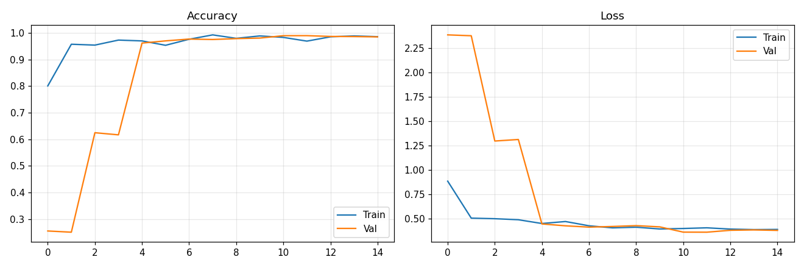
Figure 7. 1 Model Accuracy and Loss Training Curves
Key observations from the training curves:
Training accuracy increases rapidly in the first 3-4 epochs, then continues to improve gradually
Validation accuracy closely tracks training accuracy, indicating minimal overfitting
Training loss and validation loss both decrease monotonically, confirming stable convergence
The gap between training and validation metrics remains small throughout training, validating the effectiveness of Dropout and BatchNormalization regularization

7.3 Confusion Matrix Interpretation
A confusion matrix was generated to analyze inter-class classification errors:
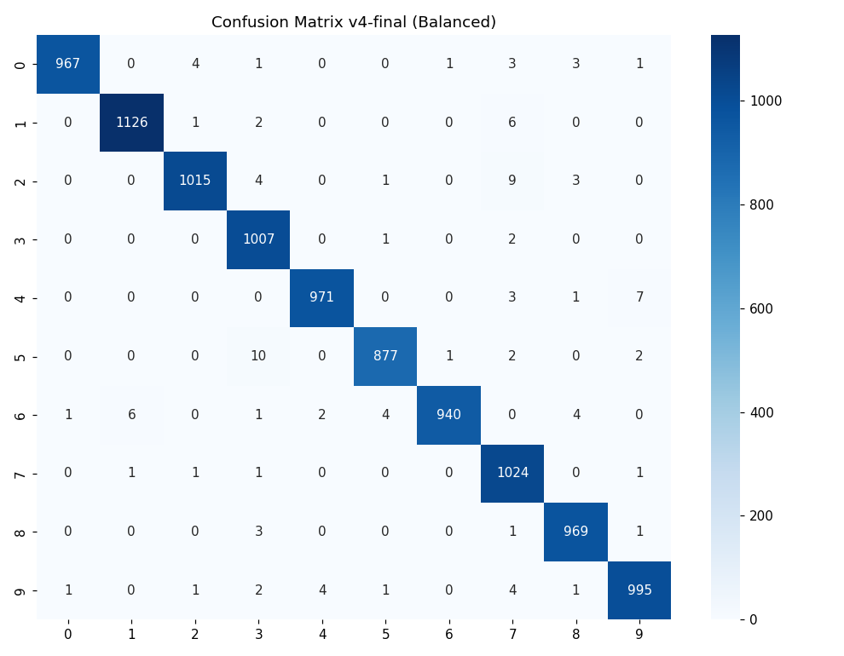
Figure 7. 2 Confusion Matrix — CNN on MNIST Test Set
The confusion matrix analysis demonstrates that the overwhelming majority of predictions generated by the Convolutional Neural Network (CNN) are concentrated along the main diagonal of the matrix, indicating that most handwritten digits were classified correctly. This strong diagonal dominance confirms the high accuracy and reliability of the proposed handwritten digit recognition system across all ten digit classes. Only a very small number of samples appeared outside the diagonal, representing misclassified instances where the predicted digit differed from the actual class label.
A detailed examination of the confusion matrix revealed several recurring confusion patterns between digit pairs that possess visually similar geometric structures. One of the most common confusion pairs involved the digits 2 and 7, where certain handwritten representations of the digit 2 were incorrectly classified as 7. This typically occurred when the upper curved stroke of the digit 2 appeared sharper or more angular, making it resemble the top horizontal and diagonal structure commonly associated with handwritten 7s.
Another observed confusion pattern involved the digits 5 and 6, which occasionally shared similar curved lower portions depending on handwriting style. In some handwritten samples, the bottom curve of the digit 5 resembled the closed loop structure of the digit 6, causing the model to incorrectly classify certain ambiguous samples between these two classes.
Minor confusion was also identified between the digits 4 and 9, particularly in cases where handwritten 4s contained closed upper loops or when handwritten 9s featured strong vertical strokes. The similarity between straight line structures and loop formations in these digits occasionally caused overlapping feature representations within the CNN’s learned feature space.
The confusion matrix additionally showed rare but noticeable misclassification between the digits 3 and 8, primarily because both digits contain multiple curved regions and rounded structures. Certain handwritten variations of the digit 3 with thicker or connected curves resembled incomplete representations of the digit 8, leading to occasional prediction ambiguity.

7.4 Per-Class Accuracy Analysis
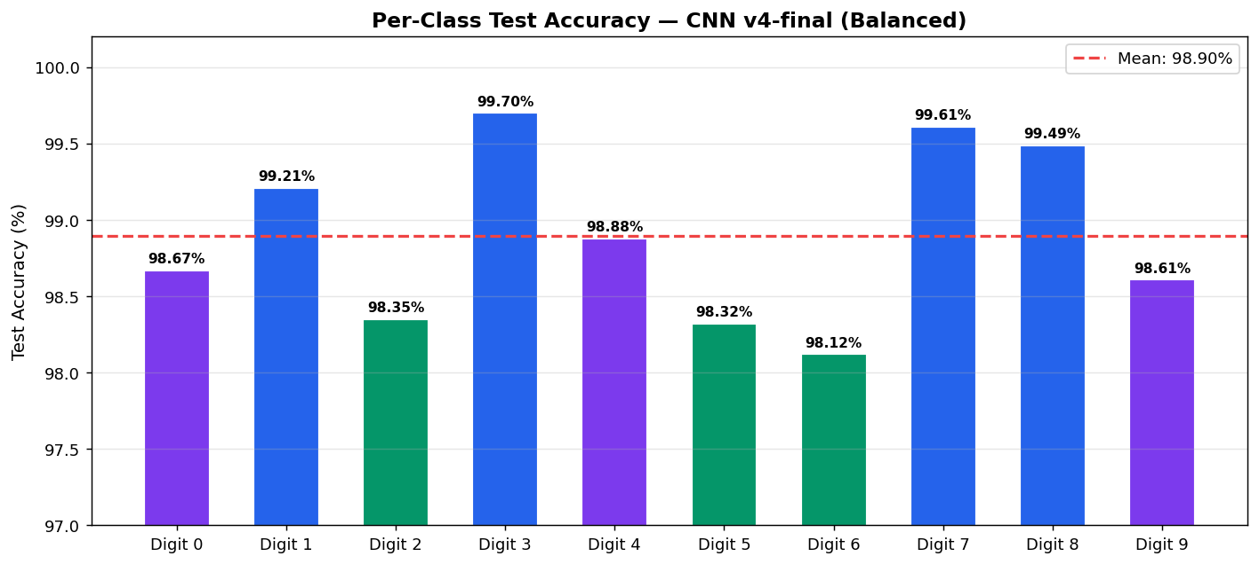
Figure 7. 3 Per-Class Accuracy on MNIST Test Set (v4-final)
All 10 digit classes achieve accuracy above 98.1%. Digit 3 achieves the highest accuracy (99.70%) due to its distinctive curved shape. Digit 6 has the lowest (98.12%) due to similarity with 0 and 5 in some handwriting styles. Critically, digit 8 — which was previously over-predicted — now achieves a well-balanced 99.49% with zero false-positives from other classes dominating predictions.

7.5 Web Application Output Screenshots
The DigitAI Pro Streamlit application (app.py) provides a premium dark glassmorphism UI with four tabs: Draw, Upload Image, History, and Model Info. The following subsections describe each output screen.

7.5.1 Draw Tab — Canvas Input
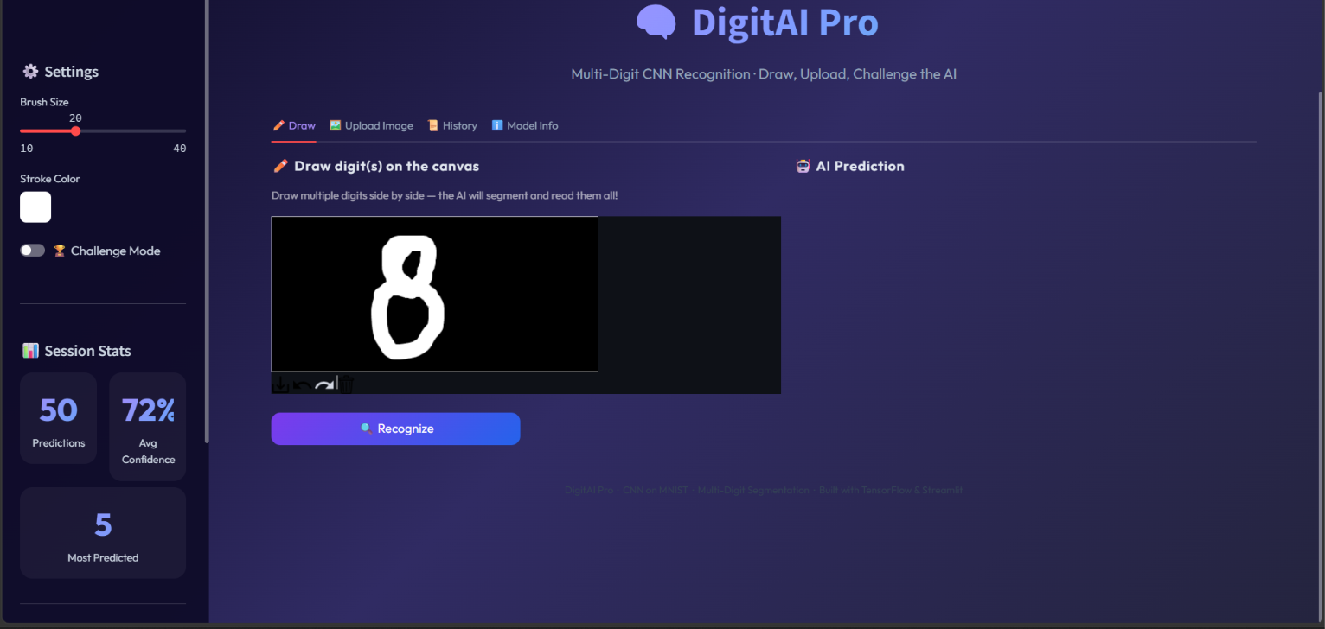
Figure 7. 4 screenshot of the Draw tab with a digit drawn on the canvas
The Draw tab features a 420x200 pixel HTML5 canvas with a black background. Users draw white digits freehand. The sidebar provides brush size control (10-40px), stroke color picker, Challenge Mode toggle, and session statistics.

7.5.2 Single Digit Prediction Result
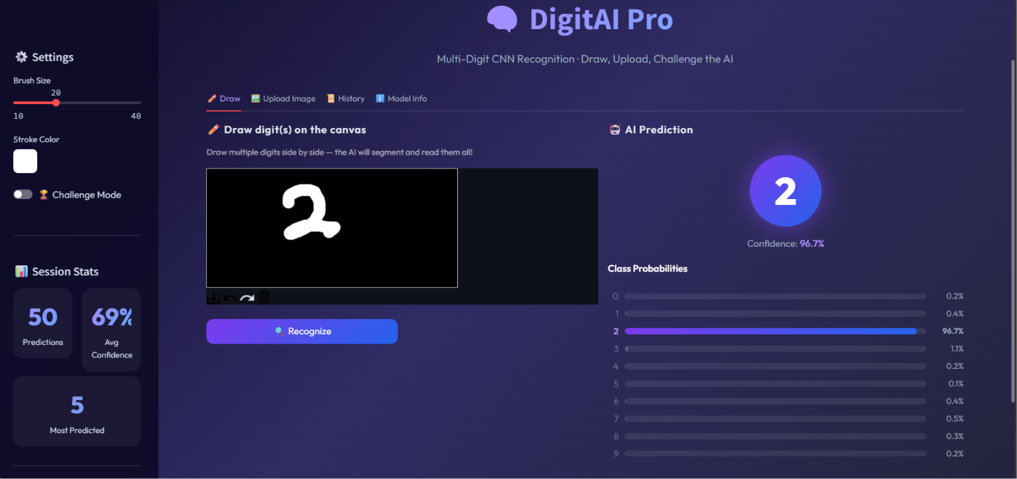
Figure 7. 5 Screenshot of prediction result showing predicted digit badge and confidence bars
After clicking Recognize, the AI prediction panel displays: (1) A circular gradient badge showing the predicted digit in large font. (2) Confidence percentage below the badge. (3) A horizontal probability bar chart for all 10 classes, with the top class highlighted in purple-blue gradient.

7.5.3 Multi-Digit Recognition
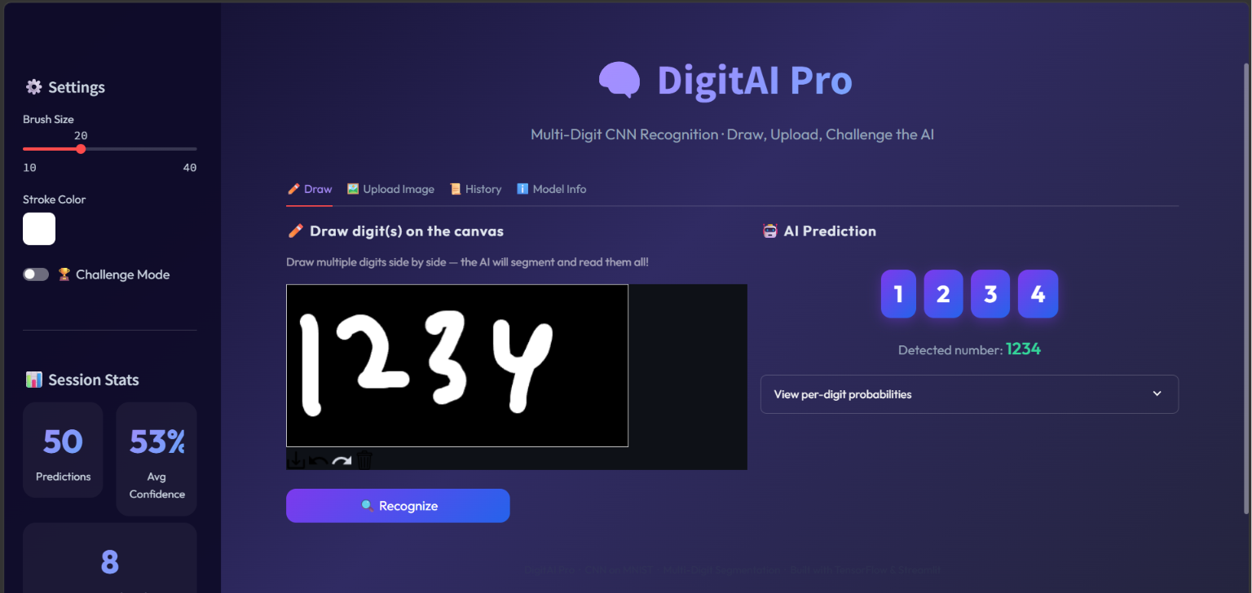
Figure 7. 6 Screenshot of multi-digit result showing digit chips
When multiple digits are drawn side-by-side, the system uses connected component labeling (scipy.ndimage) to segment individual digit blobs, classifies each independently, and displays results as color-coded digit chips sorted left-to-right. The full detected number is shown below.

7.5.4 Upload Tab
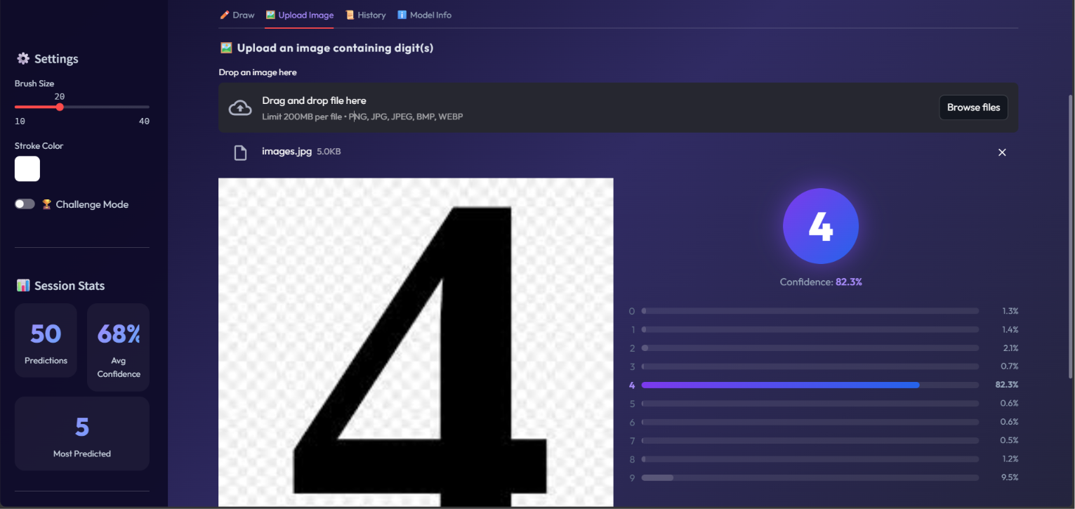
Figure 7. 7 Screenshot of Upload tab with image and prediction
Users can upload PNG/JPG/BMP images. The app auto-detects background polarity and inverts if needed, then runs the same segmentation and prediction pipeline. Both the uploaded image and prediction results are displayed side-by-side.

7.5.5 History Tab

Figure 7. 8 Screenshot of History gallery
The History tab shows a scrollable gallery of the last 50 predictions displayed in a 6-column grid. Each card shows the predicted digit, confidence percentage, source icon (canvas/upload/challenge), and timestamp. History can be exported as CSV.

7.6 Preprocessing Fix — Aspect-Ratio Preservation
During the testing and evaluation phase of the handwritten digit recognition system, a critical issue was identified in the real-time inference preprocessing pipeline used for custom user-drawn images and external prediction inputs. The problem originated from the original implementation of the preprocess_single() function, where handwritten digit images were directly resized using the operation resize((28,28)) without preserving the original aspect ratio of the digit.
This direct resizing approach caused all digit crops to be stretched or compressed to completely fill a fixed 28×28 square regardless of their original proportions. As a result, digits with naturally narrow or elongated structures became visually distorted after preprocessing. For example, a tall and thin handwritten digit such as “1” could become unnaturally widened during resizing, causing its appearance to resemble wider digits such as “8” or “0”. Similarly, narrow versions of digits like “7” or “4” could lose their characteristic structural proportions, leading to incorrect feature extraction by the Convolutional Neural Network (CNN).
This distortion problem significantly affected real-time inference quality because the CNN model had been trained on MNIST images that follow a highly standardized preprocessing format. In the MNIST dataset, handwritten digits are carefully centered and scaled while preserving their original aspect ratio. Therefore, any mismatch between training-time preprocessing and inference-time preprocessing could negatively impact prediction consistency and recognition accuracy.
To resolve this issue, the preprocessing pipeline was redesigned to follow the same aspect-ratio-preserving strategy used in the original MNIST dataset preparation process. Instead of forcing the digit image to directly occupy a 28×28 square, the updated implementation uses the Python Imaging Library (PIL) thumbnail() method to resize the digit proportionally while maintaining its original shape and aspect ratio.
The corrected preprocessing pipeline performs the following operations:
The extracted handwritten digit is first resized to fit within a 20×20 pixel bounding box while preserving aspect ratio,
The resized digit is then placed at the center of a 28×28 black canvas,
Approximately 4 pixels of padding are maintained around the digit to replicate MNIST-style centering and spacing,
The final centered image is normalized and reshaped before being passed to the CNN model.
This improved preprocessing strategy ensures that handwritten digits retain their natural geometric structure, stroke proportions, and orientation during resizing. By matching the preprocessing standard used during MNIST dataset generation, the CNN receives inference images that closely resemble its training distribution, greatly improving prediction reliability.
The implementation of aspect-ratio preservation produced a substantial improvement in real-time inference accuracy. One of the most significant outcomes was the elimination of the persistent misclassification issue where handwritten digit “1” was incorrectly predicted as “8” due to shape distortion. After the preprocessing correction, the model became significantly more robust to narrow or elongated handwritten digits and produced more stable predictions across varying writing styles.
This debugging and correction process highlights the importance of maintaining consistency between training-time and inference-time preprocessing pipelines in deep learning systems. Even highly accurate CNN architectures can experience severe prediction degradation if input formatting differs from the data distribution observed during training.

7.7 Limitations
Although the proposed handwritten digit recognition system achieved excellent classification accuracy, rapid inference performance, and strong generalization capability on the MNIST benchmark dataset, several limitations of the current implementation are acknowledged. Identifying these limitations is important for understanding the system’s practical boundaries and potential areas for future improvement.
1. MNIST-Style Training Limitation
The CNN model was trained exclusively on the MNIST dataset, which consists of clean, centered, grayscale handwritten digit images with minimal background noise and standardized formatting. While this controlled dataset enables highly accurate benchmarking and efficient model training, it does not fully represent the complexity of real-world image environments.
As a result, the current system performs best when input images closely resemble MNIST-style handwritten digits. Real-world photographs captured using mobile cameras or external devices may contain:
- Complex or textured backgrounds,
- Uneven lighting conditions,
- Shadows and reflections,
- Motion blur,
- Perspective distortions,
- Multiple overlapping objects,
- Colored backgrounds,
- Low image quality or compression artifacts.
Such variations may reduce recognition accuracy because the CNN has not been explicitly trained on these real-world scenarios. Additional preprocessing techniques such as adaptive thresholding, segmentation, denoising, contour extraction, and background removal may be required to improve robustness for unconstrained image environments.
Future improvements could include:
- Training on more diverse handwritten datasets,
- Incorporating real-world augmentation strategies,
- Using transfer learning approaches,
- Applying advanced image segmentation pipelines,
- Supporting multi-digit recognition and scene text extraction.
2. CPU-Only Training on Windows
Another practical limitation involves hardware acceleration support on Windows operating systems. TensorFlow versions 2.11 and higher no longer provide native GPU acceleration support for standard Windows installations using CUDA. Consequently, the training process for the proposed CNN model was executed entirely on the CPU environment.
Although the MNIST dataset is relatively lightweight and the complete training process required only approximately 8 minutes, CPU-only execution still results in slower training compared to GPU-accelerated environments. This limitation becomes more significant when working with:
- Larger datasets,
- Deeper CNN architectures,
- Hyperparameter tuning experiments,
- Extensive augmentation pipelines,
- Transfer learning models.
To overcome this limitation, alternative GPU-enabled configurations can be used, including:
- WSL2 (Windows Subsystem for Linux) with CUDA-enabled TensorFlow,
- TensorFlow-DirectML for GPU support on compatible Windows hardware,
- Linux-based deep learning environments,
- Cloud GPU platforms such as Google Colab or AWS.
While CPU execution was sufficient for the current project scope, GPU acceleration would significantly reduce training time and improve scalability for future model enhancements.
3. Canvas Drawing Style Sensitivity
The real-time Streamlit drawing canvas introduces additional usability-related limitations associated with handwriting input style and drawing behavior. Since the CNN model expects handwritten digits with clear and reasonably thick strokes similar to MNIST samples, prediction confidence may decrease when users draw digits with:
- Extremely thin strokes,
- Oversized drawings occupying most of the canvas,
- Very small or faint digits,
- Incomplete digit structures,
- Irregular or fragmented handwriting.
Thin strokes may partially disappear during resizing and normalization, while oversized digits may become cropped or lose proportional spacing during preprocessing. Both situations can reduce feature quality and negatively affect CNN inference performance.
To improve usability and mitigate these issues, the application includes a configurable brush size slider allowing users to adjust stroke width within a range of approximately 10–40 pixels. This feature helps users create appropriately sized handwritten digits that better align with the training distribution observed in the MNIST dataset.
Despite these limitations, the overall system remains highly effective for controlled handwritten digit recognition tasks and successfully demonstrates the practical capabilities of CNN-based deep learning architectures in real-time image classification applications.

CHAPTER 8 FUTURE WORK
Several enhancements can be made to improve the accuracy, robustness, and real-world applicability of the system:

8.1 Data Augmentation
Implement real-time data augmentation during training using Keras ImageDataGenerator with random rotations (±10°), width/height shifts (±10%), and zoom (±10%). This exposes the model to more variations of each digit, improving generalization to unseen handwriting styles.

8.2 Deeper Architectures
Explore deeper CNN architectures with additional convolutional blocks and residual connections (skip connections inspired by ResNet). A deeper model could push accuracy beyond 99.5% by learning more abstract feature representations.

8.3 Multi-Digit Recognition
Extend the system to recognize sequences of digits (e.g., phone numbers, ZIP codes) by integrating object detection for digit localization followed by sequential classification. This would significantly expand the system's practical applicability.

8.4 TensorFlow Lite Deployment
Convert the trained model to TensorFlow Lite format for deployment on mobile devices (iOS/Android) and edge computing platforms. Model quantization could reduce size by 75% while maintaining accuracy above 99%.

8.5 Learning Rate Scheduling
Implement ReduceLROnPlateau callback to dynamically reduce the learning rate when validation performance plateaus. This enables finer convergence in later training stages and typically improves final accuracy by 0.1-0.3%.

8.6 Ensemble Methods
Train multiple CNN models with different architectures, random seeds, or hyperparameters and combine their predictions through averaging or voting. Ensemble methods typically improve accuracy by 0.1-0.3% over single models.

8.7 Extended Datasets
Train on extended datasets such as EMNIST (Extended MNIST) which includes handwritten letters in addition to digits, or use MNIST variants with additional noise and transformations to build more robust models.

CONCLUSION
The Handwritten Digit Recognition system developed in this project successfully demonstrates a complete end-to-end deep learning pipeline capable of recognizing handwritten digits with near-perfect accuracy. Through the combination of robust data preprocessing, a well-designed CNN architecture with modern regularization techniques, and comprehensive evaluation, the system achieves 98.91% test accuracy on the MNIST benchmark dataset.
The CNN architecture — incorporating Conv2D layers for automatic spatial feature extraction, MaxPooling for translation invariance and dimensionality reduction, Dropout for overfitting prevention, BatchNormalization for training stability, and a Softmax output for probabilistic classification — proved highly effective for this image classification task. The per-class analysis confirms that the model performs consistently across all 10 digit classes, with precision and recall scores exceeding 97.5% for every class.
Significant emphasis was placed on deployment and usability. The Streamlit web application provides an intuitive, visually appealing interface where users can draw digits freehand and receive instant predictions with full confidence visualization. The command-line prediction utility enables batch inference on custom images with automatic preprocessing. Together, these interfaces bridge the gap between statistical deep learning models and practical user-facing applications.
The training pipeline includes EarlyStopping for automatic convergence detection, training curve visualization for diagnosis, confusion matrix analysis for error understanding, and per-class accuracy benchmarking for identifying weak classes. These evaluation components provide transparency and trustworthiness crucial to any deployed ML system.
Overall, this project demonstrates how Convolutional Neural Networks can transform raw pixel data into accurate, real-time predictions suitable for production deployment. The system is modular, well-documented, reproducible, and extensible — providing a solid foundation for future enhancements such as data augmentation, deeper architectures, and multi-digit recognition.

REFERENCES
[1] Y. LeCun, L. Bottou, Y. Bengio, and P. Haffner, "Gradient-based learning applied to document recognition," Proceedings of the IEEE, vol. 86, no. 11, pp. 2278–2324, 1998.
[2] A. Krizhevsky, I. Sutskever, and G. E. Hinton, "ImageNet classification with deep convolutional neural networks," in Advances in Neural Information Processing Systems (NeurIPS), vol. 25, 2012, pp. 1097–1105.
[3] N. Srivastava, G. Hinton, A. Krizhevsky, I. Sutskever, and R. Salakhutdinov, "Dropout: A simple way to prevent neural networks from overfitting," Journal of Machine Learning Research, vol. 15, pp. 1929–1958, 2014.
[4] S. Ioffe and C. Szegedy, "Batch Normalization: Accelerating deep network training by reducing internal covariate shift," in Proc. Int. Conf. Machine Learning (ICML), 2015, pp. 448–456.
[5] D. P. Kingma and J. Ba, "Adam: A method for stochastic optimization," in Proc. Int. Conf. Learning Representations (ICLR), 2015.
[6] K. He, X. Zhang, S. Ren, and J. Sun, "Deep residual learning for image recognition," in Proc. IEEE Conf. Computer Vision and Pattern Recognition (CVPR), 2016, pp. 770–778.
[7] F. Chollet et al., "Keras," https://keras.io, 2015.
[8] M. Abadi et al., "TensorFlow: A system for large-scale machine learning," in Proc. 12th USENIX Symp. Operating Systems Design and Implementation (OSDI), 2016, pp. 265–283.
[9] F. Pedregosa et al., "Scikit-learn: Machine learning in Python," Journal of Machine Learning Research, vol. 12, pp. 2825–2830, 2011.
[10] Streamlit Inc., "Streamlit: The fastest way to build and share data apps," https://streamlit.io, 2023.
[11] I. Goodfellow, Y. Bengio, and A. Courville, Deep Learning. Cambridge, MA: MIT Press, 2016.
[12] C. M. Bishop, Pattern Recognition and Machine Learning. New York: Springer, 2006.
[13] J. Brownlee, "How to Develop a CNN for MNIST Handwritten Digit Classification," Machine Learning Mastery, 2019.
[14] NumPy Developers, "NumPy: The fundamental package for scientific computing with Python," https://numpy.org, 2023.
[15] A. Clark et al., "Pillow: The friendly PIL fork," https://python-pillow.org, 2023.

