

Report

on

**The PacketCeaser**

Submitted By: Submitted To:

Dhruv Srivastava 2115000365 Mr. Sanjay Madaan

Abhay Srivastava 2115000012 Assistant Professor

CEA

**Title:**

The PacketCeaser

**Abstract:**

"The PacketCeaser" addresses the pervasive threat of SQL injection vulnerabilities in web applications by providing a user-friendly, mobile-centric ethical hacking tool. It caters to the increasing complexity of web applications, offering real-time detection for timely mitigation, and ensuring accessibility for both seasoned security professionals and newcomers to cybersecurity.

Key Points:

* Mobile-centric tool for detecting SQL injection vulnerabilities.
* Real-time detection enhances timely mitigation efforts.
* Fills the gap for mobile-centric solutions in ethical hacking.
* Promotes user-friendly ethical hacking practices.
* Addresses the critical need for web application security in an evolving digital landscape.

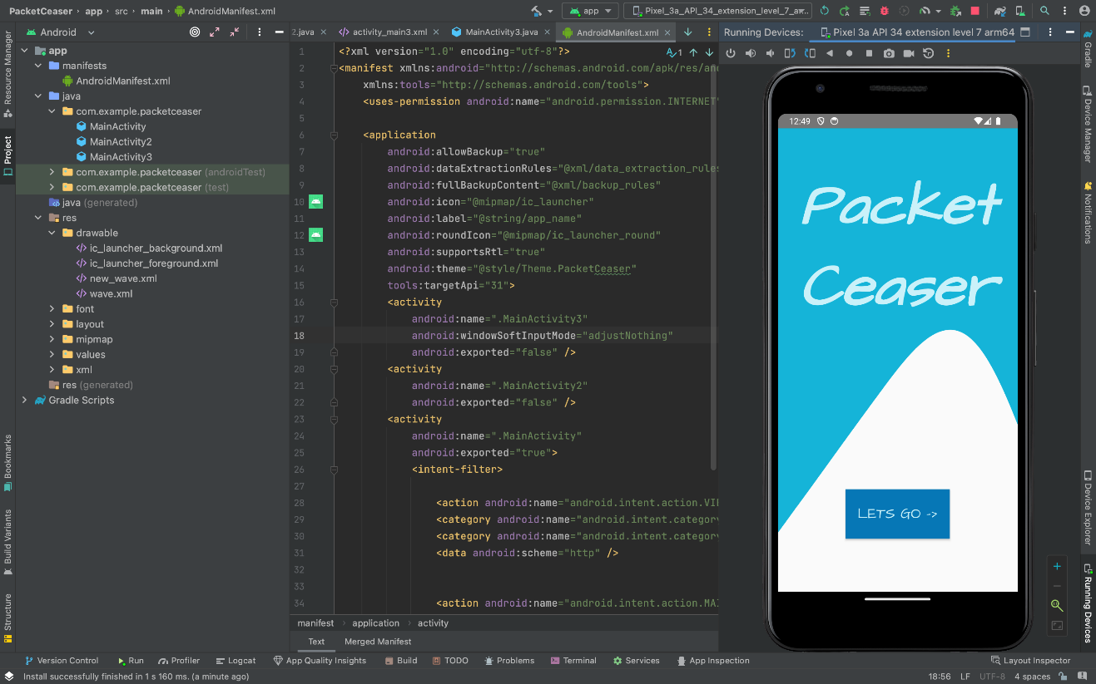

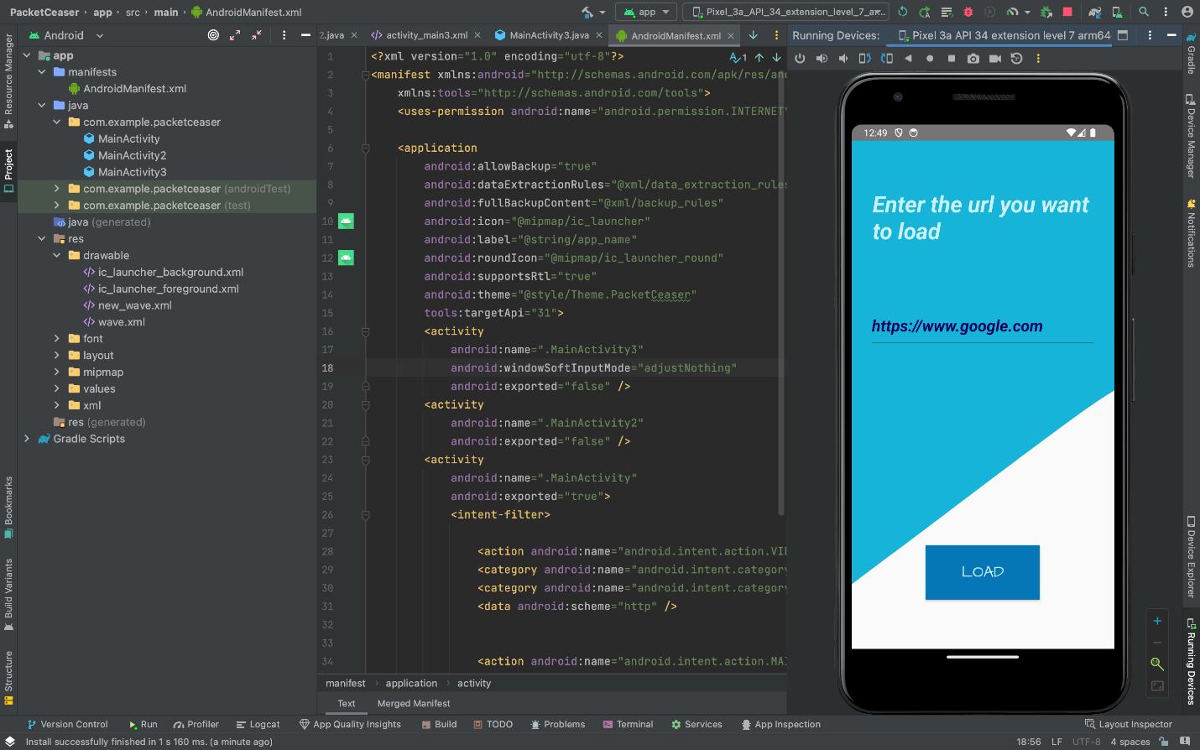

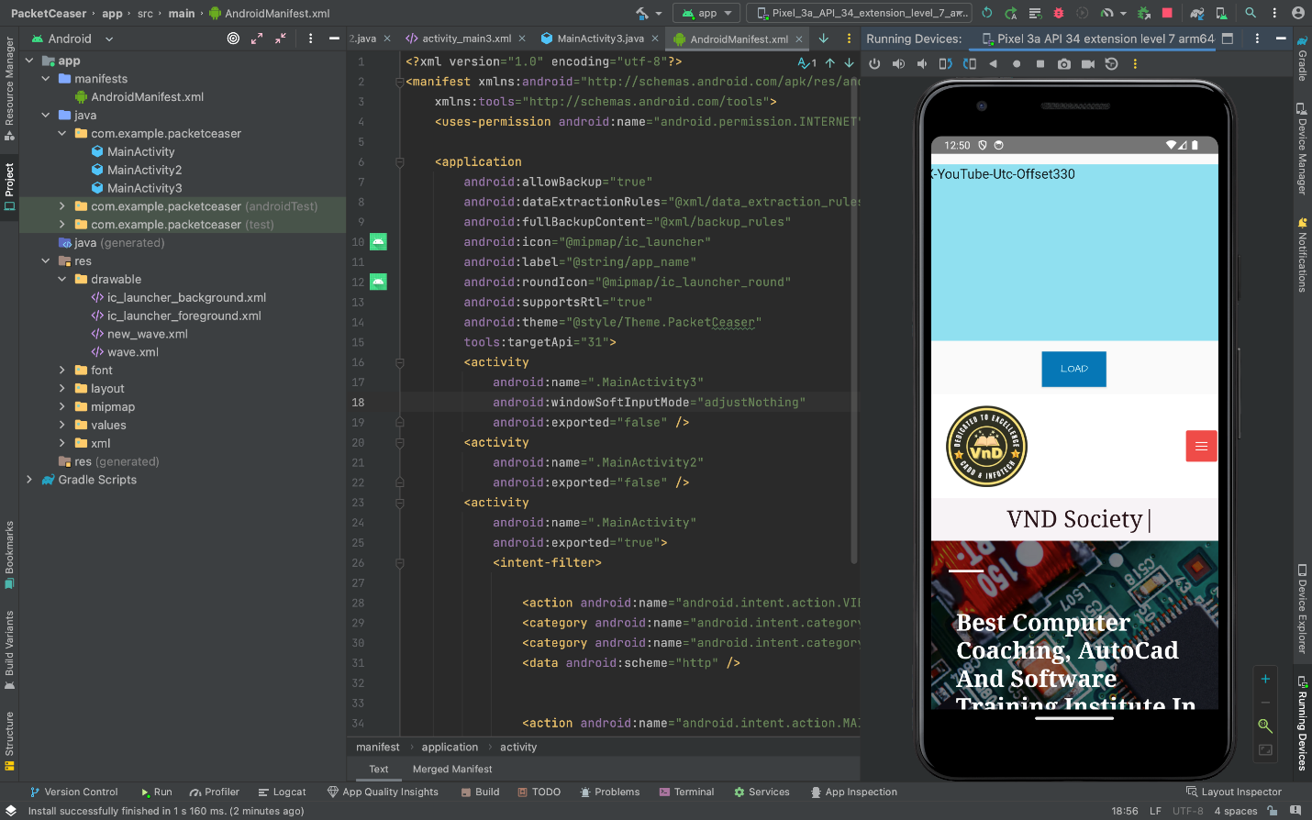

**Introduction:**

PacketCeaser is an android application that lets you capture the HTTP Headers sent through a particular website.

The app is a portable and handy substitute to tools like OWASP ZAP and Burpsuite , which can help detect vulnerabilities in applications.

PacketCeaser helps you to intercept the requests sent from your browser and helps it to edit and resend the

Data packets to server allowing you to know and edit the http headers . It also allows you to bypass any client side WAFs(Web Application Firewalls) to detect possible vulnerabilities like sql injection and many more.

**Objective:**

* **Mobile Ethical Hacking Focus:** The PacketCeaser is designed as a mobile-centric ethical hacking tool, specifically catering to security professionals and ethical hackers. Its primary objective is to detect and mitigate SQL injection vulnerabilities in web applications.
* **Real-time Vulnerability Detection:** The app excels in real-time capture and analysis of data packets, identifying patterns indicative of SQL injection vulnerabilities during the exchange of information between the Android device and the web application server.
* **User-Friendly and Flexible Operation:** The PacketCeaser features an intuitive and user-friendly interface, making it accessible to a diverse audience, from experienced security professionals to individuals in the early stages of learning about ethical hacking. The inclusion of editable packets for simulation enhances user understanding of potential vulnerabilities and allows for on-the-go vulnerability assessments.

**Scope:**

* **OWASP ZAP and Burp Suite:** OWASP ZAP and Burp Suite are renowned web application security tools, offering features for detecting and mitigating vulnerabilities. They include proxy, scanner, and manual testing tools, empowering security professionals in identifying and addressing web application security issues.
* **Gap Addressed by PacketCeaser:** An Android app, such as "The PacketCeaser," bridges a gap by providing a mobile-centric solution for ethical hacking. While ZAP and Burp Suite excel on desktops, the Android app enhances accessibility, allowing security professionals to conduct real-time vulnerability assessments on the go, addressing the evolving demands of web application security in a mobile environment.

**Methodology:**

* **Approach:** The initial thought was to intercept the traffic using a proxy server but the idea was later replaced by the idea of using the Android Studio’s web view .
* **Techniques,Tools and Languages:** PacketCeaser was developed in java with the help of android studio.The Layouts and activities were developed within android studio with the help of XML.Also,Refrences form the android studios official documentation were also used for overriding the web view’s methods.

**System design and architecture:**

1. UI:

Developed using XML for a sleek and responsive user interface.

Ensures an intuitive and enjoyable experience for users.

2. Language:

Java is used, providing real-time updates and seamless interactions. Empowers the platform with scalability and responsiveness.

3. Database:

N/A

4. Security Measures:

Implements robust security measures to protect user data and ensure platform integrity.

5. Responsive Design:

Designs the platform with a responsive layout for accessibility on various devices.

6. Scalability:

Built with scalability in mind to accommodate a growing user base and expanding event listings.

In summary, The PacketCeaser's system design and architecture combine a user-friendly UI, a dynamic and responsive application to create a seamless and innovative android app.

**Implementation Plan:**

* **Requirements Gathering:**

Android 8.0 or above.

* **Technology Selection:**

Technology stack: Java , XML.

* **System Design:**

Multiple Activites and robust UI design using buttons and other widgets

Set up and configure MongoDB as the backend database.

* **UI Development:**

Create the user interface using XML, incorporating responsive design principles.

* **Testing:**

Conduct extensive testing, including functional, usability, security, and performance testing.

* **Deployment:**

Deploy the platform on Google Play Store, ensuring scalability and high availability.

* **User Feedback:**

Collect user feedback and make necessary improvements to enhance the platform.

This concise implementation plan outlines the key steps and milestones for developing and launching the The PacketCeaser platform, ensuring a well-structured and successful project.

**Testing and quality assurance:**

Comprehensive Testing: Rigorous testing including functional, usability, security, and performance testing to ensure platform reliability.

User Feedback Integration: Collecting and implementing user feedback for continual improvement and optimization.

Security Measures: Regular updates and enhancements to security protocols to safeguard user data.

Scalability Testing: Ensuring the platform can handle growth by testing scalability and performance under varying loads.

Cross-Device Compatibility: Testing on multiple devices to guarantee a consistent and user-friendly experience.

Documentation: Maintaining comprehensive documentation for developers, administrators, and users.

**Results and Findings:**

The PacketCeaser has generated promising results:

* **Packet Capture:** The PacketCeaser captures data packets exchanged between the Android device and the target web application server.
* **Real-time Analysis:** The app provides real-time analysis of the captured packets, scanning for patterns indicative of SQL injection vulnerabilities.
* **Vulnerability Detection:** The PacketCeaser employs advanced algorithms to detect SQL injection vulnerabilities within the web application's data exchange.
* **Editable Packets:** Users can edit and manipulate captured packets within the app, simulating various attack scenarios to test the web application's resilience.
* **Detailed Reports:** The app generates detailed reports highlighting detected vulnerabilities, including information about the affected parameters and suggested mitigation strategies.
* **User-Friendly Interface:** The PacketCeaser features an intuitive and user-friendly interface, making it accessible for both experienced security professionals and those new to ethical hacking.
* **Secure Connection:** The app ensures the security and privacy of the user's data, employing encryption for the communication between the device and the web application server.
* **Ethical Guidelines:** The PacketCeaser promotes ethical hacking practices and encourages users to report identified vulnerabilities to the web application owners for responsible disclosure.

**Conclusion:**

Mobile-Centric Security Impact: The creation of an app like "The PacketCeaser" significantly enhances web application security by offering a mobile-centric tool. This approach provides security professionals with flexibility for real-time vulnerability assessments, contributing to a more dynamic and responsive cybersecurity strategy.

Swift Detection and Mitigation: The app's real-time detection of SQL injection vulnerabilities ensures rapid identification and mitigation efforts. In the fast-paced digital landscape, this capability is crucial for preventing unauthorized access, data breaches, and potential harm to users.

Educational Empowerment and Collaboration: "The PacketCeaser" not only serves as a practical educational tool for cybersecurity enthusiasts but also promotes responsible disclosure. The app fosters collaboration between security professionals and web application owners, contributing to a transparent and cooperative approach to addressing security issues.

**Future Work:**

**In future we plan to integrate artificial intelligence and machine learning to automate the process of manual security audits and testing. We plan to integrate custom scripts to automate the process of VAPT(Vulnerability Assessments and Penetration Testing ) and reduce human labour and errors.**

**Sources:**

Android Studio documentation

Youtube

ChatGPT

Google Bard