Streamlit Dashboard (Live Analytics)
Project Title
Predictive Modeling and Risk Scoring for Bank Customer Churn
Prepared By
Abhay Singh

1. Introduction
The primary purpose of the Streamlit dashboard developed in this project is to operationalize the machine learning model, translating complex predictive algorithms into an accessible, user-friendly tool. In the realm of Business Analytics, interactive dashboards are critical because they bridge the gap between technical data science teams and non-technical business stakeholders. Instead of interpreting raw code or static reports, banking executives and branch managers can utilize this dashboard to dynamically input customer data and instantly view churn probabilities. This direct access to predictive insights supports rapid, data-driven decision-making, allowing the bank to proactively intervene and retain high-risk customers before they terminate their accounts.

2. Dashboard Overview
The predictive dashboard is a dynamic, web-based application developed entirely in Python using the Streamlit framework. It is deployed online, functioning as a live analytics engine for customer churn prediction. Because it is hosted on the web, any authorized banking staff member can access the application through a standard web browser (such as Chrome or Edge) from any location, eliminating the need to install specialized software or local Python environments.

3. Dashboard Features
The application is equipped with several purpose-built features designed to aid business operations:
• Customer Input Form: Located on the sidebar, this allows staff to enter live customer details via sliders and dropdowns (e.g., Credit Score, Age, Account Balance, Number of Products). It acts as the data entry point for the prediction engine.
• Churn Prediction: A clear text output that states whether the customer is predicted to 'Stay' or 'Exit', providing an immediate bottom-line assessment.
• Prediction Probability: Displays the exact mathematical probability (e.g., 8.00%) calculated by the Random Forest model, showing exactly how likely the customer is to churn.
• Customer Risk Score: Translates the probability into a standardized 0-100 score, making it easier for staff to compare risk levels across different customers.
• Risk Gauge Visualization: A color-coded gauge chart (Green for Low Risk, Yellow for Medium Risk, Red for High Risk) that visually represents the customer's churn danger level at a glance.
• Feature Importance Visualization: A bar chart displaying which factors (e.g., Age, Salary, Credit Score) are most heavily influencing the model's predictions, providing transparency into the algorithm's 'thought process'.
• Business Recommendations: An automated engine that suggests specific actions based on the customer's risk tier (e.g., suggesting cross-selling for low-risk clients).
• Download Prediction Report: A button that allows users to export the customer's specific risk profile and recommendations for external record-keeping or CRM updates.

4. Dashboard Workflow
The application operates on a streamlined, real-time workflow:
Step 1: The user enters the customer's demographic and financial information into the sidebar input form.
↓
Step 2: The backend script preprocesses the input, applying necessary data transformations and scaling to match the training data format.
↓
Step 3: The pre-trained Random Forest machine learning model analyzes the processed data to predict churn behavior.
↓
Step 4: The model outputs a raw probability, which the system converts into a standardized risk score (Low, Medium, or High).
↓
Step 5: The dashboard updates the main interface, displaying the prediction result, risk gauge, dynamic business recommendations, and the feature importance chart.

5. Live Deployment
Live Streamlit URL:
https://bank-customer-churn-prediction-oyqynpj4er2puhwtrxpg4p.streamlit.app/
GitHub Repository:
https://github.com/abhay1278/Bank-Customer-Churn-Prediction
Technology Stack:
The project and dashboard were engineered utilizing the following modern data science stack:
• Python: The primary programming language.
• Streamlit: The web application framework used to build and deploy the dashboard.
• Pandas & NumPy: Utilized for data manipulation and numerical calculations.
• Scikit-learn: The core machine learning library used to train the Random Forest model and apply data scaling.
• Plotly: Used to generate the interactive Risk Score Gauge chart.
• Joblib: Employed to serialize, save, and load the trained machine learning model and scaler.
• GitHub: Used for version control and hosting the source code for deployment.

6. Dashboard Screenshots
The following screenshots demonstrate the functionality and interface of the deployed application: 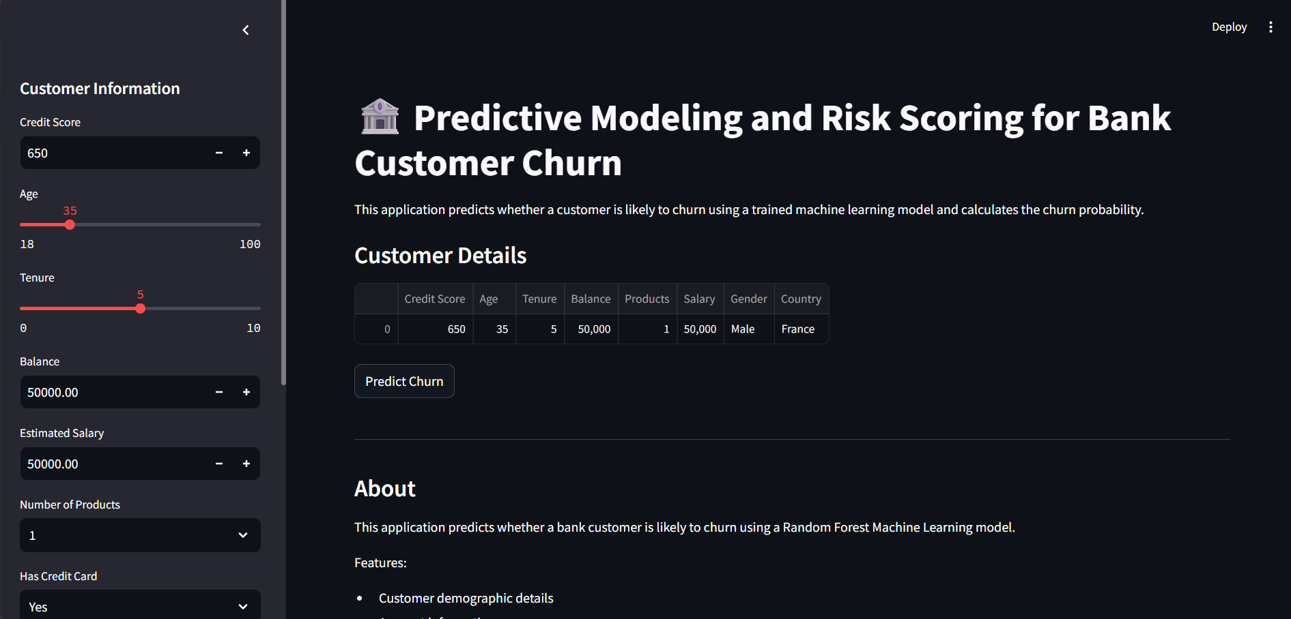
Figure 1 – Dashboard Home Page: This image displays the main landing area of the application, detailing the project title and providing a tabular overview of the customer data that has been inputted via the sidebar.
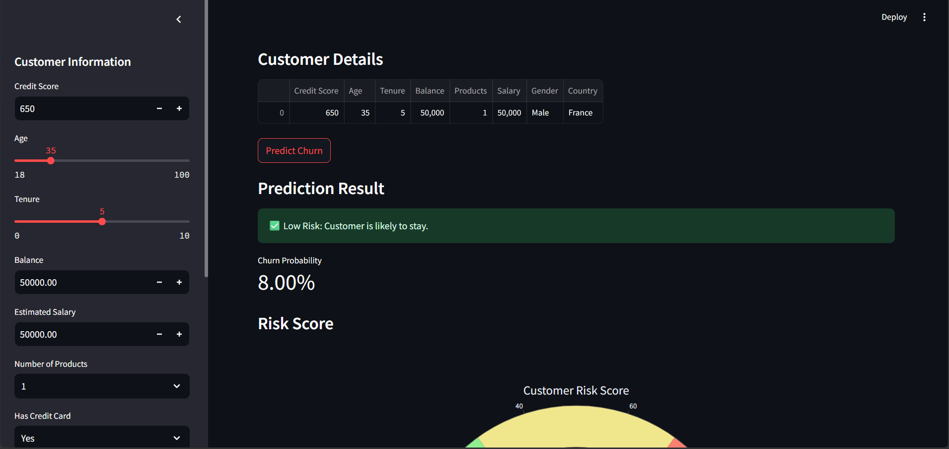
Figure 2 – Customer Input Form: This screenshot highlights the interactive sidebar where users can adjust sliders and dropdown menus to input a customer's specific financial and demographic details (e.g., Credit Score, Age, Tenure).
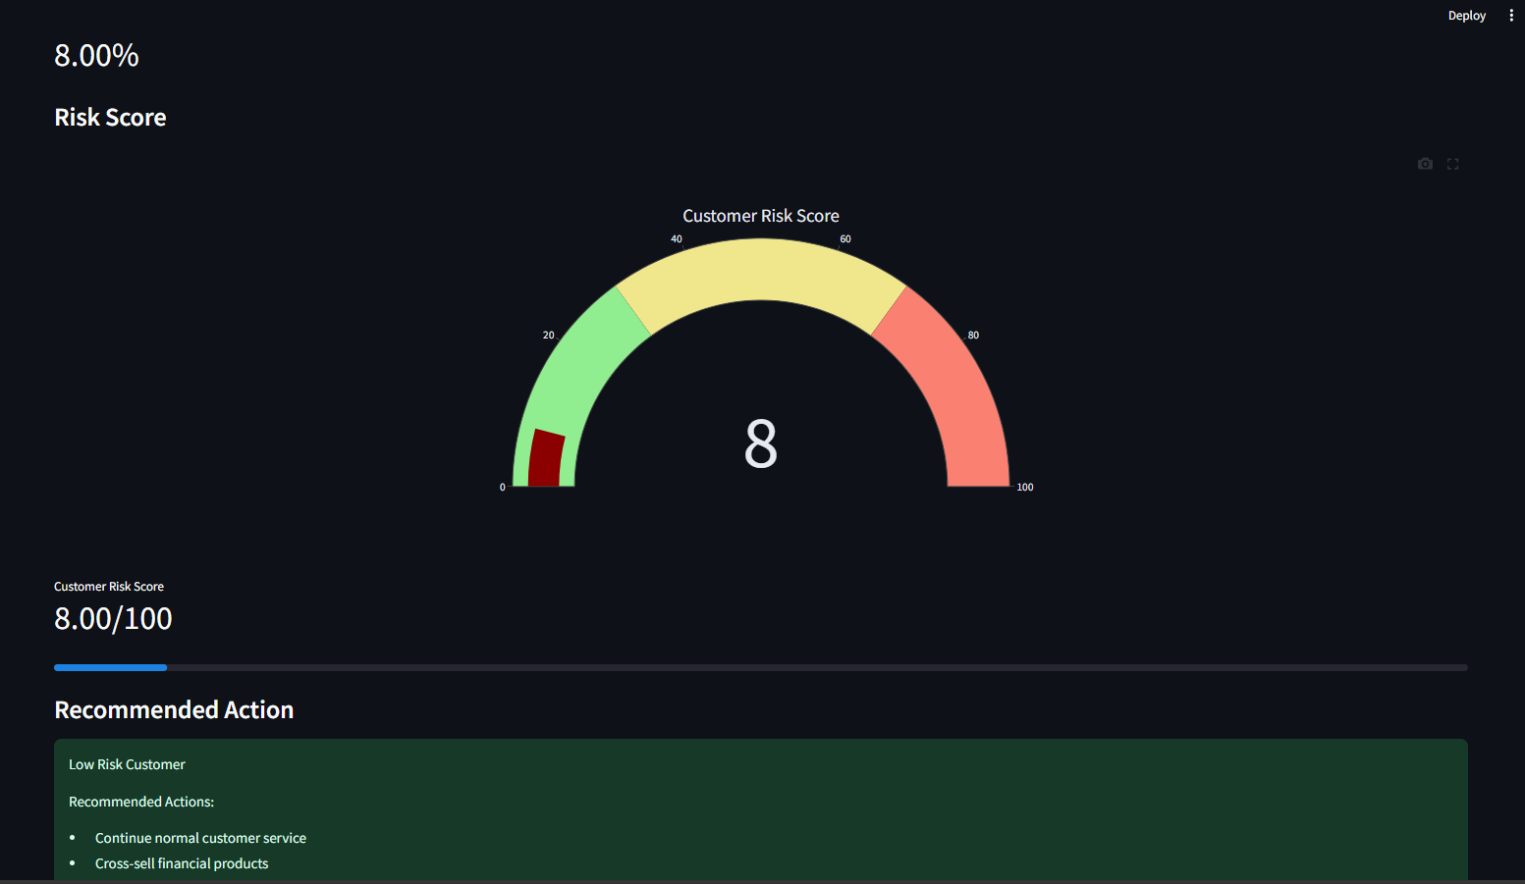
Figure 3 – Churn Prediction Result & Risk Score Gauge: This view shows the core output of the model. It displays the 'Low Risk' prediction status, the exact 8.00% churn probability, and the visual 0-100 Risk Score Gauge indicating a safe zone.
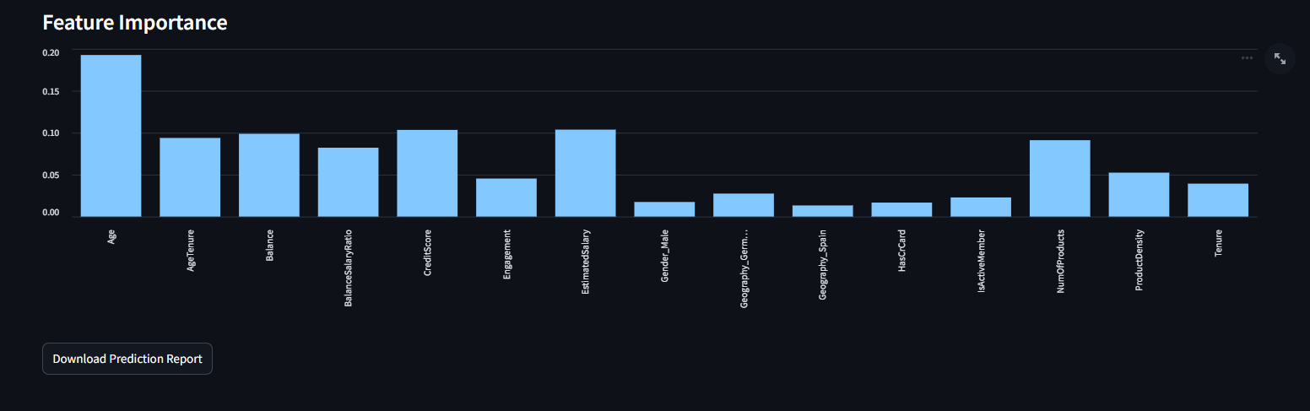
Figure 4 – Feature Importance Chart & Recommendation Engine: This section illustrates the global feature importance graph, showing that Age and Salary are primary drivers. It also displays the automated 'Recommended Action' box, suggesting cross-selling strategies for the current low-risk profile.

7. Business Benefits
The deployment of this dashboard yields significant benefits across multiple banking departments:
• Banking Executives: Gain a high-level tool to understand the ROI of machine learning initiatives and track overall customer retention strategies.
• Relationship Managers: Provided with a real-time tool to assess a customer's flight risk during live interactions, allowing them to offer targeted retention deals (like fee waivers) instantly.
• Risk Analysts: Can utilize the tool to audit individual customer profiles and understand exactly which features are driving the churn prediction.
• Customer Retention Teams: Can prioritize their outreach workflows by focusing exclusively on customers generating 'High Risk' scores on the dashboard.
• Business Decision Makers: Can use the feature importance insights to alter macro-level banking policies, such as introducing new products for older demographics if age is shown to be a high-risk factor.

8. Future Enhancements
To further scale the application and increase its utility, the following enhancements are proposed for future development:
• Database Integration & Cloud Database: Connect the app to a live, secure SQL database (e.g., AWS RDS) to pull real-time customer data automatically, rather than requiring manual input via the sidebar.
• User Authentication: Implement login screens to ensure that sensitive customer financial data is only accessible to authorized banking personnel.
• Real-Time API Deployment: Wrap the predictive model in a FastAPI backend so it can be queried by other banking systems (like a mobile app) directly.
• Batch Prediction: Add functionality to upload a CSV of thousands of customers, generating risk scores for the entire batch simultaneously.
• Email Notifications: Configure the system to automatically email relationship managers if a high-value client suddenly shifts into the 'High Risk' category.

9. Conclusion
The Streamlit dashboard successfully serves as the vital bridge between complex data science and practical business application. By transforming the outputs of a sophisticated Random Forest model into an interactive, highly visual, and accessible web interface, the dashboard ensures that the predictive insights are actually usable by the bank's frontline staff. It converts abstract machine learning metrics into actionable intelligence—such as clear risk tiers and targeted intervention recommendations—ultimately empowering the bank to proactively reduce customer churn and secure long-term revenue.

