BLINKIT DARK-STORE
NETWORK ANALYTICS
Final Analytics Report
Evaluating store performance, operational constraints,
customer outcomes and expansion decisions
Project | Details
Business problem | Identify stores/neighbourhoods suitable for expansion, optimisation, consolidation or pause.
Observation period | 1 January 2025 – 30 June 2026
Network | 60 synthetic dark stores across 6 Indian cities
Unit of analysis | One dark store on one operating day
Observations | 32,760 store-day records
Dataset | Synthetic project dataset supplied for the capstone

1. Executive Summary
This report evaluates the operating performance of Blinkit’s simulated dark-store network using 18 months of daily store-level data. The analysis combines demand, fulfilment, inventory, customer experience and contribution economics to support four management decisions: Expand, Optimise, Consolidate and Pause.
The network shows strong overall demand and customer retention, but performance varies across stores and cities. The analysis therefore supports targeted optimisation rather than broad network expansion.
Headline KPI | Network result
Sessions | 31.68 million
Orders | 9.70 million
GOV | ₹590.66 crore
NOV | ₹544.48 crore
Contribution | ₹71.45 crore
Average repeat rate | 77.48%
Average in-stock rate | 94.63%
Average promised-time hit rate | 87.82%

Key findings
- The network generated 9.70 million orders from 31.68 million sessions.
- Total contribution was ₹71.45 crore, with ₹590.66 crore GOV and ₹544.48 crore NOV.
- Kolkata recorded the highest orders and contribution among the six cities.
- Hyderabad recorded the lowest orders and contribution, but the fastest average delivery time.
- Kolkata had the slowest average delivery time, indicating a fulfilment improvement opportunity.
- In-stock rate and repeat rate showed a strong positive association (r = 0.682, p < 0.001).
- Maturity and contribution per order were statistically associated but practically very weak (r = 0.047).
- The screening heuristic produced 36 Optimise and 24 Consolidate stores, with no Expand or Pause stores.

Overall recommendation
Prioritise optimisation of the existing network before approving broad expansion. High-demand stores should receive incremental capacity only where service, inventory and contribution performance remain strong. Consolidation candidates should undergo a local overlap and utilisation review before any physical network action.

2. Dataset and Methodology

2.1 Dataset profile
Item | Description
Stores | 60
Cities | 6
Study period | 18 months
Daily observations | 32,760
Variables | 38
Granularity | Store-day
Data type | Synthetic / simulated project dataset

The workbook contains Read_Me, Dark_Store_Master, Daily_Store_Performance and Data_Dictionary sheets. The main performance table contains one record for each store-day combination.

2.2 Analytical framework
- Demand: sessions, orders, conversion rate and peak-period demand.
- Fulfilment: picking, packing, handover, delivery and promised-time performance.
- Inventory: in-stock rate, stockouts, inventory value, wastage and SKU breadth.
- Customer: repeat rate, cancellations, complaints, refunds and ratings.
- Economics: GOV, discounts, NOV, category margin and contribution.
- Capacity: picker hours, delivery-partner supply, utilisation/saturation and maturity.

2.3 Data quality and reproducibility
- No missing values were identified in the main daily performance sheet.
- No duplicate full rows, Record_IDs or Store_ID-Date combinations were identified.
- There are 60 unique stores, with 10 stores in each city.
- Store master and daily performance data were consistent for City, Store_Format and Maturity_Months.
- Capacity utilisation above 100% was retained as an overload signal.
- Negative contribution values were retained as economically meaningful observations.
- IQR extreme values were treated as flags rather than automatically deleted.
- Financial checks included AOV ≈ GOV/Orders, NOV = GOV − Discounts, and Contribution/Order = Contribution/Orders.

2.4 Derived metrics
Metric | Purpose
Total fulfilment time | Combined fulfilment component
Discount rate | Discounts relative to GOV
Delivery cost/order | Delivery cost normalised by orders
Wastage rate | Normalised wastage indicator
Stockouts per 100 orders | Stockout events normalised by orders
Contribution/order | Contribution generated per order

3. Descriptive Network and City Analysis

3.1 Network profile
At network level, demand is substantial and repeat behaviour is strong. The 77.48% average repeat rate indicates a large returning-customer base in the simulated network. The 94.63% average in-stock rate is high, while the 87.82% promised-time hit rate leaves more room for service improvement.

3.2 City-level performance
City | Orders | GOV | Contribution | Repeat | In-stock | Delivery min | Contrib./order
Bengaluru | 1,624,672 | ₹98.97 cr | ₹12.09 cr | 77.45% | 94.65% | 9.47 | ₹68.94
Delhi NCR | 1,563,665 | ₹95.45 cr | ₹11.42 cr | 77.52% | 94.67% | 9.43 | ₹66.27
Hyderabad | 1,337,524 | ₹79.85 cr | ₹8.91 cr | 77.61% | 94.86% | 9.26 | ₹61.18
Kolkata | 1,860,325 | ₹114.80 cr | ₹14.44 cr | 77.22% | 94.41% | 9.72 | ₹73.64
Mumbai | 1,685,690 | ₹102.72 cr | ₹12.63 cr | 77.59% | 94.57% | 9.52 | ₹70.82
Pune | 1,625,154 | ₹98.86 cr | ₹11.96 cr | 77.46% | 94.63% | 9.50 | ₹68.28

Kolkata leads the network on orders and contribution. Hyderabad is lowest on scale and contribution but has the fastest average delivery time. Kolkata has the slowest delivery time, suggesting that scale and fulfilment speed should be considered together.
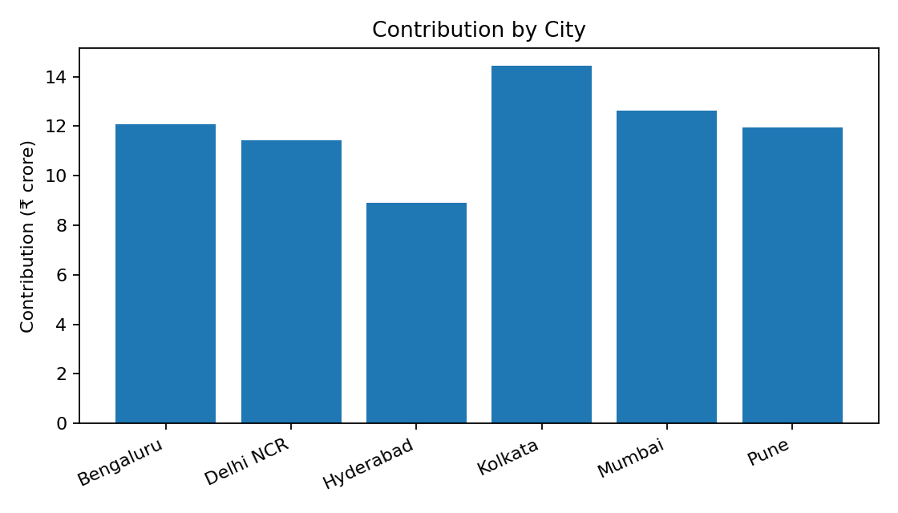

3.3 Management interpretation
- Kolkata: strongest scale and contribution, but fulfilment speed should be monitored before adding capacity.
- Hyderabad: lower scale and contribution, but strong delivery speed; investigate demand and unit economics.
- Bengaluru and Pune: broadly similar scale and contribution profiles; store-level variation should guide action.
- Mumbai: strong contribution and demand, with delivery time slightly above Bengaluru/Delhi NCR.
- Delhi NCR: strong scale, but contribution per order is below the network-leading cities.

4. Statistical and Driver Analysis

4.1 In-stock rate and repeat rate
Element | Result
H0 | No linear association between average in-stock rate and average repeat rate.
H1 | A linear association exists between average in-stock rate and average repeat rate.
Method | Pearson correlation
Correlation | r = 0.6821
p-value | 1.96 × 10⁻⁹
Interpretation | Strong positive and statistically significant association.
Business meaning | Better availability is associated with higher repeat rates in this dataset.

This is an association, not proof that improving in-stock rate alone causes repeat behaviour.

4.2 Store maturity and contribution/order
Element | Result
H0 | No linear association between maturity and contribution/order.
H1 | A linear association exists between maturity and contribution/order.
Method | Pearson correlation
Correlation | r = 0.0475
p-value | 8.05 × 10⁻¹⁸
Interpretation | Statistically significant but practically very weak association.
Business meaning | Store age alone should not be treated as a major driver of contribution/order.

4.3 Contribution driver model
Metric | Result
Model | Multiple linear regression
Features | AOV, discount rate, delivery cost/order, in-stock, delivery time, utilisation, maturity
R² | 57.3%
MAE | 15.82
RMSE | 19.61
Interpretation | Selected variables explain a meaningful share of contribution/order variation, but not all variation.

The contribution model uses an 80/20 train-test split and should be treated as a diagnostic model, not a causal model.

4.4 Repeat-rate driver model
Metric | Result
Model | Multiple linear regression
Features | Delivery time, in-stock, cancellation, complaint, promised-time hit, discount rate, maturity
R² | 7.9%
MAE | 0.0436
RMSE | 0.0546
Interpretation | Selected variables explain only a small share of repeat-rate variation.

The low R² indicates that repeat behaviour depends on additional factors not captured by the selected variables.

5. Store Segmentation and Scenario Analysis

5.1 Segmentation logic
A transparent store-level heuristic translates analytics into management decisions using demand, contribution/order, in-stock rate and promised-time performance.
Decision | Operational interpretation
Expand | Strong demand, economics, inventory and service performance.
Optimise | Viable demand with fixable operational/economic constraints.
Consolidate | Lower scale/utilisation with weaker economics; requires overlap review.
Pause | Fails minimum economic and service/inventory gates with no credible improvement path.

5.2 Final classification
Decision | Stores | Share
Optimise | 36 | 60.0%
Consolidate | 24 | 40.0%
Expand | 0 | 0.0%
Pause | 0 | 0.0%
Total | 60 | 100%

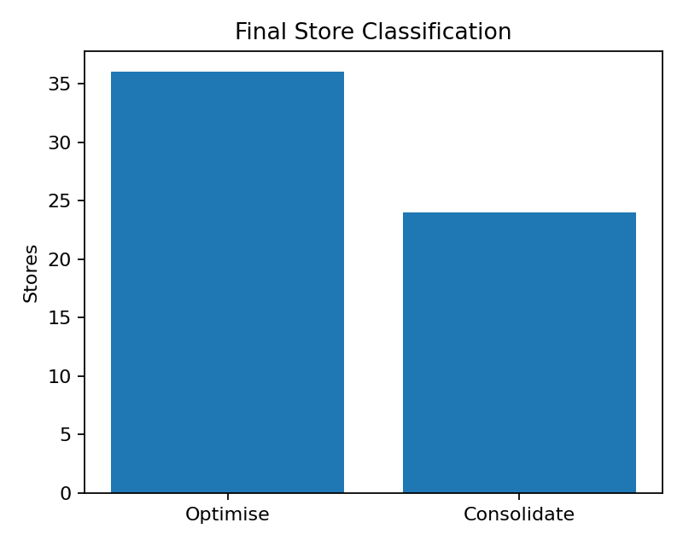
Figure 2. Final store classification.
The absence of Expand and Pause stores is a consequence of the selected percentile/median screening rules. It should not be interpreted as proof that no store could ever expand or should ever be paused.

5.3 Scenario model
Scenario | Change tested | Management use
Baseline | Current observed performance | Reference case
Demand Growth | +15% demand | Tests economics under higher volume
Delivery Cost | +15% delivery cost | Tests last-mile cost pressure
Discounts | −10% discounts | Tests economics under reduced discount intensity
In-stock | +2 percentage points | Tests potential availability improvement

The scenario model is directional and should be treated as an estimate rather than a forecast.

6. Exception and Root-Cause View

6.1 Priority exception themes
- Service pressure: review stores with lower promised-time achievement or longer delivery times.
- Inventory pressure: review lower in-stock stores because availability is strongly associated with repeat rate.
- Economic pressure: examine low contribution/order through discounting, delivery cost and order-value structure.
- Utilisation pressure: capacity above 100% should be investigated as an overload signal.
- Low-scale economics: consolidation candidates require a local overlap and strategic coverage review.

6.2 Illustrative stores
Store | City | Orders | Contribution | Repeat | In-stock | Decision
DS058 | Hyderabad | 239,723 | ₹2.07 cr | 76.92% | 94.04% | Optimise
DS033 | Bengaluru | 235,945 | ₹2.07 cr | 77.33% | 94.17% | Optimise
DS013 | Delhi NCR | 235,065 | ₹2.06 cr | 76.70% | 94.02% | Optimise
DS018 | Kolkata | 236,923 | ₹2.05 cr | 77.00% | 93.99% | Optimise
DS028 | Hyderabad | 89,536 | ₹0.44 cr | 77.77% | 95.25% | Consolidate
DS057 | Bengaluru | 89,866 | ₹0.43 cr | 77.44% | 95.20% | Consolidate
DS022 | Hyderabad | 88,840 | ₹0.43 cr | 77.72% | 95.10% | Consolidate
DS043 | Delhi NCR | 89,423 | ₹0.41 cr | 77.42% | 95.20% | Consolidate

6.3 Recommended actions
- Optimise service at high-demand stores before adding permanent capacity.
- Prioritise inventory availability where in-stock performance is weaker.
- Review delivery cost/order and discount intensity in low-contribution stores.
- Conduct neighbourhood-level overlap and utilisation review for the 24 consolidation candidates.
- Use downside scenarios before final capital or network decisions.
- Reassess classifications periodically as demand, service and economics change.

7. Executive Recommendation and Governance

7.1 Recommendation
The recommended network strategy is selective optimisation rather than immediate broad expansion. The simulated network has strong demand, repeat behaviour and overall contribution, but the current screening logic does not identify a store that simultaneously clears all selected high-performance gates for expansion.
- Prioritise the 36 Optimise stores for operational improvement and monitoring.
- Subject the 24 Consolidate stores to a second-stage review covering local overlap, coverage, utilisation and strategic importance.
- Do not use the current classification alone to approve closure, consolidation or capital expenditure.
- For future expansion, require evidence across demand, contribution, service reliability and inventory availability.
- Use downside scenarios, especially delivery-cost pressure, before approving expansion.

7.2 KPI control framework
KPI | Purpose | Management response
Orders / demand | Scale and utilisation potential | Investigate sustained weakness or overload
Contribution/order | Unit economics | Review discounts, AOV and delivery cost
In-stock rate | Customer availability | Prioritise replenishment/SKU actions
Promised-time hit rate | Service reliability | Review fulfilment and delivery capacity
Delivery time | Last-mile performance | Investigate congestion/capacity issues
Repeat rate | Customer retention | Use with operational KPIs
Capacity utilisation | Under/over-capacity | Review staffing and physical capacity

7.3 Validation and assumptions register
- All results are based on the supplied synthetic dataset.
- Observed metrics and scenario estimates are conceptually separated.
- Percentile/median decision thresholds are analytical screening rules, not corporate policy thresholds.
- Statistical significance is not treated as causality.
- Regression models use an 80/20 train-test split and report R², MAE and RMSE.
- Headline outputs should be independently reconciled before executive use.

7.4 Limitations
- The dataset is synthetic and cannot establish real Blinkit store performance.
- Property acquisition/rent economics and full corporate overhead are not included.
- Competitor-level micro-market data are unavailable.
- Category margin assumptions are simplified.
- The analysis does not establish causal relationships.
- Real-world expansion requires property, competition, traffic and strategic coverage information.

8. Conclusion
The analysis demonstrates a reproducible approach for evaluating a dark-store network using operational, customer and financial data. The simulated Blinkit network is commercially active, with 9.70 million orders, ₹590.66 crore GOV and ₹71.45 crore contribution over the study period.
Kolkata emerges as the strongest city on order volume and contribution, while Hyderabad has lower scale but faster delivery. At store level, the screening framework identifies 36 Optimise and 24 Consolidate candidates.
The key managerial conclusion is that expansion should not be based on demand alone. A robust dark-store decision should combine demand potential, service reliability, inventory availability, contribution economics and capacity resilience.

Appendix A – Metric Dictionary
Metric | Meaning
Sessions | Customer sessions entering the service funnel.
Orders | Completed orders.
Conversion Rate | Orders relative to sessions.
GOV | Gross order value before discounts.
Discounts | Discount value applied to orders.
NOV | Net order value after discounts.
Contribution | Contribution after the dataset’s specified variable costs/margins.
Contribution/order | Contribution generated per order.
AOV | Average order value.
In-stock rate | Share of relevant inventory availability.
Promised-time hit rate | Share of orders meeting promised time.
Repeat rate | Dataset’s repeat-customer outcome metric.
Capacity utilisation | Observed capacity usage relative to available capacity.

Appendix B – Reproducibility Checklist
- Load the supplied Excel workbook.
- Validate row count, stores, date range, missing values and duplicates.
- Create derived metrics without overwriting source variables.
- Aggregate daily data to store and city levels.
- Reconcile headline financial metrics.
- Run descriptive, correlation and regression analysis.
- Apply the documented screening heuristic.
- Run the simplified scenarios.

