RETAIL SALES & CUSTOMER ANALYTICS USING SQL

Submitted By: Abhay Singh
Roll Number : 2502059
Course: MBA Business Analytics
Subject: Analytics / SQL

1. INTRODUCTION
This project focuses on analyzing retail transactional data using SQL to extract meaningful business insights. The dataset contains customer purchases, product information, and order details. The project demonstrates how raw data can be transformed into structured information to support decision-making.

2. OBJECTIVE
The objective of this project is to design a relational database and perform SQL-based analysis to understand:
- Sales performance
- Customer behavior
- Product demand patterns

3. DATASET DESCRIPTION
The dataset used is the Online Retail Dataset obtained from Kaggle. It contains approximately 500,000 rows of transactional data.
Key columns include:
- InvoiceNo (Order ID)
- StockCode (Product ID)
- Description (Product Name)
- Quantity
- InvoiceDate
- UnitPrice
- CustomerID
- Country

4. DATA CLEANING
The dataset contained inconsistencies which were handled as follows:
- Removed records with NULL CustomerID
- Removed cancelled transactions (InvoiceNo starting with 'C')
- Removed negative or zero Quantity values
- Removed invalid UnitPrice values
- Converted CustomerID from float to integer
This ensured that only valid and meaningful data was used for analysis.

5. DATABASE DESIGN
The cleaned dataset was normalized into four relational tables:
- Customers (CustomerID, Country)
- Products (ProductID, ProductName, UnitPrice)
- Orders (OrderID, CustomerID, InvoiceDate)
- Order_Details (OrderID, ProductID, Quantity)
This design reduces redundancy and improves query performance.

6. SQL CONCEPTS USED
The following SQL concepts were applied:
- Data Definition Language (CREATE TABLE)
- Data Manipulation (INSERT, DELETE)
- Data Querying (SELECT)
- Joins (INNER JOIN)
- Aggregate functions (SUM, COUNT)
- GROUP BY and HAVING
- Subqueries

7. ANALYSIS PERFORMED
The following analysis was carried out:
- Total revenue calculation
- Revenue by country
- Top 10 customers based on spending
- Top-selling products
- Monthly sales trend analysis
- Identification of repeat customers
- Detection of products never ordered

8. KEY INSIGHTS
- A small group of customers contributes significantly to total revenue
- Certain products dominate overall sales
- Sales vary across months, indicating seasonal trends
- Some products show no demand and may require marketing attention

9. CONCLUSION
This project demonstrates how SQL can be used to transform raw data into structured insights. The analysis helps in understanding business performance and supports strategic decision-making.

10. TOOLS USED
- SQL Server Management Studio (SSMS)
- Microsoft Excel

11. Important Screenshots:

a) Customers Table:
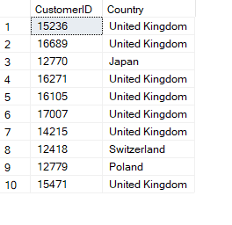
b) Products Table:

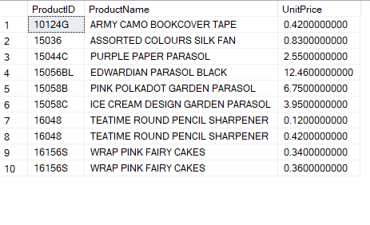
c) Orders Table:

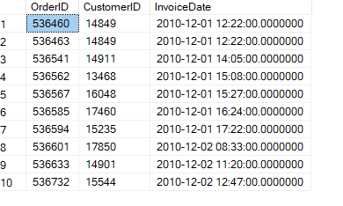
d) Order_Details:
