Receipt and Invoice Digitizer
1. Project Overview
Businesses and individuals handle a large number of paper-based receipts and invoices, which are prone to loss, manual data entry errors, and delayed processing. Managing such unstructured documents manually makes it difficult to track expenses, analyze spending patterns, and integrate data with accounting or ERP systems.
The Receipt and Invoice Digitizer project aims to automate the process of converting receipts and invoices into structured, machine-readable data using Optical Character Recognition (OCR) techniques. The system focuses on accurately extracting raw text from images and PDFs as a foundation for further data extraction, validation, and reporting.

2. Problem Statement
Receipts and invoices are typically stored as physical documents or unstructured digital files such as images and PDFs. Manual processing of these documents is time-consuming, error-prone, and inefficient. There is a need for an automated system that can ingest such documents, extract textual information reliably, and prepare the data for structured storage and analysis.

3. Project Objectives
The primary objectives of this project are:
- To develop a system capable of ingesting receipt and invoice documents in image and PDF formats.
- To preprocess documents in order to improve OCR accuracy.
- To extract raw textual content from documents using OCR.
- To present OCR results through a simple and user-friendly web interface.
- To establish a strong foundation for future field extraction, validation, and reporting modules.

4. Scope of the Project
In-Scope (Current Phase – Milestone 1)
- File upload for receipt and invoice documents.
- Image preprocessing to enhance OCR quality.
- OCR-based raw text extraction.
- Display of original image, preprocessed image, and extracted text.
- Basic project documentation and version control.

5. System Architecture
The system follows a modular and sequential architecture to ensure clarity, scalability, and ease of debugging.
High-Level Components:
- User Interface (Web Frontend)
- Document Ingestion Module
- Image Preprocessing Module
- OCR Engine
- Raw Text Output Layer
The architecture is designed so that each module performs a single responsibility and passes its output to the next stage in the pipeline.
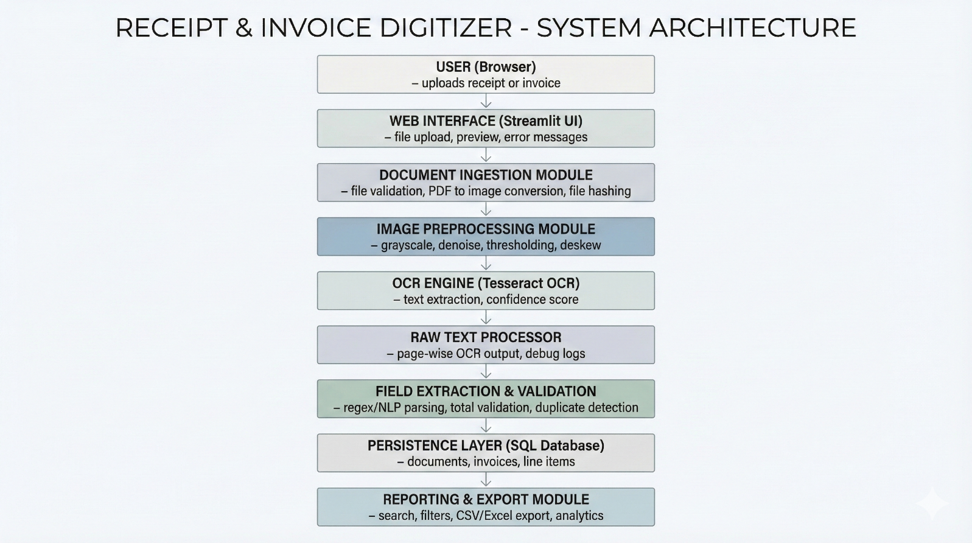

6. Workflow Description
The document processing workflow consists of the following stages:
- Uploaded – The user uploads a receipt or invoice through the web interface.
- Ingested – The system validates the file type and prepares it for processing.
- Preprocessed – The image is enhanced using grayscale conversion, noise reduction, thresholding, and deskewing.
- OCR Completed – Text is extracted from the preprocessed image using Tesseract OCR.
- Displayed – The extracted raw text is displayed to the user for review.
This workflow ensures transparency and allows visual inspection at each stage.
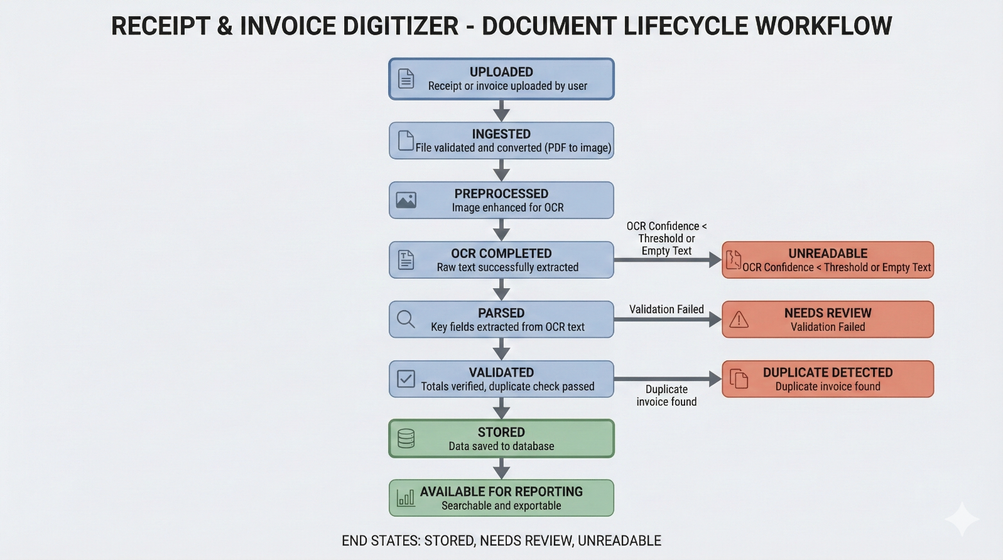

7. Technology Stack
- Programming Language: Python
- Frontend Framework: Streamlit
- OCR Engine: Tesseract OCR (v5.3.0)
- Image Processing: OpenCV, Pillow
- PDF Handling: pdf2image
- Environment Management: Conda
- Version Control: Git and GitHub

- 8. Dataset Collection
A dataset of more than 300 receipt and invoice documents was collected from publicly available and permissible online sources, along with a small number of real-world samples. The dataset includes:
- Receipt images (JPG, PNG)
- Invoice images
- Invoice PDFs
The dataset was curated to include variations in quality such as clean scans, mobile phone captures, and noisy or skewed documents to simulate real-world conditions.

9. Frontend Interface
A simple, light-themed web interface has been developed using Streamlit. The interface allows users to:
- Upload receipt or invoice documents.
- View the original uploaded image.
- View the preprocessed image.
- Review the raw OCR-extracted text.
The interface is intentionally minimal to support debugging and validation during early development.

10. Current Status (Milestone 1)
The following milestones have been achieved:
- Environment setup and dependency installation completed.
- Dataset collection and organization completed.
- Project folder structure finalized.
- Basic frontend interface developed.
- Documentation initiated and maintained.

