
IILM UNIVERSITY, GREATER NOIDA
School of Computer Science and Engineering
R E P O R T O F I N T E R N S H I P / J O B S I M U L A T I O N
DELOITTE AUSTRALIA CYBER JOB SIMULATION
Cybersecurity Job Simulation Report
Submitted in partial fulfillment of the requirements for the award of the degree of
Bachelor of Technology in Computer Science and Engineering
Submitted By: | Abhay Pandey
Section: | 2CSE34
Roll Number: | 25SCS1003003079
Academic Program: | B.Tech Computer Science & Engineering
Program Track: | Deloitte Australia Cyber Job Simulation
Platform: | Forage
Completion Date: | September 3, 2026

Verification Credentials:
Enrolment Verification Code: 6a99c5711364cf70c6765c9c | User Verification Code: 6a99c4cd6382fd454083115b | Issued by Forage

CANDIDATE'S DECLARATION
I, Abhay Pandey (Roll No: 25SCS1003003079, Section: 2CSE34), hereby declare that the report titled "Deloitte Australia Cyber Job Simulation" has been prepared by me as part of the requirements for the award of the degree of Bachelor of Technology in Computer Science and Engineering at IILM University, Greater Noida, Uttar Pradesh.
The report is based on my independent learning and the practical tasks completed during the Deloitte Australia Cyber Job Simulation, conducted through the Forage platform and completed on September 3, 2026. I further declare that this report has not been submitted to any other university or institution for the award of any degree or diploma.
Date: September 3, 2026
Place: Greater Noida, U.P.
___________________________________
Abhay Pandey
Roll No: 25SCS1003003079

ACKNOWLEDGEMENT
I would like to express my sincere gratitude to Forage and Deloitte Australia for providing me with the opportunity to complete the Cyber Job Simulation. The simulation offered practical, hands-on exposure to core cybersecurity concepts, including web activity log analysis, breach investigation, and suspicious user identification.
I also express my deep gratitude to the School of Computer Science and Engineering, IILM University, Greater Noida, for providing the academic environment, technical infrastructure, and encouragement to enhance my professional and practical skills.
Finally, I am thankful to my faculty members, academic mentors, and parents for their continuous guidance, support, and encouragement throughout the duration of this simulation program.

TABLE OF CONTENTS
1. Introduction & Context 3
2. Organization & Program Profile 3
3. Objectives of the Simulation 3
4. Internship Activities & Technical Work Performed 4
5. Skills & Learning Outcomes 5
6. Challenges & Technical Solutions 6
7. Contribution, Overall Experience & Conclusion 6
8. Original Completion Certificate Verification 7

1. INTRODUCTION & CONTEXT
The Deloitte Australia Cyber Job Simulation, offered through the Forage platform, provided a structured, practical opportunity to bridge foundational theoretical concepts in Computer Science with real-world cybersecurity operations. As a B.Tech student specialising in Computer Science and Engineering (Section 2CSE34, Roll No: 25SCS1003003079) at IILM University, completing this simulation on September 3, 2026, served as a valuable learning experience in applying analytical and investigative techniques to a simulated cybersecurity incident.
The simulation centred on supporting a simulated client through a cybersecurity breach — a core function within Deloitte's Cyber practice. The task involved reading and analysing web activity logs, investigating patterns of user behaviour, and applying structured reasoning to identify the user associated with the most suspicious activity.

2. ORGANIZATION & PROGRAM PROFILE

2.1 About Deloitte Australia
Deloitte is one of the world's largest professional services networks, providing audit, consulting, risk advisory, tax, and cybersecurity services across a wide range of industries. Deloitte Australia's Cyber practice assists organisations in identifying, investigating, and responding to cybersecurity threats, helping clients protect their digital infrastructure and sensitive data.

2.2 About Forage
Forage is a virtual work experience platform that partners with leading global organisations, including Deloitte, to offer open-access job simulations. These simulations replicate real workplace tasks, allowing students to gain practical, industry-relevant exposure to the kind of work performed by professionals in a given field, without requiring a formal internship placement.

2.3 Simulation Format
The simulation was conducted through Forage's self-paced virtual workspace, replicating the operational environment of a Deloitte cybersecurity analyst supporting a client organisation. The task required reviewing simulated web activity logs and applying investigative reasoning to determine which user's activity pattern was most indicative of a security compromise.

3. OBJECTIVES OF THE SIMULATION

- Breach Response Awareness: Understanding how organisations detect and respond to a simulated cybersecurity breach.
- Log Analysis Practice: Reading and interpreting web activity logs to identify patterns of user behaviour.
- Suspicious Activity Identification: Comparing activity across multiple users to isolate anomalous or suspicious behaviour.
- Analytical Reasoning: Applying structured, evidence-based reasoning to reach and justify an investigative conclusion.
- Client-Facing Perspective: Understanding the client-support role a cybersecurity consultant plays during an active investigation.

4. INTERNSHIP ACTIVITIES & TECHNICAL WORK PERFORMED

4.1 Web Activity Log Analysis
Web activity logs of the kind used in this simulation typically record information such as user identifiers, timestamps, page or resource requests, IP-related activity, and other markers of user behaviour on a system. Analysing such logs involves examining these fields systematically to establish a baseline of normal activity and to flag entries that deviate from expected patterns — for example, unusual request frequency, access at atypical times, or activity inconsistent with a user's typical role.
The task required working through the provided log data methodically, comparing individual user entries against one another, and applying reasoning to distinguish ordinary browsing or system activity from behaviour that warranted further investigation.

4.2 Cybersecurity Breach Investigation
The simulation was framed around supporting a simulated Deloitte client that had experienced a cybersecurity breach. The investigative process involved reviewing the available activity data for the client's environment, considering which users had access to the systems in question, and evaluating the evidence to determine the likely source of the suspicious activity.

4.3 Suspicious User Identification
Using the patterns observed in the log analysis stage, user activity was compared and cross-referenced to identify the individual whose behaviour was most consistent with the suspicious activity under investigation. This required structured, evidence-based reasoning rather than assumption, reflecting the analytical approach used by cybersecurity professionals when triaging a potential incident.

4.4 Task Completion & Certification
Upon successful completion of the practical tasks in cybersecurity, a Certificate of Completion for the Deloitte Australia Cyber Job Simulation was issued by Forage on September 3, 2026, verifying the completion of the simulation. The certificate is reproduced in Section 8 of this report.
Specific log data, task questions, and answer submissions from the simulation workspace are [TO BE PROVIDED] and may be appended to this report as supplementary evidence where available.

5. SKILLS & LEARNING OUTCOMES
The simulation drew upon, and helped reinforce, a range of technical and professional skills relevant to a B.Tech Computer Science and Engineering curriculum. The table below outlines how each core skill area connected to the practical work performed.
Skill Area | Connection to the Simulation
Computer Networking | Interpreting web traffic, user requests, and network-related activity within the log data.
Log Analysis | Reading and systematically reviewing web activity logs to identify unusual patterns.
Data Analysis | Filtering, comparing, and interpreting entries across multiple users to draw conclusions.
Web Security | Understanding what constitutes suspicious web activity and how it relates to a cybersecurity breach.
Spreadsheet Skills | Organising and reviewing log-related data in a structured, tabular format.
Data Visualization Tools | Presenting observed activity patterns clearly to support the investigative findings.
Data Structures | Understanding how log entries and user records are organised for efficient review.
Data Modeling | Relating user attributes and activity fields to one another to build an investigative picture.
Programming / Python Programming | Underlying programming concepts relevant to log processing; [TO BE PROVIDED] regarding specific tools used, as this was not evidenced in the material provided.
Software Development | General awareness of how analytical tools and workspaces are built to support investigations.
Formal Communication | Communicating investigative findings and conclusions clearly and professionally.
Planning | Following a structured, step-by-step investigative process rather than an ad-hoc approach.

6. CHALLENGES & TECHNICAL SOLUTIONS
Identified Challenge | Root Cause | Approach / Solution
Distinguishing normal activity from genuinely suspicious behaviour | Log data contains a mix of routine and anomalous entries across multiple users | Established a baseline of expected activity before flagging deviations, and cross-checked entries rather than relying on a single data point
Avoiding premature conclusions | Risk of identifying a user based on incomplete evidence | Applied a structured, evidence-based comparison across all available user activity before reaching a conclusion

7. CONTRIBUTION, OVERALL EXPERIENCE & CONCLUSION

7.1 Contribution & Overall Experience
Through independent completion of the Deloitte Australia Cyber Job Simulation, I gained practical exposure to the kind of investigative and analytical work performed by cybersecurity consultants when supporting a client through a security incident. The task reinforced the importance of methodical log review and evidence-based reasoning over assumption-driven conclusions.

7.2 Conclusion
The Deloitte Australia Cyber Job Simulation, completed via Forage, served as a valuable practical supplement to my B.Tech Computer Science and Engineering coursework at IILM University. The experience strengthened my understanding of web activity log analysis, cybersecurity breach investigation, and the analytical discipline required to identify suspicious user behaviour, while reinforcing the value of structured, evidence-based communication of findings.

8. ORIGINAL COMPLETION CERTIFICATE VERIFICATION
This section displays the verified Certificate of Completion issued by Forage on behalf of Deloitte Australia, confirming the successful completion of the practical tasks undertaken in the Cyber Job Simulation.
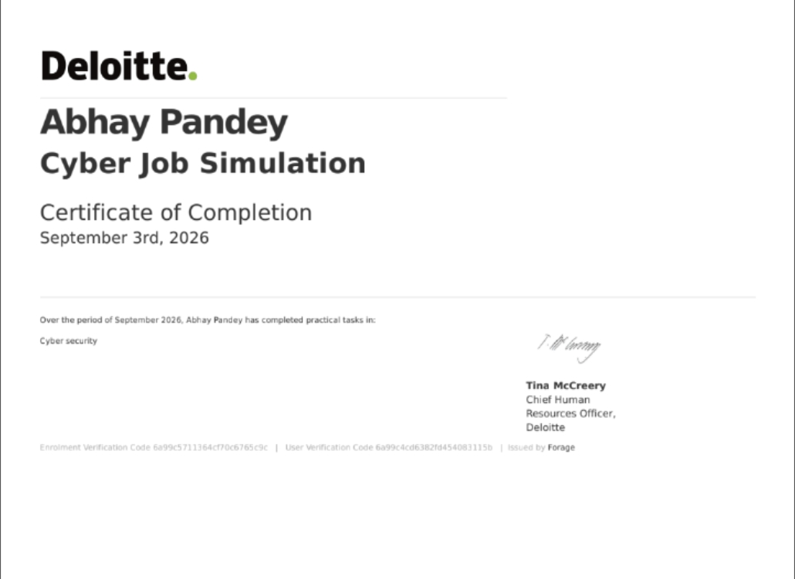
Figure 1: Certificate of Completion — Deloitte Australia Cyber Job Simulation, issued via Forage (September 3, 2026).
The certificate confirms that Abhay Pandey successfully completed practical tasks in Cyber Security as part of the Deloitte Australia Cyber Job Simulation during the period of September 2026. The certificate carries an Enrolment Verification Code (6a99c5711364cf70c6765c9c) and a User Verification Code (6a99c4cd6382fd454083115b), issued by Forage and countersigned by Tina McCreery, Chief Human Resources Officer, Deloitte.

