**CASE STUDY SOLUTION**

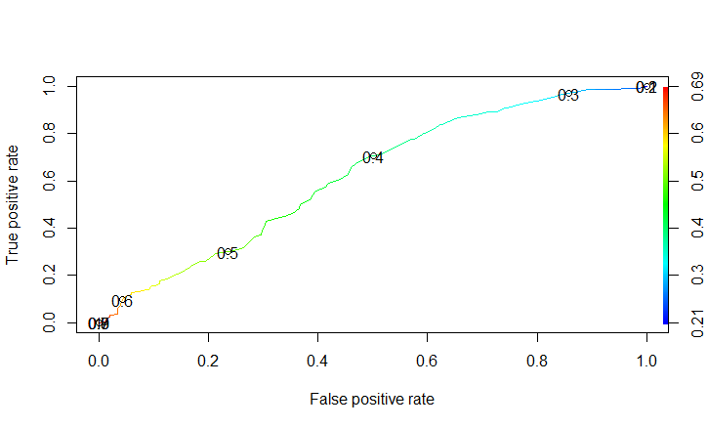

1. Age variable is more significant that Sex variable for determination of diabetes(NDD). Also, ROC curve is attached above which helped to deduce the cutoff point.
2. For this case, I found out that OGTT1FBS can’t be replaced with HBA1C1.This was performed using Logistic Regression technique.
3. For this case, pairwise scatter plot was made, and from the summary we deduced age is the only prominent variable. Also, age was the only variable which was strongly co-related with NDD.

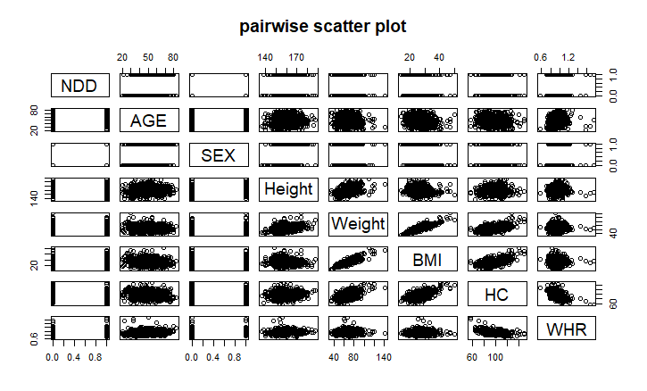

1. Here, PPBS1 is having the highest accuracy of all the case i.e. using glm command with both 1) PPBS1 & FBS and 2) FBS alone. Hence, PPBS1 is alone capable of predicting the diabetes.