**Module :** 7

**Topic :** RDBMS & Database Programming with JDBC

**Name :** Abhay Gajjar

----------------------------------------------------

Queries :

**1) Select unique job from EMP table ?**

=> SELECT DISTINCT job FROM emp;

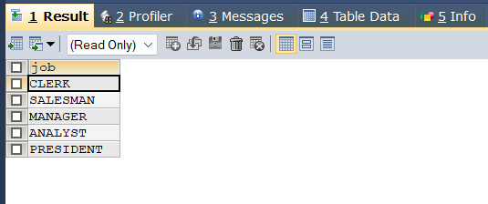

**2) List the details of the emps in asc order of the Dptnos and desc of Jobs ?**

=> SELECT * FROM EMP ORDER BY Deptno ASC, Job DESC;

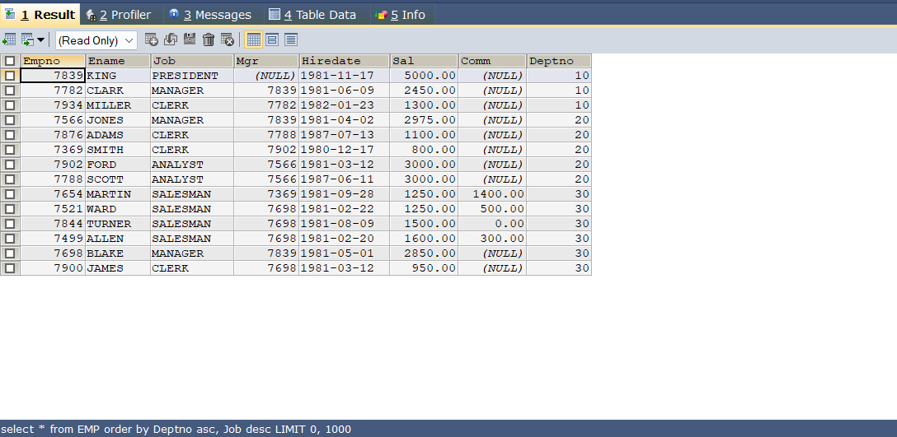

**3) Display all the unique job groups in the descending order?**

=> SELECT DISTINCT(Job) FROM EMP ORDER BY Job DESC;

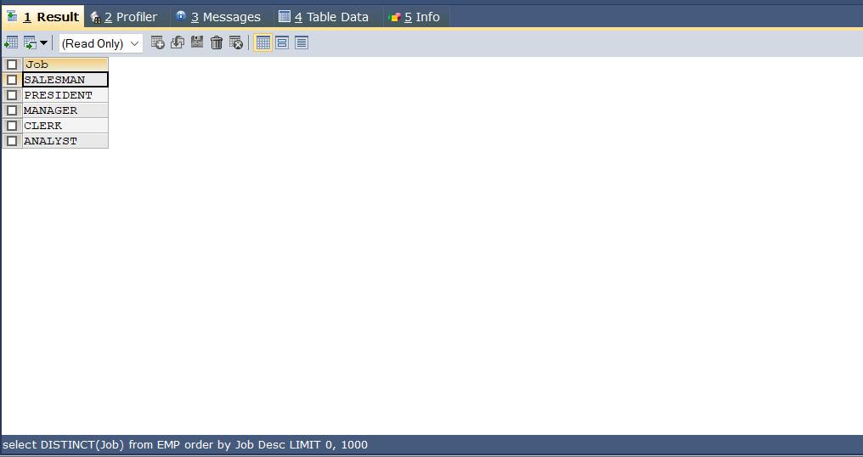

**4) List the emps who joined before 1981.**

=> SELECT * FROM EMP WHERE Hiredate < '1981-01-01';

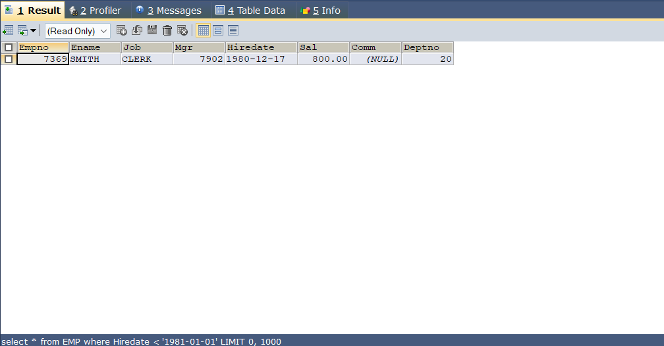

**5) List the Empno, Ename, Sal, Daily sal of all emps in the asc order of Annsal.**

=> SELECT empno,ename,sal,sal/365 AS dailysal FROM emp ORDER BY sal ASC;

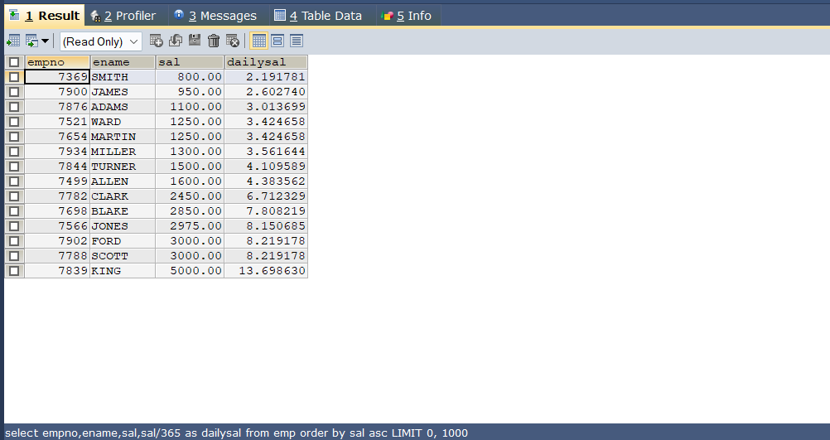

**6) List the Empno, Ename, Sal, Exp of all emps working for Mgr 7369.**

=> SELECT Empno,Ename,Sal,(YEAR(CURDATE())-YEAR(Hiredate)) AS EXP FROM EMP WHERE Mgr=7369;

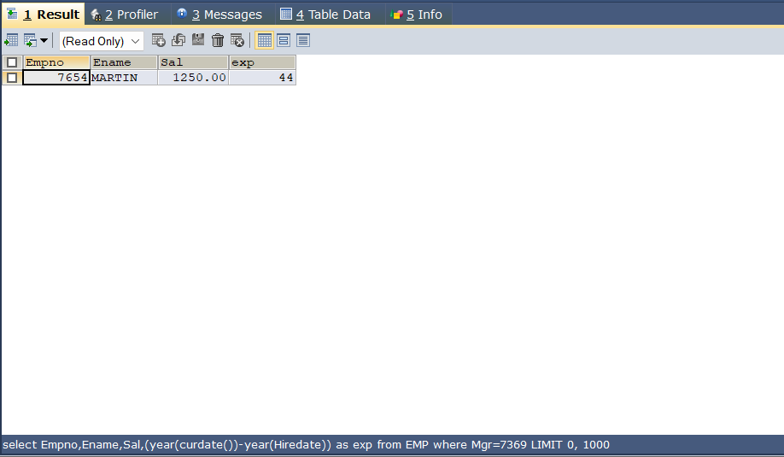

**7) Display all the details of the emps who’s Comm. Is more than their Sal?**

=> SELECT * FROM emp WHERE comm > sal;

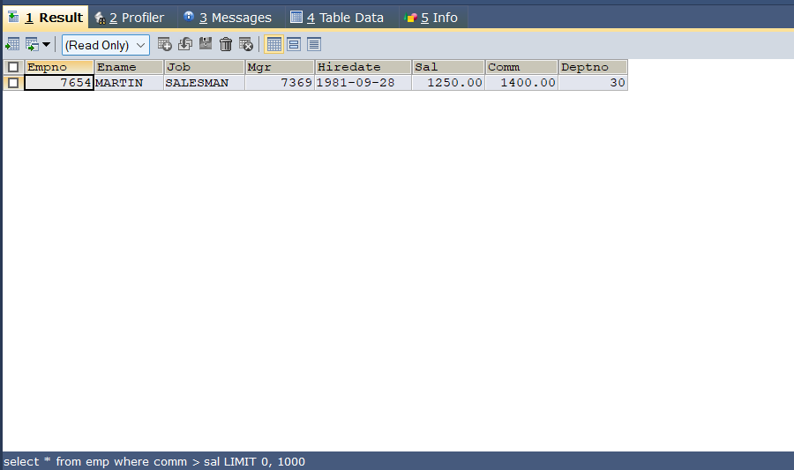

**8) List the emps who are either ‘CLERK’ or ‘ANALYST’ in the Desc order.**

=> SELECT * FROM emp WHERE job='clerk' OR job='analyst' ORDER BY job DESC;

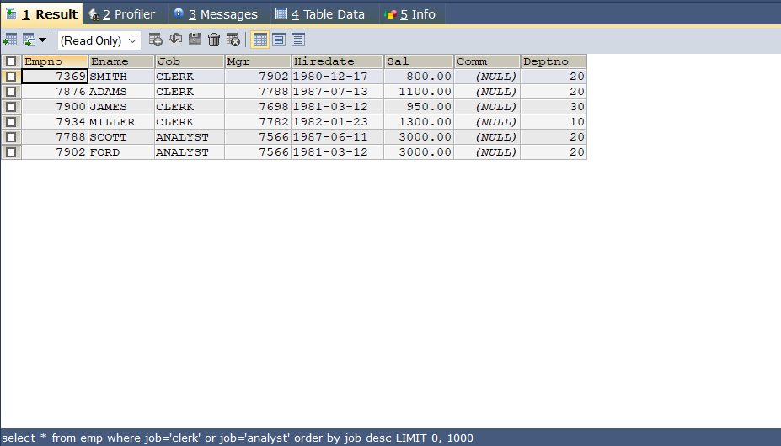

**9) List the emps Who Annual sal ranging from 22000 and 45000.**

=> SELECT * FROM emp WHERE (sal*12) BETWEEN 22000 AND 45000;

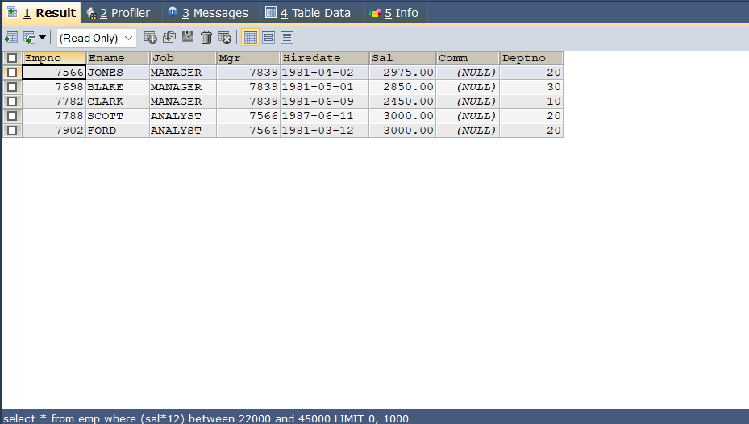

**10) List the Enames those are starting with ‘S’ and with five characters.**

=> SELECT ename FROM emp WHERE ename LIKE 'S____';

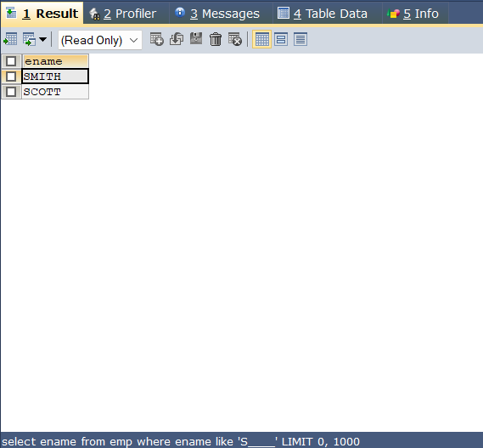

**11) List the emps whose Empno not starting with digit 78.**

=> SELECT * FROM emp WHERE empno LIKE '78%';

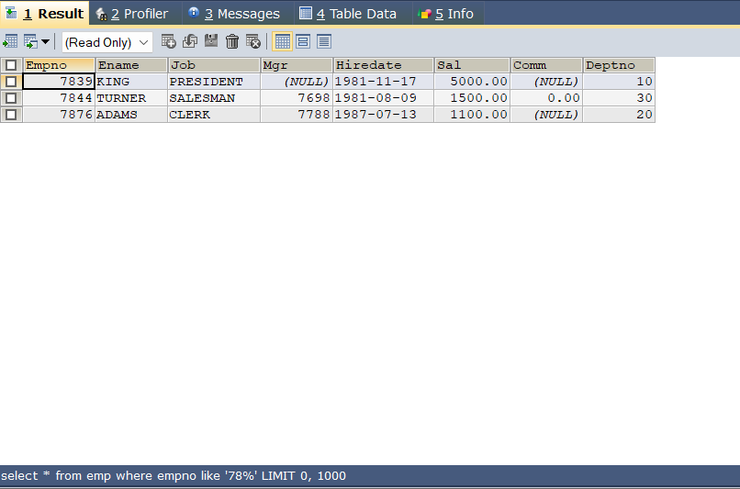

**12) List all the Clerks of Deptno 20.**

=> SELECT * FROM emp WHERE job='clerk' AND deptno=20;

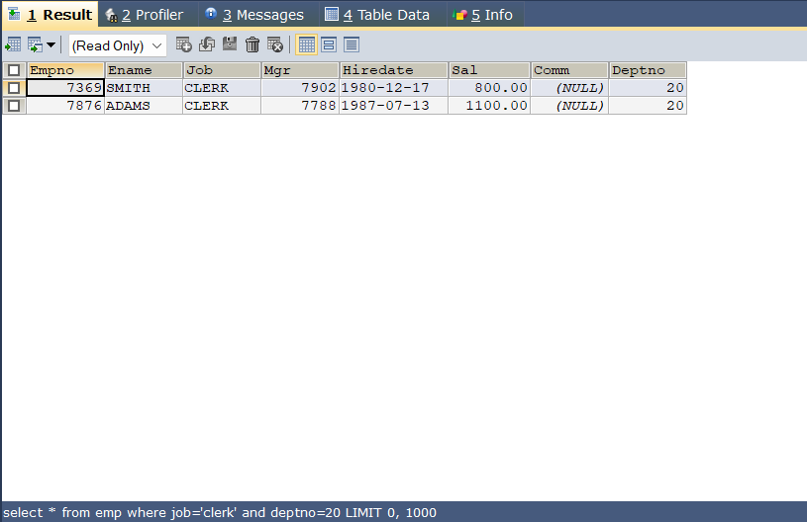

**13) List the Emps who are senior to their own MGRS.**

=> SELECT e.empno, e2.ename FROM emp e , emp e2 WHERE e.mgr = e2.empno AND e.Hiredate < e2.Hiredate;

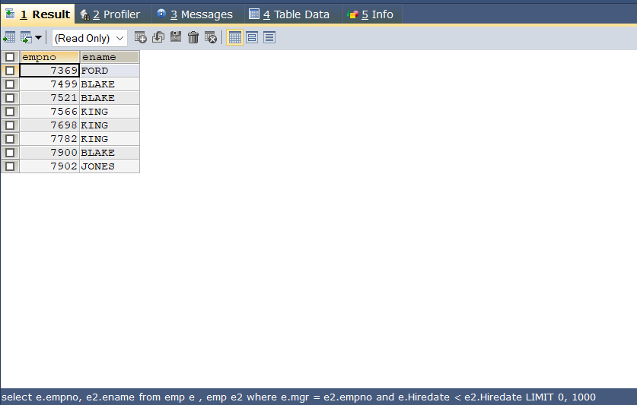

**14) List the Emps of Deptno 20 who’s Jobs are same as Deptno10.**

=> SELECT * FROM emp WHERE deptno=20 AND job IN (SELECT job FROM emp WHERE deptno=10);

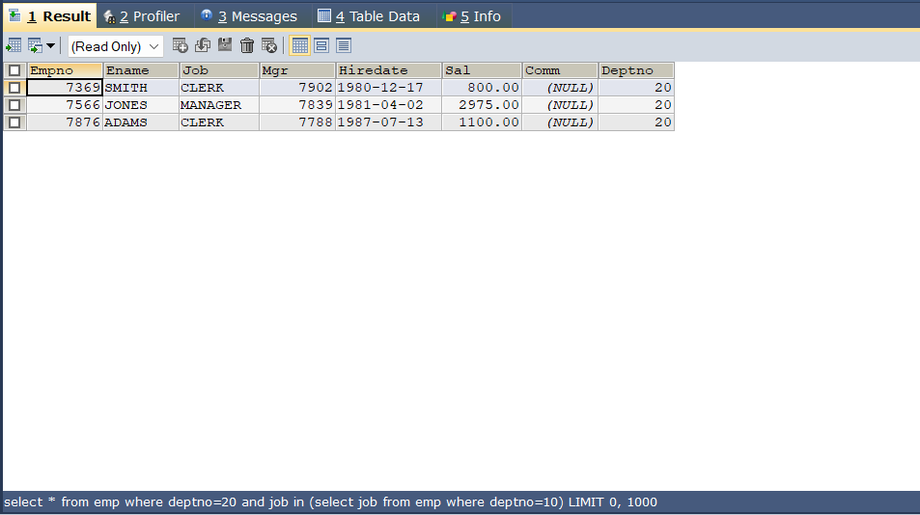

**15) List the Emps who’s Sal is same as FORD or SMITH in desc order of Sal.**

=> SELECT * FROM emp WHERE sal = (SELECT sal FROM emp WHERE ename='ford') OR sal = (SELECT sal FROM emp WHERE ename='smith') ORDER BY sal DESC;

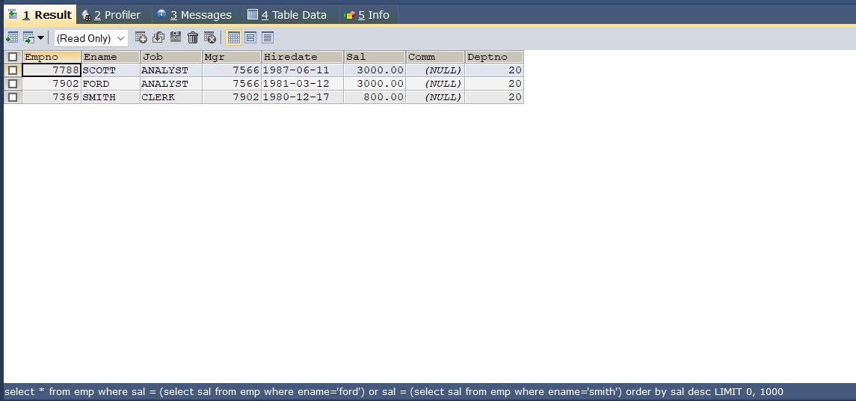

**16) List the emps whose jobs same as SMITH or ALLEN.**

=> SELECT * FROM emp WHERE job IN (SELECT job FROM emp WHERE ename = 'smith') OR job IN (SELECT job FROM emp WHERE ename = 'allen');

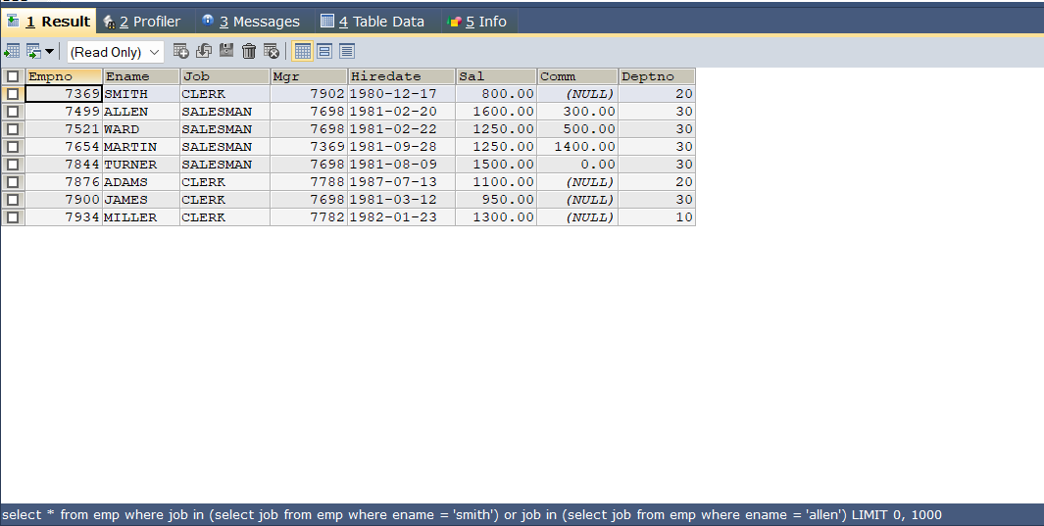

**17) Any jobs of deptno 10 those that are not found in deptno 20.**

=> SELECT DISTINCT job FROM emp WHERE deptno=10 AND job NOT IN (SELECT DISTINCT job FROM emp WHERE deptno=20);

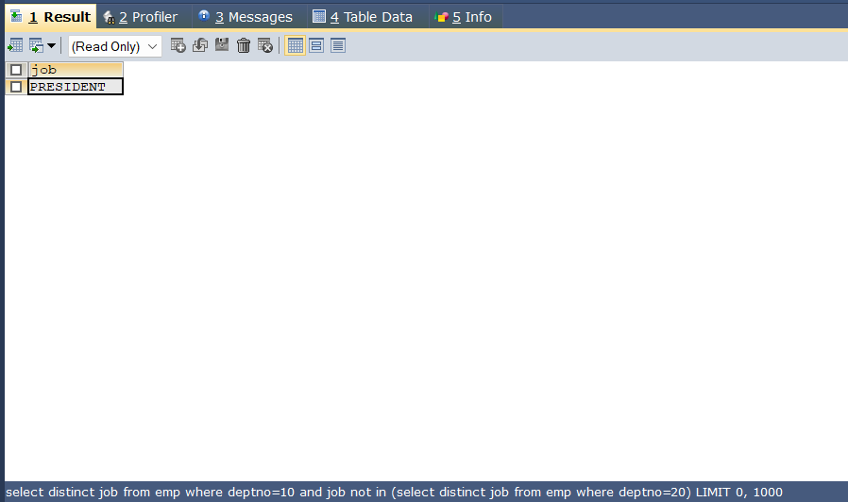

**18) Find the highest sal of EMP table.**

=> SELECT MAX(sal) AS HighestSalary FROM emp;

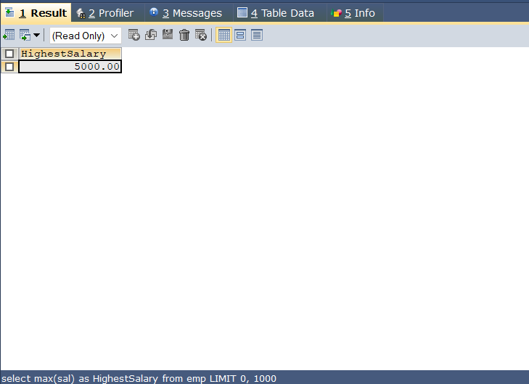

**19) Find details of highest paid employee.**

=> SELECT * FROM emp WHERE Sal = (SELECT MAX(Sal) FROM emp);

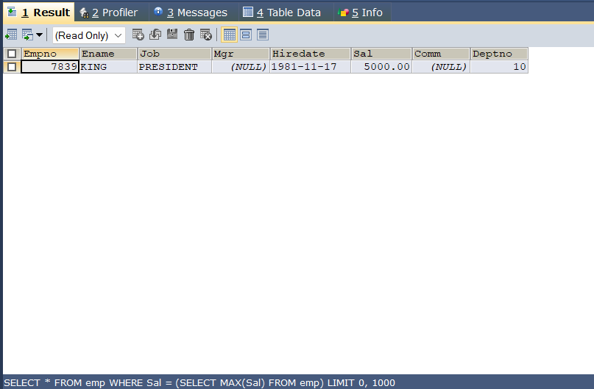

**20) Find the total sal given to the MGR.**

=> SELECT SUM(Sal) AS TotalManagerSalary

FROM emp WHERE job = 'mgr';

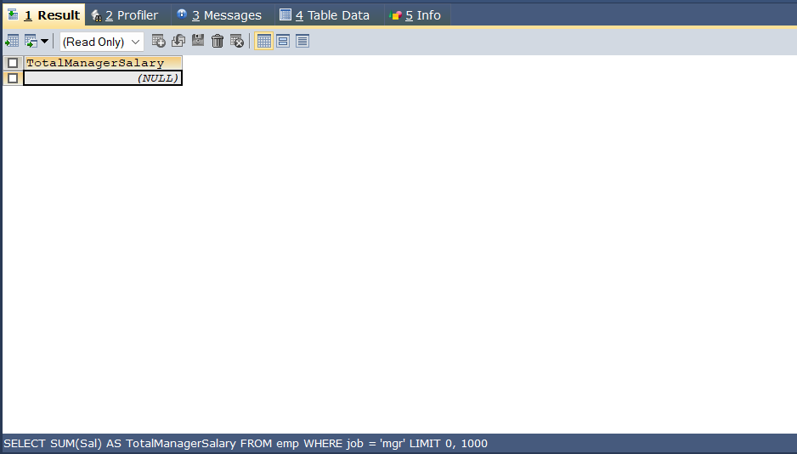

**21) List the emps whose names contains ‘A’.**

=> SELECT * FROM emp WHERE Ename LIKE '%A%';

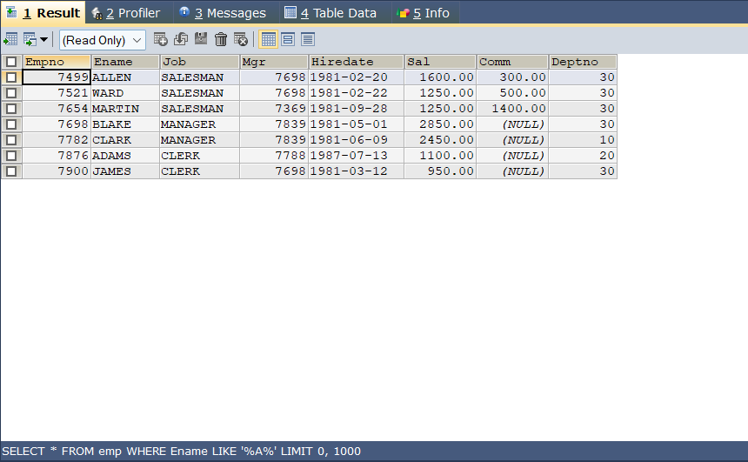

**22) Find all the emps who earn the minimum Salary for each job wise in ascending order.**

=> SELECT E.*

FROM emp E

JOIN (

SELECT Job, Sal

FROM emp

WHERE (Job, Sal) IN ( SELECT Job, MIN(Sal) FROM emp GROUP BY Job ) ) M ON E.Job = M.Job AND E.Sal = M.Sal ORDER BY E.Job ASC;

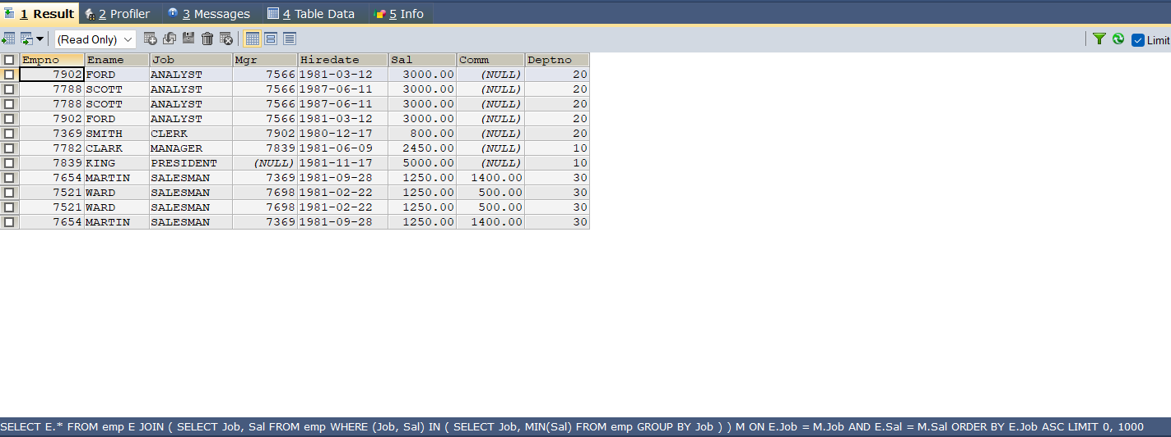

**23) List the emps whose sal greater than Blake’s sal.**

=> SELECT * FROM emp WHERE Sal > (SELECT Sal FROM emp WHERE Ename = 'BLAKE');

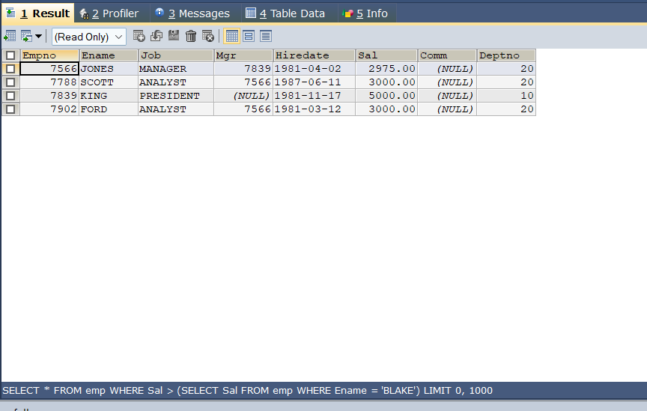

**24) Create view v1 to select ename, job, dname, loc whose deptno are same.**

=> CREATE VIEW v1 AS

SELECT E.ename, E.job, D.dname, D.loc

FROM emp E

JOIN dept D

ON E.deptno = D.deptno;

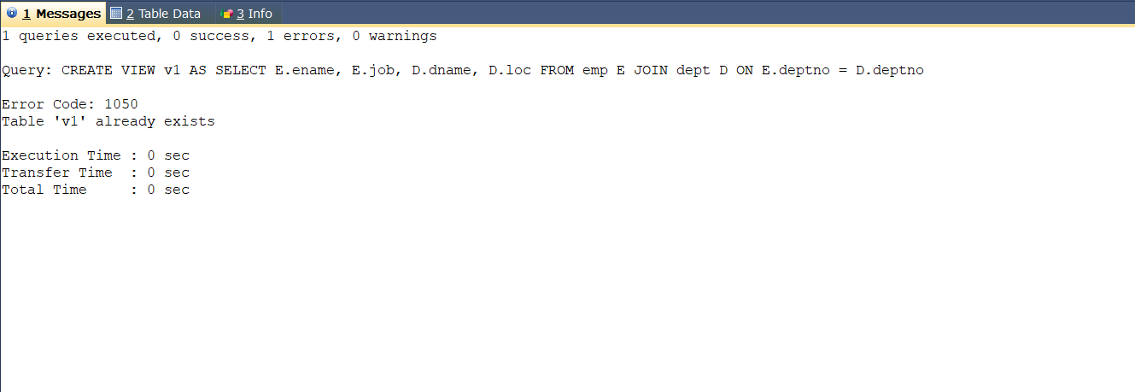

**25) Create a procedure with dno as input parameter to fetch ename and dname.**

=> DELIMITER //

CREATE PROCEDURE GetEmployeeDetails(IN dno INT)

BEGIN

SELECT E.ename, D.dname

FROM emp E

JOIN dept D ON E.deptno = D.deptno

WHERE E.deptno = dno;

END //

DELIMITER ;

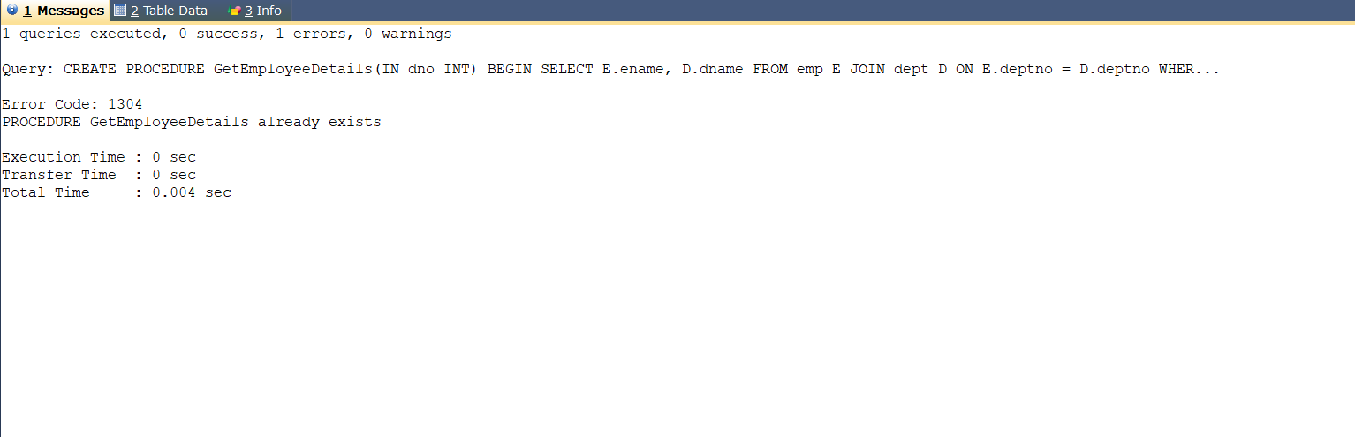

**26) Add column Pin with bigint data type in table student.**

=> ALTER TABLE student ADD COLUMN Pin BIGINT;

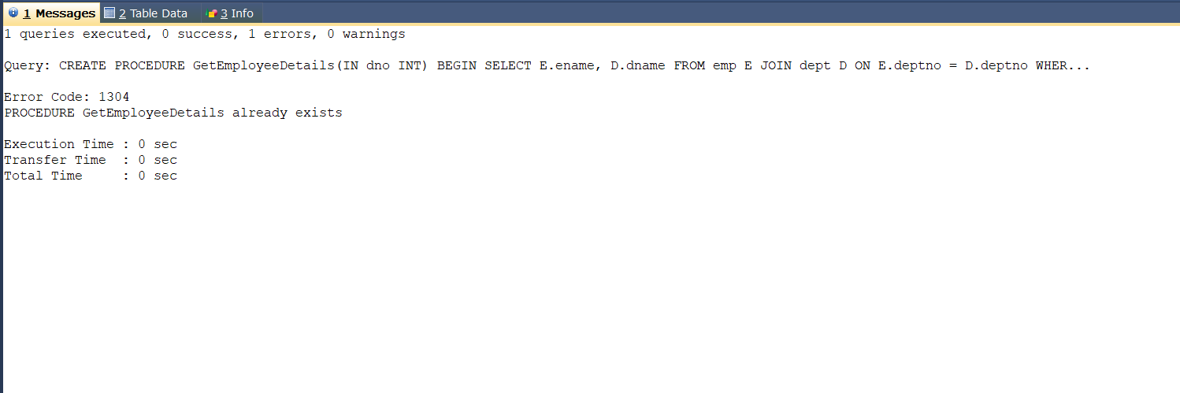

**27) Modify the student table to change the sname length from 14 to 40.**

=> ALTER TABLE student

MODIFY COLUMN sname VARCHAR(40);

DESCRIBE student;

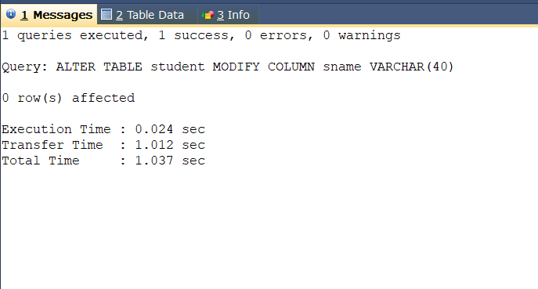

**28) Create trigger to insert data in emp_log table whenever any update of sal in EMP table. You can set action as ‘New Salary’.**

=> DELIMITER //

CREATE TRIGGER after_sal_update

AFTER UPDATE ON EMP

FOR EACH ROW

BEGIN

IF NEW.sal <> OLD.sal THEN

INSERT INTO emp_log (Empno, ACTION, ChangeDate)

VALUES (NEW.Empno, 'New Salary', NOW());

END IF;

END //

DELIMITER ;



    