**Abhay Gajjar**

**DBMS ASSESSMENT – 4**

* **SQL Queries :**

**1.) Over here the table Nobel_win will contain attributes like year, subject, winner, country and category.**

**Answer :**

[CREATE](http://localhost/phpmyadmin/url.php?url=https://dev.mysql.com/doc/refman/8.0/en/create-table.html) [TABLE](http://localhost/phpmyadmin/url.php?url=https://dev.mysql.com/doc/refman/8.0/en/create-table.html) noble_win ( Year year, Subject varchar(40), Winner varchar(50), Country varchar(60), Category varchar(50) );

**Output :**

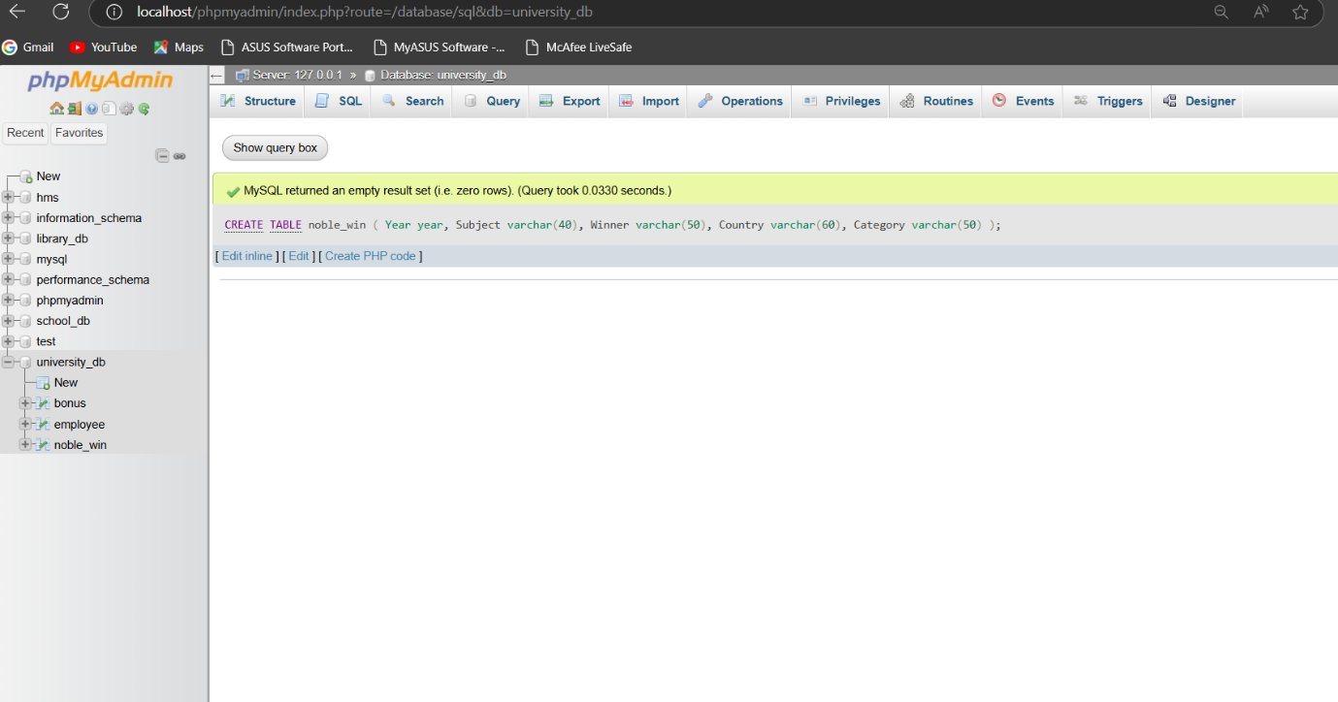

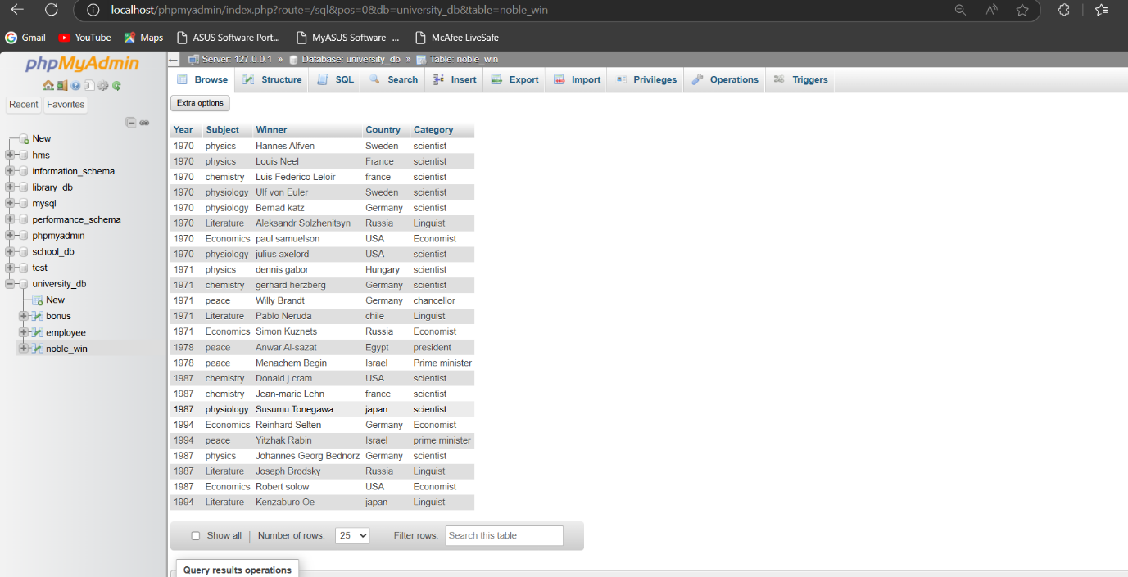

**Now make sure to solve the following query :**

**2.) Write sql query to find the nobel prize winners of the year 1970. Return year,subject and winner .**

**Answer :**

SELECT Year ,Subject,Winner

FROM noble_win

WHERE Year=1970;

**Output :**

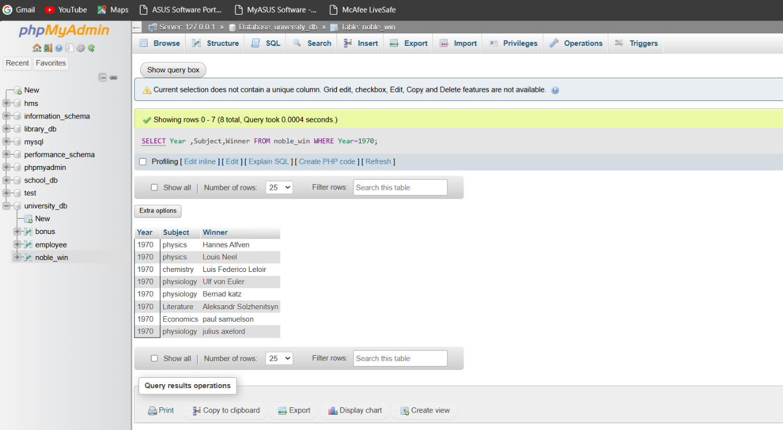

**3.) Write sql query to find the nobel prize winners in chemistry between the years 1965 and 1975. Begin and end values are includedReturn year, subject, winner and country .**

**Answer :**

SELECT Year,Subject,Winner,Country

FROM noble_win

WHERE subject = "Chemistry" AND Year BETWEEN 1965 AND 1975;

**Output :**

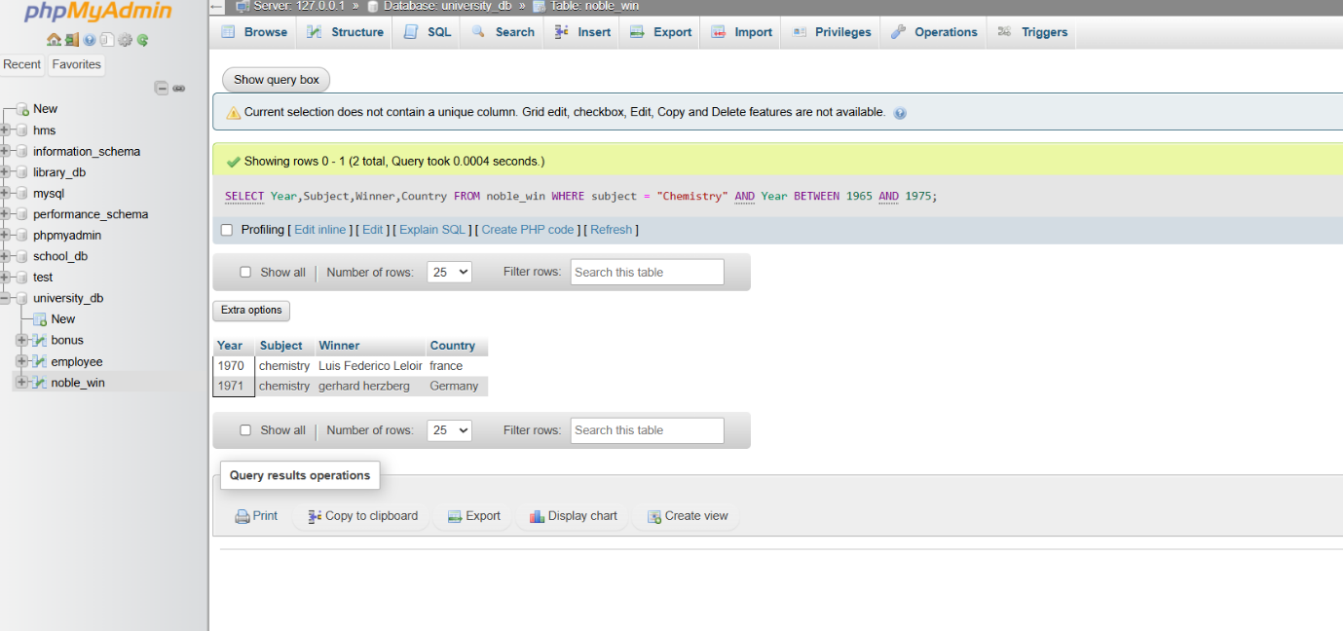

**4.) Write sql query to retrieve the details of the winners whose first name matches with the string ‘Louis’. Return year,subject,winner,country .**

**Answer :**

SELECT Year , Subject,Winner,Country

FROM noble_win

WHERE Winner LIKE “Louis%”;

**Output :**

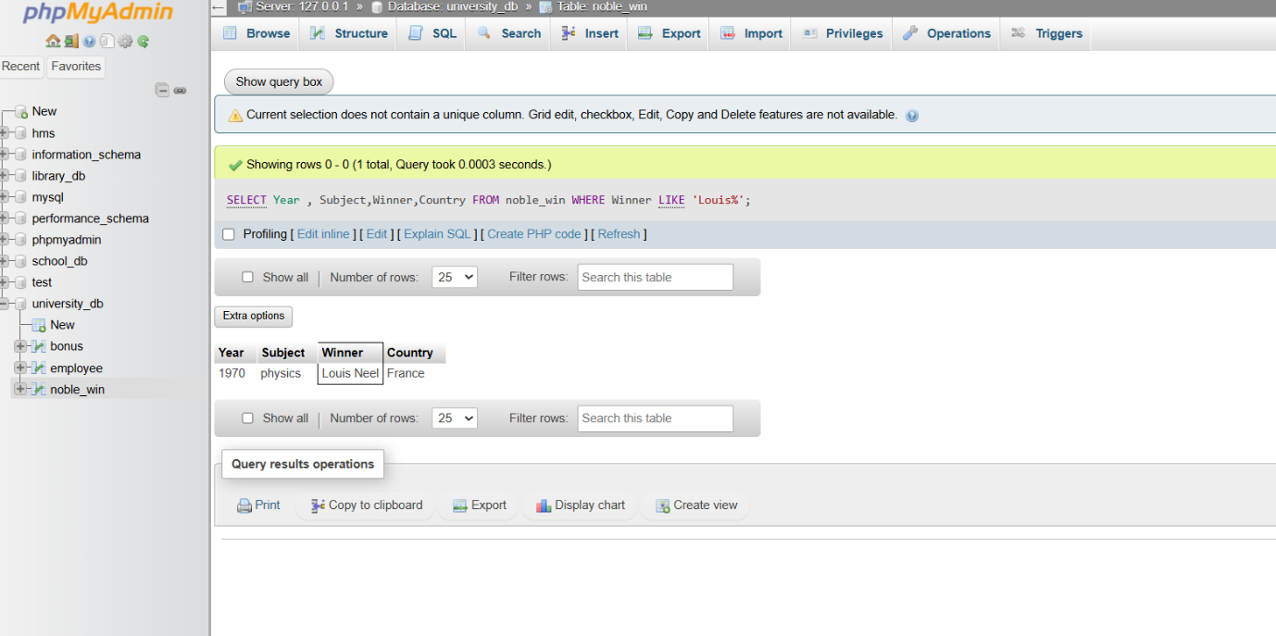

**5.) Write sql query to find Nobel prize winners for the subject that does not begin with the letter ‘P’. Order the result by year, descending and winner in ascending .**

**Answer :**

SELECT Year , Subject,Winner,Country,Category

FROM noble_win

WHERE Subject NOT LIKE "p%" ORDER BY Year DESC , Winner ASC;

**Output :**

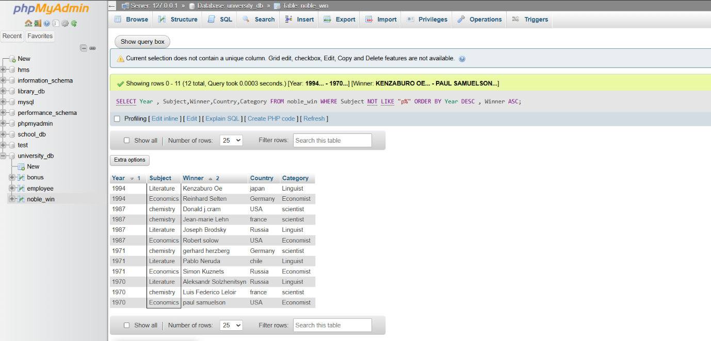

**6.) Write sql query to find the details of 1970 Nobel prize winners. Order the result by subject, ascending except for ‘Chemistry’ and ‘Economics’ which will come at the end of the result set. Return year, subject, winner , country and category.**

**Answer :**

[SELECT](http://localhost/phpmyadmin/url.php?url=https://dev.mysql.com/doc/refman/8.0/en/select.html) Year, Subject, Winner, Country, Category

FROM noble_win

WHERE Year = 1970

ORDER BY [CASE](http://localhost/phpmyadmin/url.php?url=https://dev.mysql.com/doc/refman/8.0/en/control-flow-functions.html%23operator_case)

WHEN Subject [IN](http://localhost/phpmyadmin/url.php?url=https://dev.mysql.com/doc/refman/8.0/en/comparison-operators.html%23function_in)("Chemistry" ,"Economics")

THEN 1

ELSE 0

END, Subject ASC;

**Output :**

