**CP3407**

**Project Part 1**



**Abhay Anil – JC539324**

**GITHUB link:** <https://github.com/abhayanill/CP3407>

**Project description for non-ICT-technical stakeholders and general audience**

**Concept Formulation**

An application that helps users find similar users who want to play a sport do lack the number of players or a venue to play the game. The application helps the user create a profile with their basic information and helps select the sports they are interested in and asks the user about the days they are looking to play and the location they are looking for, then the application gives the user a list from the server of other similar users on the network who are looking to play the same game around the same location on those given days and gives them a platform to interact with each other.

**Problem Understanding**

Many people want to play a sport but lack the following:

* Not having enough players
* Not knowing the availability of sports venues in their location
* Not aware of the cost to hire a sports venue
* Lack sports equipment

**System Proposal Development**

Systems that can be used are:

* Database storing all the user’s information and retrieving them based on the users searches to give them the result they’re looking for
* Accessing the existing databases of sports venues to give the user cost and availability details of the venues around their location
* Giving users a platform to interact with each other(Messaging)

**Feasibility** **Study**

Similar systems have been deployed by many other Social Media Companies such as Facebook, Twitter, etc, where users with similar interests can form groups based on it. Even other online ecommerce websites use similar systems where the users searches for their required item and are given results based on the search and availability**.**

**Project Goals**

The goal of the application is to:

* Help users find similar users to play a sport with
* Help users find sports venues around their location
* Helps users know the availability and cost of the venues

**Project Design**

**Architecture Design**

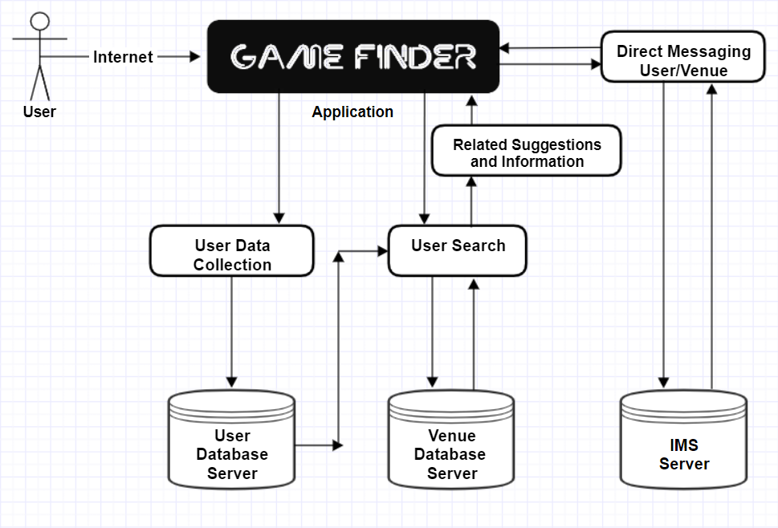

**Database Design**

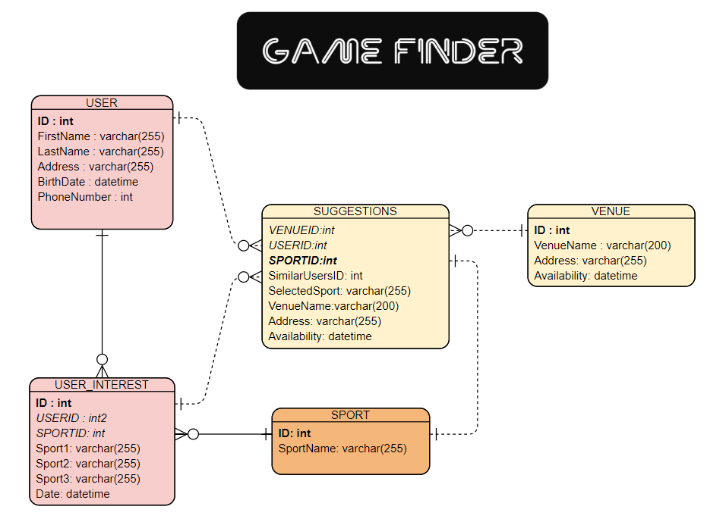

**Interface Design**

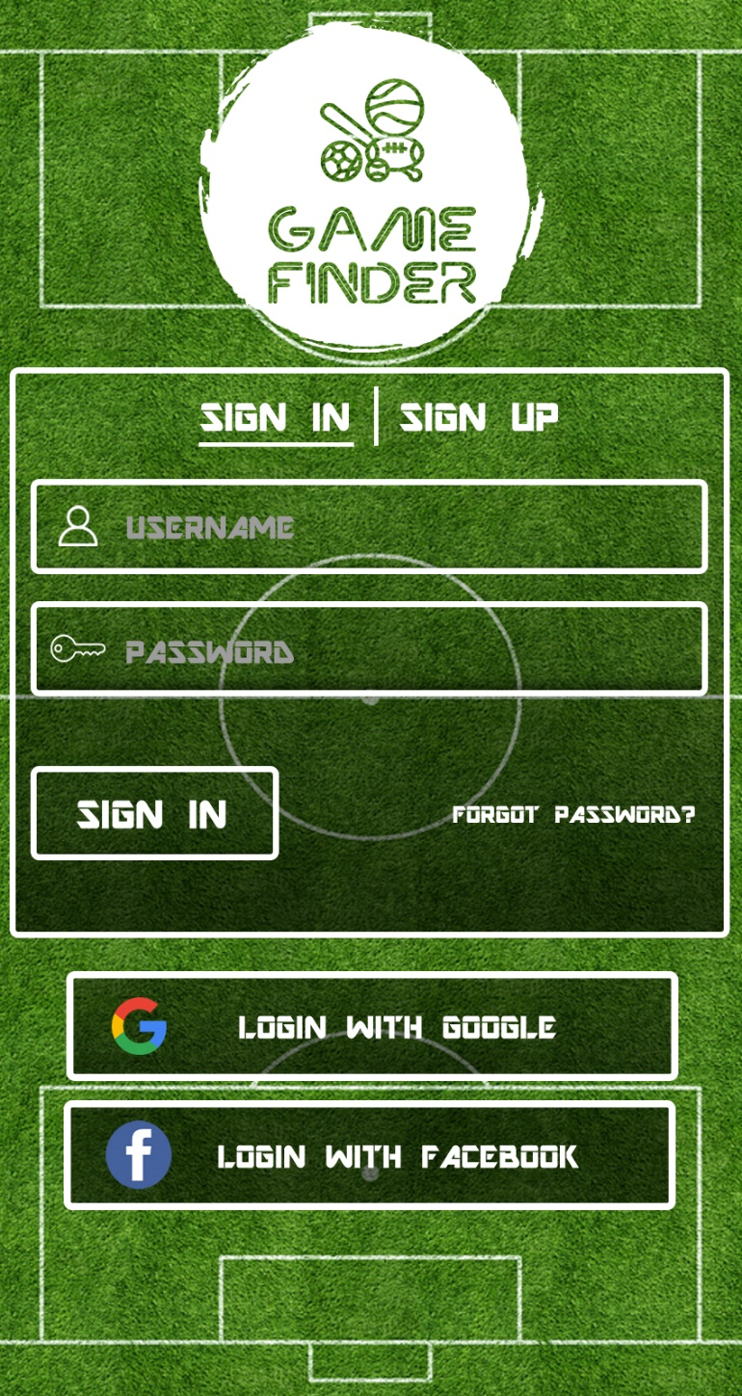

**Login Page**

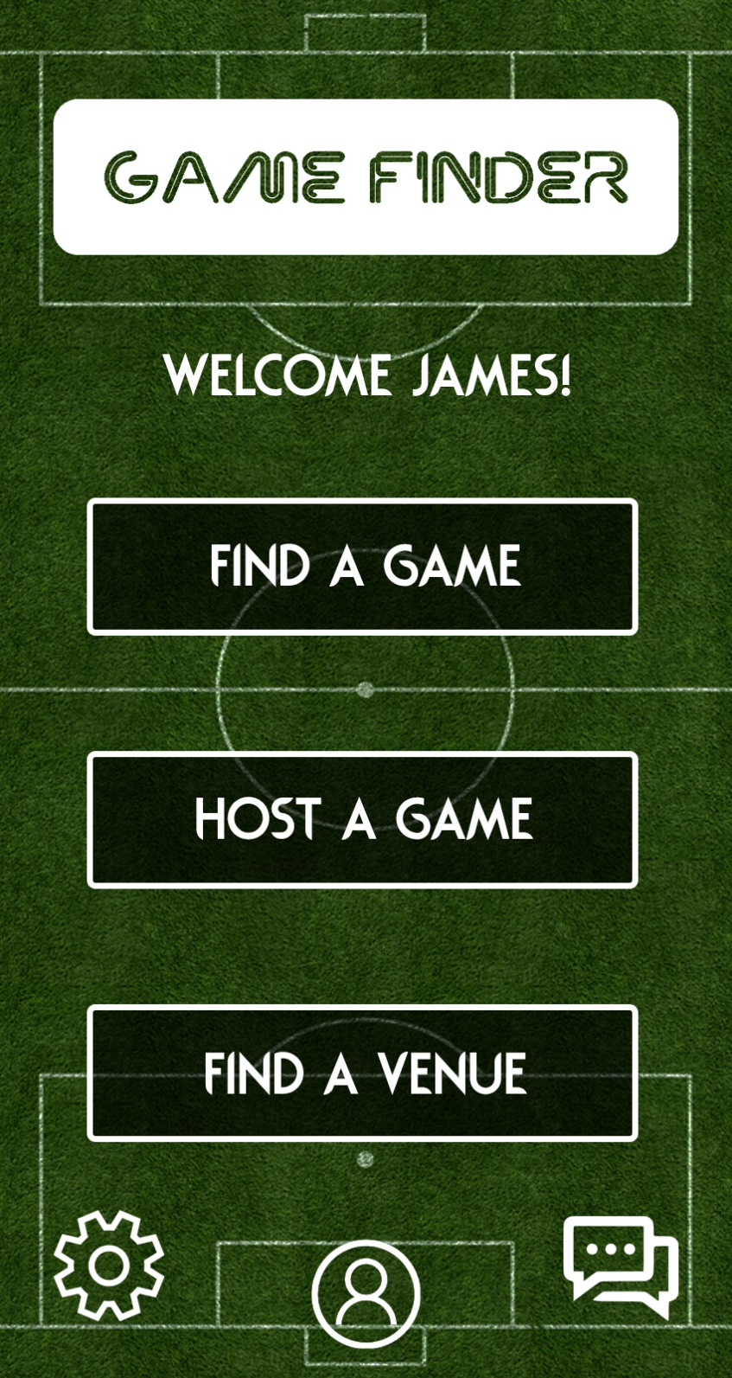

**Main Page**

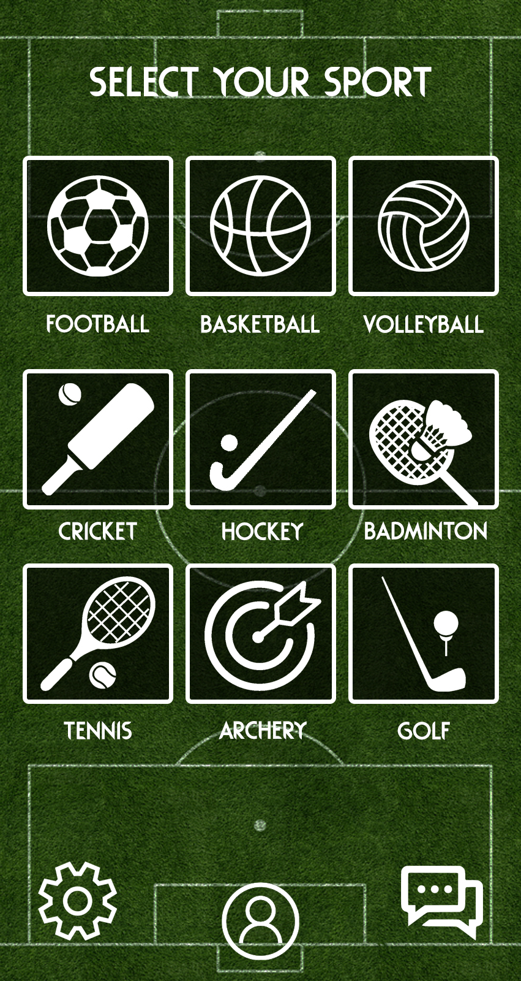

**Sport Selection Page**

**Project development and release ICT infrastructure**

Development Environment**: Android Studio**

Programming Language**: Java**

Source Code Repository: **Git Bash**

Version Control: **GitHub**

Project collaboration tool: **Not Required**

**Prototypes made with PhotoShop and Adobe XD uploaded to GitHub**