**ADVANCED INTERNET PROGRAMMING**

**Subject Code:22CAP653**

**Student Name: Abhay Bissa UID: 22MCC20086 Section/Group: MCD-2A Semester: 2nd**

**Date of Performance:03-March-2023**

**Experiment No. 2**

Create a serlvet that describes how to use the HttpSession object to find out the creation time and the last accessed time for a session. We would associate a new session with the request if one does not already exist

1. **Aim/Overview of the practical:**

**Task to be done:**

**Experiment No. 2:**

1. **Code for experiment/practical:**

**import java.io.IOException;**

**import java.io.PrintWriter;**

**import java.util.*;**

**import javax.servlet.ServletException;**

**import javax.servlet.annotation.WebServlet;**

**import javax.servlet.http.HttpServlet;**

**import javax.servlet.http.HttpServletRequest;**

**import javax.servlet.http.HttpServletResponse;**

**import javax.servlet.http.HttpSession;**

**/\*\***

**\***

**\* @author Lenovo**

**\*/**

**@WebServlet(urlPatterns = {"/NewServlet1"})**

**public class NewServlet1 extends HttpServlet {**

**void processRequest(HttpServletRequest request, HttpServletResponse response)**

**throws ServletException, IOException {**

**response.setContentType("text/html;charset=UTF-8");**

**try (PrintWriter out = response.getWriter()) {**

**/* TODO output your page here. You may use following sample code. */**

**out.println("<!DOCTYPE html>");**

**out.println("<html>");**

**out.println("<head>");**

**out.println("<title>Servlet NewServlet1</title>");**

**out.println("</head>");**

**out.println("<body>");**

**HttpSession session = request.getSession(true);**

**String a = session.getId();**

**Date b = new Date(session.getCreationTime());**

**if (session.isNew()) {**

**out.println("<br>");**

**out.println("<center>");**

**out.println("Welcome new User!");**

**out.println("<table border=2px>");**

**out.println("<th>Session info</th>");**

**out.println("<th>Values</th>");**

**out.println("<td>");**

**out.println("</td>");**

**out.println("</tr>");**

**out.println("</tr>");**

**out.println("<td>");**

**out.println("session id:");**

**out.println("</td>");**

**out.println("<td>");**

**out.println(""+a);**

**out.println("</td>");**

**out.println("</tr>");**

**out.println("<tr>");**

**out.println("<td>");**

**out.print("last access time:");**

**out.println( "<td>");**

**out.print(new Date(session.getLastAccessedTime()));**

**out.println("</td>");**

**out.println("</tr>");**

**out.println("<tr>");**

**out.println("<td>");**

**out.println("date:");**

**out.println("</td>");**

**out.println("<td>");**

**out.println(b+"");**

**out.println("</td>");**

**out.println("</tr>");**

**out.println("</table>");**

**out.println("</center>");**

**}else**

**out.println("Welcome back!");**

**out.println("<h1>Servlet NewServlet1 at " + request.getContextPath() + "</h1>");**

**out.println("</body>");**

**out.println("</html>");**

**}**

**}**

1. **Result/Output/Writing Summary:**

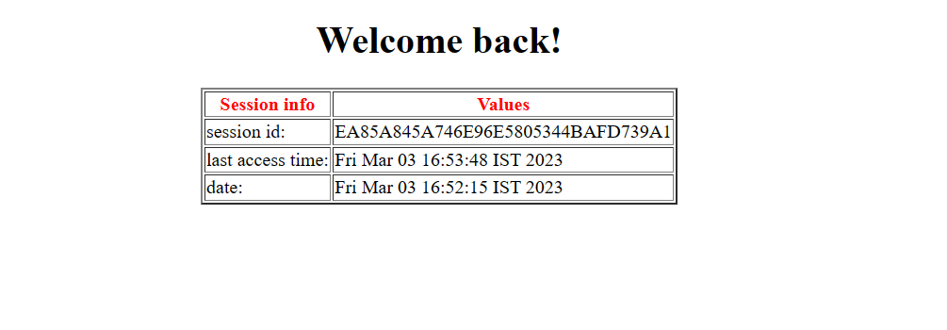

**Learning outcomes (What I have learnt):**

**1. How to create a session**

**2. How to get session details**

**Evaluation Grid:**

|  |  |  |  |
| --- | --- | --- | --- |
| Sr. No. | Parameters | Marks Obtained | Maximum Marks |
| 1. | Demonstration and Performance |  | 5 |
| 2. | Worksheet |  | 10 |
| 3. | Lab Quiz |  | 5 |