Windows Server

2012

Windows Server

2012

API Server

Database

Web Application

  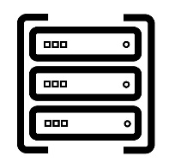 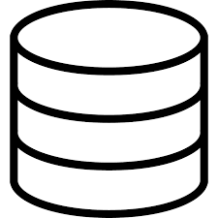

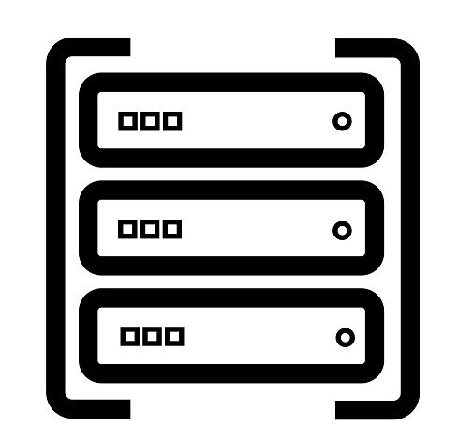

IIS Server (8.5)

IIS Server (8.5)

Application User

Application Server

Database Server

C#, Asp.Net Web API

Angular JS

SQL Server 2014 (SP3)