**DotNet Core API Calls:**

**GetLongestCrawlFilm**

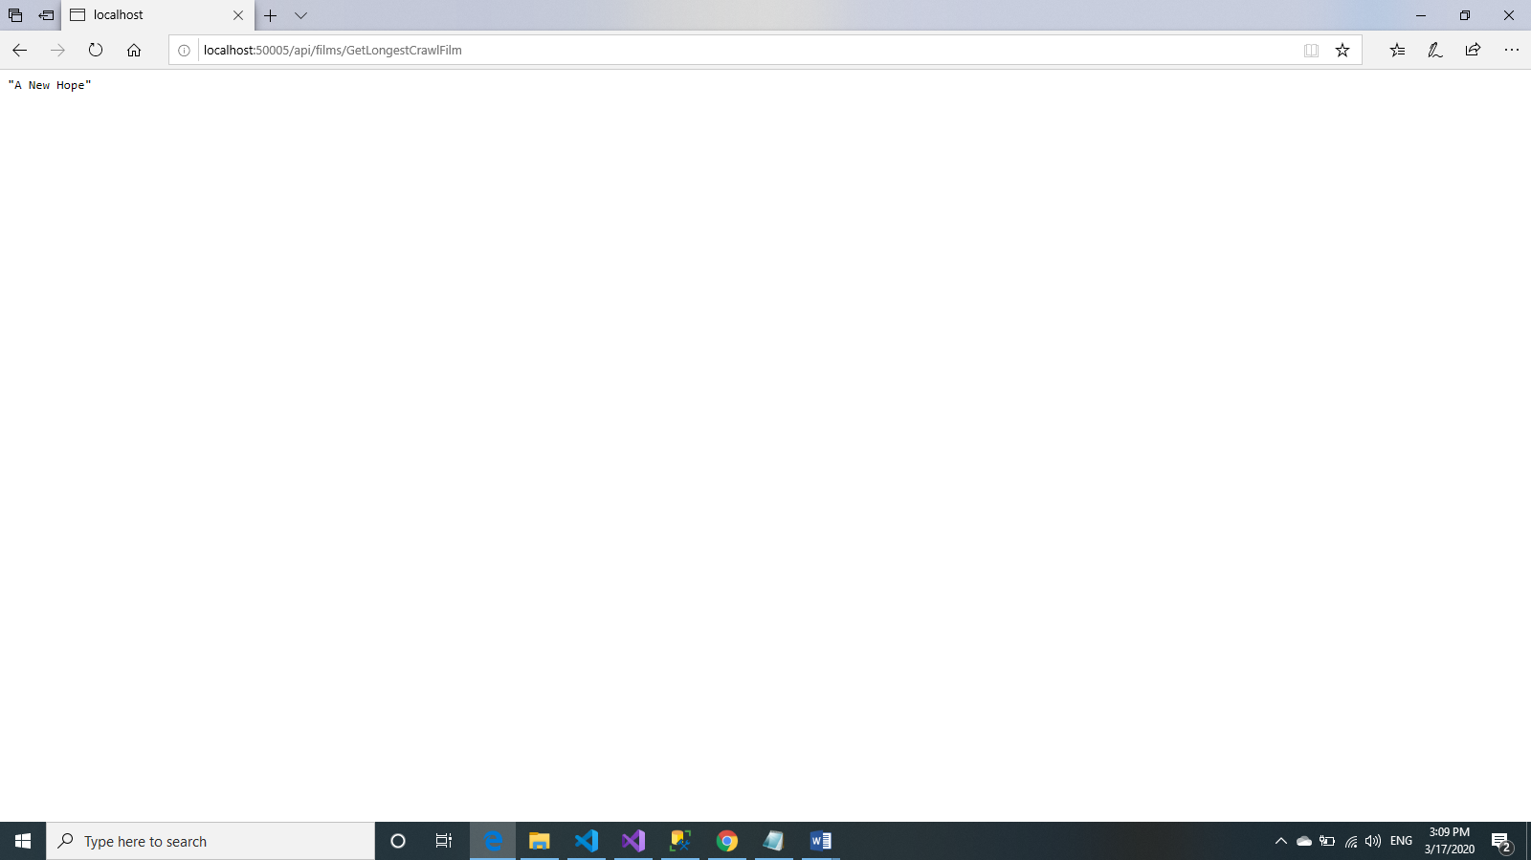

**GetMaximumCharacterAppearance (JSON Result)**

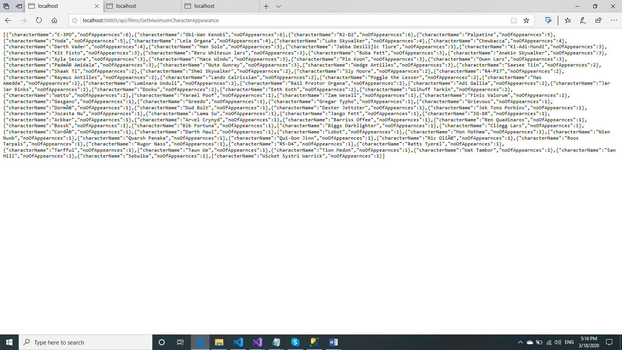

**GetSpeciesMaximumAppearance (JSON Result)**

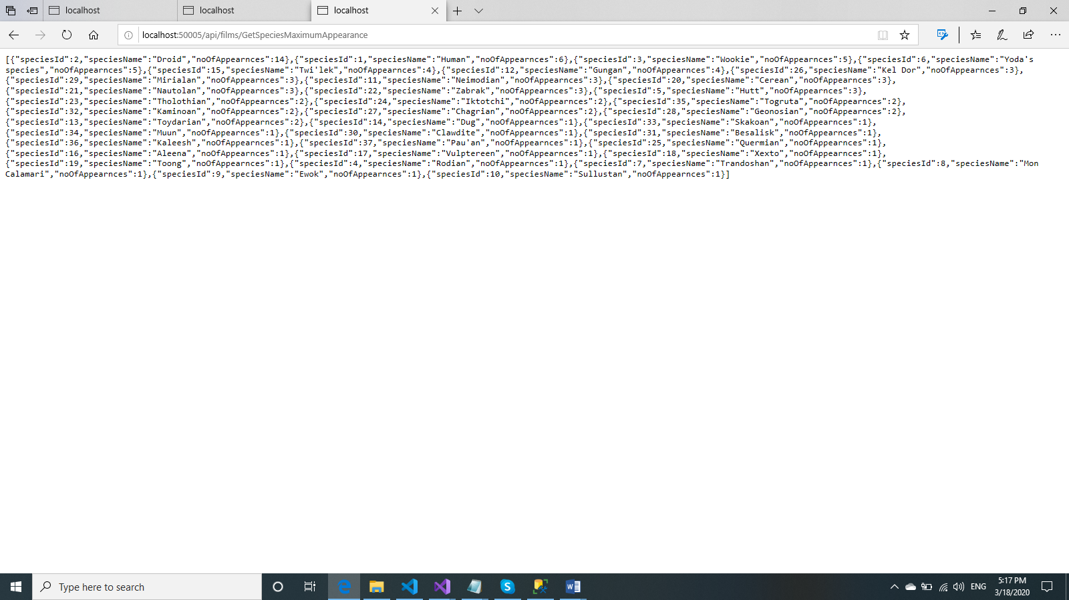

**GetMostPilotsPlanet (JSON Result)**



**ReactJS Components**

**GetLongestCrawlFilm**

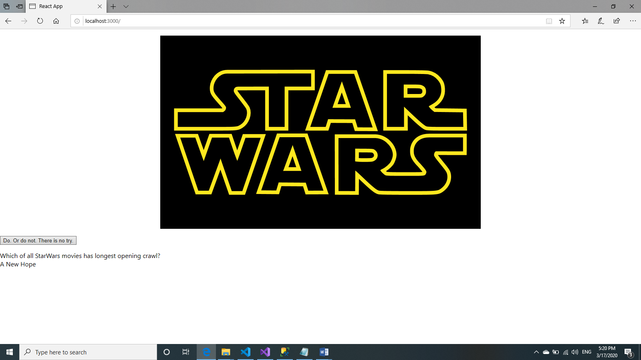

**GetMaximumCharacterAppearance**

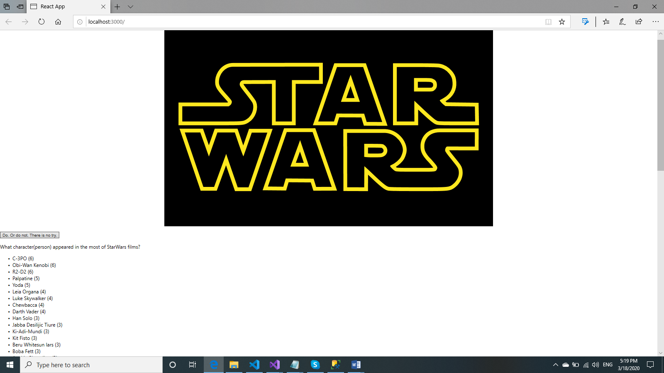

**GetSpeciesMaximumAppearance**

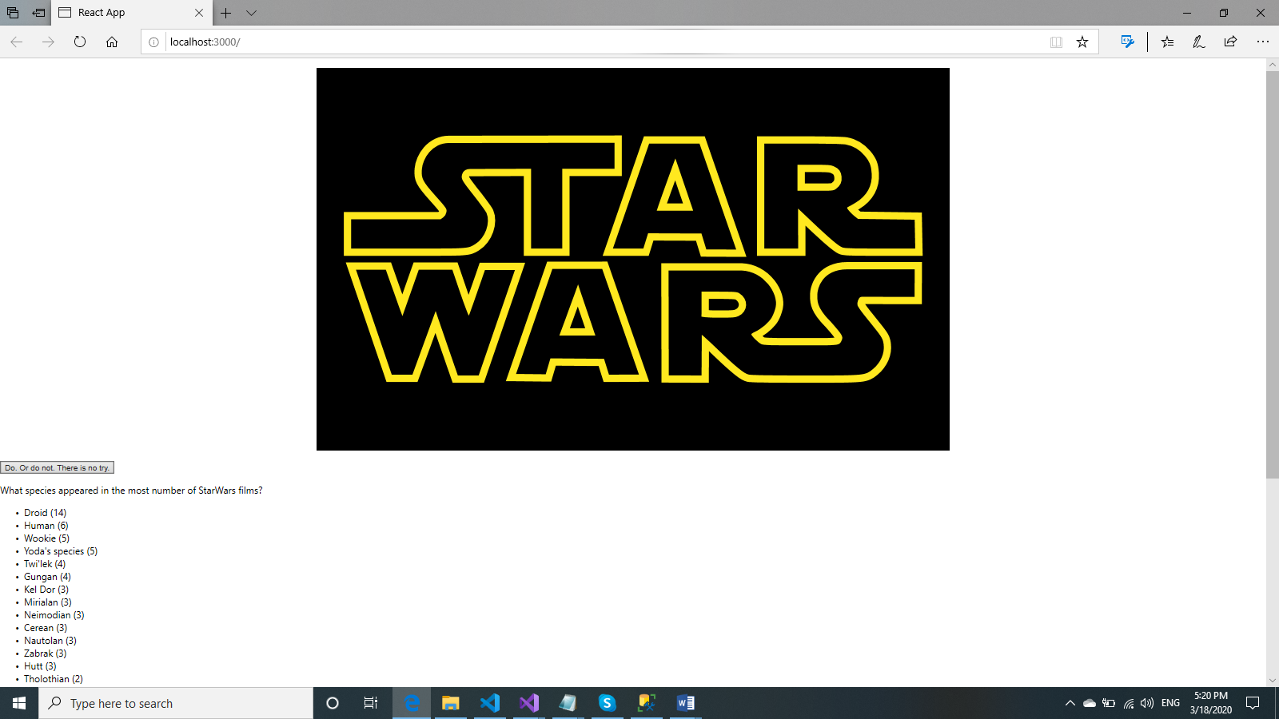

**GetMostPilotsPlanet**

