**TradeCraft – Entity – Relationship Diagram**

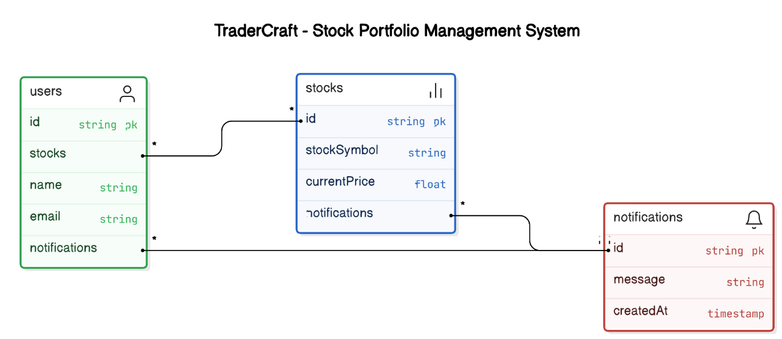

**DATABASE SCHEMA**

CREATE TABLE Stocks (

id VARCHAR PRIMARY KEY,

stockSymbol VARCHAR NOT NULL,

currentPrice FLOAT NOT NULL,

name VARCHAR NOT NULL

);

CREATE TABLE Users (

id VARCHAR PRIMARY KEY,

email VARCHAR NOT NULL

);

CREATE TABLE Notifications (

id VARCHAR PRIMARY KEY,

message VARCHAR NOT NULL,

createdAt TIMESTAMP NOT NULL

);

CREATE TABLE UserStocks (

userId VARCHAR NOT NULL,

stockId VARCHAR NOT NULL,

PRIMARY KEY (userId, stockId),

FOREIGN KEY (userId) REFERENCES Users(id),

FOREIGN KEY (stockId) REFERENCES Stocks(id)

);

CREATE TABLE UserNotifications (

userId VARCHAR NOT NULL,

notificationId VARCHAR NOT NULL,

PRIMARY KEY (userId, notificationId),

FOREIGN KEY (userId) REFERENCES Users(id),

FOREIGN KEY (notificationId) REFERENCES Notifications(id)

);

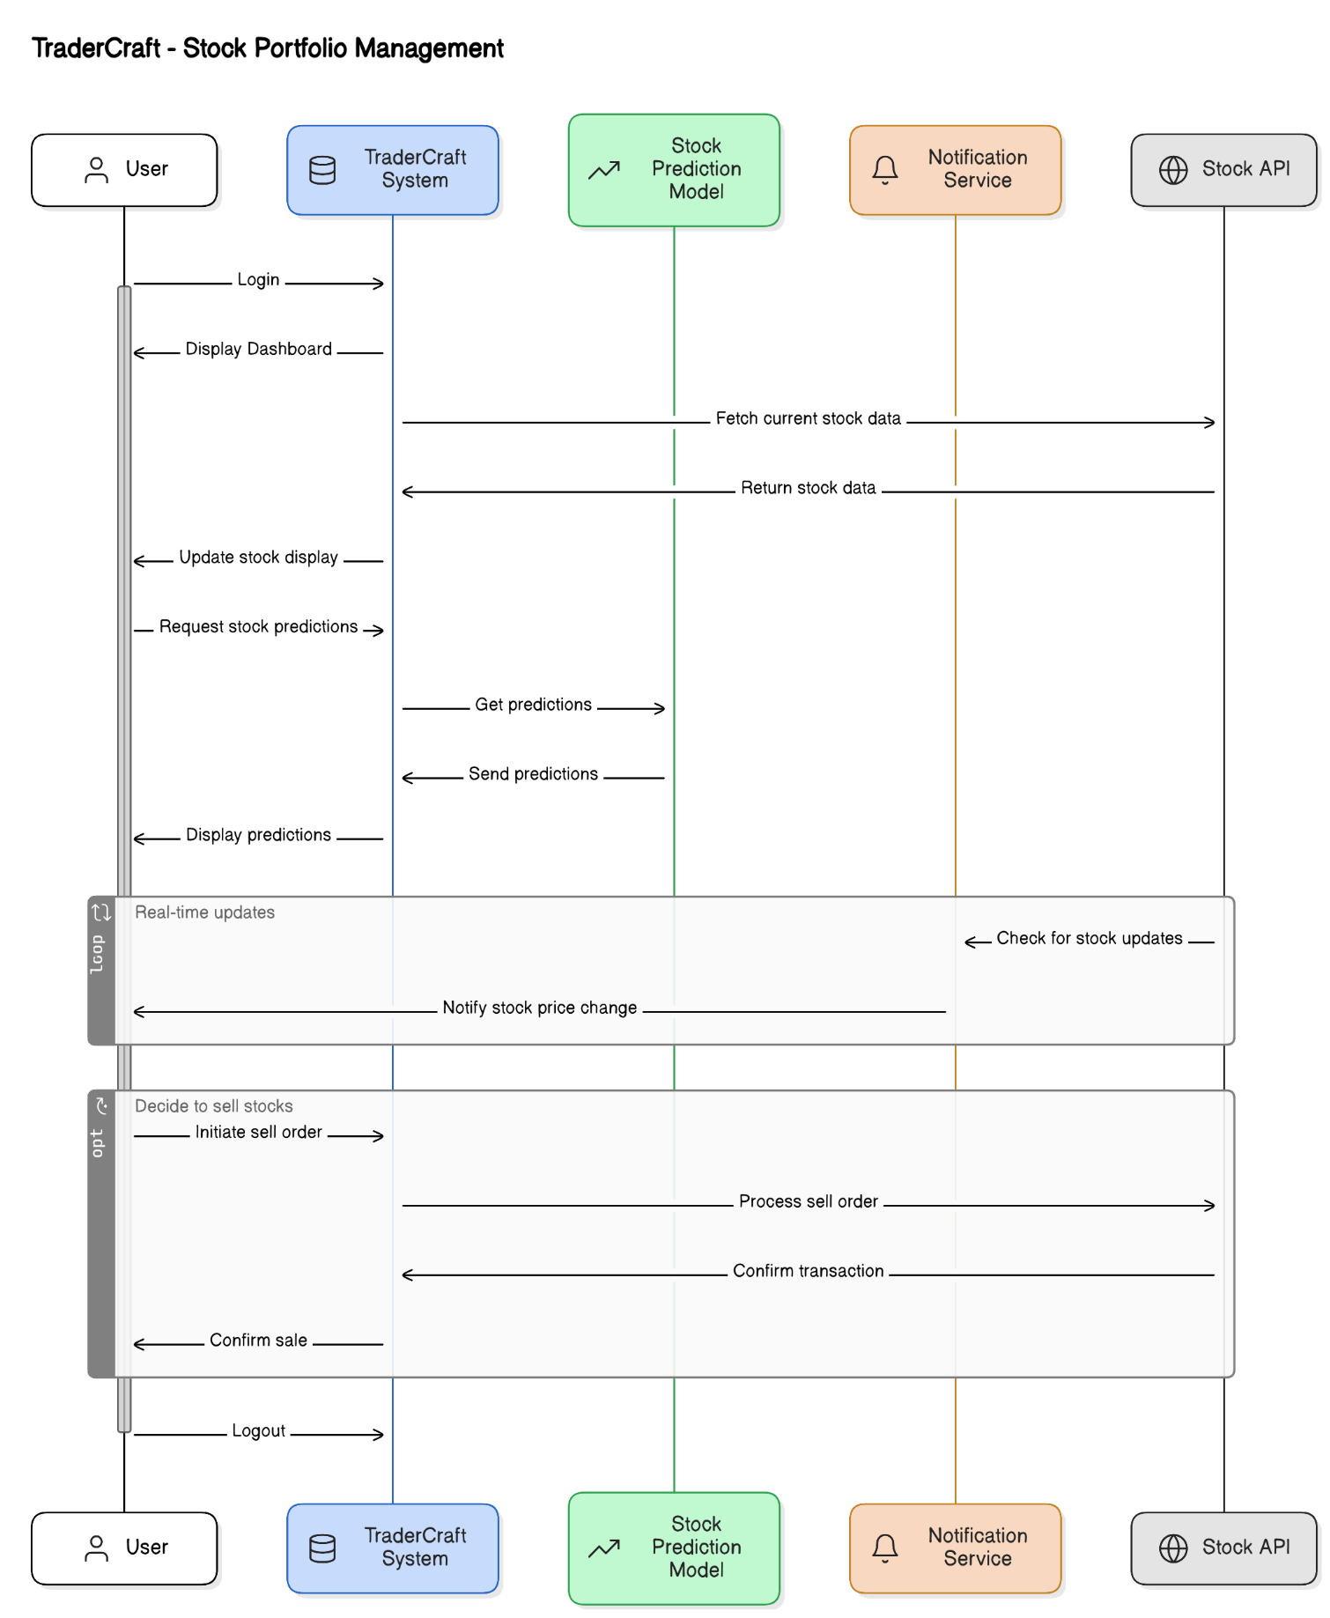**TradeCraft – Interaction ( Sequence) Diagram**

**TradeCraft – Control Flow Diagram**

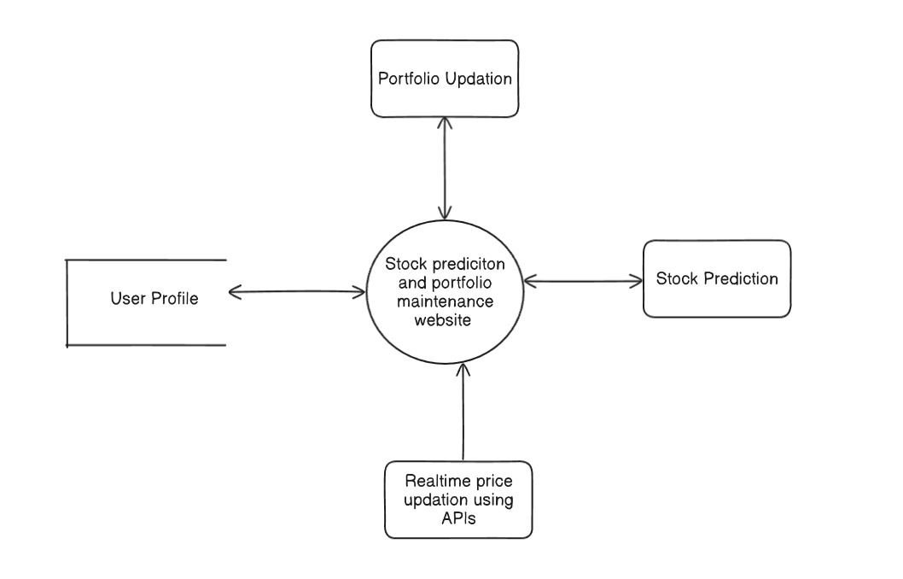

**TradeCraft – Cloud Architecture**

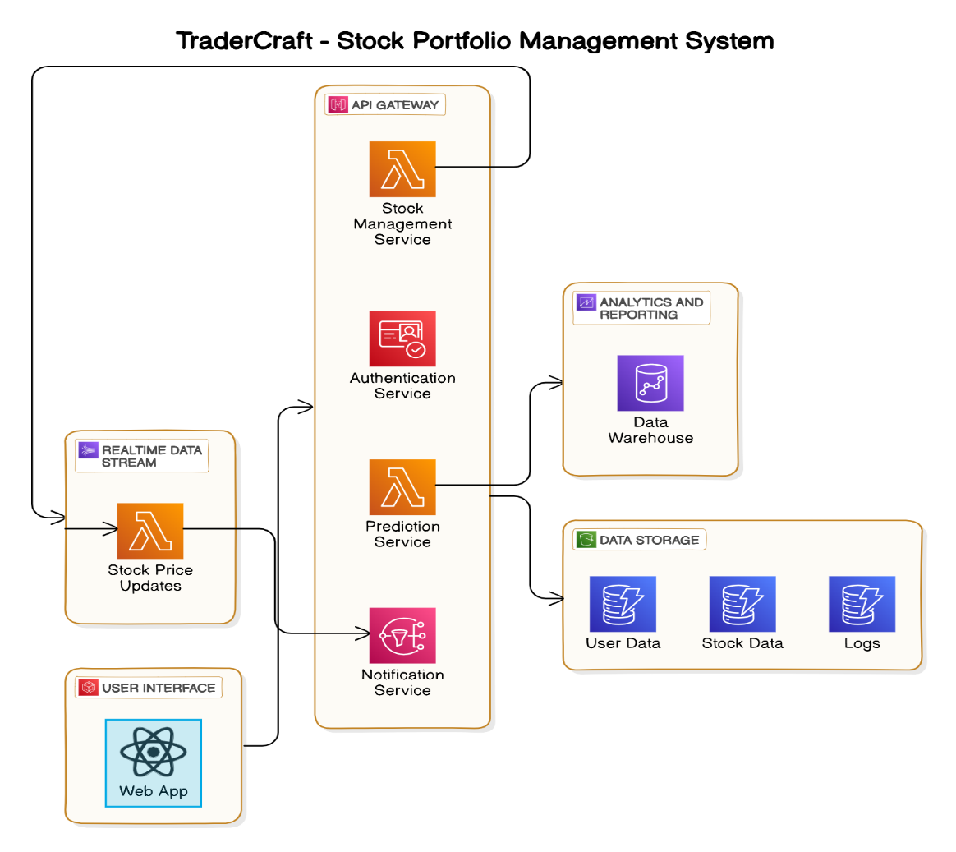

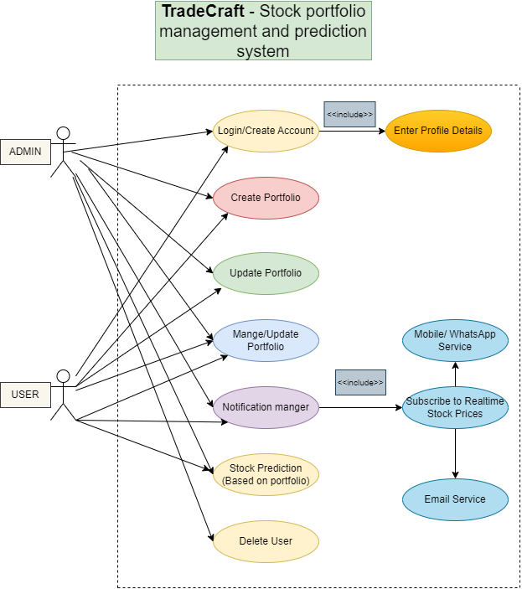**TradeCraft – Use Case Diagram**