**Abhay Doke**

**Intelligent Visual Computing**

**Assignment 4**

**1. Signed distance to tangent plane**

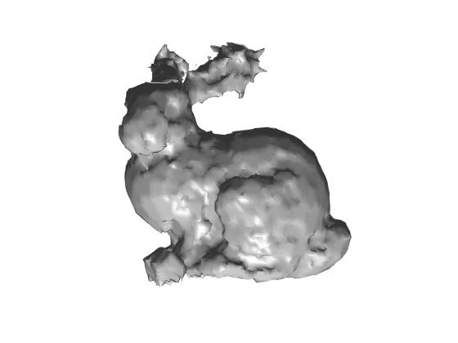

**Bunny_500**

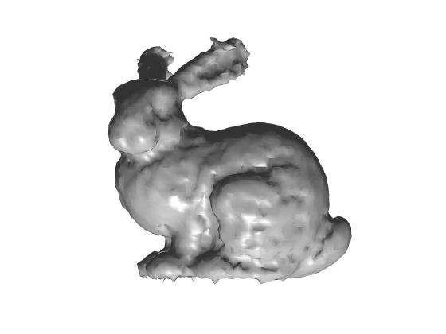

**Bunny_1000**

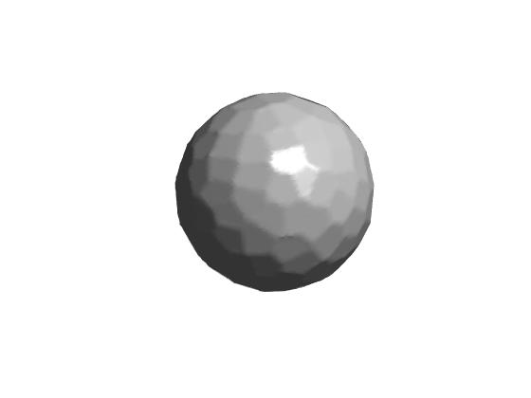

**Sphere**

**2. Moving least squares distance to tangent**

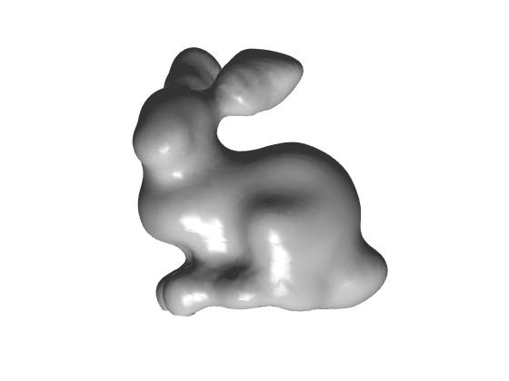

**Bunny_500**

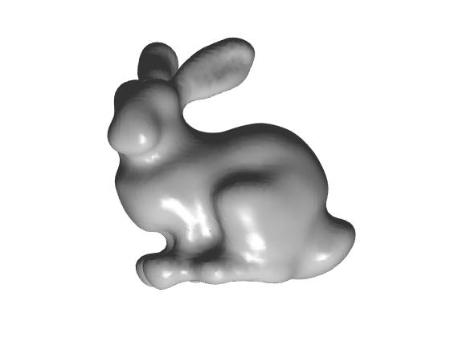

**Bunny_1000**

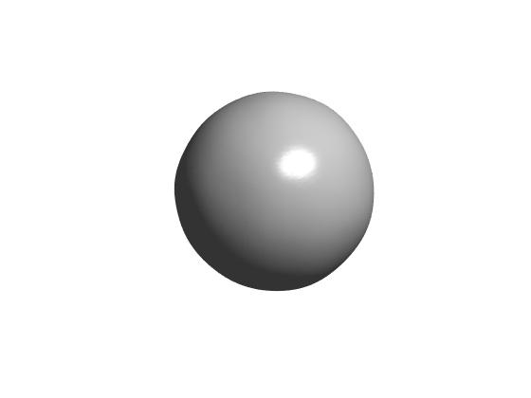

**Sphere**