**Abhay Doke**

**Intelligent Visual Computing**

**Assignment 6**

**1. Laplacian Smoothing**

1. **noisy_lowres_torus.obj**

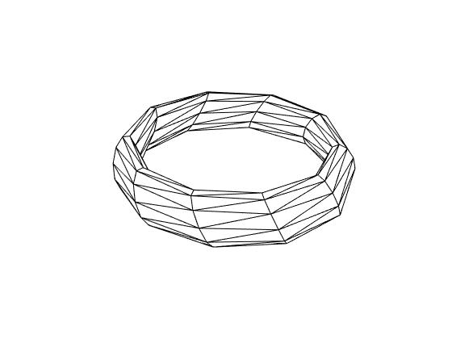

1. **noisy_torus.obj**

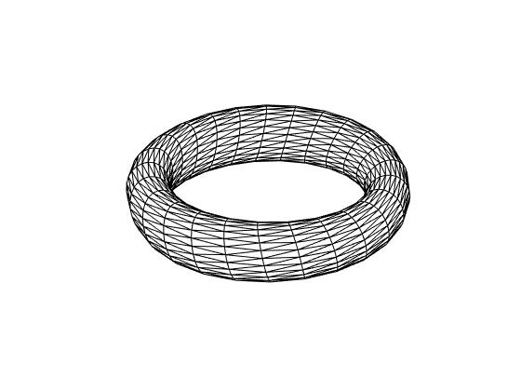

1. **noisy_cube.obj**

