MIS-6236-DATA MANAGEMENT



Eccel- A Telecom Company

May 03, 2014

**Project Report.**

**MIS-6326 Data Management**

**Prepared by**

**Group Members**

Rohith Raj

Colin Witkowski

Richard Clark

Abhay Joshi

Jiaying Zhu

Company Background: Colin Witkowski

Problem Description: Colin Witkowski

Overall Database Structure: Group

Access Implimentation: Richard Clark

Table Description : Colin Witkowski & Richard Clark

Entity Relationship Diagram: Richard Clark

Data and Information: Jiaying Zhu

Relations Database Schema: Rohith Raj & Abhay Joshi

Forms: Richard Clark

Reports: Abhay Joshi & Richard Clark

**Under the guidance of Professor**

Young U. Ryu

Associate Professor

Information Systems

University of Texas at Dallas

Table of Contents

Problem Statement 4

Organization Description 4

Company Employees 4

Company Services 4

Television 5

Phone 5

Internet 5

Scope of Database 6

Account 6

Customer 6

Employees 6

Sales 6

Service Type 6

Service 6

OrderLine 7

OrderHeader 7

Billing 7

Billing Details 7

Entity Relationship Diagram 8

Relational Model 9

SQL Commands 10

Data Input Screen: Forms 13

Sample Reports 19

Menu Screens: 26

# Problem Statement

Given the ever-changing dynamics of the Telecommunications market, ECCEL wants to keep their system up-to-date to better compete. The existing database used by ECCEL is capable of handling a significant volume of orders, but internal consistency and the ability to update customer information accurately to reflect new services being offered or changed has not been adequate. ECCEL needs a relational database that can accept new customers with differing services, provide accurate and up-to-date account status, and allow for internal consistency within ECCEL.

# Organization Description

ECCEL is a medium-sized telecommunications company with sizeable client base and an urban focus in North America. They utilize older cable networks, but have been implementing a newer fiber network with plans to roll-over all customers in the next four years. In addition, they are currently in the process of modifying their system to offer more business services, but want to first implement a more stable relational database to service their residential clients. Their offerings include television, phones, and internet.

# Company Employees

ECCEL maintains three key centers to service their customers in Toronto, Houston, and Portland. Each center employees roughly 200 full-time staff, but also employees a wide variety of contract labor to service technical and customer service needs. Their primary support center is contracted out to a call-center in New Jersey that regularly access their system. In addition, storefronts are franchised out. Currently, there are nearly 400 storefronts in North America. This does not include services offered by larger retailers carrying ECCEL products offerings.

# 

# Company Services

Following the new fiber network release, the company currently has several offerings that are largely restricted to individuals and small businesses in scope. These include television, phone, and internet offerings. Following a successful implementation of a new relational database, plans are being made to offer more diverse phone and internet offerings to better service individuals

## Television

Television packages offered through ECCELcurrently include four key offerings. The offerings include a “Basic” package that offers 200 basic channels for $25USD/month, “Sports” which offers the same 200 as the “Basic” package and 50 additional premium sport channels for $40USD/month, “Premium” which offers the same 200 as the “Basic” package and 100 premium channels for $45USD/month, and “Ultimate” which offers all of the channels included in all packages for a total of 350 channels with a price of $60USD/month. All of these offerings are monthly, with no fixed contract, although promotions are offered that reduce these prices accordingly based on the individual sales representative.

## Phone

Phone packages currently offered through ECCEL currently include three basic offerings. A single phone line with no answering machine is currently offered for $20.00USD/Month. A single phone line with an answering machine is offered for $30.00USD/month. Lastly, there is a two phone line with answering machine package that is offered for $40.00USD/month.All of these offerings are monthly, with no fixed contract, although promotions are offered that reduce these prices accordingly based on the individual sales representative.

## Internet

ECCEL currently offers four internet packages. The “Basic” package which averages speeds of 15mbps at a cost of $35.00USD/month, the “Advanced” package which averages speeds of 25mbps at a cost of $50.00USD/month, the “Super” package which averages speeds of 35mbps at a cost of $60.00USD/month, and the “Ultimate” package which averages speeds of 50mbps at a cost of $75.00USD/month. All of these offerings are monthly, with no fixed contract, although promotions are offered that reduce these prices accordingly based on the individual sales representative.

# Scope of Database

## Account

The Account Table is the qualifying table that allows customers to access their information at a later date and identify whether or not an account is active. Identified by the unique, assignedAccountNo, it has a many-to-one relationship with the Customer table that holds customer information. It has a user-generated PIN that verified the account given the AccountNo. It also has a one-to-many relationship with the Order Header table, which references the AccountNo. In addition, it has Boolean flag that can be triggered to note when the account is active or not.

## Customer

The Customer Table is used to hold customer information for references in the Account table, which it has a many-to-one relationship with. It is identified by the unique, assigned CustID. It holds the customer’s name, contact information, location, and whether or not the offering is commercial or not.

## Employees

The Employees Table is used to identify employee information for use when referencing the unique, assigned EmployeeID in the Sales table. This relationship is one-to-many to reflect the variety of sales that employees can be involved in. It holds employee’s names and department.

## Sales

The Sales Table is identified by the unique, assigned TransNo. It keeps track of the dates of sales and runs it against the Employee database to identify the employee involved. It has a many-to-one relationship with this table. The Sales table also has a one-to-many relationship with the Order Header table using the TransNo. This is to clarify the individual order.

## Service Type

The Service Type Table is identified by the unique, assigned ServiceTypeID. It is used to track the different types of services offered. It has a one-to-many relationship with the Service table.

## Service

The Service Table is used to describe, identify, price, and activate various services offered by ECCEL. It is identified by the unique, assigned ServiceID. The Service table has a many-to-one relationship with the Service Type table and a one-to-many relationship with the OrderLine table.

## OrderLine

The OrderLine table is used identify pricing and quantity of services that are being purchased. It is identified by the unique, assigned OrderLineID and OrderID. It has a many-to-one to relationship with the OrderHeader table. It also has a one-to-many and many-to-many relationship with the BillingDetails table.

## OrderHeader

The OrderHeader table is an essential referential table that is used to compile service, account, sales, and billing information. It is identified by the unique, assigned OrderID. It also utilizes the unique AccountNo and TransNo, as well as noting the date of the transaction. It has a many-to-one relationship with the Account table, many-to-one relationship with the Sales table, one-to-many relationship with the Billing table, and a one-to-many relationship with the OrderLine table.

## Billing

The Billing Table is identified by the unique, assigned BillingNo. It is used to bill the customers based on their orders. It has many to one relationship with Orderheader. It has one -many relationship with Billing details table. It also describes the method of payment, details of the card used and due date of payment.

## Billing Details

Billing Details Table is identified by combination of identifiers BillingNo,OrderServiceID,OrderId. Billing details matches up information from Billing, Order, OrderLine tables to generate a bill to concerned customer based on their orders and services provided.

# Entity Relationship Diagram



# Relational Model

Customer(CustID,FirstName,Last Name , Street, City, State, Zip, Phone, Country, CommercialOption )

Account(AccountNo, CustID,PINNo,ExistBalance,AccountActiv)

Account.CustID referencesCustomer.CustID

Employee(EmployeeID, EmployeeName,EmployeeDept)

Sales(TransID, EmployeeID, TransDate)

Sales.EmployeeID references Employee.EmployeeID

OrderHeader(OrderID, AccountNo,OrderDate,TransID)

OrderHeader.AccountNo references Account.AccountNo

OrderHeader.TransID references Sales.TransID

OrderLine(OrderServiceID,OrderID, ServiceID, Unit Price, Total Price,Quantity)

OrderLine.OrderID references OrderHeader.OrderID

OrderLine.ServiceID references Service.ServiceID

ServiceType(ServiceTypeID, ServiceTypeDesc)

Service(ServiceID, ServiceTypeID, ServiceDesc, ServicePrice, ServiceActivity)

Service.ServiceTypeID referencesServiceType.ServiceTypeID

Billing(BillingNo,OrderID,CreditCardType,CreditCardNo,CreditCardExpDate,AmountDue,DueDate, ExistBalance)

Billing.OrderID referencesOrderHeader.OrderID

BillingDetails(BillingNo,OrderServiceID,OrderID)

BillingDetails.BillingNo referencesBilling.BillingNo

BillingDetails.OrderServiceID referencesOrderLine.OrderServiceID

BillingDetails.OrderID referencesOrderLine.OrderID

# SQL Commands

**CREATE TABLE Customer**

(CustID CHAR(10) NOT NULL,

FirstName VARCHAR(50) NOT NULL,

LastName VARCHAR(50) NOT NULL,

Street VARCHAR(25) NOT NULL,

City VARCHAR(50) NOT NULL,

State VARCHAR(2) NOT NULL,

Zip VARCHAR(10) NOT NULL,

Phone CHAR(15) NOT NULL,

PRIMARY KEY (CustID))

**CREATE TABLE Account**

(AccountNo CHAR(20) NOT NULL,

CustID CHAR(10) NOT NULL,

PINNO CHAR(10) NOT NULL,

ExistBalance CHAR(25) NULL,

AccountActiv VARCHAR(25) NOT NULL,

PRIMARY KEY (AccountNo)

FORIEGN KEY (CustID) references Customer)

**CREATE TABLE Employee**

(EmployeeID CHAR(10) NOT NULL,

EmployeeName VARCHAR(50) NOT NULL,

EmployeeDept VARCHAR(50) NOT NULL,

PRIMARY KEY (EmployeeID))

**CREATE TABLE Sales**

(TransID CHAR(10) NOT NULL,

EmployeeID CHAR(10) NOT NULL,

TransDate DATE NULL,

PRIMARY KEY (TransID)

FOREIGN KEY (EmployeeID) references Employee)

**CREATE TABLE OrderHeader**

(OrderID CHAR(20) NOT NULL,

AccountNo CHAR(20) NOT NULL,

OrderDate DATE NULL,

TransID CHAR(10) NOT NULL,

PRIMARY KEY (OrderID)

FOREIGN KEY (AccountNo) references Account

FOREIGN KEY (TransID) references Sales)

**CREATE TABLE ServiceType**

(ServiceTypeID CHAR(10) NOT NULL,

ServiceTypeDesc VARCHAR(50) NOT NULL,

PRIMARY KEY (ServiceTypeID))

**CREATE TABLE Service**

(ServiceID CHAR(10) NOT NULL,

ServiceTypeID VARCHAR(50) NOT NULL,

ServiceDesc VARCHAR(50) NOT NULL,

ServicePrice, CHAR(25) NOT NULL,

Service Activity VARCHAR(50) NOT NULL,

PRIMARY KEY (ServiceID)

FOREIGNKEY(ServiceTypeID) references ServiceType)

**CREATE TABLE OrderLine**

(OrderServiceID CHAR(10) NOT NULL,

OrderID CHAR(20) NOT NULL,

ServiceID CHAR(20) NOT NULL,

Unit Price CHAR(10) NOT NULL,

Quantity INTEGER NOT NULL DEFAULT 1,

Total CHAR(30) NOT NULL,

PRIMARY KEY (OrderServiceID)

FOREIGN KEY (OrderID) references OrderHeader

FOREIGN KEY (ServiceID) references Service)

**CREATE TABLE Billing**

(BillingNo CHAR(10) NOT NULL,

OrderID CHAR(20) NOT NULL,

CreditCardType VARCHAR(20)NOT NULL,

CreditCardNo CHAR(10) NOT NULL,

CreditCardExpDate DATE NULL,

Amountdue CHAR(25) NULL,

Duedate DATE NULL,

OrderTotal CHAR(25) NULL,

PRIMARY KEY (BillingNo)

FOREIGN KEY (OrderID) references OrderHeader)

**CREATE TABLE BillingDetails**

(BillingNo CHAR(10) NOT NULL,

OrderServiceID CHAR(10) NOT NULL,

OrderID CHAR(20) NOT NULL,

PRIMARY KEY (BillingNo) references Billing,

PRIMARY KEY (OrderServiceID) references OrderLine,

PRIMARY KEY (OrderID) references OrderHeader)

# Data Input Screen: Forms

1. Account Input Screen
2. Customer Information Screen
3. Employee Registration Screen
4. Order Input Screen
5. Sales Input Screen
6. Service Information Screen
7. Service Type Information Screen
8. Billing Information Screen

Account Input Screen:

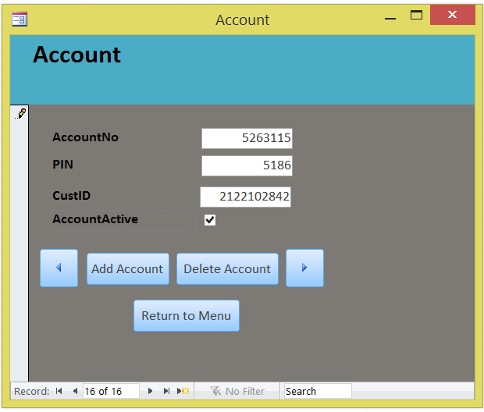

Customer Information Screen:

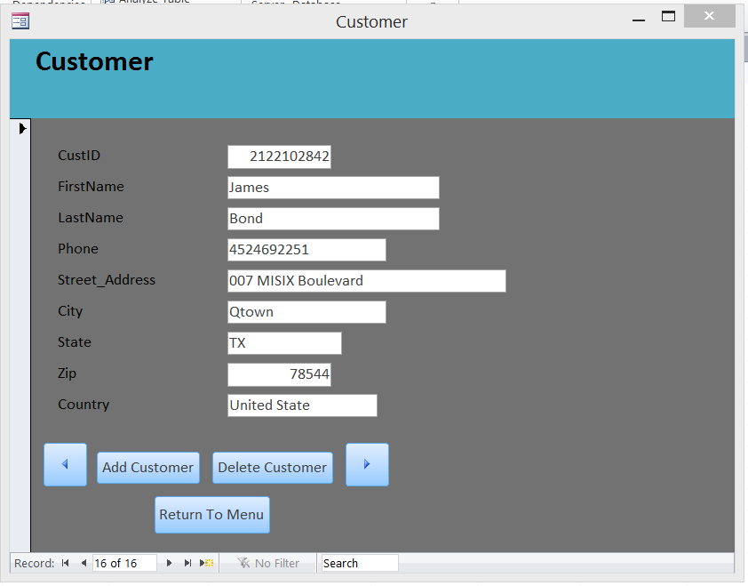

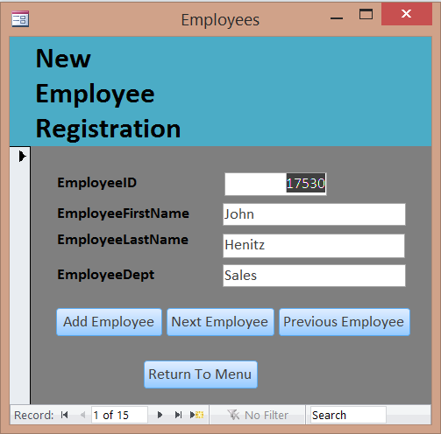Employee Registrations Screen:

Order Input Screen:

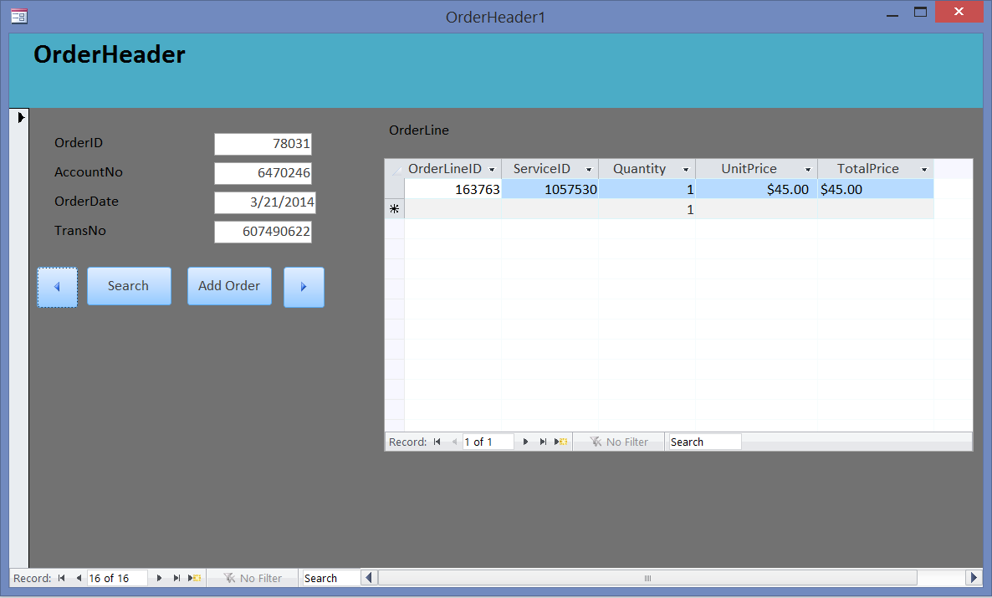

Sales Input Screen:

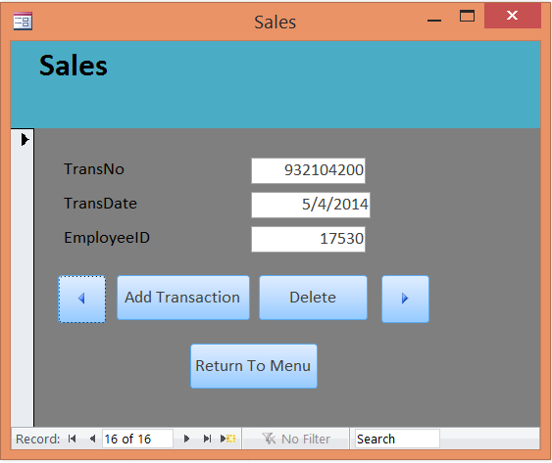

Service Information Screen:

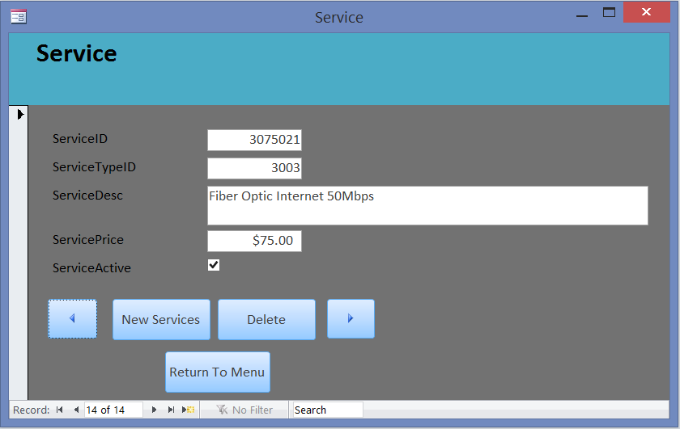

Service Type Information Screen:

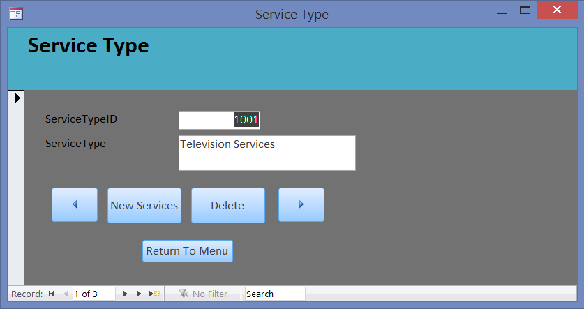

Billing Information Screen:

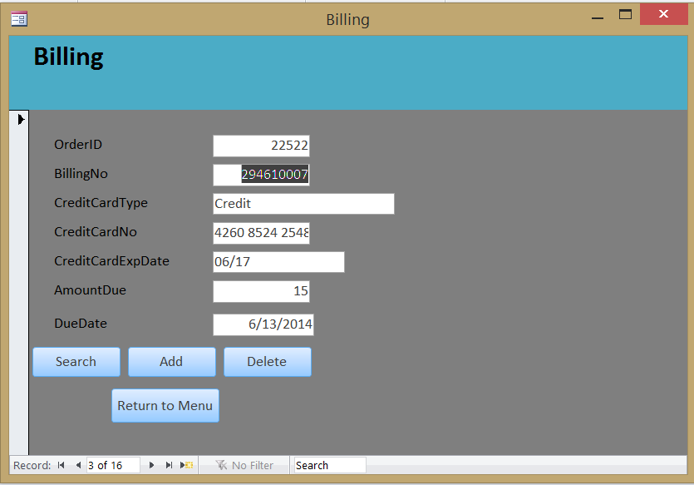

# Sample Reports

1. Customer Account Information Report
2. Billing By Account Report
3. Customer Information Report
4. Orders By Account Report
5. Sales by Employees Report
6. Services by ServiceID Report
7. Serivices by ServiceType Report

Customer Account Information Report:

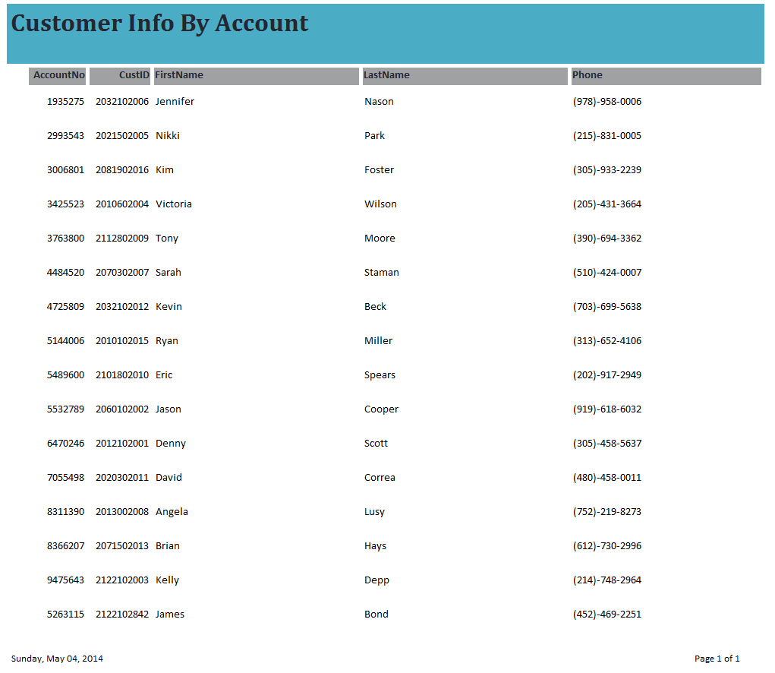

Billing By Account Report:

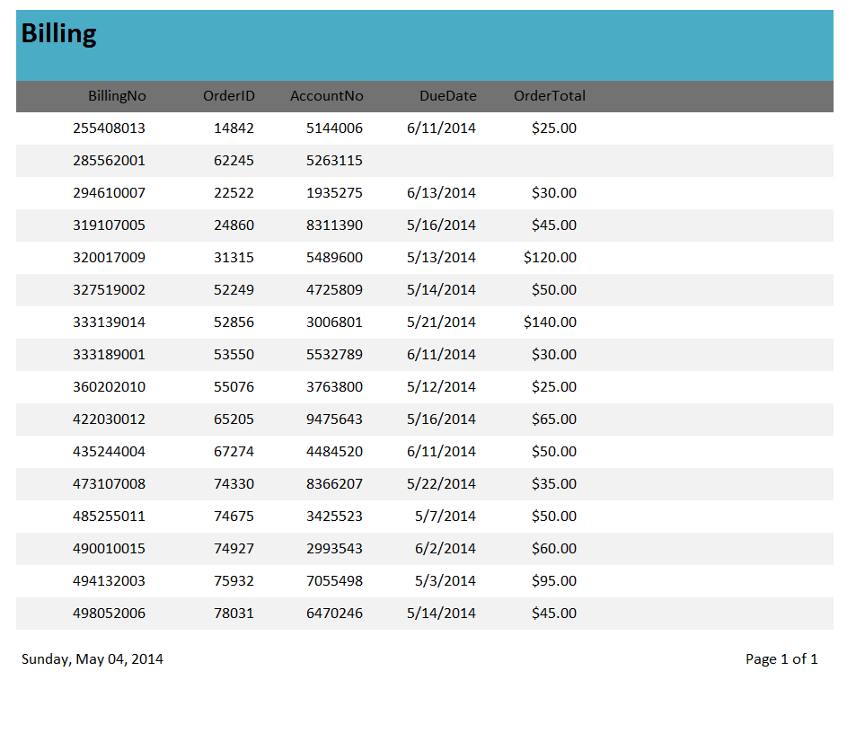

Customer Information Report:

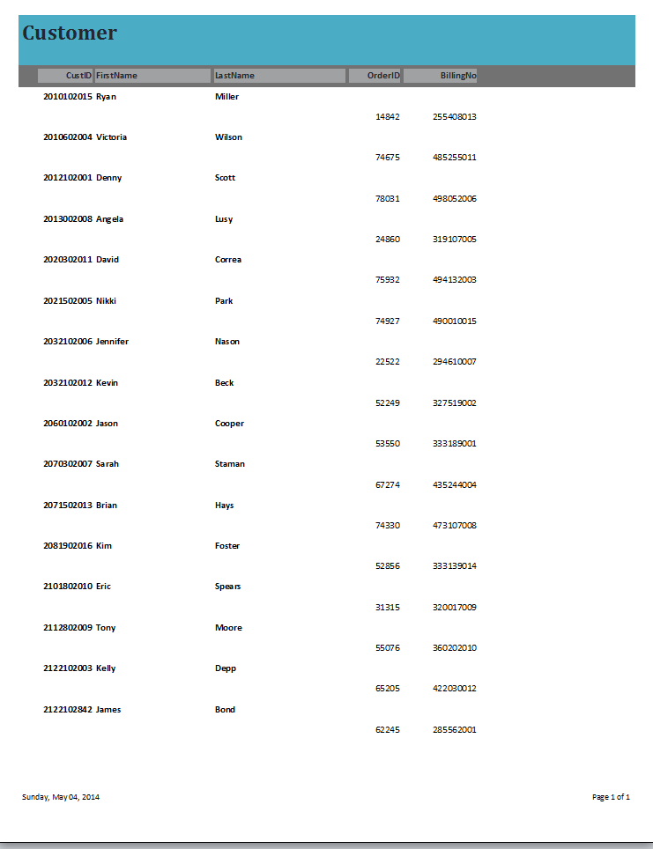

Orders By Account Report:

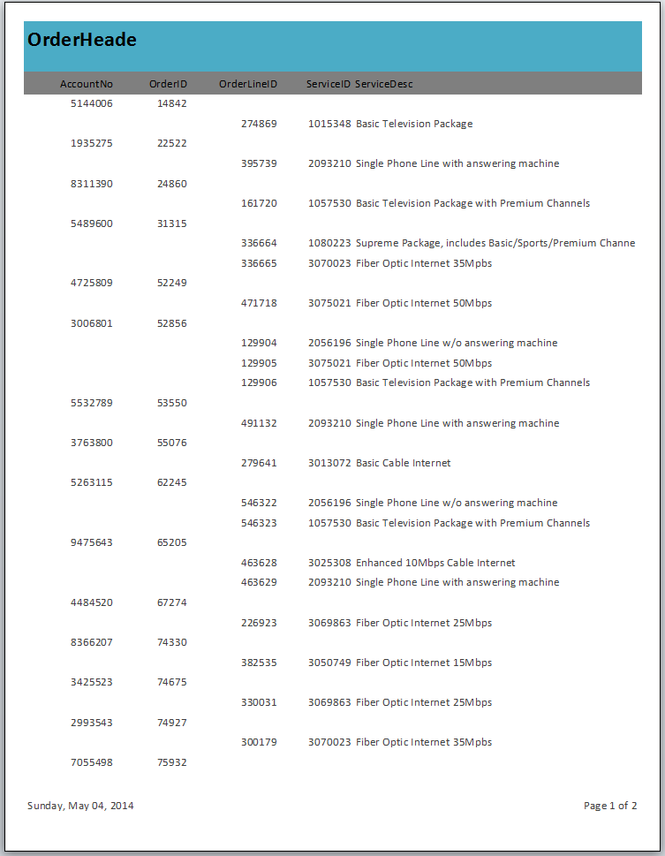

Sales By Employee Report:

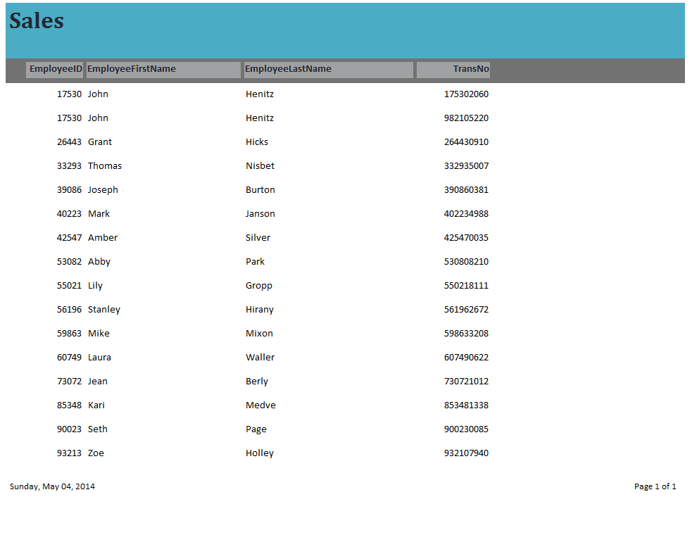

Services ByServiceID:

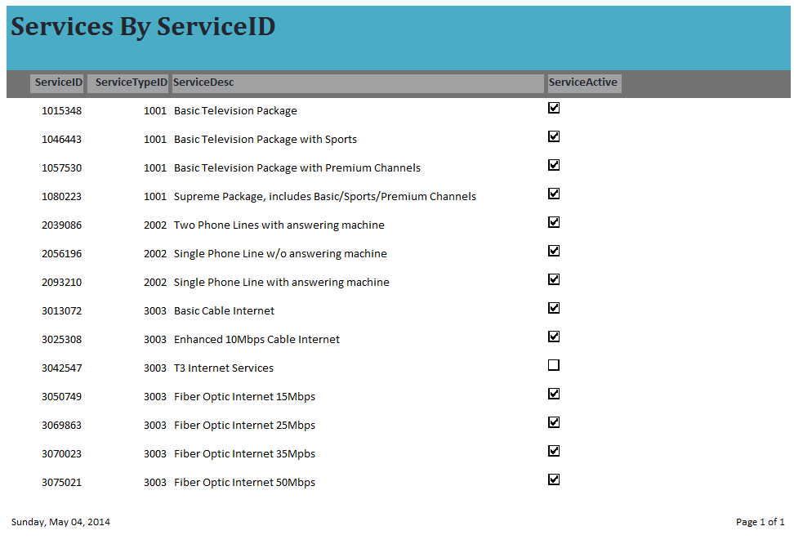

Services By Service Type:

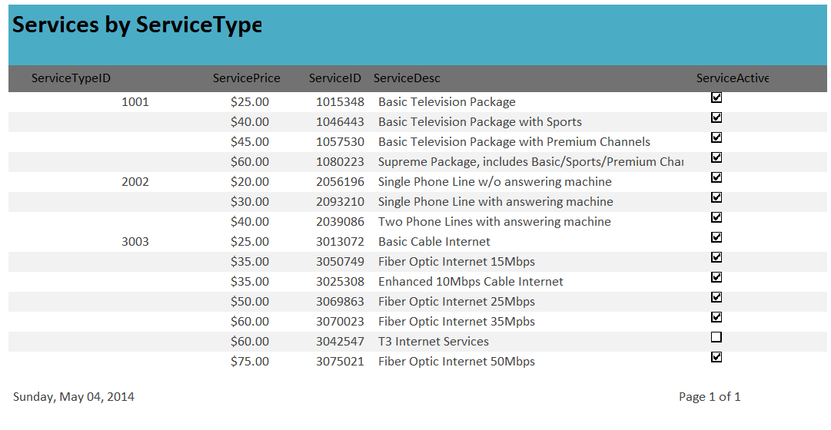

# Menu Screens:

1. ECCEL Main Menu Screen
2. Order Menu Screen
3. Service Menu Screen
4. Report Menu Screen

ECCEL Main Menu Screen:

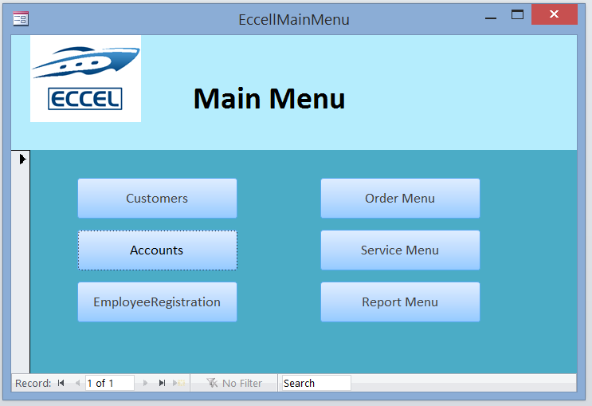

**Order Menu Screen**

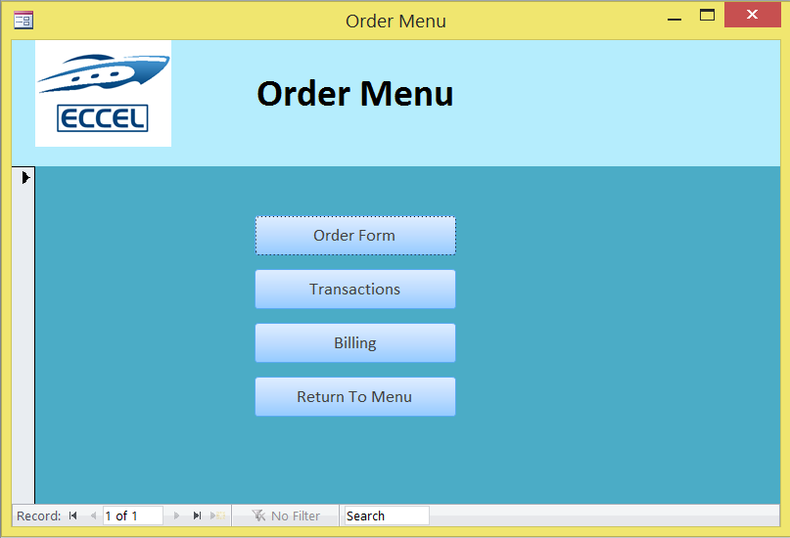

Service Menu Screen:

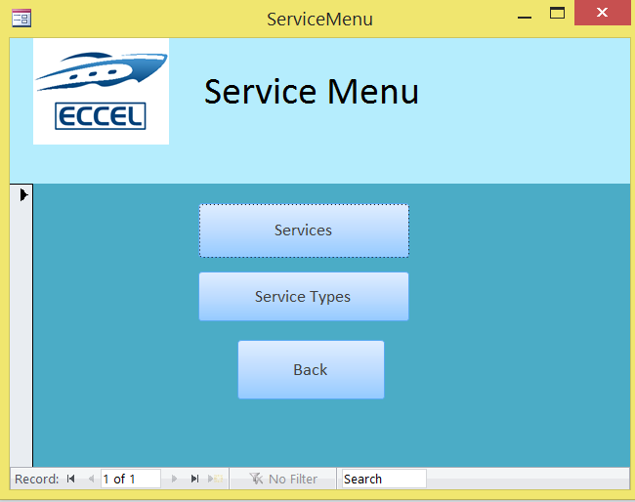

Report Menu Screen:

