For animation by css

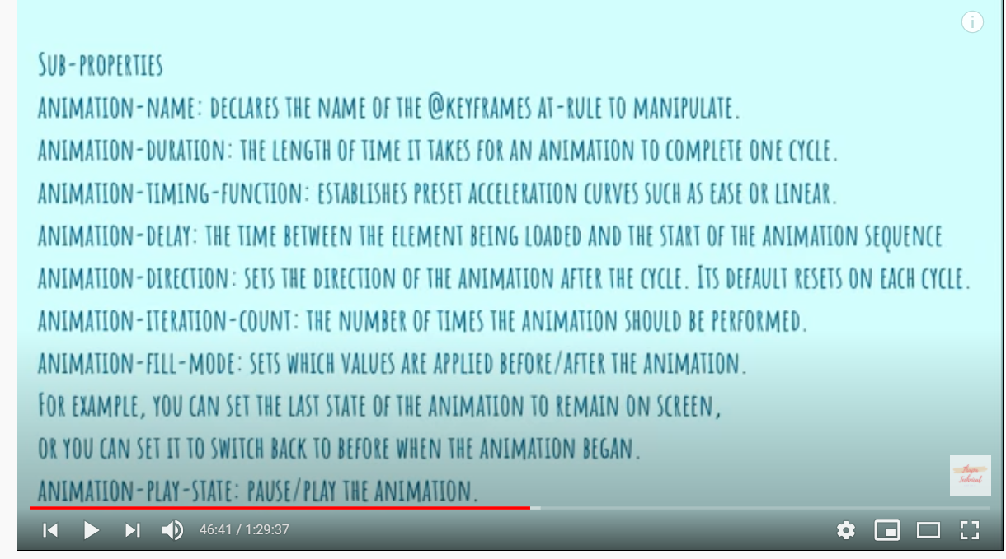

Don’t use predefined html tags for props, it will give a waring, alt tag must have different names, cannot use same name otherwise it will give a warning

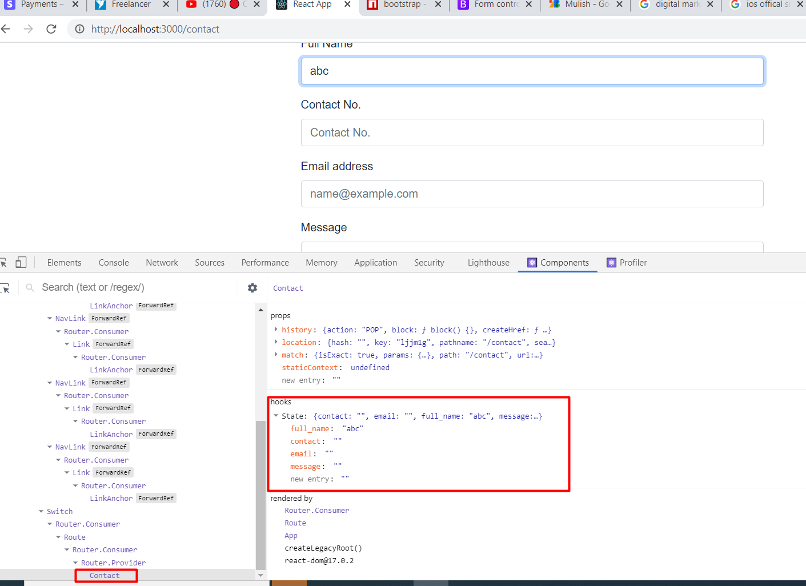

You have to create a separate new repository

Your github repository must be public

And your branch must be gh-pages. If it is master you can change it by going to code after clicking on your repository

<https://create-react-app.dev/docs/deployment/>

<https://www.youtube.com/watch?v=iyFjdmzcpws>

<https://abhaykartikey42050.github.io/reactlivewebsite> (if you click enter on the url after page load it will give 404 page not found)

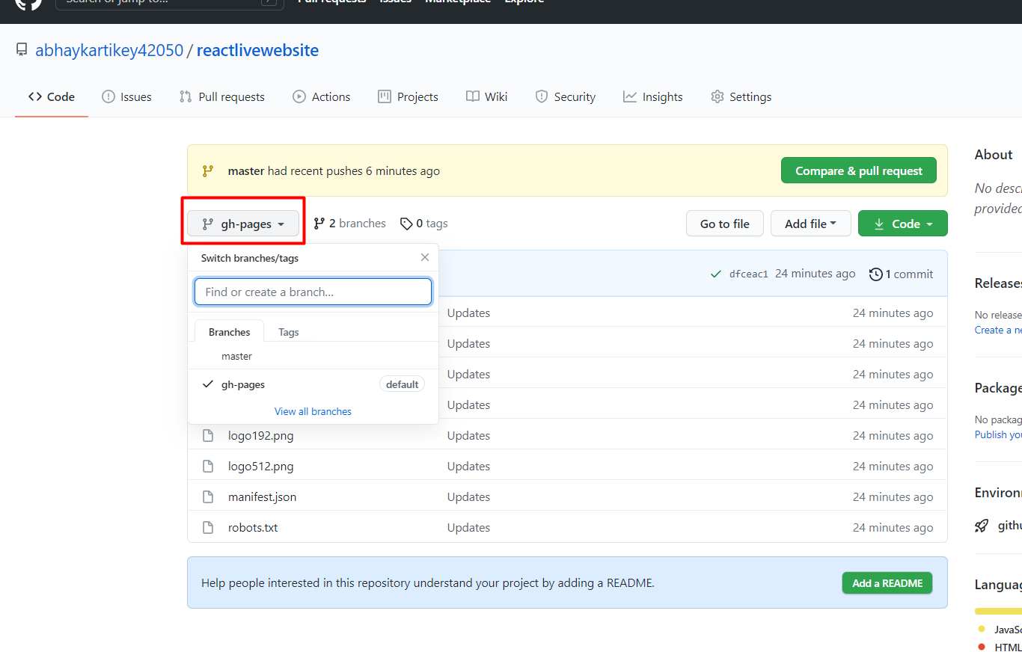

Pressed enter on this url and a 404 page came up (don’t press enter the url will be <https://abhaykartikey42050.github.io/reactlivewebsite>)

