**To Do Sample App**This is small sample application, which has single page UI. Frontend uses Angular $http inbuilt service to call REST APIs. REST APIs has been developed using Spring boot application.

This application run on 8080 port which is defined in application.properties file.  
  
# Run server on 8080 port

server.port=8080  
  
This application allows to create / delete and change the status of To Do list task/job. (I would love to personally use it in my laptop to maintain my daily job work for it’s simplicity. )

But for demo purpose I have created it using in memory database i.e H2.

# Enabling H2 Console

spring.h2.console.enabled=true  
  
Here is how the application looks like

User can mention the description and click on add button to add the task. Once done user can click on the added task rows anywhere to update the status of task. (It allows to click any number of times on job to mark it either complete or pending ). To delete the job user can simply click on the ‘X’ icon in the right side of job rows.   
  
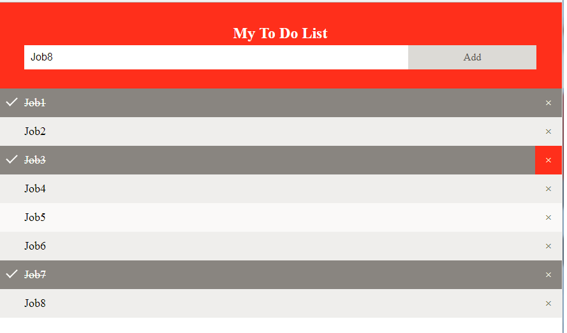

This data is saved in single JOB table as follows

