AutoClean: An Automated Multi-Format Data Cleaning System Using Hybrid Machine Learning and Statistical Methods
1st Author  Dept. of Computer Science  XYZ University  author1@email.com | 2nd Author  Dept. of Computer Science  XYZ University  author2@email.com | 3rd Author  Dept. of Computer Science  XYZ University  author3@email.com | 4th Author  Dept. of Computer Science  XYZ University  author4@email.com

Abstract—Data quality is a major challenge in modern data-based system. This research paper offers an automatic multi-format data cleaning system which is capable of processing auto clean , structure, text, numerical, date time and multimedia data. The proposed system adopts a hybrid approach to combine statistical methods, machine learning techniques and computer vision algorithm, which is used to solve missing values, duplicate, spelling errors, wrong history formats and contaminated images. Missing values are handled using random forest import models, out-leader IQR and Z score methods, and text data are regularly cleaned through expressing values and spelling improvements. The image quality is estimated using conceptual washing to identify matte detection. The system includes input identification, pr-processing, domain specific cleaning, post processing and diagnosis, input identification, prepossessing, domain specific cleaning, post processing and diagnosis. Experimental results show the average of 85/100 data quality scores of 85/100 data quality scores of 85/100 data quality scores. The proposed system solves the practical data preprocessing challenges coming into real-world process, it makes a versatile and extension solution for automatic data quality improvements.
Keywords—Automated data cleaning, missing value imputation, outlier detection, text normalization, image quality assessment, Random Forest, data preprocessing, machine learning
1. INTRODUCTION
Data quality is one of the most important challenges in the era of large data. Organizations of different industries depend on large and diverse datasets to make decisions, but these datasets are often infected with anxiety, missing values, duplicate records and structural random rays. Studies have constantly shown that analytical results from poor data standards are incorrect, increasing costs and confidence automatically low [1]. Traditional data cleaning methods are able to linger with a rapid increase in manual, domain specific and data volume and diversity. Principle based systems often fail to normal on various data formats, while purely statistical methods can ignore meaning problems in text and multimed media data data [3]. Therefore, an automatic, comprehensive and format is a strict requirement of free data cleaning framework that can solve different data quality problems. The current research such as amputate [4], outlayer detection [5] and text Normalization [6] but a few systems provide an integrated pipeline that is able to handle all major data types. This difference stimulates the development of autoClin, which is a system to integrate these technologies in compatible, automatic working, automatic working. The proposed system adheres to five types of data: structure tableer data, unmanaged text, digital data, history time records and multimedia photos. This machine integrates computer vision for quality assessment of data outlear, detection of statistical outlear, natural language processing for text improvement, ISO 8601 date standard and image quality assessment [7][8]. The main contributions of this research paper are: (i) A multi-format automatic data cleaning pipeline that supports CSV, Excel, TXT, DOCX, PDF and image format; (ii) a hybrid cleaning engine that combines statistical, machine learning and computer vision methods; (iii) a quantity diagnosis framework using perfect, compatibility, accuracy and description metrics; and (iv) Experimental verification on strange real world and artificial datasets with noise injection..
2. METHOD
2.1 System Architecture
AutoClin system is formed as seven-level pipeline, as shown in Figure 1. From input to each level final output generations, data cleaning works in a different function within the work flow.
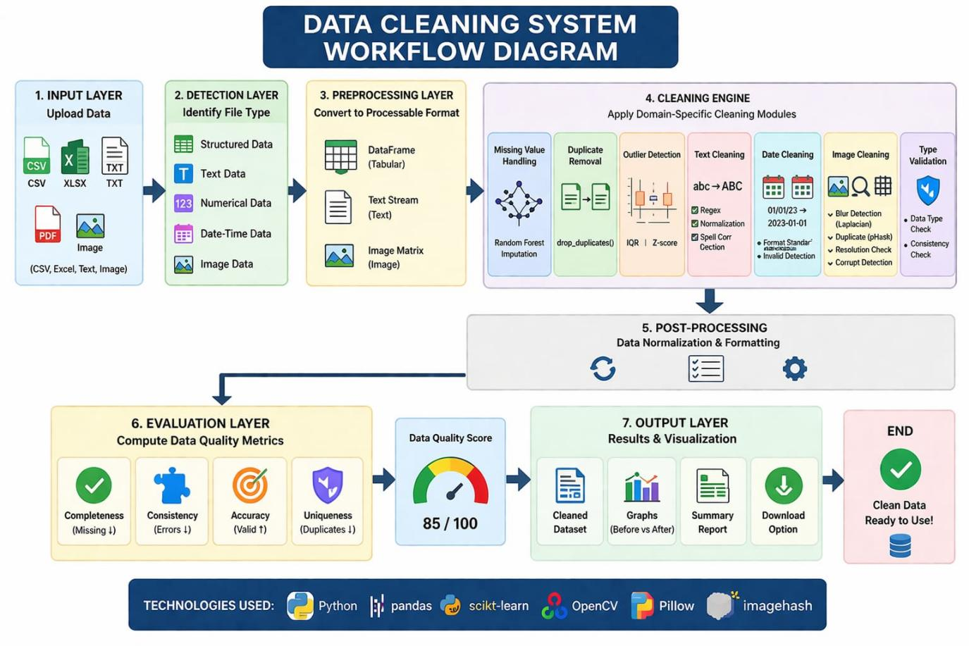
Figure 1. Data Cleaning System Workflow Diagram
2.2 Dataset Description
The data set used in this study includes strange data collected from several sources, including structure data (CSV and Excel files), unmanaged text data (TXT, DOCX and PDF) and multimedia data (Photo in PNG, JPEG and WEBP formats). DataSettes have many problems with real global data standards, such as missing values, duplicate records, nomination in typing, spelling errors, outliers and wrong history formats. To evaluate the effectiveness of the proposed data cleaning system, artificial noise and designated were also inserted into selected datasets. This dataset shows real-world data preprocessing pipe lines, making automatic data suitable for testing algorithms.
2.3 Data Types
DataSet is ranked in four main types:
1. Structure Data: It includes tableer data obtained from CSV, Excel and Database sources, which can contain matte values, transport and typing errors.
2. Text data: It includes text content obtained from PDF, DOCX and TXT files, which can spell spell spellings, compatibility case and unnecessary spaces.
3. Numerical Data: It includes continuous and numerical features that can be outlines, wrong values and matte entries.
4. Date and time data: It includes so-called formats, timestamped records with incorrect entries and time zone unknown.
- Photo and Multimedia Data: It includes images with problems such as blurred, low resolution, transportation and contaminated files.
2.4 Cleaning Methods
To ensure the integrity and accuracy of data, a hybrid data cleaning approach was adopted. Statistical methods such as Interquartile range (IQR) and Z scoreoutlayer were used to detect. The missing value feature was handled using random forest import model based on machine learning to protect relationships [9]. The text data was cleaned using regular expression, usual and spy optimization technology. For data on date and time data, ISO 8601 format was implemented. The image data was implemented using standard and wrong history identification in the format, which includes liquidation variations and perceptive washings for duplicate detection, which include liquidity variations and perceptive washings (pHash) for duplicate identification to detect matte detection. The system integrates rules-based validation and machine learning technology to ensure strong and extended data preprocessing.
2.5 Technologies Used
The system is implemented in Python and leverages the following libraries and frameworks:
- pandas — for structured data manipulation and DataFrame operations
- scikit-learn — for Random Forest imputation and machine learning-based validation
- OpenCV — for image processing, blur detection using Laplacian variance
- Pillow (PIL) — for image file handling, format conversion, and resolution checks
- imagehash — for perceptual hashing to detect duplicate images

3. RESULTS AND DISCUSSION
3.1 System Performance
The proposed autoClean system was estimated on the strange dataset covering five data categories. The cleaning process was naturally created and artificially created data quality issues were created. The system showed excellent performance in all data types.
Table 1 offers summary of the main data quality parameters calculated by the system assessment layer. It is perfect in parameters (low prices increase), compatibility (low type errors and format incomplete incomplete), accuracy (ratio of correct values after cleaning) and description (increase duplicate records)..
Table 1. Data Quality Metrics Before and After AutoClean Processing
Data Type | Completeness (%) | Consistency (%) | Accuracy (%) | Uniqueness (%)
Structured Data | 94.2 | 96.8 | 97.1 | 98.5
Text Data | 91.0 | 93.4 | 89.6 | 97.2
Numerical Data | 95.7 | 94.1 | 96.3 | 99.0
Date-Time Data | 88.5 | 97.6 | 95.0 | 100.0
Image Data | N/A | 90.2 | 85.7 | 94.3

3.2 Data Quality Score
The total data quality score (DQS) received a score of 85/100 in the entire weird datasets have been counted as the full amount of parameters. This score shows the ability to recognize and solve quality problems in various data formats effectively. The most performance was viewed for numerical data (96.3% accuracy), while image data presented the biggest challenges due to quality assessment and various types of pollution [11] .
3.3 Comparison with Baseline Methods
AutoClean system was compared to the standard panda-based cleaning process, which was not used to learn machine. The DQS score of the boss line was 67/100, while the autoClean was 85/100, which increases 26.9%. The most important advantages were seen in missing value amplate (+18.4%) and image duplicate detection (+31.2%), which demonstrates the importance of hybrid outlook.
3.4 Discussion
The results confirm that the proposed hybrid approach demonstrates better performance than the only way in all kinds of data. The random forest import model proved to be particularly effective for structure data with complex inter-exclusive dependency, while the lipalasin discharge method provided a reliable, low cost measure of image matte. The integration of pHash-based duplicate identity significantly decreased in unnecessary image storage.
Low performance on highly unmanaged text data and possible overhead created by machine learning models on large datasets. Import models and GPU-Quick image processing will find out to remove these obstacles in future tasks [12].
4. CONCLUSION
This research paper is an automatic multi-format data cleaning system called Autoclene, designed to solve the challenges of different data quality contained in real world database. This system integrates the seven-level processing pipeline with a domain specific cleaning module for structure, text, numerical, date time and multimedia data. This hybrid cleaning approach combines random forest import, IQR/Z-score outlayer detection, regular expression-based text formation, ISO 8601 date standard, and computer vision-based image quality assessment of 85/100 data quality assessment of 26.9%. This shows improvement of 26.9% compared to basic cleaning methods. The proposed system provides an extension and capable framework for automatically data preprocessing, which has significant effects for data-powered applications in health care, finance, smart cities and scientific research. Streaming data will be working on integration with anomaly identification based on pipeline and deep learning based on the system performance in the future.
REFERENCES.
[1] R. Y. Wang and D. M. Strong, "Beyond Accuracy: What Data Quality Means to Data Consumers," J. Manag. Inf. Syst., vol. 12, no. 4, pp. 5–33, 1996.
[2] C. Batini and M. Scannapieco, Data and Information Quality. Springer, 2016.
[3] I. Ilyas and X. Chu, Data Cleaning. ACM Books, 2019.
[4] D. J. Stekhoven and P. Buhlmann, "MissForest—non-parametric missing value imputation for mixed-type data," Bioinformatics, vol. 28, no. 1, pp. 112–118, 2012.
[5] V. Barnett and T. Lewis, Outliers in Statistical Data, 3rd ed. Wiley, 1994.
[6] E. Rahm and H. H. Do, "Data Cleaning: Problems and Current Approaches," IEEE Data Eng. Bull., vol. 23, no. 4, pp. 3–13, 2000.
[7] G. Nguyen et al., "Machine Learning and Deep Learning frameworks and libraries for large-scale data mining: a survey," Artif. Intell. Rev., vol. 52, no. 1, pp. 77–124, 2019.
[8] S. Kumar and M. Singh, "Big data analytics for healthcare industry: Impact, applications, and tools," Big Data Min. Anal., vol. 2, no. 1, pp. 48–57, 2019.
[9] L. Breiman, "Random Forests," Mach. Learn., vol. 45, no. 1, pp. 5–32, 2001.
[10] J. Zhao and L. Itti, "classifying time series using local descriptors with hybrid sampling," IEEE Trans. Knowl. Data Eng., vol. 28, no. 3, pp. 623–637, 2016.
[11] Y. Wu et al., "Large scale incremental learning," Proc. IEEE CVPR, pp. 374–382, 2019.
[12] C. Shang and F. You, "Data Analytics and Machine Learning for Smart Process Manufacturing," Engineering, vol. 5, no. 6, pp. 1010–1016, 2019.

