PROJECT REPORT OF CO-OP Project at Industry (Module-2)
ON
AI-Based Smart Loan Recovery Calling System
submitted in partial fulfilment of the requirements for the award of degree of

BACHELOR OF ENGINEERING
In
COMPUTER SCIENCE AND ENGINEERING

Submitted by: Supervised By:
Abhay Kumar Singh Dr. Swati Goel
2210991146 Chitkara University
Vipin Sharma
2210990965
Shivansh Setia
2210992327
MD Ahsan Iqbal
2210991911

DEPARTMENT OF COMPUTER SCIENCE AND ENGINEERING

AI-Based Smart Loan Recovery Calling System

Abstract
It is an established fact that the present-day financial services companies are confronted with an issue regarding their inability to recover their loans through the traditional methods of debt recovery. Statistics prove that through traditional loan recovery processes where humans act as the main agents to call up the borrowers, recovery rate remains around 20% or even less whereas the global market size for debt collection software is estimated at USD 4.92 Billion in 2023 and will exhibit a compounded annual growth rate of around 9.6% during the forecast period. In light of the above statistics, the present paper aims to propose and analyze an AI Based Smart Loan Recovery Calling System – which involves the use of various Artificial Intelligence techniques including NLP, ASR, Sentiment Analysis, Predictive Analytics, and Machine Learning to perform automated outbound calling operations in order to make loan recovery more effective and efficient in compliance with the guidelines prescribed by the Reserve Bank of India (RBI). According to RBI regulations, recovery agents can only call the customers between 8:00 AM and 7:00 PM and must not harass the borrowers as well as disclose pertinent information about the customers. The research paper discusses the architecture, approach, process pipeline, two case studies, data visualizations, problems, and future scope for the development of such a framework.

Keywords – Artificial Intelligence, AI Loan Recovery System, NLP, Machine Learning, Sentiment Analysis, Predictive Analytics, Voice Bot, Conversation AI, NBFC, RBI Compliant, Non-Performing Asset.

Introduction
  - Background: The Loan Recovery Crisis

In 2023, the worldwide market for debt recovery software reached USD 4.92 billion, with forecasts predicting USD 9.27 billion by 2030, reflecting a CAGR of 9.6% (Grand View Research, 2024). Human-led collections are time-consuming, unreliable, and progressively becoming more expensive and unethical. According to industry analysts, the success rate achieved through traditional collection procedures does not exceed 20%, resulting in failure rates of four out of five attempts, thereby impacting borrower relations (Nobel Biz, 2025). The following figure demonstrates the performance difference between traditional collections and AI-assisted collections.
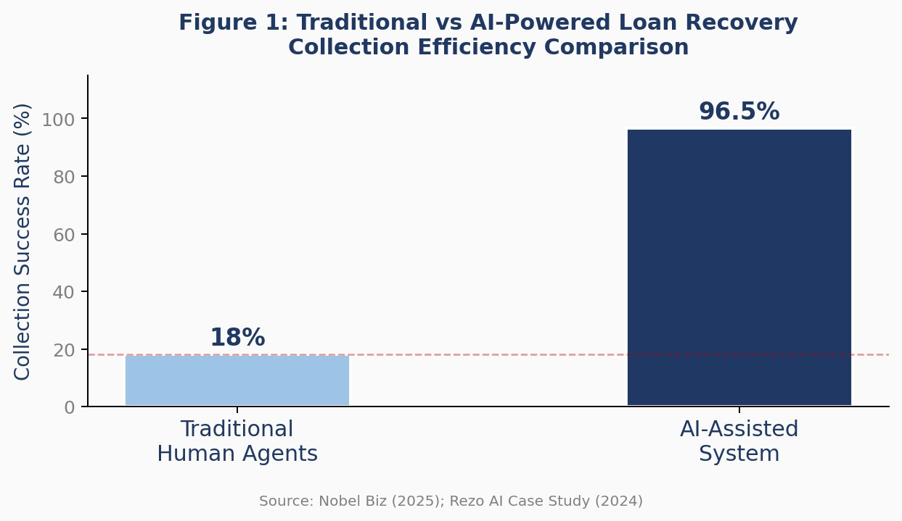
Figure 1: Comparison of Traditional vs AI-Powered Loan Recovery Collection Efficiency (Nobel Biz, 2025; Rezo AI, 2024)

The issue gets compounded in the case of India due to increased non-performing assets (NPAs). As per the definition provided by the Reserve Bank of India (RBI), any loan that is not repaid for over 90 days becomes an NPA. Further categorization of such non-performing assets is given in Table 1. It has been estimated through a survey conducted by an expert panel and referred to in MoneyView (2025) that almost 39% of borrowers in India have received harassing calls regarding loan recovery.
Table 1: NPA Classification and AI-Driven Recovery Strategy
Classification | Days Past Due (DPD) | Recovery Approach
Sub-Standard | 90 – 365 days overdue | Automated AI calling + personalised EMI restructuring offers
Doubtful | More than 12 months overdue | AI calling with human escalation for negotiation
Loss Assets | Written off / deemed uncollectible | Specialist human agents + legal department
  - The Shift to AI-Driven Recovery

The worldwide market for artificial intelligence in finance is expected to increase from USD 38.36 billion in 2024 to USD 190.33 billion in 2030, growing at a CAGR of 30.6% (MarketsandMarkets, 2024). The use of artificial intelligence-powered voicebots, conversational AI systems, and predictive analytics tools is revolutionizing the way financial organizations handle debt collection. In fact, the adoption rate of AI among debt collection agencies has increased rapidly, going from 11% in 2023 to 18% in 2024, with predictions surpassing 70% in late 2025 (Bridgeforce, 2024; Rezo AI, 2025). This trend is depicted in Figure 4 (Section VIII), while the most important return on investment indicators are highlighted in Figure 5.

  - Research Objectives

The objective of this study is to develop an integrated architecture for AI-Based Smart Loan Recovery Call System; explore the AI technologies driving this system; review the integration process in relation to LMS, CRM and Payments systems; understand the RBI regulations; conduct an in-depth study on the two cases of Rezo AI from India and Apifonica from Mexico; and propose future research avenues.
- Literature Review
  - Limitations of Traditional Loan Recovery

There is evidence that traditional methods of debt collection are inefficient. According to Chang (2019), machine learning can be applied to predicting repayment of loans, thereby laying the groundwork for a data-centric method. Blessie and Rekha (2019) showed that there is substantial predictive information in past repayments, which cannot be captured by a human-centric approach alone. According to a 2023 study by TransUnion, only 11% of third-party collections agencies were using AI or machine learning, even though most recognized its potential. This gap has been considerably reduced, as illustrated in Figure 4.

  - AI and NLP in Conversational Debt Collection

NLP-based voicebots can detect the intent of borrowers, regardless of how they communicate. ASR transforms spoken answers into text while TTS transforms text answers generated by AI technology back into audible responses. Nobel Biz (2025) states that voicebots powered by artificial intelligence are capable of responding to queries, unlike IVR technologies which do not change their response patterns. RTS Labs (2025) mentions that artificial intelligence assistants nowadays process as much as 80 percent of questions raised by debtors, leaving humans to manage negotiations only. According to Floatbot (2023), borrowers are more willing to interact with artificial intelligence rather than human operators since there is no chance of being embarrassed.
  - Predictive Analytics and Borrower Segmentation

The BBVA AI Factory (2025) gives an elaborate description of a supervised machine learning pipeline for early debt recovery based on sociodemographic features, financial behavior, and debt status indicators assessed with chronologically structured training-validation-testing data. Predictive analytics practitioners in the industry claim that their use leads to collection efficiency improvements by 30% and cost reductions by 40% (RTS Labs, 2025). In an example given by World Business Outlook (2025), a credit card company used predictive analytics that detected 35% of future defaulters weeks ahead of the first missed installment payment.
  - Sentiment Analysis and Empathetic AI

AI applications capable of analyzing call records, emails, and chat history are able to recognize intentions, sentiments, and signs of financial distress. Cognizant (2024) explains how LLMs allow banks to develop repayment programs based on unique personal circumstances, while real-time language processing produces conviction scores that work together with propensity-to-pay scoring. It is this ability to recognize signs of emotional distress without turning into a conflict situation that becomes a crucial part of how AI applications mitigate borrower complaints and enhance satisfaction scores, as seen in the Rezo AI example.

  - Regulatory Landscape

According to the RBI guidelines, the window for contacting borrowers is between 8:00 AM and 7:00 PM, and any call outside these hours will be considered harassment and penalized by the relevant regulatory body. Banks are required to disclose the names of all debt collectors, record all calls, and ensure that the collectors introduce themselves and the bank at the beginning of each call (Bajaj Finserv, 2025; RBI Guidelines, 2024). Refer to Table 3 in Section VI for the exact correlation of each RBI guideline to its AI solution.

- Proposed System Architecture
  - Overview

The suggested AI-Based Intelligent Loan Recovery Calling System is a multi-tier cloud-based framework which involves natural language processing (NLP), automatic speech recognition (ASR), text-to-speech (TTS), sentiment analysis, predictive analytics, and machine learning. Instead of automating the entire process of loan recovery calls, the AI system performs as an augmented layer in intelligence, where the automation of routine work takes place along with human intervention for complicated issues.

Table 2: AI System Technology Stack and Function Mapping
System Layer | Technology | Function in Loan Recovery
Conversational AI | NLP + ASR + TTS | Understand borrower speech, generate empathetic responses in real time
Predictive Analytics | XGBoost, LightGBM | Score repayment propensity, prioritise outreach timing and channel
Sentiment Analysis | BERT / LLM classifiers | Detect distress, anger, cooperation; trigger human escalation
Compliance Engine | Rule engine + audit log | Enforce RBI contact windows (8 AM–7 PM), disclosure scripts, contact limits
Data Integration | APIs + ETL pipeline | Connect LMS, CRM, credit bureau (CIBIL/Experian), UPI payment gateway
Source: Proposed System Design; RTS Labs (2025); BBVA AI Factory (2025)
  - System Layers

Data Ingestion & Unification Layer: Consists of collecting borrower information from LMS, Credit Bureau APIs (CIBIL, Experian), CRM systems, payment gateway transaction history, WhatsApp/SMS interactions, and previously recorded calls. The data collected is standardized and then loaded into a PCI DSS compliant data lake. The borrower’s profile updates continuously as more data gets collected.

Predictive Analytics Layer: Gradient boosting algorithms (XGBoost, LightGBM), logistic regression models process consolidated borrower data to produce Repayment Propensity Score (RPS). Scores are used to assign priorities, timing, and channels for communication with borrowers. Borrowers are grouped based on DPD, RPS, and preferred channel.

Conversational AI Layer: ASR converts voice from borrower to text. Intent recognition models detect the intent: willingness to pay, ask for a deferral, disclose hardship, or file disputes. TTS converts response texts to voices in real-time. It handles more than 10 languages and 500 dialects (Rezo AI, 2023), which is vital for India.

Sentiment Analysis Layer: Continuous monitoring of sentiment in response to borrower messages. Emotional states of distress, frustration, confusion, and cooperation are analyzed in real time. If there are signs of distress or an unresolvable dispute, the call is automatically forwarded to a live agent with the entire transcript of the conversation including emotional trend line.

Compliance & Audit Layer: Automatically logs and audits all interactions. The software ensures adherence to RBI rules about calling windows, maximum number of calls, mandatory disclosures, and profanity filters. The calls are automatically recorded and transcripted to comply with the RBI tape recording policy.

- Methodology
  - Borrower Segmentation Model

This platform categorizes borrowers based on DPD, RPS, the reason for defaulting (either no funds, forgetting, or deliberate default—each needing a completely unique approach according to Rezo AI, 2023), the sentiment profile of their previous conversations, and communication channel. Such a refined segmentation process ensures that the appropriate action is taken for every borrower category, resulting in optimal performance and minimal effort wasted through unnecessary communications.
  - Machine Learning Pipeline

The pipeline utilizes the methodology published by BBVA AI Factory, which includes: (i) Construction of the dataset using the data lake, (ii) Train/validation/test split based on the date to mimic production, (iii) Univariate/bivariate analysis of variables for feature engineering, (iv) Upper Bound Complex Model with Auto-ML and (v) Candidate Model selection based on interpretability and deployability criteria. Performance metrics include AUC-ROC, precision, recall, and F1-score. Periodic model retraining is done to avoid performance degradation.
  - Call Flow Design

The AI-powered phone call goes through the following process: (i) Identification and Disclosure – The AI agent identifies itself and the financial institution it represents during the call initiation, as per the RBI guidelines; (ii) Intent Probing – The AI agent asks about the borrower’s knowledge of the overdue amount;

(iii) Offer Presentation – Personalized payment plans are offered depending on the RPS and segment; (iv) Payment Collection – If the borrower accepts, an online payment link is provided via SMS or WhatsApp and a Promise to Pay (PTP) is made; and (v) Escalation – Disputes or difficult situations lead to human intervention with a detailed context.

- Case Studies

Case Study 1: Rezo AI — AI-Powered Loan Recovery for a Leading Indian NBFC
Background and Customer Information: Rezo AI is an Indian-born conversational AI brand that has innovated in using artificial intelligence technology for collecting loans in the NBFC industry. The customer is an NBFC operating in India with a loan portfolio worth more than USD 10 billion and sales of more than INR 15,000 crores. Its collections process is manual and inefficient, resulting in a 85% success rate, below industry standards, because of generic communication styles that could not be personalized (Rezo AI Case Study, 2024).

Implementation: Rezo AI deployed their Agentic AI platform for their collections scenario. This idea was based on the premise that there were three different motivations for non-payment among the clients: absence of money, forgetfulness, or intentional default. Agentic AI spoke 10+ languages and 500+ dialects, was deployed in less than two weeks, and categorized borrowers based on their payment trends and amount of unpaid debts.

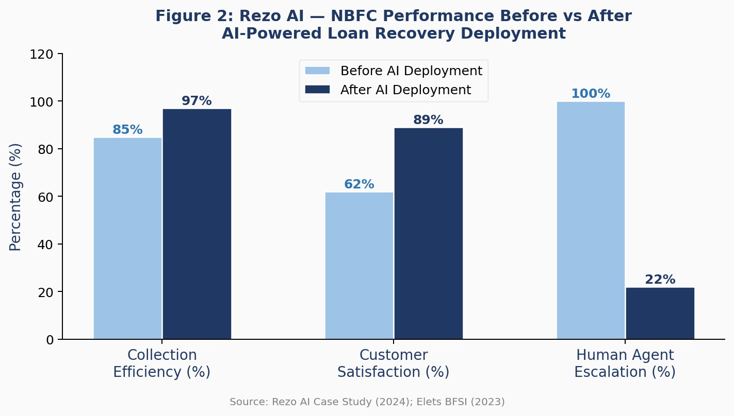
Figure 2: Rezo AI — NBFC Performance Before vs After AI Deployment (Rezo AI, 2024; Elets BFSI, 2023)

Findings: In less than six months from being put into operation, the collection efficiency of the NBFC grew from 85% to 96-98%, marking an increase of more than 10%. In addition to that, natural language processing, prompt payment processing, and prevention of any form of harassment increased CSAT. Moreover, a trial revealed how fast the solution can be implemented in just two weeks and how much better the results can be with the help of personalisation.

Lessons Learnt: Localisation is key to success in multilingual environments; segmentation by cause is crucial for achieving optimal results; AI can deliver increased recovery rates and greater customer satisfaction at once, proving the two concepts as compatible.

Case Study 2: Apifonica — AI Voice Agent for Debt Recovery in Mexico's Microloan Sector

Introduction: The microloan sector of Mexico is considered to be one of the most difficult for debt collection worldwide. In 2023, the outstanding debts of the Mexican microloan sector amounted to about 42 billion pesos (more than USD 2 billion), with the proportion of unpaid bills being more than 20% in certain firms. The average loan amount is around USD 294, which means that in some cases, the cost of an individual human call may be higher than the outstanding debt (Apifonica, 2024). The client wished to experiment with AI automation among 90+ DPD clients — the hardest-to-collect category.

Implementation: All contacts were managed by the AI agent during the trial period, which allowed checking the technology's ability to cope with the maximum load without assistance from a person. For this purpose, the AI agent applied NLP to interpret the borrowers' responses irrespective of the phrasing, adjusted the dialogue dynamically depending on the borrower's behavior, and rescheduled follow-up calls for non-answered accounts, increasing the campaign's duration by only one day compared to the two months needed for human operators.

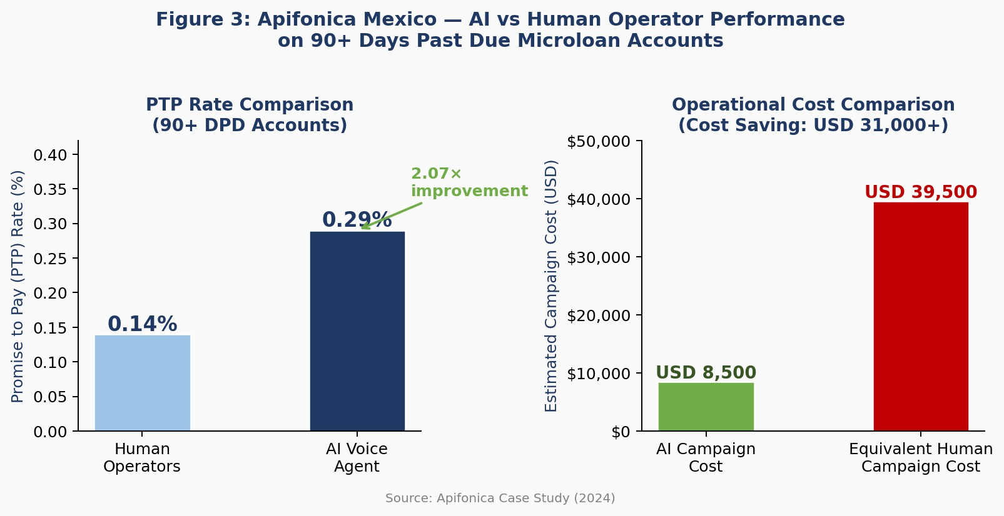
Figure 3: Apifonica Mexico — AI vs Human Operator Performance on 90+ DPD Accounts (Apifonica, 2024)

Results: The AI agent recorded a PTP rate of 0.29%, which is almost double the rate of 0.14% obtained by the human operator on similar accounts. The exercise brought back around USD 10,000 in payments from virtually dead accounts, and saved over USD 31,000 in operational cost against an identical human-led campaign (see Figure 3). An automation rate of 40-60% was found to be optimal, where the rest is carried out by humans for empathic interaction.

Lessons learned: AI voice agents beat humans even in tough collection scenarios; 100% automation is possible, but 40-60% is more economical; AI provides behavioural data to make campaigns increasingly effective; and AI is most effective when applied to large and low value portfolios.

Comparative Analysis:

Table 3 below provides a comparative analysis of parameters and results of the two exercises based on geography, type of loan, target segment, rate of automation, and other important results.

Table 3: Case Study Comparative Analysis — Rezo AI (India) vs Apifonica (Mexico)
Parameter | Rezo AI — Indian NBFC | Apifonica — Mexico Microloan
Geography | India | Mexico
Loan Type | Consumer, Housing, SME, Rural, Two- Wheeler Finance | Microloans (avg. USD 294 per account)
Target Segment | All DPD segments — early and late stage | 90+ Days Past Due accounts
Automation Rate | Partial — AI handles routine; humans handle complex | 100% in pilot; 40-60% recommended for production
Key Outcome | Collection efficiency: 85% → 97%  (+12 pts, 6 months) | PTP rate 2.07× higher than human agents; USD 31K+ cost saving
Languages | 10+ languages, 500+ Indian dialects | Spanish (single language market)
Deployment Time | 2 weeks to go-live | Phased pilot over 30 days
Source: Rezo AI Case Study (2024); Apifonica Case Study (2024)

- Implementation Pipeline

Phase 1: Data Preparation and Infrastructure Setup

Leverage APIs to consolidate borrowers' data into a single, RBI-compliant data lake from LMS, CRM, and credit bureaus. Ensure data cleansing, standardisation, and enhancement. Ensure PCI DSS compliance, data encryption, and role-based access control. Store recordings of voice calls that comply with RBI’s requirement of storing tapes of all recovery calls.

Phase 2: Model Training and Compliance Configuration

Train the predictive model using the machine learning pipeline discussed in Section IV using historical repayments, interaction history, and socio-demographic characteristics. Define the compliance layer with hard constraints such as no outbound calls after 8:00AM or before 7:00PM, restrictions on calling frequencies, the need to use disclosures, and profanity blocking.

Phase 3: Pilot Deployment

Deployment should be on a small portfolio of borrowers – mainly Sub-Standard DPDs – under the supervision of humans through real-time dashboards. The deployment will be ready for implementation within two weeks, as proven by the Rezo AI experience. Pilot the model for 30 to 60 days before full-scale deployment. Weekly compliance reports should be produced for regulators.

Phase 4: Full-Scale Rollout and Continuous Monitoring

Scale beyond the pilot program throughout the loan portfolio. Perform A/B testing of AI-generated campaigns versus conventional strategies using similar borrowers. Monitor key performance indicators such as RPC rate, PTP conversion rate, payment completion rate, AHT, cost per unit recovered, and compliance event rate. Redesign models regularly to avoid degradation in results.

- Regulatory Compliance Framework

Compliance will not be an extra feature but will be an essential part of the architecture. All levels of the AI system have RBI compliance as rigid constraints. Table 4 gives a full correspondence between RBI requirements and their implementation into the AI system.

Table 4: RBI Compliance Requirements and AI System Implementation
RBI Requirement | Specification | AI System Implementation
Contact Time Window | Calls permitted 8:00 AM to 7:00 PM only | Hard-coded time-gate in compliance engine; auto-reschedule if outside window
Disclosure Obligation | Agent must identify themselves and the bank they represent | AI agent identifies itself as automated caller, states bank name at call start
Call Recording | Banks must maintain tape recordings of all recovery calls | All calls auto-recorded and archived with searchable transcript
No Harassment | Abusive language, threats, and intimidation are prohibited | NLP profanity filter blocks prohibited language; sentiment engine flags borderline responses
Agent Details Publication | Banks must publish names of recovery agents on official website | AI system identity disclosed in bank's published agent registry
Source: RBI Guidelines (2024); Bajaj Finserv (2025); MoneyView (2025)

- Results and Discussion

The two case studies, together with industry data from the literature review, make up an empirically strong basis for the proposed solution. Figure 4 below presents the fast-paced uptake of AI technology within the debt collection industry:
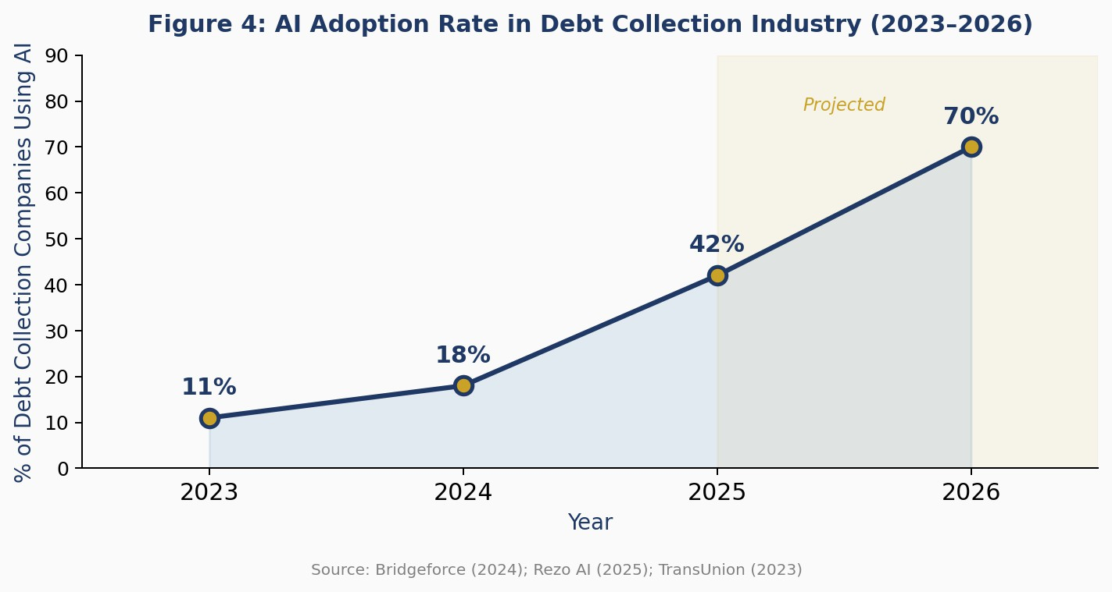
Figure 4: AI Adoption Rate in Debt Collection Industry 2023–2026 (Bridgeforce, 2024; Rezo AI, 2025; TransUnion, 2023)

Figure 5 summarises the key ROI metrics reported across all major real-world AI loan recovery deployments reviewed in this paper:

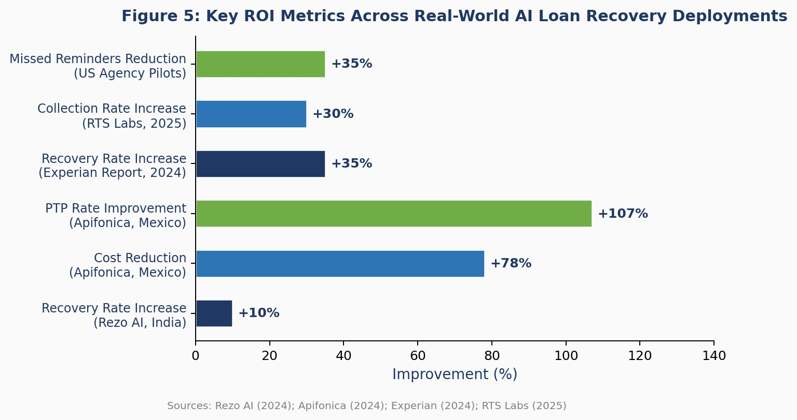

Figure 6 illustrates the operational distribution of AI vs human agent query handling in deployed systems:
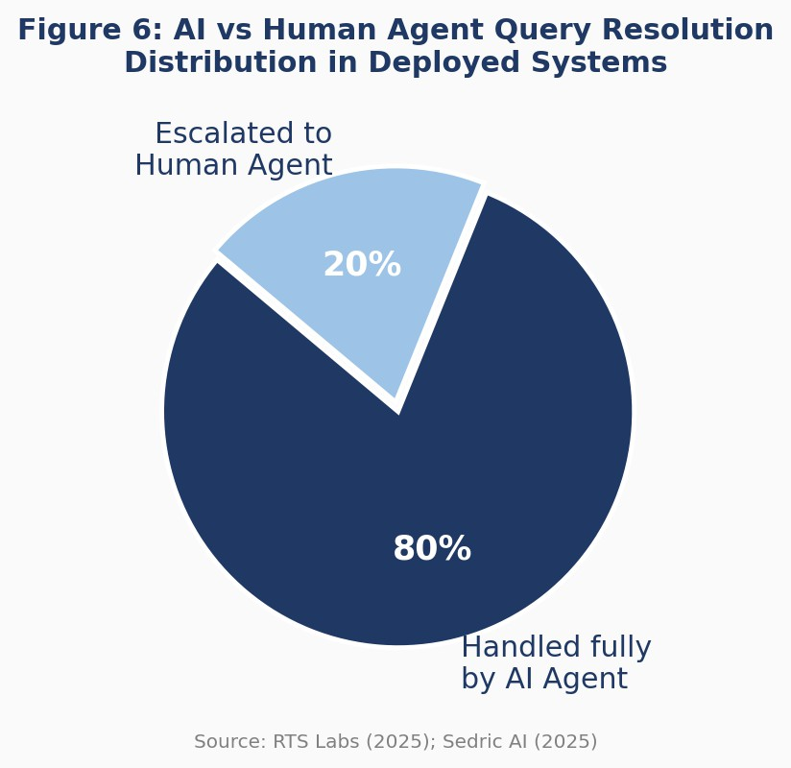

The consistency of results irrespective of geographies, market size, and strategies used ensures a very high level of confidence in the viability of the proposed system. In particular, artificial intelligence is not going to sacrifice the experience of the borrowers at the expense of efficiency since an intelligently created system will make sure that no abusive behavior occurs, which constitutes the largest number of complaints to the RBI Ombudsman and borrower dissatisfaction.

- Key Challenges and Mitigation Strategies

1. Data Privacy and Security

The personal and financial data being processed through the use of artificial intelligence includes audio files of voices. The RBI mandates that the communication be discreet and does not allow the borrower’s details to be shared with any third-party individual.

2. Regulatory Compliance Complexity

It becomes imperative that RBI’s rule about its contact window (8 AM to 7 PM), its requirement for disclosure and recording, and its ban on harassment be incorporated into the system as mandatory rules and not merely as guidelines. The compliance engine should automatically schedule any calls made outside the permitted window.

3. Algorithmic Bias and Fairness

Models built from historical data may incorporate biases based on correlations between demographic stand-ins and loan repayment probability that unfairly discriminate against certain borrower groups. Bias auditing, model building with fairness considerations, varied training data, and Explainable Artificial Intelligence (XAI) methods that allow for model decision compliance audit are needed precautions.

4. Speech Recognition in Multilingual Contexts
ASR continues to face issues related to heavy accents, noise, and code switching between English and regional languages, which is very prevalent in India. This was tackled by Rezo AI using multi-language and multi-dialect training on 10+ languages and 500+ dialects. Fallback strategies, where calls can be seamlessly transferred to human operators if ASR confidence drops below certain levels, are imperative.
5. Borrower Trust
AI transparency (identifying the caller as an AI system from the beginning of the call), empathic conversation structure, and constant availability of human recourse are important for sustaining customer trust. The Rezo AI example showed that well-designed AI collection systems can positively impact borrower satisfaction metrics, thereby refuting the myth about decreased experience quality associated with automation.

- Future Directions
• Authentication using Voice Biometrics: Incorporate voice biometric authentication as part of the call, ensuring increased security from any fraudulent activity while avoiding the use of PIN-based authentication.
• Multilingual NLP with Advanced Algorithms: Create multilingual NLP systems tailored for specific Indian language combinations (such as Hindi-English, Tamil-English, Telugu-English, and more) that go beyond the 10 languages covered currently.
• Dynamic Call Script Generation using LLM: Leverage LLMs to create dynamic call scripts by taking into account borrower-specific information at hand, moving away from decision tree-based call scripts.
• Federated Learning: Apply federated learning techniques to train AI models across different bank's datasets while maintaining privacy of borrower data across multiple banks.
• Explainable AI: Create explainability layers so that the decision process made by AI can be audited by compliance and regulatory bodies in light of emerging regulations around the globe regarding AI governance.
• UPI Payment: Embed UPI payment functionality within the call itself so that borrowers can make payment during the call itself rather than outside, thereby removing the last remaining obstacle in the recovery journey.
• Proactive Default Prevention: Expand the application of AI from its current capacity for reactive recovery into a system of proactive prevention, which means to detect defaulting accounts prior to missing the first payment and taking measures immediately, as proven through the example of a credit card firm (World Business Outlook, 2025).

- Conclusion
Loan collection can be considered one of the most resource-consuming and reputation-sensitive operations in financial services. The current manual loan collection process fails on many fronts: It is inefficient, inconsistent, costly, and often leads to customer complaints and regulatory fines. In this context, the introduction of the AI-based smart loan recovery calling system suggested in this work represents a solution that combines comprehensiveness, ethicality, and empirical validation.
Two practical examples in question – namely, the application of Rezo AI's algorithm by an Indian NBF (85% to 97% loan collection efficiency over the course of six months) and the pilot implementation of Apifonica's algorithm in Mexico ($31,000-plus worth of operational cost savings and a PTP rate more than doubled) – directly support the conclusion that AI-based loan recovery systems yield substantially better performance. This assertion is additionally corroborated by industry statistics provided in Figures 4 and 5 (AI penetration in collections growing from 11% in 2023 to 70%+ in 2026 and a consistently high ROI).
With NLP, ASR, TTS, sentiment analysis, predictive analytics, and machine learning technologies all integrated into a single, compliance-compliant framework with RBI regulations baked-in from the start rather than added on later, the new system will ensure that Indian and international financial organizations can achieve both financial success and lower regulatory risks, while providing superior customer experiences for borrowers as well. It is apparent that the time for doubt over the use of AI in loan collections has passed; the question now is how soon.

References
[1] Chang, H. (2019). Loan Repayment Prediction Using Machine Learning Algorithms. UCLA Electronic Theses and Dissertations.
[2] Blessie, E. C., & Rekha, R. (2019). Exploring the Machine Learning Algorithm for Prediction of the Loan Sanctioning Process. IJITEE, 9(1).
[3] Grand View Research. (2024). Debt Collection Software Market Size & Share Report, 2024–2030. Retrieved from https://www.grandviewresearch.com/industry-analysis/debt-collection-software-market-report
[4] MarketsandMarkets. (2024). AI in Finance Market — Global Forecast to 2030. Retrieved from https://www.marketsandmarkets.com
[5] BBVA AI Factory. (2025). Smoothing Risk: A Machine Learning Pipeline for Early Debt Recovery. Retrieved from https://www.bbvaaifactory.com
[6] Rezo AI. (2024). How a Leading NBFC Achieved 10% Jump in Collection Efficiency with Agentic AI. Retrieved from https://www.rezo.ai/case-study/leading-nbfc-achieved-10-jump-in-collection-efficiency-with-agentic-ai
[7] Rezo AI. (2025). AI in Debt Collection: Transforming Recovery While Improving Customer Experience. Retrieved from https://www.rezo.ai/our-blogs/ai-in-debt-collection
[8] Apifonica. (2024). Case Study: Using AI to Automate Debt Collection in Mexico. https://www.apifonica.com/en/blog/ai- debt-collection-automation-mexico/
[9] Elets BFSI. (2023). Rezo.ai introduces AI-driven loan recovery product for NBFCs; Pilot project reveals 10 percent increase in loan recovery. https://bfsi.eletsonline.com
[10] Experian. (2024). Artificial Intelligence in Debt Recovery: Improved recovery rates and cost savings. Cited by SquadStack AI. (2024).
[11] OpenMIC AI. (2025). AI voice agents that will revolutionize debt collection in 2025.

DECLARATION
We hereby certify that the work which is being presented in the project report entitled "AI-Based Smart Loan Recovery Calling System" in partial fulfilment of requirement for the award of the degree of Bachelor of Engineering (Computer Science and Engineering) submitted in the Department of Computer Science and Engineering at Chitkara University Institute of Engineering and Technology, Chitkara University, Punjab, India, is an authentic record of our own work carried out under the supervision of <Name of the Mentor>. The matter presented in this project report has not been submitted in any other university/institute for the award of any degree.

Place: Rajpura  Date: ……………. | (Abhay Kumar Singh)  (Vipin Sharma)  (MD Ahsan Iqbal)  (Shivansh Setia)

This is to certify that the above statement made by the candidates is correct to the best of my knowledge and belief.

Dr. Swati Goel
Professor
Department of Computer Science and Engineering
Chitkara University Institute of Engineering and Technology,
Chitkara University, Punjab, India
ACKNOWLEDGEMENT
We would like to express our sincere gratitude to all those who have supported and guided us throughout this project. We are deeply thankful to our mentor and supervisor for their invaluable guidance, continuous encouragement, and constructive feedback that greatly contributed to the successful completion of this work.

We would also like to extend our heartfelt thanks to the Department of Computer Science and Engineering, Chitkara University Institute of Engineering and Technology, Chitkara University, Punjab, for providing us with the necessary resources and an excellent academic environment.

Our sincere appreciation goes to the faculty members and staff who provided timely assistance and motivation throughout the project. We are also grateful to our families and friends for their constant support and encouragement.

Finally, we acknowledge all the researchers and industry practitioners whose published work has been referenced and cited in this report, as their contributions have significantly enriched our understanding of the subject.

Place: Rajpura  Date: ……………. | (Abhay Kumar Singh)  (Vipin Sharma)  (MD Ahsan Iqbal)  (Shivansh Setia)

