**Lawyer Appointment System**

A project submitted to

**UKA TARSADIA UNIVERSITY**

in partial fulfillment of the requirements for the degree of

**Bachelor of Science**

in

**Information Technology**

for

**5 Years Integrated M.Sc. (IT)**

By

**Kanabar Priya**

(201806100110051)

Guided by

**Ms. Foram Shah**

**Guide**



**Babu Madhav Institute of Information Technology**

**Uka Tarsadia University**

**Bardoli – 394350**

**December 2020**

**CERTIFICATE**

This is to certify that **Kanabar Priya (201806100110051)**has submitted project entitled “**Lawyer Appointment System”** as the partial fulfillment for the award of the degree of Bachelor of Science in Information Technology for 5 Years Integrated M.Sc. (IT) in 2020 – 2021.

**Date:**

**Place:**

**Ms. Foram Shah Dr. JitendraNasriwala**

Guide Programme Coordinator,

**External Examiner**



**Babu Madhav Institute of Information Technology,**

**Uka Tarsadia University,**

**Bardoli – 394350**

**Table of Content**

|  |  |  |  |  |
| --- | --- | --- | --- | --- |
| **Chapters** | **Particulars** | | | **Page no.** |
| **1** | **Introduction** | | |  |
| 1.1 | Problem Definition | |  |
| 1.2 | Initial Requirement Document | |  |
| 1.3 | Project Objective | |  |
| 1.4 | Product Scope | |  |
|  | | | | |
| **2** | **Overall Description** | | |  |
| 2.1 | Product Perspective/ Environment Description | |  |
|  | 2.1.1 | Hardware Interface/ Hardware Specification |  |
|  | 2.1.2 | SoftwareInterface/ SoftwareSpecification |  |
|  | | | | |
| **3** | **System Planning** | | |  |
| 3.1 | Software Engineering Model | |  |
|  | 3.2 | CPM PERT | |  |
|  | | | | |
| **4** | **System Specific Requirements** | | |  |
| 4.1 | Functional Requirement | |  |
| 4.2 | Non-functional Requirement | |  |
|  | | | | |
| **5** | **System Analysis** | | |  |
| 5.1 | Use case Diagram | |  |
| 5.2 | Activity Diagrams | |  |
|  | | | | |
| **6** | **System Design** | | |  |
| 6.1 | Database Design | |  |
| 6.1.1 | Database Schema |  |
| 6.1.2 | Data Dictionary |  |
|  | | | | |
| **7** | **System Implementation** | | |  |
| 7.1 | Screenshots | |  |
|  | | | | |
| **8** | **Testing** | | |  |
| 8.1 | Test Cases | |  |
|  | | | | |
| **9** | **Future Enhancement** | | |  |
|  |  | | |  |
|  | **Conclusion** | | |  |
|  |  | | |  |
|  | **Bibliography** | | |  |

**List of Figures**

|  |  |  |
| --- | --- | --- |
| **Figure no.** | **Figure Description** | **Page no.** |
| **5.1.1** | **Use Case Diagram for Admin** |  |
| **5.1.2** |  |  |
| **5.1.3** |  |  |
| **5.2.1** | **Activity Diagram for Manage Product** |  |
| **5.2.2** |  |  |
| **5.2.3** |  |  |
| **5.2.4** |  |  |
| **5.2.5** |  |  |
| **5.3.1** | **Sequence Diagram for “adding a product”** |  |

**List of Tables**

|  |  |  |
| --- | --- | --- |
| **Table no.** | **Table Description** | **Page no.** |
|  | Data Dictionary Tables |  |
| 8.1.1 | Test Cases for Login |  |
| 8.1.2 | Test Cases for Registering Client |  |

**Chapter 1: Introduction**

* 1. **Problem Definition:**

Lawyer finding system (LFS) is a web application for lawyers and their service. This system will help lawyer(s) to manage their business systematically and help people to find an appropriate lawyer based on their needs. There shall be four main users in LFS Administrator, Lawyer, Client and visitors. Here people can search lawyers and request appointment with the lawyer they find is appropriate for their case, join meetings, pay charges, give feedback. Also lawyer can request for registration, accept/decline the requested appointment, Schedule meetings, schedule reminder, view payment details, view report.

**1.2 Initial Requirement Document**

|  |  |  |
| --- | --- | --- |
| Title of the project | | Lawyer Finding System |
| Stakeholders involved in capturing requirement | | Myself and Project Guide |
| Techniques used for requirement capturing | | Interviewing and Brainstorming |
| Name of the person along with designation | | Priya kanabar(student)  Ms. ForamShah(Faculty/Guide) |
| Date | | 5 August 2020 |
| Users of the system | | Lawyer, Client,Admin, Guest |
| Version | | 1.1 |
| **Consolidated list of initial requirements:** | | |
| 1 | Lawyers can request admin for their registration | |
| 2 | Admin will manage request of lawyers, if request gets accepted system will generate a password and mail it to the lawyer as a confirmation of registration. | |
| 3 | Registration for all users who want to proceed for further communication with lawyer will be mandatory. | |
| 4 | Authentication will be done for all the registered users. | |
| 5 | Registered users can manage their profile | |
| 6 | All users would be able to view the details of lawyer’s profile | |
| 7 | Registered users can request for appointment and schedule a meeting with the lawyer they want.  (request can be made only for the time slots which are available for respected lawyer) | |
| 8 | Lawyers can manage requests for appointment with clients, once the request is accepted lawyer will send a mail to the client about the details of meeting. | |
| 9 | There will be a Google map integration to track lawyer office location. | |
| 10 | All users shall have the facility to Search the lawyers by location and specialities of lawyer | |
| 11 | Clients can give feedback related to their lawyer. | |
| 12 | There will be a facility of chat box(room) for discussion. | |
| 13 | There will be a google calendar integration to arrange a personal meet (google-meet) between client and lawyer. | |
| 14 | There will be a schedule reminder for all the registered users. | |
| 15 | client can pay the charges of meeting to the lawyer (payment gateway). | |
| 16 | The receipt for fees would be generated and mailed to client. | |
| 17 | A report would be generated for:  1) List of the cases taken by lawyer at the end of every month.  2)feedback/ratings given by clients. (for admin)  3) List of number of users should be generated at the end of every month. | |

**1.3 Project Objective:**

The main aim of Lawyer Appointment System (LAS) is to provide an application through which people can find lawyers according to their requirements in a way which is more effective and efficient. LAS will provide a digital platform where lawyers can register themselves to increase their business and network and visitors can register themselves to connect with lawyer.

LAS will help lawyers to increase their productivity by allowing lawyers to manage their schedule properly, it will also reduce the cost of an office for lawyers by providing a way for arranging meetings online, LAS will provide an easy way for communication between lawyer and client. Another goal of LAS is to save amount of time required for searching lawyers and expenditure of money on travelling, also to save environment by decreasing pollution created by travelling for meetings.

**1.4 Product Scope:**

Lawyer Appointment system (LAS) is primarily structured to provide Business-to-consumer(C2C) service. It is deigned in such a way that lawyers and general people can use it. Lawyers need to request for getting registered in system to admin, only those lawyers would be allowed to access the system whose details are verified accepted by admin.Any person who wants to find a lawyer for their work can register in the system and request for appointment. A person can communicate with lawyer only if lawyer accepts the appointment request. After finalization of appointment only lawyer can schedule the online meetings for communication with clients and client can join the meeting

Primary functions of LFS are:

* Searching lawyer.
* Requesting appointments
* Managing Appointments.
* Scheduling meetings

**Chapter 2: Overall Description**

* 1. **Product perspective/Environment Description:**

The basic requirements for running the system are as follows:

* + 1. ***Hardware Interface/ Hardware Specification***
* CPU: Intel i3 or above;
* RAM:4GB or above;
* Hard disk: 10GB or above.

***2.1.2 Software Interface / Software Specification***

* MS-Windows Operating System.
* Microsoft Visual Studio 2010 for designing front-end.
* MS SQL server 2008 for back-end

**Chapter 3: System Planning**

* 1. **Software Engineering Model:**

Waterfall methodology is selected for developing this software. As the major requirements of the system were gathered at the beginning and were able to define clearly.

It has mainly five phases: Requirement analysis, design, implementation, testing and maintenance.

Requirements are gathered and freezed after the first phase. In designing phase, the software requirement specification given in the requirement analysis phase are transformed into design structure that is suitable for implementation in a specified programming language. During the implementation phase, the design is transformed into source code. Integration and unit testing are carried out to verify the functioning of the software. After the adequate testing, the software is given to the customer for acceptance testing.

Iterative waterfall methodology is chosen for a project as “Requirements are completely known in the beginning of the project”.

**Chapter 4: System Specific Requirements**

**4.1 Functional Requirements:**

**1: Registration and Login**

|  |  |  |
| --- | --- | --- |
| **RN** | **Description** | **Comments** |
| FR1 | System shall provide an interface to:   1. Lawyers for registering through admin’s permission by providing following details:  * Photo, Name, Office Address, Email Id, Gender, Contact no, Date of birth, Experience, Specialization, Achievements, license.  1. Visitor can register themselves on their own by providing details like:  * Photo, Name, Address, Email Id, Gender, Contact no, Password, Date of birth | Registration form |
| FR2 | A login facility for authentication and enabling only authorized access to the system.   * User needs to provide a login id and password for verification, if they are valid then the user will be directed to the respective dashboard otherwise it will display an invalid credentials message | Login form |
| FR3 | System will provide a change password facility where user can change the password if needed. | Change password |
| FR4 | System shall provide a facility of forgot password if the user has forgotten the password   * when user will request for new password system will generate a OTP which will be mailed to user and after verification of OTP user can change the password | Login form  Forgot password |
| FR5 | All registered users shall be able to maintain their profile   1. Users will be able to update their profile which includes  * address, contact no and profile picture only.  1. Users will be able to view their profile | User Profile |

**2: Searching-Lawyer**

|  |  |  |
| --- | --- | --- |
| **RN** | **Description** | **Comments** |
| FR1 | All users will be able to search lawyer(s) and view their profile to examine their details.  Users can search by:   * The location of lawyer. * The specialization of lawyer. | Search lawyer interface |
| FR2 | There will be a google-map facility available for clients to track the lawyer’s office. | Locating lawyer’s office |

**3: Request appointment**

|  |  |  |
| --- | --- | --- |
| **RN** | **Description** | **Comments** |
| FR1 | Clients shall be able to request an appointment with the lawyer they want.  Clients will request appointment by providing following details:   * Description of case * time and date (date for which appointment requested) | Request appointment interface |
| FR2 | Lawyer shall be able to view the details given by client before accepting appointment |  |
| FR3 | Lawyer can manage the request’s for appointments.   1. Approve appointment:  * Once appointment is approved lawyer will schedule a meeting with client according to the appointment time and date which will be mailed to user.  1. Reject appointment:  * If lawyer rejects the request then also user will be notified through mail | View appointment |

**4: Chat-box and meet**

|  |  |  |
| --- | --- | --- |
| **RN** | **Description** | **Comments** |
| FR1 | System shall provide a facility of chat room for providing a communication interface except meetings for in between talks and other discussions. | Chat-box interface |
| FR2 | There will be a google-calendar (for meet) integration for providing the facility to schedule an online meet for lawyers and clients | Google-calendar interface |
| FR3 | Lawyer can schedule the meeting through google calendar  Client can only join the meeting |  |

**5: Schedule reminding**

|  |  |  |
| --- | --- | --- |
| **RN** | **Description** | **Comments** |
| FR1 | System shall provide a facility for reminding schedule to client and lawyer. |  |
| FR2 | Lawyer and client both can:   * Add reminder * Update reminder * Delete reminder * View reminder   for their schedule. | Arrange Schedule |

**6: Manage Case-form**

|  |  |  |
| --- | --- | --- |
| **RN** | **Description** | **Comments** |
| **FR1** | Lawyer can create a case form in which he can store details of client’s case. |  |
| **FR2** | Lawyer can:   * Add case-form * Search case-form * Update case-form * View case-form | Case-form interface |
| **FR3** | Clients shall be able to view case form details. |  |
| **FR4** | Admin can view total number of cases of al lawyer(s) |  |

**7: Manage Feedback**

|  |  |  |
| --- | --- | --- |
| **RN** | **Description** | **Comments** |
| **FR1** | Client can give suggestions and their views by sharing their experience relate to system. | Feedback form |
| **FR2** | Client can rate lawyer on the basis of their experience, rating given by them will be maintained on lawyer’s profile |  |
| **FR3** | Admin can view feedback given by clients |  |

**8: Manage Payment**

|  |  |  |
| --- | --- | --- |
| **RN** | **Description** | **Comments** |
| **FR1** | client can pay the meet charges through payment gateway. | Payment gateway |
| **FR2** | Client can view the receipt of payment. | payment receipt |
| **FR3** | Lawyer can view details of payments |  |

**9: Report**

|  |  |  |
| --- | --- | --- |
| **RN** | **Description** | **Comments** |
| **FR1** | Admin can generate a report which will show number of users in the system. (every month) | Report generation |
| **FR2** | Lawyer can view a report of total number of cases handled by them. | View report |
| **FR3** | Admin can generate a report for the feedbacks given by clients. (every month) |  |

**4.2 Non-functional Requirement**

|  |  |  |
| --- | --- | --- |
| **RN** | **Description** | **Comments** |
| NFR1 | For using systemit is required to learn, operate and understand the functions of software, considering the ease of each user a user friendly interface is made so that every user can easily understand the way to use the system and get familiar. | Usability |
| NFR2 | The working and operations of software are as simple as possible | Simplicity |
| NFR3 | Efforts are done for Fixing the errors during maintenance phase | Maintainability |
| NFR4 | All user’s password will be stored in encrypted form. | Security |

**Chapter5: System Analysis**

**5.1 Use Case Diagram for Lawyer Appointment System:**

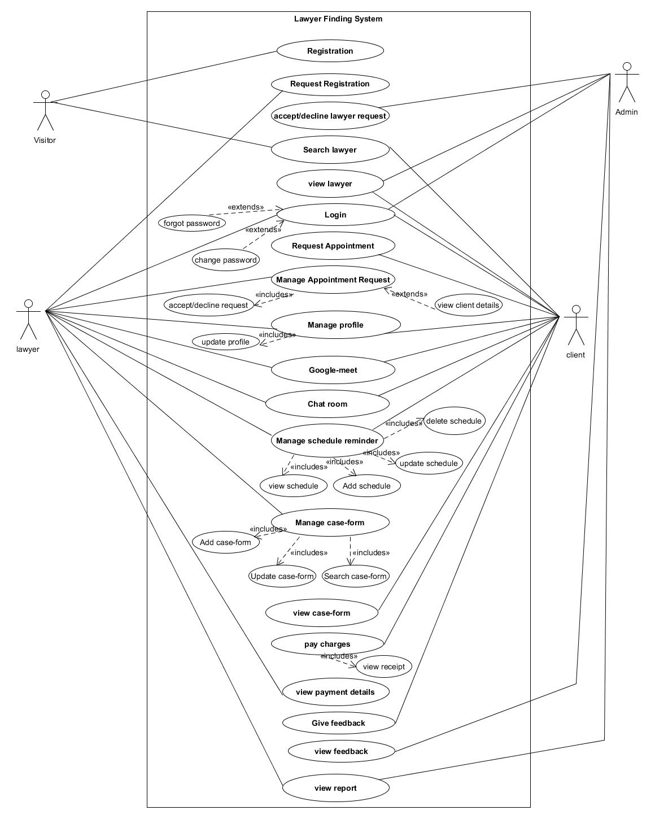

**5.2 Activity Diagrams:**

* **Activity diagram for Lawyer registration**

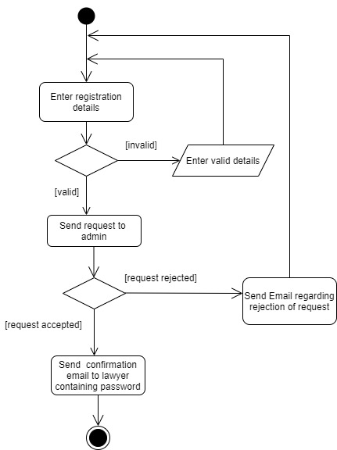

* **Activity diagram for Searching Lawyer:**

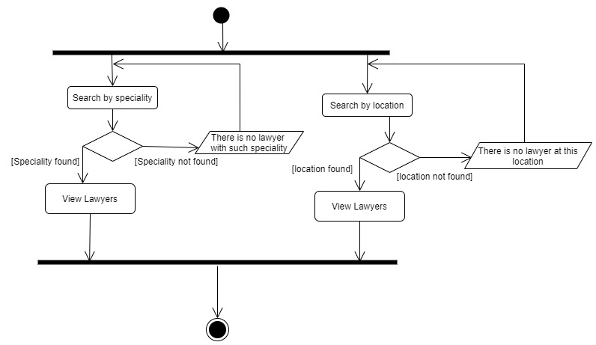

* **Activity diagram for Request Appointment**

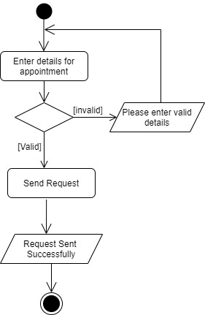

* **Activity diagram for case Request**
* 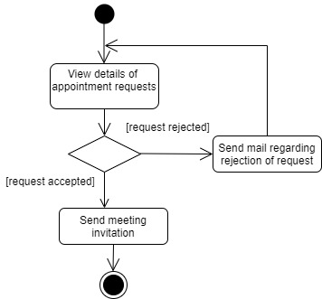
* **Activity diagram for manage manage use case**

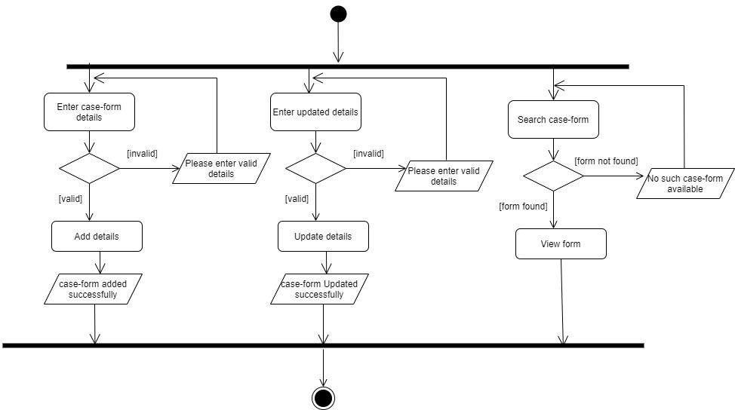

* **Activity diagram for payment**

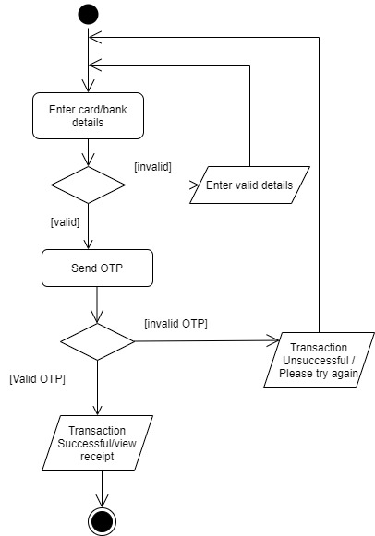

**Chapter 6: System Design**

**6.1 Database Design**

**6.1.1 Database Schema**

* **Tbl_Login**(Username,Password,status,userId(Fk),RequestId(Fk))
* **Tbl_User**(UserId(PK), Image,Name,ContactNo,,Gender,Address, Date_Of_Birth,)

* **Tbl_Registrationrequest**(RequestId(PK), Image,Name,ContactNo,,Gender,Address, Date_Of_Birth ,Experience, Specialization, Achievements, license, LawyerFes Date/Time, Status)
* **Tbl_Case**(CaseId(PK), UserId(FK), CaseDescription, Status, ReqestId(FK))
* **Tbl_Appointment**(AppointmentId(Pk), CaseId(FK)   ,Date/Time)
* **Tbl_ScheduleReminder**(ScheduleId(PK), Description, AppointmentId(FK))
* **Tbl_Payment**(PaymentId(PK), caseId(FK), Total_Amount,otp,TransactionId)

* **Tbl_Googlemeet**(MeetId(PK), Link, AppointmentId(FK))
* **Tbl_Feedback**(feedbackId(PK), CaseId(FK), Feedback Description, FeedbackPoints)
* **Tbl_Map**(MapId(PK), RequestId(Fk), Address, longitude, latitude)

**6.1.2 DataDictionary**

* **Table Name**: - Tbl_Login
* **Table Description**: -This table stores login credential of users.

|  |  |  |  |  |  |
| --- | --- | --- | --- | --- | --- |
| **Sr.No** | **Field Name** | **Data Type** | **Size** | **Constraint** | **Description** |
| 1. | UserName | varchar | 320 | Not Null  Unique Key | Unique Username (EmailId) for each User |
| 2. | Password | char | 20 | Not Null | Password for each user |
| 3. | Status | int | - | Not Null | Allows to find who is the user |
| 4. | UserId | int |  | Foreign Key | Identifies the user |
| 5. | RequestId | Int |  | Foreign Key | Identifies the lawyer |

* **Table Name**: - Tbl_RegistrationRequest
* **Table Description**: -This table stores all the details about lawyer registration

|  |  |  |  |  |  |
| --- | --- | --- | --- | --- | --- |
| **Sr.No** | **Field Name** | **Data Type** | **Size** | **Constraint** | **Description** |
| 1. | RequestId | int | - | Primary Key | Uniquely determines the user. |
| 2 | Image | image |  | Not Null | Image of the user |
| 3. | Name | char | 50 | Not Null | FullName of the user. |
| 4. | ContactNo | bigint | - | Not Null | Specifies Contact number of the lawyer. |
| 5. | Gender | Char | 1 | Not Null | Specifies gender of lawyer. |
| 6. | Address | varchar | 100 | Not Null | Address of lawyer. |
| 7. | Date_Of_Birth | date |  | Not Null | Date on which the lawyer was born |
| 8. | Experience | int |  |  | Number of years the lawyer has worked |
| 8. | Specialization | char | 20 |  | Any specific strength of lawyer |
| 9. | Achievements | char | 50 | - | Any specific achievement |
| 10. | Proof | Image |  |  | Image for license |
| 11. | LawyerFess | Int |  |  | Charges of the lawyer |
| 12 | Status | char | 1 |  | Status of request accepted or rejected A/R |

* **Table Name**: - Tbl_user
* **Table Description**: -This table stores all the details about the client

|  |  |  |  |  |  |
| --- | --- | --- | --- | --- | --- |
| **Sr.No** | **Field Name** | **Data Type** | **Size** | **Constraint** | **Description** |
| 1. | UserId | int |  | Primary Key | Uniquely identifies the user |
| 2. | Image | image |  | Not Null | Image of the user |
| 3. | Name | char | 50 | Not Null | FullName of the user. |
| 4. | ContactNo | bigint | - | Not Null | Specifies Contact number of the user. |
| 5. | Gender | Char | 1 | Not Null | Specifies gender of user M/F for male and female respectively. |
| 6. | Address | varchar | 100 | Not Null | Address of user. |
| 7. | Date_Of_Birth | date |  | Not Null | Date on which the user was born |

* **Table Name**: - Tbl_Case
* **Table Description**: -This table stores all the details about the case

|  |  |  |  |  |  |
| --- | --- | --- | --- | --- | --- |
| **Srno.** | **Field Name** | **Data Type** | **Size** | **constraint** | **Description** |
| 1. | CaseId | int |  | Primary Key | Uniquely identifies a case |
| 2. | UserId | int |  | Foreign key | Identifies the client who has requested appointment |
| 3. | CaseDescription | varchar | 200 | Not Null | Small description related to case |
| 4. | Status | char | 1 | - | Status of the request accepted or rejected A/R |
| 5. | RequestId | int |  | Foreign key | Identifies the lawyer |

* **Table Name**: - Tbl_Appointment
* **Table Description**: -This table stores all the details about the case

|  |  |  |  |  |  |
| --- | --- | --- | --- | --- | --- |
| **Sr.No** | **Field Name** | **Data Type** | **Size** | **Constraint** | **Description** |
| 1. | AppointmentId | int |  | Primary Key | Uniquely identifies a appointment |
| 2. | CaseId | int |  | Foreign key | Identifies the case |
| **3.** | Date | date |  | Not Null | Date/time when the meeting is to be scheduled |
| **4** | Time | Varchar(20) |  |  | Time for appointment |

* **Table Name**: - Tbl_ScheduleReminder
* **Table Description**: -This table stores all the details about the schedule of client/Lawyer

|  |  |  |  |  |  |
| --- | --- | --- | --- | --- | --- |
| **Sr.No** | **Field Name** | **Data Type** | **Size** | **Constraint** | **Description** |
| 1. | ScheduleId | int |  | Primary Key | Uniquely identifies a schedule |
| 2. | Description | varchar | 100 | Not Null | Description related to the schedule |
| 3. | AppointmentId | int |  | Foreign key | Identifies the appointment |

* **Table Name**: - Tbl_Payment
* **Table Description**: -This table stores all the details about the payment

|  |  |  |  |  |  |
| --- | --- | --- | --- | --- | --- |
| **Sr.No** | **Field Name** | **Data Type** | **Size** | **Constraint** | **Description** |
| 1. | PaymentId | int |  | Primary key | Uniquely describes the payment record |
| 2. | caseId | int |  | Foreign key | Identifies the case |
| 3. | Total_Amount | int |  | Not Null | Total amount to be paid is calculated by adding all the adding charges |
| 4. | OTP | int |  |  | A unique otp for transaction |
| 5. | TransactionId | int |  |  | Transaction id for each payment |

* **Table Name**: - Tbl_Googlemeet
* **Table Description**: -This table stores all the details about the meetings

|  |  |  |  |  |  |
| --- | --- | --- | --- | --- | --- |
| **Sr.No** | **Field Name** | **Data Type** | **Size** | **Constraint** | **Description** |
| 1. | MeetId | int |  | Primary Key | Uniquely identifies a meeting |
| 2. | Link | char | 15 | Not Null | Link for the meet |
| 3. | AppointmentId | int |  | Foreign Key | Identifies the appointment |

* **Table Name**: - Tbl_Feedback
* **Table Description**: -This table stores all the details about the feedback

|  |  |  |  |  |  |
| --- | --- | --- | --- | --- | --- |
| **Sr.No** | **Field Name** | **Data Type** | **Size** | **Constraint** | **Description** |
| 1. | FeedbackId | int |  | Primary Key | Uniquely identifies a fedback |
| 2. | CaseId | int |  | Foreign Key | Identifies the case |
| 3. | Feedback Description | Varchar | 100 | Not Null | Description related to lawyer’s service |
| 4. | FeedbackPoints | int |  |  | Number of points given by client to lawyer |

* **Table Name**: - Tbl_Map
* **Table Description**: -This table stores all the details about the Map

|  |  |  |  |  |  |
| --- | --- | --- | --- | --- | --- |
| **Sr.No** | **Field Name** | **Data Type** | **Size** | **Constraint** | **Description** |
| 1. | MapId | int |  | Primary Key | Uniquely identifies a Map |
| 2 | RequestId | int |  | Foreign Key | Identifies the lawyer uniquely |
| 3. | Address | varchar | 100 | Not Null | Full address in the map |
| 4. | longitude | numeric(12,6) |  | Not Null | Longitude if map |
| 5. | latitude | numeric(12,6) |  | Not Null | Latitude of map |

**Chapter 7: System Implementation**

**7.1 Screenshots**

**Chapter 8: Testing**

**8.1 Test Case**

* **Test Cases for Login**

|  |  |  |  |  |  |
| --- | --- | --- | --- | --- | --- |
| **Test Case Id** | **Test Case Description** | **Input -1**  **Username** | **Input -2**  **Password** | **Expected Result** | **Remark(if any)** |
| TC1 | Authentication Successful | Valid Input | Valid Input | User is authenticated successfully | - |
| TC2 | Username is invalid | Invalid Input | Invalid Input | Error message displaying invalid credentials | username and password entered are not matching according to the user type |
| TC3 | Password is invalid | Valid Input | Invalid Input | Error message displaying invalid credentials |  |
| TC3 | Both username and passwords are invalid | Invalid Input | Invalid Input | Error message displaying invalid credentials |  |

* **Test Cases of client registration**

|  |  |  |  |  |  |  |  |  |  |  |  |
| --- | --- | --- | --- | --- | --- | --- | --- | --- | --- | --- | --- |
| **Test Case Id** | **Test Case Description** | **Input -1**  **Name** | **Input -2**  **Image** | **Input -3**  **Contact** | **Input -4**  **Email-ID** | **Input -5**  **Gender** | **Input -6**  **Address** | **Input -7**  **Date_of_birth** | **Input -8**  **Password** | **Expected Result** | **Remark (if any)** |
| TC1 | Registration Successful | Valid Input | Valid Input | Valid Input | Valid Input | Valid Input | Valid Input | Valid Input | Valid Input | User is authenticated successfully | - |
| TC2 | Name is invalid | Invalid Input | Valid Input | Valid Input | Valid Input | Valid Input | Valid Input | Valid Input | Valid Input | Error message displaying invalid first name | Invalid input when user enters any character other than alphabets |
| TC3 | Image is invalid | Valid Input | Invalid  Input | Valid Input | Valid Input | Valid Input | Valid Input | Valid Input | Valid Input | Error message displaying select proper image | Invalid input when file uploaded is not jpg,bmp,png or gif file |
| TC4 | Contact number is invalid | Valid Input | Valid Input | Invalid Input | Valid Input | Valid Input | Valid Input | Valid Input | Valid Input | Error message displaying invalid contact | Invalid input when user enters characters other than numbers or when the number entered having less or more than 10 numbers |
| TC5 | Email Id | Valid Input | Valid Input | Valid Input | Invalid Input | Valid Input | Valid Input | Valid Input | Valid Input | Error message displaying invalid email id | Invalid input if format of emailed is not proper |
| TC6 | Gender | Valid Input | Valid Input | Valid Input | Valid Input | Invalid Input | Valid Input | Valid Input | Valid Input | Error message displaying to select gender |  |
| TC7 | Address | Valid Input | Valid Input | Valid Input | Valid Input | Valid Input | Invalid Input | Valid Input | Valid Input | Error message displaying to enter address |  |
| Tc7 | Date_of_birth | Valid Input | Valid input | Valid input | Valid input | Valid input | Valid input | Invalid Inout | valid | Error please select date of birth |  |
| TC8 | Password | Valid Input | Valid Input | Valid Input | Valid Input | Valid Input | Valid Input | Valid Input | Invalid Input | Error message displaying to choose password must be at least 8 characters |  |
|  |  |  |  |  |  |  |  |  |  |  |  |

**Chapter 9: Future Enhancement**

This project can have a large scope ahead. Project can be updated with following requirements:

* Lawyer Appointment system can include other functionalities like :

1. Enhance system for more than taking only appointments
2. Build own meet application for arranging meetings
3. Make reach of the system at national level so all the lawyers and people know about it

**Conclusion**

The project “Lawyer Appointment System” shall be able to overcome issues which are faced by the people for finding a appropriate lawyer according to their requirements and lawyers will get appropriate clients for their work.

**Bibliography**

Following resources were helpful in completing this project:

* <https://www.c-sharpcorner.com/>
* UMLET software for creating use case diagrams
* draw.io for creating activity diagrams
* software engineering: A practitioner’s approach – Roger Pressman