Use Case : Capturing market spoofing activities in real-time

Problem Statement :

As a regulator, I would like to monitor all the market abuses in timely manner for various asset classes like – Equity, Fixed Income, Forex Trading etc. As a starting point, looking to build a model to capture spoofing activities within 30 minutes of it's occurrence.

What is Spoofing Activity ?

When a trader wants to buy/sell certain instrument at best price, he places few fake visible orders in market on opposite side. This causes price to move in direction favorable to him. Once his Genuine order is fulfilled, he cancels all fake orders. This activity is called as spoofing.

For Example -
Figure given below shows one such activity, where trader tried to put sell orders with huge quantity and a genuine buy order. Looking at this, other traders thought that there is huge supply in the market, which caused the price to move downwards. Once the trader required price is reached and genuine buy order is fulfilled, he cancels all fake sell orders. This activity is called as Spoofing activity.

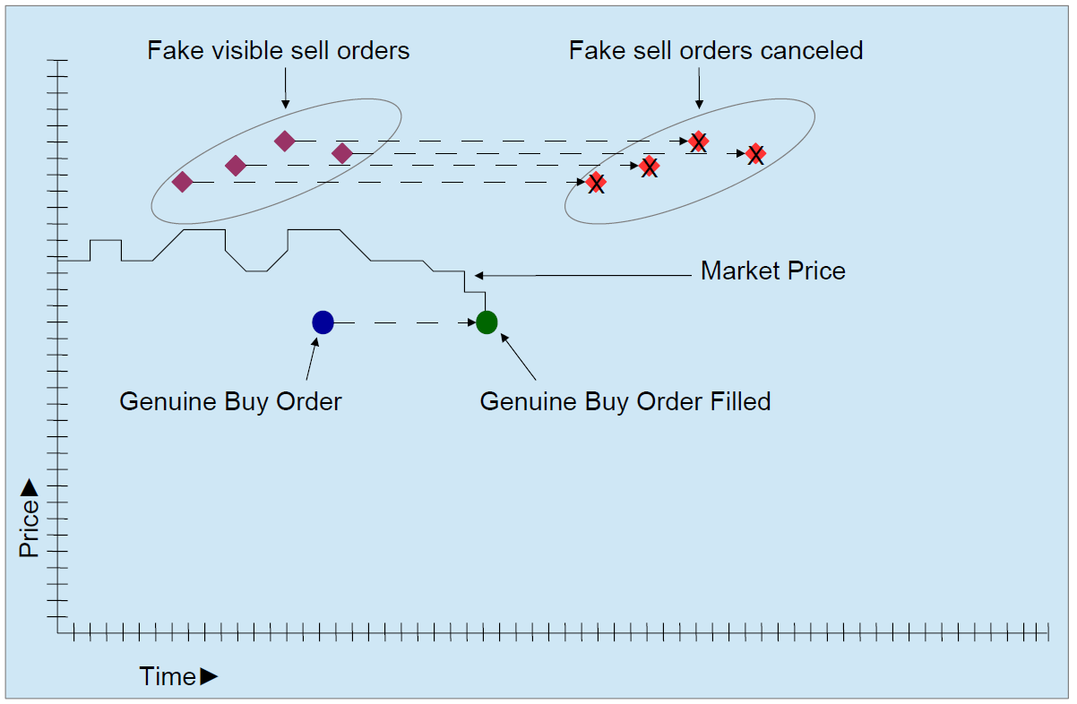

Input Data :
A stream of Orders data and a stream of trades with all relevant facts will be provided.

Processing :
Capture all the pairs in real-time where
- Trader has placed orders on one side and canceled it immediately after some time.
- There was some execution on opposite side by the same trader.

Output :

A) A real time updating UI has to be created which displays
- All the orders and trades flowing in system.
- Number of alerts created with time

B) A flat file which stores all the pairs of possible spoofing exceptions.

Solution Lever : Developer is free to use the tools he/she is well versed with.

Possibly below tools can help to get the task done.

    - Kafka as event buffer
    - Spark Structured Streaming
    - Mat Plot Lib for UI display

