**ASSIGNMENT NO - 6**

**Aim : write a simple android program for a simple image viewer.**

* **Description:**

I have to create an android application which will show the image present in the gallery so I will do the following steps:

* Create a new project
* Name them as simple image viewer app
* It will generate activity_main.xml and mainactivity.java file
* Then I will make two tools as image viewer and button to select the image.
* **Expected input:**

My expected input is the image gallery from which I will select the image.

* **Expected output:**

My expected output will be the image in the form of rectangular box in the image viewing app.

* **Discussion:**

In this program I have initialise the image view tools as well as the button . on clicking the button it will show all the image present in the gallery and then I will select the image which I have to show through my gallery and this will show the image in the assigned image viewer app. If we want to see other image then we will again click the button and select the different image from the gallery.

* **Error checking :**

I have done the error checking there is no any error the program is running well and fine.

* **Assumption taken:**

There must be some image in the gallery to show.

* **Scope for improvement:**

Its user interface as well as option should be improve.

* **Additional feature :**

Photo can be zoomed in as well as zoomed out etc.

Activity_main.xml

*<?***xml version="1.0" encoding="utf-8"***?>*<**androidx.constraintlayout.widget.ConstraintLayout xmlns:android="http://schemas.android.com/apk/res/android"  
 xmlns:app="http://schemas.android.com/apk/res-auto"  
 xmlns:tools="http://schemas.android.com/tools"  
 android:layout_width="match_parent"  
 android:layout_height="match_parent"  
 tools:context=".MainActivity"**>  
  
  
 <**ImageView  
 android:id="@+id/imageView"  
 android:layout_width="366dp"  
 android:layout_height="284dp"  
 app:layout_constraintBottom_toBottomOf="parent"  
 app:layout_constraintEnd_toEndOf="parent"  
 app:layout_constraintHorizontal_bias="0.355"  
 app:layout_constraintStart_toStartOf="parent"  
 app:layout_constraintTop_toTopOf="parent"  
 app:layout_constraintVertical_bias="0.062"** />  
  
 <**Button  
 android:id="@+id/button"  
 android:layout_width="141dp"  
 android:layout_height="87dp"  
 android:text="SELECT"  
 app:layout_constraintBottom_toBottomOf="parent"  
 app:layout_constraintEnd_toEndOf="parent"  
 app:layout_constraintHorizontal_bias="0.498"  
 app:layout_constraintStart_toStartOf="parent"  
 app:layout_constraintTop_toTopOf="parent"  
 app:layout_constraintVertical_bias="0.579"** />  
</**androidx.constraintlayout.widget.ConstraintLayout**>

**Mainactivity.java**

**package** com.example.lab_report_6;  
  
**import** androidx.annotation.Nullable;  
**import** androidx.appcompat.app.AppCompatActivity;  
  
**import** android.content.Intent;  
**import** android.os.Bundle;  
**import** android.provider.MediaStore;  
**import** android.view.View;  
**import** android.widget.Button;  
**import** android.widget.ImageView;  
  
**public class** MainActivity **extends** AppCompatActivity {  
  
 **private final int GALLERY_REQ_CODE** = 1000;  
 ImageView **imgGallery**;  
 @Override  
 **protected void** onCreate(Bundle savedInstanceState) {  
 **super**.onCreate(savedInstanceState);  
 setContentView(R.layout.***activity_main***);  
  
 **imgGallery** = findViewById(R.id.***imageView***);  
 Button btnGallery = findViewById((R.id.***button***));  
  
 btnGallery.setOnClickListener(**new** View.OnClickListener() {  
 @Override  
 **public void** onClick(View view) {  
 Intent iGallery = **new** Intent(Intent.***ACTION_PICK***);  
 iGallery.setData(MediaStore.Images.Media.***EXTERNAL_CONTENT_URI***);  
 startActivityForResult(iGallery,**GALLERY_REQ_CODE**);  
  
 }  
 });  
 }  
  
 @Override  
 **protected void** onActivityResult(**int** requestCode, **int** resultCode, @Nullable Intent data) {  
 **super**.onActivityResult(requestCode, resultCode, data);  
  
 **if**(resultCode == ***RESULT_OK***){  
 **if**(requestCode==**GALLERY_REQ_CODE**){  
 *//for gallery* **imgGallery**.setImageURI(data.getData());  
  
  
 }  
 }  
 }  
}

**Output**

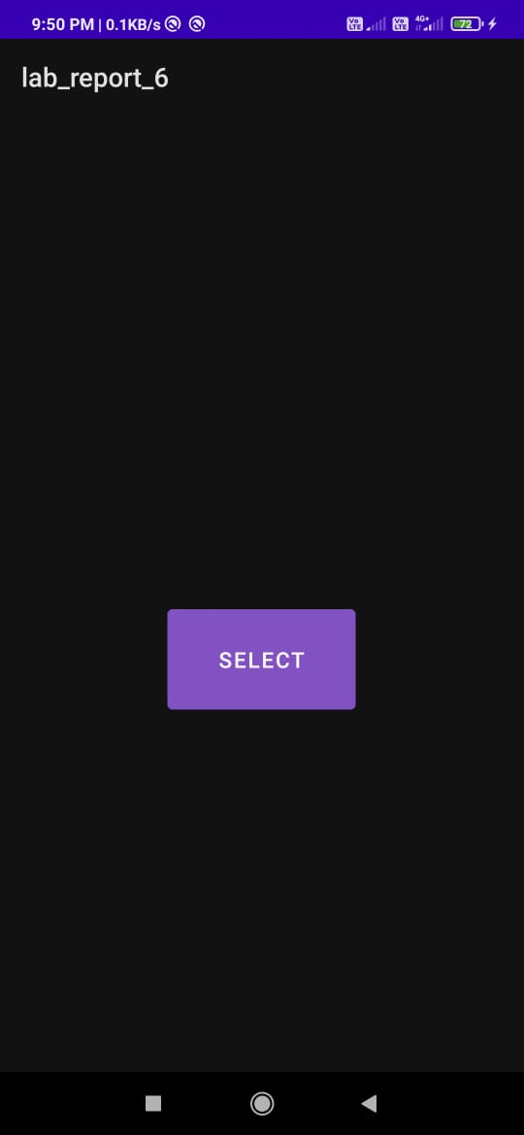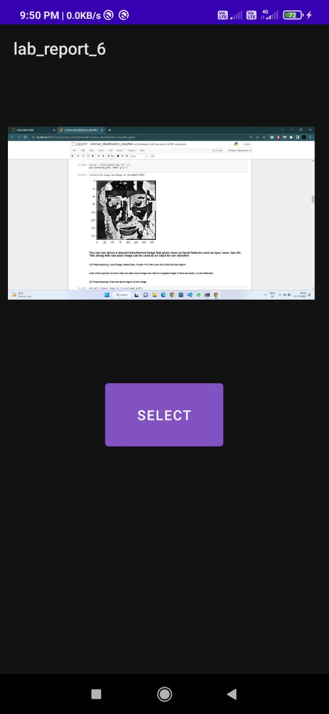

**After selecting the image**

**Before opening gallery**