**ASSIGNMENT NO - 1**

**Aim : write a simple android program to create a form for new student enrolled in your institute , which must include some basic information of the student like – Student ID , student name , sex, email , dob etc.**

* **Description:**

I have to create an android application for registration of the student which consist of some of the field like name , sex, student reg_no, email etc:

* Create a new project.
* Name them as registration form.
* It will generate activity_main.xml and mainactivity.java file.
* Create another activity to show the result.
* **Expected input:**

My expected input is the student detail.

* **Expected output:**

My expected output is the page showing the registration has been completed .

* **Discussion:**

In this program I have to create the form which will take the user input and show that the user has been successfully registered in other page.

* **Error checking :**

I have done the error checking there is no any error the program is running well and fine.

* **Assumption taken:**

There is no any assumption.

* **Scope for improvement:**

Its user interface should be improved and database should be connected to store the data.

* **Additional feature :**

It will display all the data in proper format.

**Activity_main.xml**

*<?***xml version="1.0" encoding="utf-8"***?>*<**androidx.constraintlayout.widget.ConstraintLayout xmlns:android="http://schemas.android.com/apk/res/android"  
 xmlns:app="http://schemas.android.com/apk/res-auto"  
 xmlns:tools="http://schemas.android.com/tools"  
 android:layout_width="match_parent"  
 android:layout_height="match_parent"  
 android:layout_margin="10dp"  
 android:background="#D6D5CC"  
 android:textAlignment="center"  
 tools:context=".MainActivity"**>  
  
 <**EditText  
 android:id="@+id/name"  
 android:layout_width="370dp"  
 android:layout_height="wrap_content"  
 android:ems="10"  
 android:hint="Enter your name"  
 android:inputType="textPersonName"  
 android:textAlignment="center"  
 android:textColor="@color/design_default_color_error"  
 android:textColorHint="#2196F3"  
 android:textSize="20sp"  
 app:layout_constraintBottom_toBottomOf="parent"  
 app:layout_constraintEnd_toEndOf="parent"  
 app:layout_constraintHorizontal_bias="0.5"  
 app:layout_constraintStart_toStartOf="parent"  
 app:layout_constraintTop_toTopOf="parent"  
 app:layout_constraintVertical_bias="0.142"** />  
  
 <**EditText  
 android:id="@+id/editTextTextPostalAddress"  
 android:layout_width="370dp"  
 android:layout_height="50dp"  
 android:ems="10"  
 android:hint="Enter your Address"  
 android:inputType="textPostalAddress"  
 android:textAlignment="center"  
 android:textColorHint="#2196F3"  
 android:textSize="20sp"  
 app:layout_constraintBottom_toBottomOf="parent"  
 app:layout_constraintEnd_toEndOf="parent"  
 app:layout_constraintHorizontal_bias="0.5"  
 app:layout_constraintStart_toStartOf="parent"  
 app:layout_constraintTop_toTopOf="parent"  
 app:layout_constraintVertical_bias="0.232"** />  
  
 <**TextView  
 android:id="@+id/textView"  
 android:layout_width="383dp"  
 android:layout_height="52dp"  
 android:text="REGISTARION FORM"  
 android:textAlignment="center"  
 android:textSize="34sp"  
 android:textStyle="bold"  
 app:layout_constraintBottom_toBottomOf="parent"  
 app:layout_constraintEnd_toEndOf="parent"  
 app:layout_constraintHorizontal_bias="0.413"  
 app:layout_constraintStart_toStartOf="parent"  
 app:layout_constraintTop_toTopOf="parent"  
 app:layout_constraintVertical_bias="0.044"** />  
  
 <**EditText  
 android:id="@+id/reg"  
 android:layout_width="370dp"  
 android:layout_height="47dp"  
 android:ems="10"  
 android:hint="Enter your regiistration no"  
 android:inputType="number"  
 android:textAlignment="center"  
 android:textColorHint="#2196F3"  
 android:textSize="20sp"  
 app:layout_constraintBottom_toBottomOf="parent"  
 app:layout_constraintEnd_toEndOf="parent"  
 app:layout_constraintHorizontal_bias="0.5"  
 app:layout_constraintStart_toStartOf="parent"  
 app:layout_constraintTop_toTopOf="parent"  
 app:layout_constraintVertical_bias="0.336"** />  
  
 <**EditText  
 android:id="@+id/editTextTextEmailAddress"  
 android:layout_width="370dp"  
 android:layout_height="61dp"  
 android:ems="10"  
 android:hint="Enter your email address"  
 android:inputType="textEmailAddress"  
 android:textAlignment="center"  
 android:textColorHint="#2196F3"  
 android:textSize="20sp"  
 app:layout_constraintBottom_toBottomOf="parent"  
 app:layout_constraintEnd_toEndOf="parent"  
 app:layout_constraintHorizontal_bias="0.589"  
 app:layout_constraintStart_toStartOf="parent"  
 app:layout_constraintTop_toTopOf="parent"  
 app:layout_constraintVertical_bias="0.432"** />  
  
 <**RadioGroup  
 android:id="@+id/radioGroup"  
 android:layout_width="384dp"  
 android:layout_height="56dp"  
 android:orientation="horizontal"  
 app:layout_constraintBottom_toBottomOf="parent"  
 app:layout_constraintEnd_toEndOf="parent"  
 app:layout_constraintHorizontal_bias="0.5"  
 app:layout_constraintStart_toStartOf="parent"  
 app:layout_constraintTop_toTopOf="parent"  
 app:layout_constraintVertical_bias="0.59"**>  
  
 <**RadioButton  
 android:id="@+id/radioButton1"  
 android:layout_width="127dp"  
 android:layout_height="56dp"  
 android:layout_marginLeft="35dp"  
 android:text="female"  
 android:textColor="@color/teal_200"  
 android:textSize="20sp"** />  
  
 <**RadioButton  
 android:id="@+id/radioButton"  
 android:layout_width="127dp"  
 android:layout_height="56dp"  
 android:text="male"  
 android:textColor="#4CAF50"  
 android:textSize="20sp"** />  
  
 </**RadioGroup**>  
  
 <**TextView  
 android:id="@+id/textView2"  
 android:layout_width="223dp"  
 android:layout_height="29dp"  
 android:text="Gender"  
 android:textAlignment="center"  
 android:textSize="20sp"  
 android:textStyle="bold"  
 app:layout_constraintBottom_toBottomOf="parent"  
 app:layout_constraintEnd_toEndOf="parent"  
 app:layout_constraintHorizontal_bias="0.502"  
 app:layout_constraintStart_toStartOf="parent"  
 app:layout_constraintTop_toTopOf="parent"  
 app:layout_constraintVertical_bias="0.518"** />  
  
 <**Button  
 android:id="@+id/btn"  
 android:layout_width="196dp"  
 android:layout_height="69dp"  
 android:background="#CDDC39"  
 android:text="SUBMIT"  
 android:textAlignment="center"  
 app:iconTint="#CDDC39"  
 app:layout_constraintBottom_toBottomOf="parent"  
 app:layout_constraintEnd_toEndOf="parent"  
 app:layout_constraintHorizontal_bias="0.5"  
 app:layout_constraintStart_toStartOf="parent"  
 app:layout_constraintTop_toTopOf="parent"  
 app:layout_constraintVertical_bias="0.989"** />  
  
 <**TextView  
 android:id="@+id/textView3"  
 android:layout_width="wrap_content"  
 android:layout_height="wrap_content"  
 android:text="Date of birth"  
 android:textAlignment="center"  
 android:textSize="20sp"  
 app:layout_constraintBottom_toBottomOf="parent"  
 app:layout_constraintEnd_toEndOf="parent"  
 app:layout_constraintStart_toStartOf="parent"  
 app:layout_constraintTop_toTopOf="parent"  
 app:layout_constraintVertical_bias="0.673"** />  
  
 <**EditText  
 android:id="@+id/dd"  
 android:layout_width="120dp"  
 android:layout_height="50dp"  
 android:ems="10"  
 android:hint="DD"  
 android:inputType="number"  
 android:textAlignment="center"  
 app:layout_constraintBottom_toBottomOf="parent"  
 app:layout_constraintEnd_toEndOf="parent"  
 app:layout_constraintHorizontal_bias="0.011"  
 app:layout_constraintStart_toStartOf="parent"  
 app:layout_constraintTop_toTopOf="parent"  
 app:layout_constraintVertical_bias="0.752"** />  
  
 <**EditText  
 android:id="@+id/mm"  
 android:layout_width="120dp"  
 android:layout_height="50dp"  
 android:ems="10"  
 android:hint="MM"  
 android:inputType="number"  
 android:textAlignment="center"  
 android:textSize="20sp"  
 app:layout_constraintBottom_toBottomOf="@+id/btn"  
 app:layout_constraintEnd_toEndOf="parent"  
 app:layout_constraintStart_toStartOf="parent"  
 app:layout_constraintTop_toTopOf="parent"  
 app:layout_constraintVertical_bias="0.761"** />  
  
 <**EditText  
 android:id="@+id/yy"  
 android:layout_width="120dp"  
 android:layout_height="50dp"  
 android:ems="10"  
 android:hint="YYYY"  
 android:inputType="number"  
 android:textAlignment="center"  
 android:textSize="20sp"  
 app:layout_constraintBottom_toBottomOf="parent"  
 app:layout_constraintEnd_toEndOf="parent"  
 app:layout_constraintHorizontal_bias="0.977"  
 app:layout_constraintStart_toStartOf="parent"  
 app:layout_constraintTop_toTopOf="parent"  
 app:layout_constraintVertical_bias="0.752"** />  
  
</**androidx.constraintlayout.widget.ConstraintLayout**>

**Activity_main2.xml**

*<?***xml version="1.0" encoding="utf-8"***?>*<**androidx.constraintlayout.widget.ConstraintLayout xmlns:android="http://schemas.android.com/apk/res/android"  
 xmlns:app="http://schemas.android.com/apk/res-auto"  
 xmlns:tools="http://schemas.android.com/tools"  
 android:layout_width="match_parent"  
 android:layout_height="match_parent"  
 tools:context=".MainActivity2"**>  
  
 <**TextView  
 android:id="@+id/output"  
 android:layout_width="wrap_content"  
 android:layout_height="wrap_content"  
 android:textSize="34sp"  
 app:layout_constraintBottom_toBottomOf="parent"  
 app:layout_constraintEnd_toEndOf="parent"  
 app:layout_constraintStart_toStartOf="parent"  
 app:layout_constraintTop_toTopOf="parent"** />  
</**androidx.constraintlayout.widget.ConstraintLayout**>

**MainActivity.kt**

**package** com.example.labfirstproject  
  
**import** android.content.Intent  
**import** androidx.appcompat.app.AppCompatActivity  
**import** android.os.Bundle  
**import** android.view.View  
**import** android.widget.Button  
**import** android.widget.EditText  
**import** android.widget.Toast  
  
**class** MainActivity : AppCompatActivity() {  
 **override fun** onCreate(savedInstanceState: Bundle?) {  
 **super**.onCreate(savedInstanceState)  
 setContentView(R.layout.*activity_main*)  
  
 **val** name = findViewById<EditText>(R.id.*name*)  
 **val** reg = findViewById<EditText>(R.id.*reg*)  
 **val** dd = findViewById<EditText>(R.id.*dd*)  
 **val** mm = findViewById<EditText>(R.id.*mm*)  
 **val** yy = findViewById<EditText>(R.id.*yy*)  
 **val** submit = findViewById<Button>(R.id.*btn*)  
  
 submit.setOnClickListener **{  
 var** enteredName = name.*text*.toString()  
 **var** enteredreg = reg.*text*.toString()  
 **var** dd1 = dd.*text*.toString()  
 **var** mm1 = mm.*text*.toString()  
 **var** yy1 = yy.*text*.toString()  
 **if** (enteredName==**""**)  
 {  
 *//grettingTextView.text = ""* Toast.makeText(  
 **this**@MainActivity,  
 **"please enter your name"**,  
 Toast.*LENGTH_SHORT* ).show()  
 }  
 **else if** ((enteredreg==**""** )|| (enteredreg.**length** < 10))  
 {  
 *//grettingTextView.text = ""* Toast.makeText(  
 **this**@MainActivity,  
 **"please enter your registration no of 10 character"**,  
 Toast.*LENGTH_SHORT* ).show()  
 }  
 **else if** (dd1 ==**""** || dd1.*toInt*()>31 || dd1.*toInt*()<1)  
 {  
 Toast.makeText(  
 **this**@MainActivity,  
 **"please enter the proper date between 1 and 31"**,  
 Toast.*LENGTH_SHORT* ).show()  
 }  
 **else if** (mm1 ==**""** || mm1.*toInt*()>12 || mm1.*toInt*()<1)  
 {  
 Toast.makeText(  
 **this**@MainActivity,  
 **"please enter the proper month between 1 and 12"**,  
 Toast.*LENGTH_SHORT* ).show()  
 }  
 **else if** (yy1 ==**""** || yy1.*toInt*()>2007 || yy1.*toInt*()<1995)  
 {  
 Toast.makeText(  
 **this**@MainActivity,  
 **"please enter the proper year less than 2007"**,  
 Toast.*LENGTH_SHORT* ).show()  
 }  
 **else** {  
 **val** intent = Intent(**this**,MainActivity2::**class**.*java*)  
 intent.putExtra(**"USER"**,enteredName)  
 startActivity(intent)  
 }  
 **}** }  
}

**MainActivity2.kt**

**package** com.example.labfirstproject  
  
**import** androidx.appcompat.app.AppCompatActivity  
**import** android.os.Bundle  
**import** android.widget.TextView  
  
**class** MainActivity2 : AppCompatActivity() {  
 **override fun** onCreate(savedInstanceState: Bundle?) {  
 **super**.onCreate(savedInstanceState)  
 setContentView(R.layout.*activity_main2*)  
  
 **val** username = *intent*.getStringExtra(**"USER"**)  
 **val** textview = findViewById<TextView>(R.id.*output*)  
 **val** message = **"Welcome ,$**username**, registration completed"** textview.*text* = message  
 }  
}

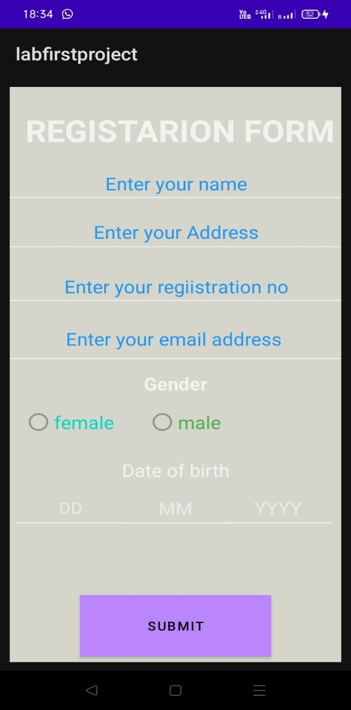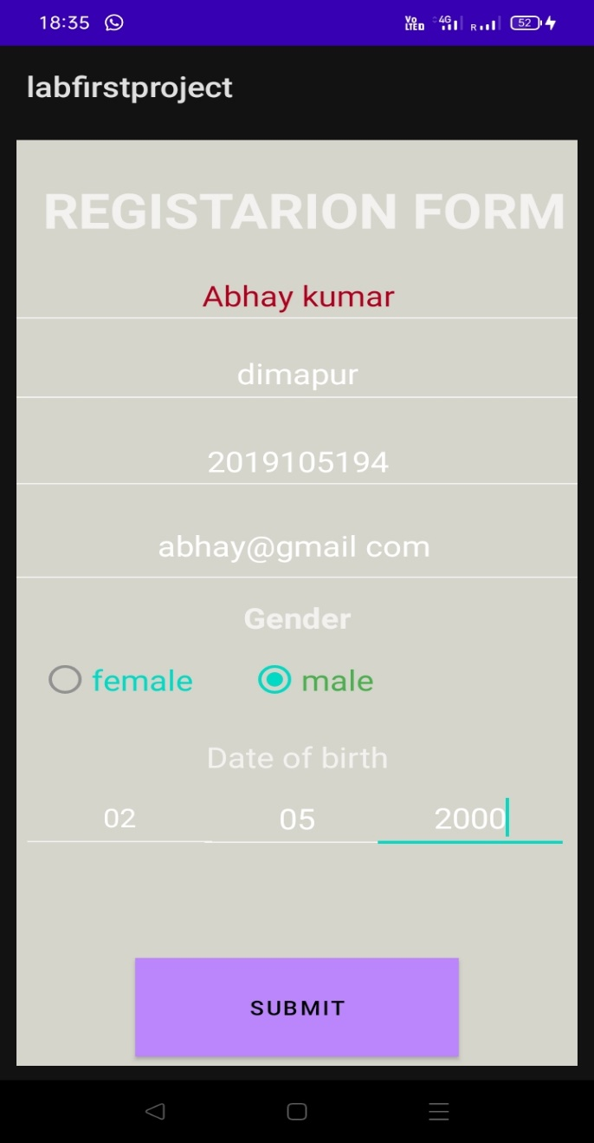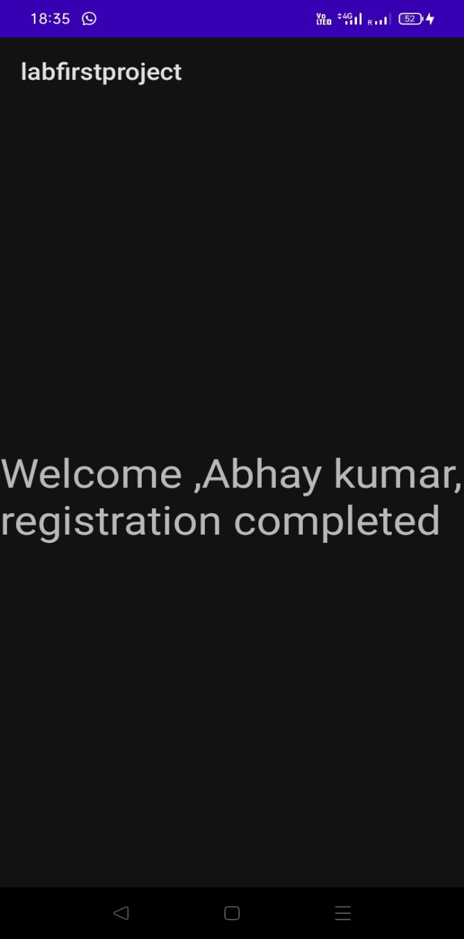

**Detail inserted**

**Registration form**

**Output**

**Registration completed**