**ASSIGNMENT NO - 2**

**Aim : To write an android program to mimic the function of a calculator which must include some basic arithmetic operation like addition, subtraction, multiplication and division.**

* **Description:**

I have to create an android application which will take the input from the user and give the result by performing the assigned operation like addition, subtraction, multiplication, division the steps are as follows :

* Create a new project.
* Name them as calculator.
* It will generate activity_main.xml and mainactivity.java file.
* Assigned all the functionality of the calculator like no, operation and many more.
* Perform the operation as required.
* **Expected input:**

My expected input the integer value.

* **Expected output:**

My expected output will be the result which will came after performing the operation .

* **Discussion:**

In this program I have to create the calculator with having the basic functionality like addition , subtraction, multiplication, division and no as well, when a user gives some input to the calculator it will perform the given task and display the result.

* **Error checking :**

I have done the error checking there is no any error the program is running well and fine.

* **Assumption taken:**

There is no any assumption.

* **Scope for improvement:**

Its user interface should be improved and database should be connected to store the data.

* **Additional feature :**

It will display all the data in proper format.

**Activity_main.xml**

*<?***xml version="1.0" encoding="utf-8"***?>*<**androidx.constraintlayout.widget.ConstraintLayout xmlns:android="http://schemas.android.com/apk/res/android"  
 xmlns:app="http://schemas.android.com/apk/res-auto"  
 xmlns:tools="http://schemas.android.com/tools"  
 android:layout_width="match_parent"  
 android:layout_height="match_parent"  
 tools:context=".MainActivity"**>  
  
 <**Button  
 android:id="@+id/btnr"  
 android:layout_width="wrap_content"  
 android:layout_height="wrap_content"  
 android:text="refresh"  
 app:layout_constraintBottom_toBottomOf="parent"  
 app:layout_constraintEnd_toEndOf="parent"  
 app:layout_constraintHorizontal_bias="0.368"  
 app:layout_constraintStart_toStartOf="parent"  
 app:layout_constraintTop_toTopOf="parent"  
 app:layout_constraintVertical_bias="0.874"** />  
  
 <**Button  
 android:id="@+id/btne"  
 android:layout_width="wrap_content"  
 android:layout_height="wrap_content"  
 android:text="="  
 app:layout_constraintBottom_toBottomOf="parent"  
 app:layout_constraintEnd_toEndOf="parent"  
 app:layout_constraintHorizontal_bias="0.832"  
 app:layout_constraintStart_toStartOf="parent"  
 app:layout_constraintTop_toTopOf="parent"  
 app:layout_constraintVertical_bias="0.737"** />  
  
 <**Button  
 android:id="@+id/btnd"  
 android:layout_width="wrap_content"  
 android:layout_height="wrap_content"  
 android:text="/"  
 app:layout_constraintBottom_toBottomOf="parent"  
 app:layout_constraintEnd_toEndOf="parent"  
 app:layout_constraintHorizontal_bias="0.444"  
 app:layout_constraintStart_toStartOf="parent"  
 app:layout_constraintTop_toTopOf="parent"  
 app:layout_constraintVertical_bias="0.737"** />  
  
 <**Button  
 android:id="@+id/btnm"  
 android:layout_width="wrap_content"  
 android:layout_height="wrap_content"  
 android:text="*"  
 app:layout_constraintBottom_toBottomOf="parent"  
 app:layout_constraintEnd_toEndOf="parent"  
 app:layout_constraintHorizontal_bias="0.05"  
 app:layout_constraintStart_toStartOf="parent"  
 app:layout_constraintTop_toTopOf="parent"  
 app:layout_constraintVertical_bias="0.737"** />  
  
 <**Button  
 android:id="@+id/btns"  
 android:layout_width="wrap_content"  
 android:layout_height="wrap_content"  
 android:text="-"  
 app:layout_constraintBottom_toBottomOf="parent"  
 app:layout_constraintEnd_toEndOf="parent"  
 app:layout_constraintHorizontal_bias="0.832"  
 app:layout_constraintStart_toStartOf="parent"  
 app:layout_constraintTop_toTopOf="parent"  
 app:layout_constraintVertical_bias="0.631"** />  
  
 <**Button  
 android:id="@+id/btnp"  
 android:layout_width="wrap_content"  
 android:layout_height="wrap_content"  
 android:text="+"  
 app:layout_constraintBottom_toBottomOf="parent"  
 app:layout_constraintEnd_toEndOf="parent"  
 app:layout_constraintHorizontal_bias="0.403"  
 app:layout_constraintStart_toStartOf="parent"  
 app:layout_constraintTop_toTopOf="parent"  
 app:layout_constraintVertical_bias="0.631"** />  
  
 <**Button  
 android:id="@+id/btn4"  
 android:layout_width="wrap_content"  
 android:layout_height="wrap_content"  
 android:text="4"  
 app:layout_constraintBottom_toBottomOf="parent"  
 app:layout_constraintEnd_toEndOf="parent"  
 app:layout_constraintHorizontal_bias="0.049"  
 app:layout_constraintStart_toStartOf="parent"  
 app:layout_constraintTop_toTopOf="parent"  
 app:layout_constraintVertical_bias="0.409"** />  
  
 <**Button  
 android:id="@+id/btn1"  
 android:layout_width="wrap_content"  
 android:layout_height="wrap_content"  
 android:text="1"  
 app:layout_constraintBottom_toBottomOf="parent"  
 app:layout_constraintEnd_toEndOf="parent"  
 app:layout_constraintHorizontal_bias="0.049"  
 app:layout_constraintStart_toStartOf="parent"  
 app:layout_constraintTop_toTopOf="parent"  
 app:layout_constraintVertical_bias="0.313"** />  
  
 <**Button  
 android:id="@+id/btn0"  
 android:layout_width="wrap_content"  
 android:layout_height="wrap_content"  
 android:text="0"  
 app:layout_constraintBottom_toBottomOf="parent"  
 app:layout_constraintEnd_toEndOf="parent"  
 app:layout_constraintHorizontal_bias="0.044"  
 app:layout_constraintStart_toStartOf="parent"  
 app:layout_constraintTop_toTopOf="parent"  
 app:layout_constraintVertical_bias="0.631"** />  
  
 <**Button  
 android:id="@+id/btn9"  
 android:layout_width="wrap_content"  
 android:layout_height="wrap_content"  
 android:text="9"  
 app:layout_constraintBottom_toBottomOf="parent"  
 app:layout_constraintEnd_toEndOf="parent"  
 app:layout_constraintHorizontal_bias="0.817"  
 app:layout_constraintStart_toStartOf="parent"  
 app:layout_constraintTop_toTopOf="parent"  
 app:layout_constraintVertical_bias="0.527"** />  
  
 <**Button  
 android:id="@+id/btn8"  
 android:layout_width="wrap_content"  
 android:layout_height="wrap_content"  
 android:text="8"  
 app:layout_constraintBottom_toBottomOf="parent"  
 app:layout_constraintEnd_toEndOf="parent"  
 app:layout_constraintHorizontal_bias="0.416"  
 app:layout_constraintStart_toStartOf="parent"  
 app:layout_constraintTop_toTopOf="parent"  
 app:layout_constraintVertical_bias="0.527"** />  
  
 <**Button  
 android:id="@+id/btn7"  
 android:layout_width="wrap_content"  
 android:layout_height="wrap_content"  
 android:text="7"  
 app:layout_constraintBottom_toBottomOf="parent"  
 app:layout_constraintEnd_toEndOf="parent"  
 app:layout_constraintHorizontal_bias="0.05"  
 app:layout_constraintStart_toStartOf="parent"  
 app:layout_constraintTop_toTopOf="parent"  
 app:layout_constraintVertical_bias="0.527"** />  
  
 <**Button  
 android:id="@+id/btn6"  
 android:layout_width="wrap_content"  
 android:layout_height="wrap_content"  
 android:text="6"  
 app:layout_constraintBottom_toBottomOf="parent"  
 app:layout_constraintEnd_toEndOf="parent"  
 app:layout_constraintHorizontal_bias="0.817"  
 app:layout_constraintStart_toStartOf="parent"  
 app:layout_constraintTop_toTopOf="parent"  
 app:layout_constraintVertical_bias="0.409"** />  
  
 <**Button  
 android:id="@+id/btn3"  
 android:layout_width="wrap_content"  
 android:layout_height="wrap_content"  
 android:text="3"  
 app:layout_constraintBottom_toBottomOf="parent"  
 app:layout_constraintEnd_toEndOf="parent"  
 app:layout_constraintHorizontal_bias="0.817"  
 app:layout_constraintStart_toStartOf="parent"  
 app:layout_constraintTop_toTopOf="parent"  
 app:layout_constraintVertical_bias="0.313"** />  
  
 <**Button  
 android:id="@+id/btn2"  
 android:layout_width="wrap_content"  
 android:layout_height="wrap_content"  
 android:text="2"  
 app:layout_constraintBottom_toBottomOf="parent"  
 app:layout_constraintEnd_toEndOf="parent"  
 app:layout_constraintHorizontal_bias="0.416"  
 app:layout_constraintStart_toStartOf="parent"  
 app:layout_constraintTop_toTopOf="parent"  
 app:layout_constraintVertical_bias="0.313"** />  
  
 <**Button  
 android:id="@+id/btn5"  
 android:layout_width="wrap_content"  
 android:layout_height="wrap_content"  
 android:text="5"  
 app:layout_constraintBottom_toBottomOf="parent"  
 app:layout_constraintEnd_toEndOf="parent"  
 app:layout_constraintHorizontal_bias="0.416"  
 app:layout_constraintStart_toStartOf="parent"  
 app:layout_constraintTop_toTopOf="parent"  
 app:layout_constraintVertical_bias="0.409"** />  
  
 <**TextView  
 android:id="@+id/textView2"  
 android:layout_width="333dp"  
 android:layout_height="58dp"  
 android:textSize="34sp"  
 app:layout_constraintBottom_toBottomOf="parent"  
 app:layout_constraintEnd_toEndOf="parent"  
 app:layout_constraintHorizontal_bias="0.453"  
 app:layout_constraintStart_toStartOf="parent"  
 app:layout_constraintTop_toTopOf="parent"  
 app:layout_constraintVertical_bias="0.103"** />  
</**androidx.constraintlayout.widget.ConstraintLayout**>

Mainactivity.kt

**package** com.example.calculator  
  
**import** androidx.appcompat.app.AppCompatActivity  
**import** android.os.Bundle  
**import** android.widget.Button  
**import** android.widget.EditText  
**import** android.widget.TextView  
  
**class** MainActivity : AppCompatActivity() {  
 **override fun** onCreate(savedInstanceState: Bundle?) {  
 **super**.onCreate(savedInstanceState)  
 setContentView(R.layout.activity_main)  
  
 **var** value = findViewById<TextView>(R.id.textView2)  
 **var** btn1 = findViewById<Button>(R.id.btn1)  
 **var** btn2 = findViewById<Button>(R.id.btn2)  
 **var** btn3 = findViewById<Button>(R.id.btn3)  
 **var** btn4 = findViewById<Button>(R.id.btn4)  
 **var** btn5 = findViewById<Button>(R.id.btn5)  
 **var** btn6 = findViewById<Button>(R.id.btn6)  
 **var** btn7 = findViewById<Button>(R.id.btn7)  
 **var** btn8 = findViewById<Button>(R.id.btn8)  
 **var** btn9 = findViewById<Button>(R.id.btn9)  
 **var** btn0 = findViewById<Button>(R.id.btn0)  
  
 **var** btnp = findViewById<Button>(R.id.btnp)  
 **var** btns = findViewById<Button>(R.id.btns)  
 **var** btnm = findViewById<Button>(R.id.btnm)  
 **var** btnd = findViewById<Button>(R.id.btnd)  
 **var** btne = findViewById<Button>(R.id.btne)  
 **var** btnr = findViewById<Button>(R.id.btnr)  
  
 **var** initial_value = **""  
 var** mo = **""** btn1.setOnClickListener **{  
 var** valu = value.text.toString()  
 value.text = valu+**"1"  
 }** btn2.setOnClickListener **{  
 var** valu = value.text.toString()  
 value.text = valu+**"2"  
 }** btn3.setOnClickListener **{  
 var** valu = value.text.toString()  
 value.text = valu+**"3"  
 }** btn4.setOnClickListener **{  
 var** valu = value.text.toString()  
 value.text = valu+**"4"  
 }** btn5.setOnClickListener **{  
 var** valu = value.text.toString()  
 value.text = valu+**"5"  
 }** btn6.setOnClickListener **{  
 var** valu = value.text.toString()  
 value.text = valu+**"6"  
 }** btn7.setOnClickListener **{  
 var** valu = value.text.toString()  
 value.text = valu+**"7"  
 }** btn8.setOnClickListener **{  
 var** valu = value.text.toString()  
 value.text = valu+**"8"  
 }** btn9.setOnClickListener **{  
 var** valu = value.text.toString()  
 value.text = valu+**"9"  
 }** btn0.setOnClickListener **{  
 var** valu = value.text.toString()  
 value.text = valu+**"0"  
 }** btnp.setOnClickListener **{  
 var** valu = value.text.toString()  
 initial_value = valu  
 mo = **"+"** value.text = **""  
 }** btns.setOnClickListener **{  
 var** valu = value.text.toString()  
 initial_value = valu  
 mo = **"-"** value.text = **""  
 }** btnm.setOnClickListener **{  
 var** valu = value.text.toString()  
 initial_value = valu  
 mo = **"*"** value.text = **""  
 }** btnd.setOnClickListener **{  
 var** valu = value.text.toString()  
 initial_value = valu  
 mo = **"/"** value.text = **""  
 }** btne.setOnClickListener **{  
 var** valu = value.text.toString()  
 **if** (mo == **"+"**) {  
 **var** fin = initial_value.toInt()+valu.toInt()  
 value.text = **"$**fin**"** }  
 **else if** (mo ==**"-"**)  
 {  
 **var** fin = initial_value.toInt()-valu.toInt()  
 value.text = **"$**fin**"** }  
 **else if** (mo == **"*"**)  
 {  
 **var** fin = initial_value.toInt()*valu.toInt()  
 value.text = **"$**fin**"** }  
 **else if** (mo == **"/"**)  
 {  
 **var** fin = initial_value.toInt()/valu.toInt()  
 value.text = **"$**fin**"** }  
 **}** btnr.setOnClickListener **{** initial_value = **""** mo = **""** value.text = **""  
 }** }  
  
  
  
}

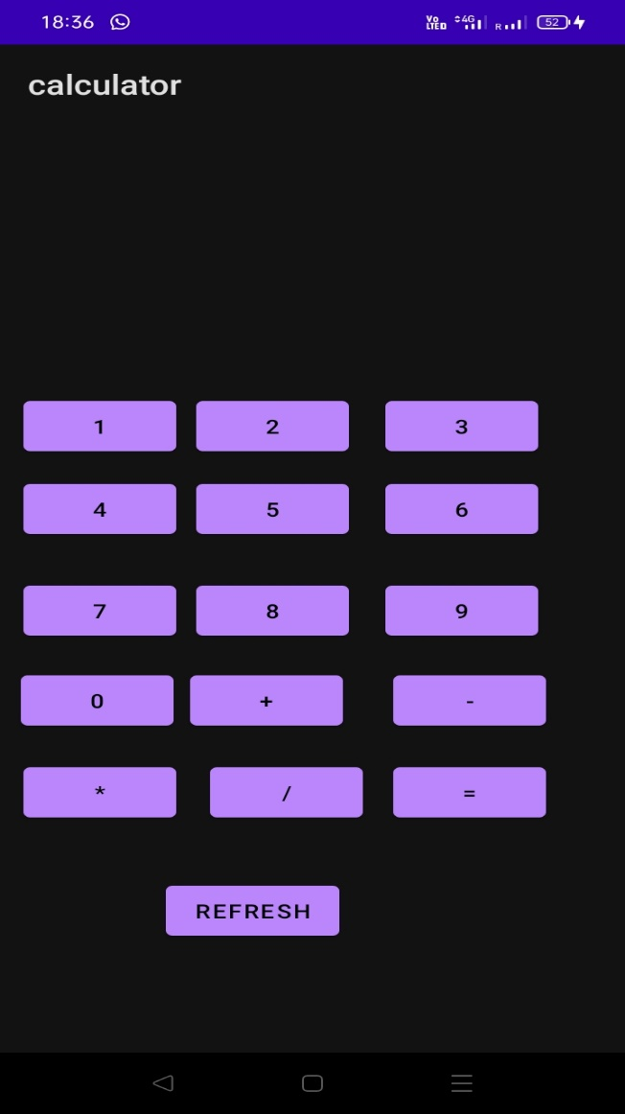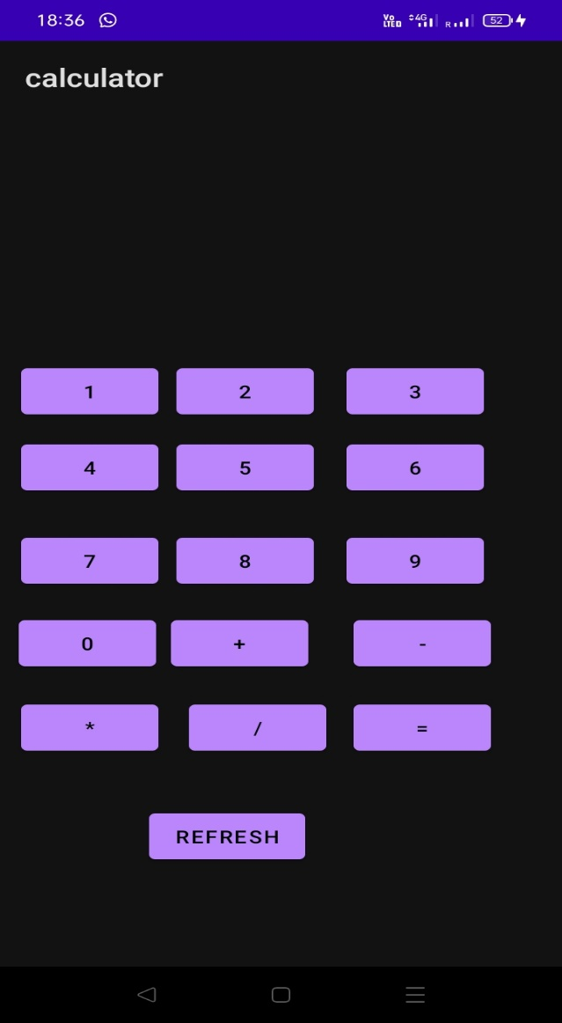

**Output**

**Giving input**

**Calculator**

12 + 13

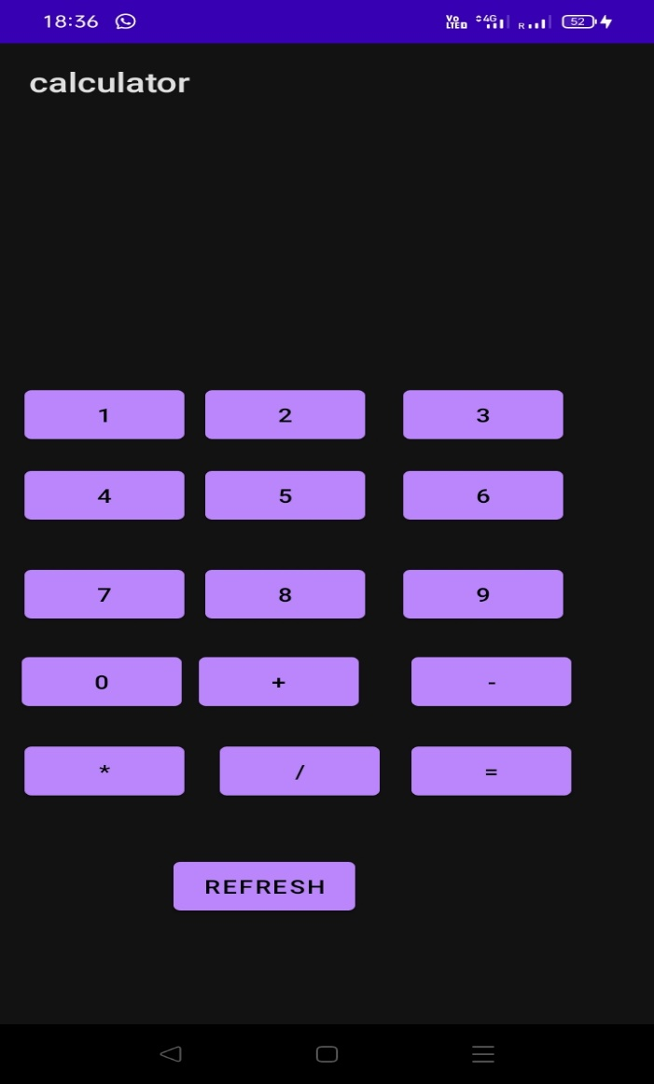

**Output**

25