**ASSIGNMENT NO - 4**

**Aim : To write an android program for a functioning Alarm clock with on/off toggle option .**

* **Description:**

I have to create an android application which can setup and discard the alarm using alarmclock:

* Create a new project.
* Name them as alarmclock.
* It will generate activity_main.xml and mainactivity.java file.
* **Expected input:**

My expected input is the time at which we have to set the alarm the clock.

* **Expected output:**

My expected output is the alarm clock which will set the alarm according to our requirement and give notification at the allotted time .

* **Discussion:**

In this program I will create an application which consist of the user interface where a user can choose the time and set the alarm.

* **Error checking :**

I have done the error checking there is no any error the program is running well and fine.

* **Assumption taken:**

There should be the system compatible with alarm clock.

* **Scope for improvement:**

Its user interface should be improved and some more function can be added.

* **Additional feature :**

It will notify the user at a particular time.

**Activity_main.xml**

*<?***xml version="1.0" encoding="utf-8"***?>*<**LinearLayout  
 xmlns:android="http://schemas.android.com/apk/res/android"  
 android:layout_width="match_parent"  
 android:layout_height="match_parent"  
 android:orientation="vertical"**>  
  
 *<!--Added Time picker just to pick the alarm time-->  
 <!--gravity is aligned to center-->* <**TimePicker  
 android:id="@+id/timePicker"  
 android:layout_width="wrap_content"  
 android:layout_height="wrap_content"  
 android:layout_gravity="center"** />  
  
 *<!--Added Toggle Button to set the alarm on or off-->  
 <!--ByDefault toggleButton is set to false-->* <**ToggleButton  
 android:id="@+id/toggleButton"  
 android:layout_width="wrap_content"  
 android:layout_height="wrap_content"  
 android:layout_gravity="center"  
 android:layout_margin="20dp"  
 android:checked="false"  
 android:onClick="OnToggleClicked"** />  
  
 *<!--"OnToggleClicked" method will be implemented in MainActivity.java -->*</**LinearLayout**>

**MainActivity.java**

**package** com.example.cloc;  
  
**import** android.app.AlarmManager;  
**import** android.app.PendingIntent;  
**import** android.content.Intent;  
**import** android.os.Bundle;  
**import** android.view.View;  
**import** android.widget.TimePicker;  
**import** android.widget.Toast;  
**import** android.widget.ToggleButton;  
  
**import** androidx.appcompat.app.AppCompatActivity;  
  
**import** java.util.Calendar;  
  
**public class** MainActivity **extends** AppCompatActivity {  
 TimePicker **alarmTimePicker**;  
 PendingIntent **pendingIntent**;  
 AlarmManager **alarmManager**;  
  
 @Override  
 **protected void** onCreate(Bundle savedInstanceState) {  
 **super**.onCreate(savedInstanceState);  
 setContentView(R.layout.***activity_main***);  
  
 **alarmTimePicker** = (TimePicker) findViewById(R.id.***timePicker***);  
 **alarmManager** = (AlarmManager) getSystemService(***ALARM_SERVICE***);  
  
 }  
  
 *// OnToggleClicked() method is implemented the time functionality* **public void** OnToggleClicked(View view) {  
 **long** time;  
 **if** (((ToggleButton) view).isChecked()) {  
 Toast.*makeText*(MainActivity.**this**, **"ALARM ON"**, Toast.***LENGTH_SHORT***).show();  
 Calendar calendar = Calendar.*getInstance*();  
  
 *// calendar is called to get current time in hour and minute* calendar.set(Calendar.***HOUR_OF_DAY***, **alarmTimePicker**.getCurrentHour());  
 calendar.set(Calendar.***MINUTE***, **alarmTimePicker**.getCurrentMinute());  
  
 *// using intent i have class AlarmReceiver class which inherits  
 // BroadcastReceiver* Intent intent = **new** Intent(**this**, alarmReceiver.**class**);  
  
 *// we call broadcast using pendingIntent* **pendingIntent** = PendingIntent.*getBroadcast*(**this**, 0, intent, 0);  
  
 time = (calendar.getTimeInMillis() - (calendar.getTimeInMillis() % 60000));  
 **if** (System.*currentTimeMillis*() > time) {  
 *// setting time as AM and PM* **if** (calendar.***AM_PM*** == 0)  
 time = time + (1000 * 60 * 60 * 12);  
 **else** time = time + (1000 * 60 * 60 * 24);  
 }  
 *// Alarm rings continuously until toggle button is turned off* **alarmManager**.setRepeating(AlarmManager.***RTC_WAKEUP***, time, 10000, **pendingIntent**);  
 *// alarmManager.set(AlarmManager.RTC_WAKEUP, System.currentTimeMillis() + (time * 1000), pendingIntent);* } **else** {  
 **alarmManager**.cancel(**pendingIntent**);  
 Toast.*makeText*(MainActivity.**this**, **"ALARM OFF"**, Toast.***LENGTH_SHORT***).show();  
 }  
 }  
}

**AlarmReceiver.java**

**package** com.example.cloc;  
  
**import** android.content.BroadcastReceiver;  
**import** android.content.Context;  
**import** android.content.Intent;  
**import** android.media.Ringtone;  
**import** android.media.RingtoneManager;  
**import** android.net.Uri;  
**import** android.os.Build;  
**import** android.os.Vibrator;  
**import** android.widget.Toast;  
  
**import** androidx.annotation.RequiresApi;  
  
**public class** alarmReceiver **extends** BroadcastReceiver {  
  
 @RequiresApi(api = Build.VERSION_CODES.***Q***)  
 @Override  
 **public void** onReceive(Context context, Intent intent) {  
  
 Vibrator vibrator = (Vibrator) context.getSystemService(context.***VIBRATOR_SERVICE***);  
 vibrator.vibrate(4000);  
  
 Toast.*makeText*(context, **"Alarm! Wake up! Wake up!"**, Toast.***LENGTH_LONG***).show();  
 Uri alarmUri = RingtoneManager.*getDefaultUri*(RingtoneManager.***TYPE_ALARM***);  
 **if** (alarmUri == **null**) {  
 alarmUri = RingtoneManager.*getDefaultUri*(RingtoneManager.***TYPE_NOTIFICATION***);  
 }  
  
 *// setting default ringtone* Ringtone ringtone = RingtoneManager.*getRingtone*(context, alarmUri);  
  
 *// play ringtone* ringtone.play();  
  
 }  
}

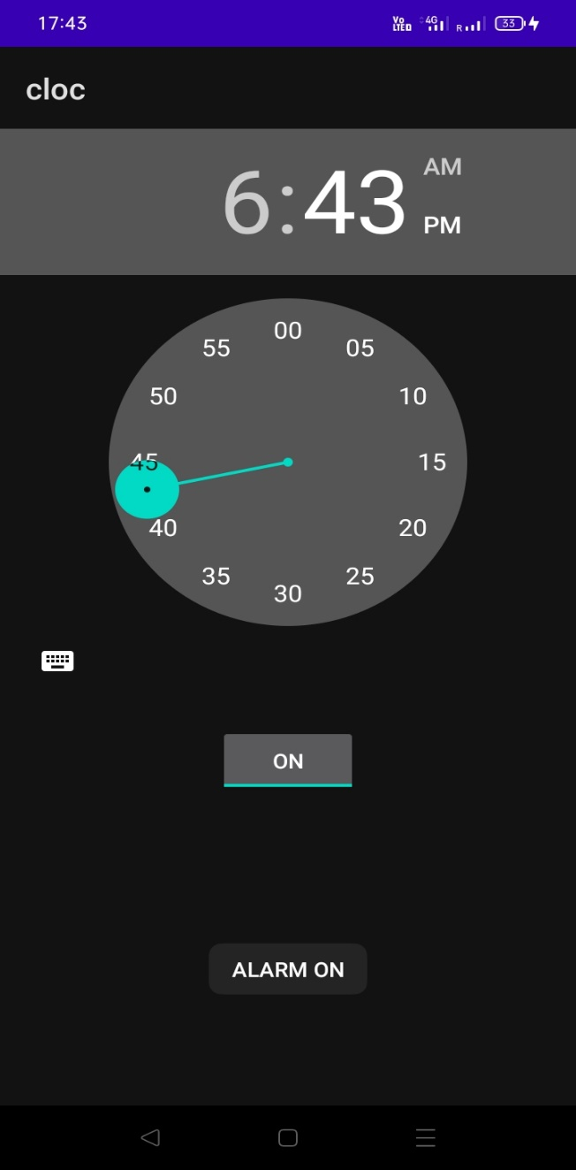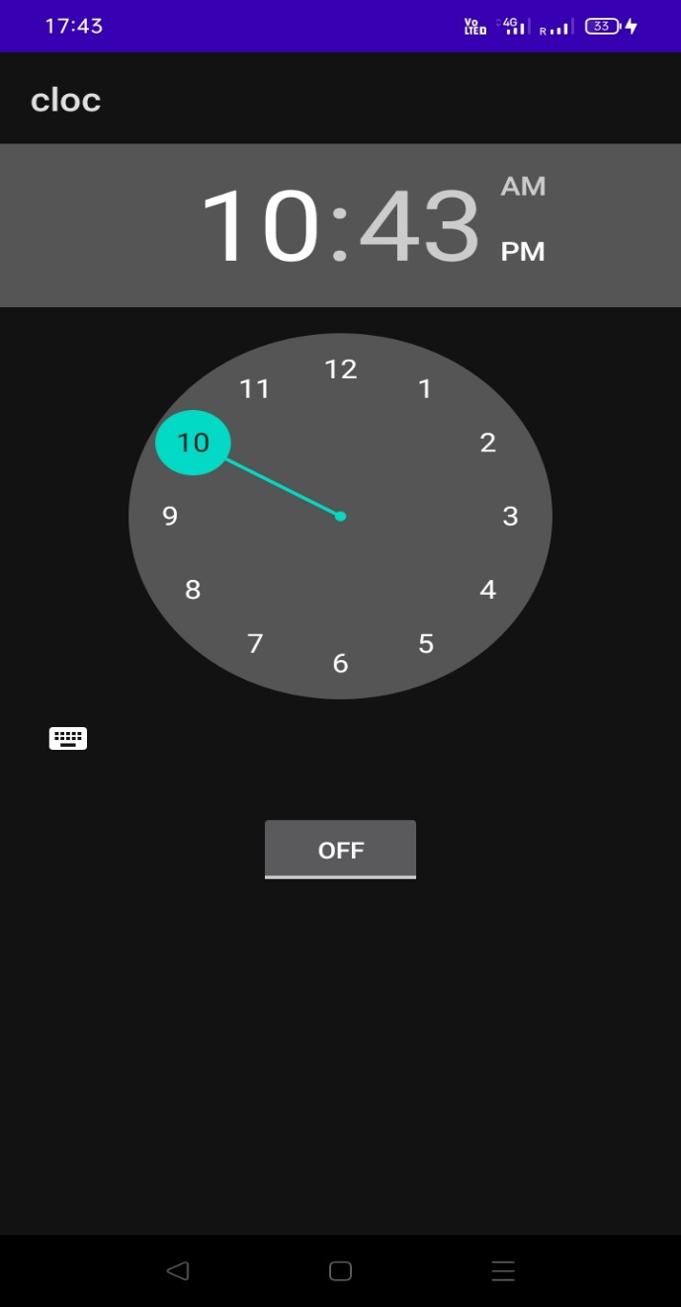

**Alarm on**

**Alarm clock**

**Output**