**ASSIGNMENT NO - 7**

**Aim : write a simple android program to create a contact app with basic functionality like saving the contact.**

* **Description:**

I have to create an android application adding a new contact in to the contact list.

* Create a new project.
* Name them as registration form.
* It will generate activity_main.xml and mainactivity.java file.
* It will save the contact in the contact list.
* **Expected input:**

My expected input is mobile no and name.

* **Expected output:**

My expected output is showing the name in alphabetical order .

* **Discussion:**

In this program I have to create the form which will take the mobile no and name and save is to the contact list according to the alphabetical order.

* **Error checking :**

I have done the error checking there is no any error the program is running well and fine.

* **Assumption taken:**

There should be the read and write permission.

* **Scope for improvement:**

Its user interface should be improved and database should be connected to store the data.

* **Additional feature :**

It will display all the data in proper format, here alphabetically.

**Activity_main.xml**

*<?***xml version="1.0" encoding="utf-8"***?>*<**androidx.constraintlayout.widget.ConstraintLayout xmlns:android="http://schemas.android.com/apk/res/android"  
 xmlns:app="http://schemas.android.com/apk/res-auto"  
 xmlns:tools="http://schemas.android.com/tools"  
 android:layout_width="match_parent"  
 android:layout_height="match_parent"  
 tools:context=".MainActivity"**>  
  
 <**EditText  
 android:id="@+id/editTextTextPersonName"  
 android:layout_width="287dp"  
 android:layout_height="85dp"  
 android:ems="10"  
 android:hint="Name ..."  
 android:inputType="textPersonName"  
 app:layout_constraintBottom_toBottomOf="parent"  
 app:layout_constraintEnd_toEndOf="parent"  
 app:layout_constraintHorizontal_bias="0.54"  
 app:layout_constraintStart_toStartOf="parent"  
 app:layout_constraintTop_toTopOf="parent"  
 app:layout_constraintVertical_bias="0.086"** />  
  
 <**EditText  
 android:id="@+id/editTextNumber"  
 android:layout_width="282dp"  
 android:layout_height="91dp"  
 android:layout_marginTop="53dp"  
 android:ems="10"  
 android:hint="Number ..."  
 android:inputType="number"  
 app:layout_constraintBottom_toBottomOf="parent"  
 app:layout_constraintEnd_toEndOf="parent"  
 app:layout_constraintHorizontal_bias="0.519"  
 app:layout_constraintStart_toStartOf="parent"  
 app:layout_constraintTop_toBottomOf="@+id/editTextTextPersonName"  
 app:layout_constraintVertical_bias="0.116"** />  
  
 <**Button  
 android:id="@+id/button"  
 android:layout_width="158dp"  
 android:layout_height="54dp"  
 android:layout_marginTop="96dp"  
 android:onClick="buttonAddContact"  
 android:text="Add Contact"  
 app:layout_constraintBottom_toBottomOf="parent"  
 app:layout_constraintEnd_toEndOf="parent"  
 app:layout_constraintHorizontal_bias="0.498"  
 app:layout_constraintStart_toStartOf="parent"  
 app:layout_constraintTop_toBottomOf="@+id/editTextNumber"  
 app:layout_constraintVertical_bias="0.149"** />  
</**androidx.constraintlayout.widget.ConstraintLayout**>

**Mainactivity.java**

**package** com.example.project_7;  
  
**import** androidx.appcompat.app.AppCompatActivity;  
**import** androidx.core.app.ActivityCompat;  
  
**import** android.Manifest;  
**import** android.app.Activity;  
**import** android.content.ContentProviderOperation;  
**import** android.content.OperationApplicationException;  
**import** android.content.pm.PackageManager;  
**import** android.os.Bundle;  
**import** android.os.RemoteException;  
**import** android.provider.ContactsContract;  
**import** android.view.View;  
**import** android.widget.EditText;  
  
**import** java.util.ArrayList;  
  
**public class** MainActivity **extends** AppCompatActivity {  
  
 **private** EditText **editTextName**,**editTextNumber**;  
  
  
 @Override  
 **protected void** onCreate(Bundle savedInstanceState) {  
 **super**.onCreate(savedInstanceState);  
 setContentView(R.layout.***activity_main***);  
 *//THESE LINE OF CODE WILL GIVE THE PERMISSION TO WRITE INTO THE CONTACT* ActivityCompat.*requestPermissions*(**this**,  
 **new** String[]{Manifest.permission.***WRITE_CONTACTS***},  
 PackageManager.***PERMISSION_GRANTED***);  
  
 **editTextName** = findViewById(R.id.***editTextTextPersonName***);  
 **editTextNumber** = findViewById(R.id.***editTextNumber***);  
 }  
  
 **public void** buttonAddContact(View view){  
 ArrayList<ContentProviderOperation> contentProviderOperations  
 = **new** ArrayList<ContentProviderOperation>();  
  
 contentProviderOperations.add(ContentProviderOperation.*newInsert*(  
 ContactsContract.RawContacts.***CONTENT_URI***)  
 .withValue(ContactsContract.RawContacts.***ACCOUNT_TYPE***, **null**)  
 .withValue(ContactsContract.RawContacts.***ACCOUNT_NAME***, **null**)  
 .build());  
  
 *// Adding Name* contentProviderOperations.add(ContentProviderOperation  
 .*newInsert*(ContactsContract.Data.***CONTENT_URI***)  
 .withValueBackReference(ContactsContract.Data.***RAW_CONTACT_ID***,0)  
 .withValue(ContactsContract.Data.***MIMETYPE***,  
 ContactsContract.CommonDataKinds.StructuredName.***CONTENT_ITEM_TYPE***)  
 .withValue(ContactsContract.CommonDataKinds.StructuredName.***DISPLAY_NAME***,  
 **editTextName**.getText().toString())  
 .build());  
  
 *// Adding Number* contentProviderOperations.add(ContentProviderOperation  
 .*newInsert*(ContactsContract.Data.***CONTENT_URI***)  
 .withValueBackReference(ContactsContract.Data.***RAW_CONTACT_ID***,0)  
 .withValue(ContactsContract.Data.***MIMETYPE***,  
 ContactsContract.CommonDataKinds.Phone.***CONTENT_ITEM_TYPE***)  
 .withValue(ContactsContract.CommonDataKinds.Phone.***NUMBER***,  
 **editTextNumber**.getText().toString())  
 .withValue(ContactsContract.CommonDataKinds.Phone.***TYPE***,  
 ContactsContract.CommonDataKinds.Phone.***TYPE_MOBILE***)  
 .build());  
  
 **try** {  
 getContentResolver().applyBatch(ContactsContract.***AUTHORITY***, contentProviderOperations);  
 } **catch** (OperationApplicationException e) {  
 e.printStackTrace();  
 } **catch** (RemoteException e) {  
 e.printStackTrace();  
 }  
  
 }  
}

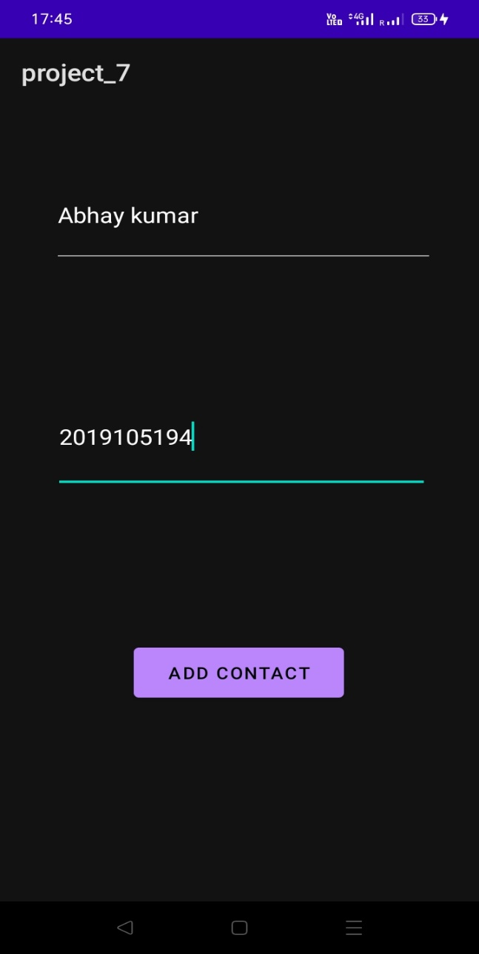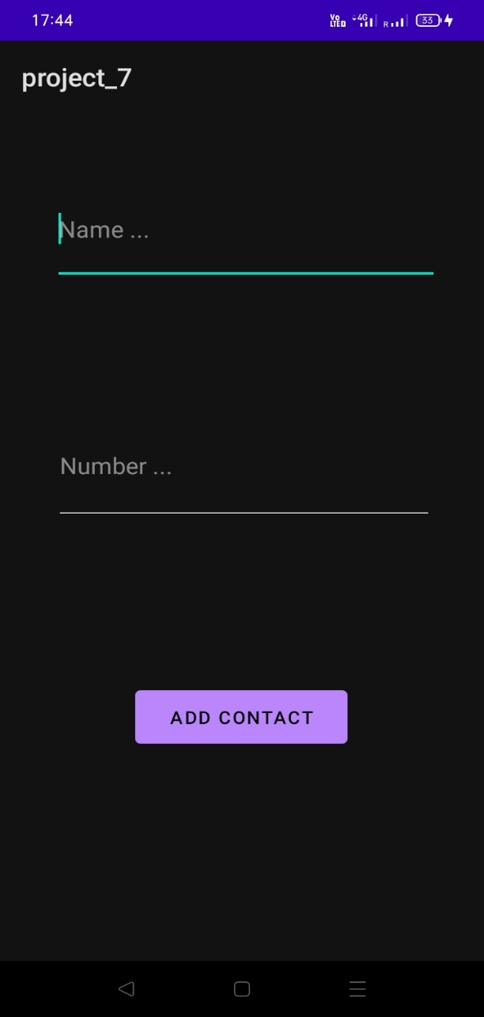

**Output**

**Input data**

**Contact form**

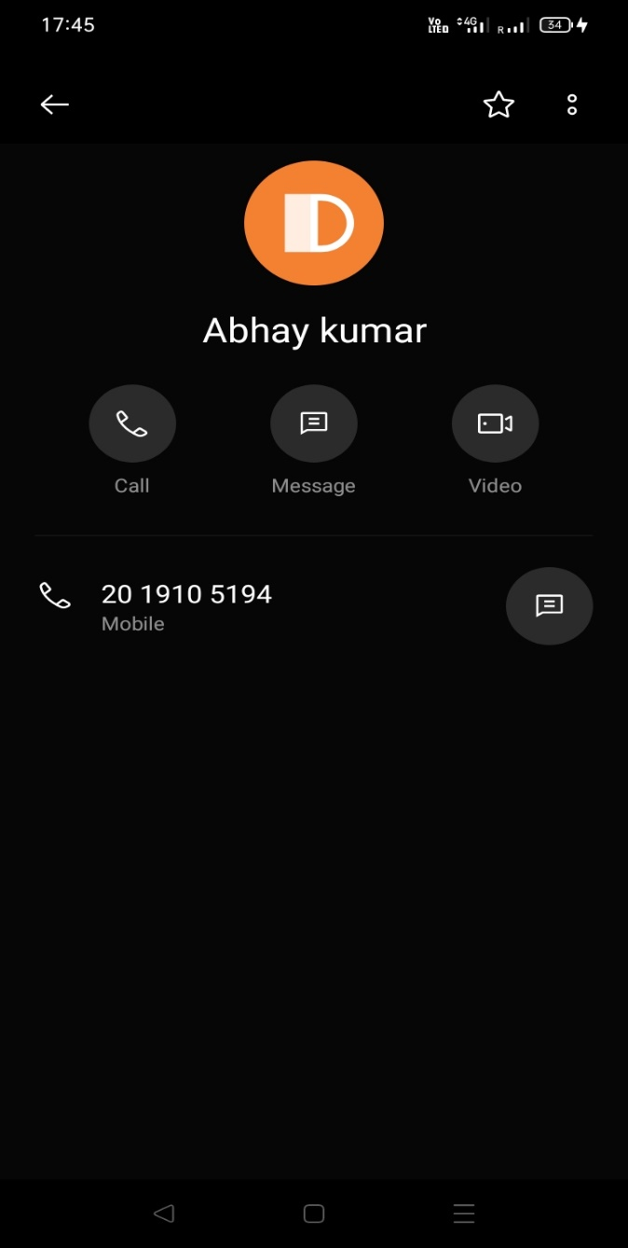

**Saved contact**