**ASSIGNMENT NO - 3**

**Aim : To write an android program to take in the input from the user (name , address , age , registration no) and submit to display the detail in the other screen.**

* **Description:**

I have to create an android application which will take the input from the user in a user form which consist of name , address , registration no etc . on pressing the submit button a new page will be displayed which will show the result which I have submitted :

* Create a new project.
* Name them as user input form.
* It will generate activity_main.xml and mainactivity.java file.
* Create another activity file which will display the output on clicking the submit button.
* **Expected input:**

My expected input is name, reg_no , address , email_id.

* **Expected output:**

My expected output will be a new page displaying all the entered value .

* **Discussion:**

In this program I have to create the form which consist of some input field like name, registration no, address and email id . The user will fill up all these data and then on clicking the submit button we will get a new page which will display all the data which I have submitted in the first page.

* **Error checking :**

I have done the error checking there is no any error the program is running well and fine.

* **Assumption taken:**

There is no any assumption.

* **Scope for improvement:**

Its user interface should be improved and database should be connected to store the data.

* **Additional feature :**

It will display all the data in proper format.

**Activity_main.xml**

*<?***xml version="1.0" encoding="utf-8"***?>*<**androidx.constraintlayout.widget.ConstraintLayout xmlns:android="http://schemas.android.com/apk/res/android"  
 xmlns:app="http://schemas.android.com/apk/res-auto"  
 xmlns:tools="http://schemas.android.com/tools"  
 android:layout_width="match_parent"  
 android:layout_height="match_parent"  
 android:layout_margin="10dp"  
 android:background="#D6D5CC"  
 android:textAlignment="center"  
 tools:context=".MainActivity"**>  
  
 <**EditText  
 android:id="@+id/name"  
 android:layout_width="370dp"  
 android:layout_height="wrap_content"  
 android:ems="10"  
 android:hint="Enter your name"  
 android:inputType="textPersonName"  
 android:textAlignment="center"  
 android:textColor="@color/design_default_color_error"  
 android:textColorHint="#2196F3"  
 android:textSize="20sp"  
 app:layout_constraintBottom_toBottomOf="parent"  
 app:layout_constraintEnd_toEndOf="parent"  
 app:layout_constraintHorizontal_bias="0.5"  
 app:layout_constraintStart_toStartOf="parent"  
 app:layout_constraintTop_toTopOf="parent"  
 app:layout_constraintVertical_bias="0.142"** />  
  
 <**EditText  
 android:id="@+id/addr"  
 android:layout_width="370dp"  
 android:layout_height="50dp"  
 android:ems="10"  
 android:hint="Enter your Address"  
 android:inputType="textPostalAddress"  
 android:textAlignment="center"  
 android:textColorHint="#2196F3"  
 android:textSize="20sp"  
 app:layout_constraintBottom_toBottomOf="parent"  
 app:layout_constraintEnd_toEndOf="parent"  
 app:layout_constraintHorizontal_bias="0.5"  
 app:layout_constraintStart_toStartOf="parent"  
 app:layout_constraintTop_toTopOf="parent"  
 app:layout_constraintVertical_bias="0.232"** />  
  
 <**TextView  
 android:id="@+id/textView"  
 android:layout_width="383dp"  
 android:layout_height="52dp"  
 android:text="REGISTARION FORM"  
 android:textAlignment="center"  
 android:textSize="34sp"  
 android:textStyle="bold"  
 app:layout_constraintBottom_toBottomOf="parent"  
 app:layout_constraintEnd_toEndOf="parent"  
 app:layout_constraintHorizontal_bias="0.413"  
 app:layout_constraintStart_toStartOf="parent"  
 app:layout_constraintTop_toTopOf="parent"  
 app:layout_constraintVertical_bias="0.044"** />  
  
 <**EditText  
 android:id="@+id/reg"  
 android:layout_width="370dp"  
 android:layout_height="47dp"  
 android:ems="10"  
 android:hint="Enter your regiistration no"  
 android:inputType="number"  
 android:textAlignment="center"  
 android:textColorHint="#2196F3"  
 android:textSize="20sp"  
 app:layout_constraintBottom_toBottomOf="parent"  
 app:layout_constraintEnd_toEndOf="parent"  
 app:layout_constraintHorizontal_bias="0.5"  
 app:layout_constraintStart_toStartOf="parent"  
 app:layout_constraintTop_toTopOf="parent"  
 app:layout_constraintVertical_bias="0.336"** />  
  
 <**EditText  
 android:id="@+id/email"  
 android:layout_width="370dp"  
 android:layout_height="61dp"  
 android:ems="10"  
 android:hint="Enter your email address"  
 android:inputType="textEmailAddress"  
 android:textAlignment="center"  
 android:textColorHint="#2196F3"  
 android:textSize="20sp"  
 app:layout_constraintBottom_toBottomOf="parent"  
 app:layout_constraintEnd_toEndOf="parent"  
 app:layout_constraintHorizontal_bias="0.589"  
 app:layout_constraintStart_toStartOf="parent"  
 app:layout_constraintTop_toTopOf="parent"  
 app:layout_constraintVertical_bias="0.432"** />  
  
 <**Button  
 android:id="@+id/btn"  
 android:layout_width="196dp"  
 android:layout_height="69dp"  
 android:background="#CDDC39"  
 android:text="SUBMIT"  
 android:textAlignment="center"  
 app:iconTint="#CDDC39"  
 app:layout_constraintBottom_toBottomOf="parent"  
 app:layout_constraintEnd_toEndOf="parent"  
 app:layout_constraintHorizontal_bias="0.5"  
 app:layout_constraintStart_toStartOf="parent"  
 app:layout_constraintTop_toTopOf="parent"  
 app:layout_constraintVertical_bias="0.989"** />  
  
</**androidx.constraintlayout.widget.ConstraintLayout**>

**Activity_main2.xml**

*<?***xml version="1.0" encoding="utf-8"***?>*<**androidx.constraintlayout.widget.ConstraintLayout xmlns:android="http://schemas.android.com/apk/res/android"  
 xmlns:app="http://schemas.android.com/apk/res-auto"  
 xmlns:tools="http://schemas.android.com/tools"  
 android:layout_width="match_parent"  
 android:layout_height="match_parent"  
 android:layout_margin="10dp"  
 android:background="#D6D5CC"  
 android:backgroundTint="#CDDC39"  
 android:textAlignment="center"  
 tools:context=".MainActivity"**>  
  
 <**EditText  
 android:id="@+id/name"  
 android:layout_width="370dp"  
 android:layout_height="70dp"  
 android:ems="10"  
 android:inputType="textPersonName"  
 android:textAlignment="center"  
 android:textColor="@color/design_default_color_error"  
 android:textColorHint="#2196F3"  
 android:textSize="20sp"  
 app:layout_constraintBottom_toTopOf="@+id/addr"  
 app:layout_constraintEnd_toEndOf="parent"  
 app:layout_constraintHorizontal_bias="0.5"  
 app:layout_constraintStart_toStartOf="parent"  
 app:layout_constraintTop_toBottomOf="@+id/textView"  
 app:layout_constraintVertical_bias="0.142"** />  
  
 <**EditText  
 android:id="@+id/addr"  
 android:layout_width="376dp"  
 android:layout_height="70dp"  
 android:ems="10"  
 android:inputType="textPostalAddress"  
 android:textAlignment="center"  
 android:textColorHint="#2196F3"  
 android:textSize="20sp"  
 app:layout_constraintBottom_toBottomOf="parent"  
 app:layout_constraintEnd_toEndOf="parent"  
 app:layout_constraintStart_toStartOf="parent"  
 app:layout_constraintTop_toTopOf="parent"  
 app:layout_constraintVertical_bias="0.323"** />  
  
 <**TextView  
 android:id="@+id/textView"  
 android:layout_width="383dp"  
 android:layout_height="52dp"  
 android:text="REGISTRATION COMPLETED"  
 android:textAlignment="center"  
 android:textSize="24sp"  
 android:textStyle="bold"  
 app:layout_constraintBottom_toBottomOf="parent"  
 app:layout_constraintEnd_toEndOf="parent"  
 app:layout_constraintHorizontal_bias="0.413"  
 app:layout_constraintStart_toStartOf="parent"  
 app:layout_constraintTop_toTopOf="parent"  
 app:layout_constraintVertical_bias="0.044"** />  
  
 <**EditText  
 android:id="@+id/reg"  
 android:layout_width="370dp"  
 android:layout_height="70dp"  
 android:ems="10"  
 android:inputType="number"  
 android:textAlignment="center"  
 android:textColorHint="#2196F3"  
 android:textSize="20sp"  
 app:layout_constraintBottom_toBottomOf="parent"  
 app:layout_constraintEnd_toEndOf="parent"  
 app:layout_constraintStart_toStartOf="parent"  
 app:layout_constraintTop_toTopOf="parent"  
 app:layout_constraintVertical_bias="0.549"** />  
  
 <**EditText  
 android:id="@+id/email"  
 android:layout_width="370dp"  
 android:layout_height="70dp"  
 android:ems="10"  
 android:inputType="textEmailAddress"  
 android:textAlignment="center"  
 android:textColorHint="#2196F3"  
 android:textSize="16sp"  
 app:layout_constraintBottom_toBottomOf="parent"  
 app:layout_constraintEnd_toEndOf="parent"  
 app:layout_constraintHorizontal_bias="0.727"  
 app:layout_constraintStart_toStartOf="parent"  
 app:layout_constraintTop_toTopOf="parent"  
 app:layout_constraintVertical_bias="0.739"** />  
  
  
</**androidx.constraintlayout.widget.ConstraintLayout**>

**MainActivity.kt**

**package** com.example.labproject3  
  
**import** android.content.Intent  
**import** android.os.Bundle  
**import** android.widget.Button  
**import** android.widget.EditText  
**import** android.widget.Toast  
**import** androidx.appcompat.app.AppCompatActivity  
  
**class** MainActivity : AppCompatActivity() {  
 **override fun** onCreate(savedInstanceState: Bundle?) {  
 **super**.onCreate(savedInstanceState)  
 setContentView(R.layout.*activity_main*)  
  
  
 **val** name = findViewById<EditText>(R.id.*name*)  
 **val** reg = findViewById<EditText>(R.id.*reg*)  
 **val** addr = findViewById<EditText>(R.id.*addr*)  
 **val** submit = findViewById<Button>(R.id.*btn*)  
 **val** email = findViewById<EditText>(R.id.*email*)  
  
 submit.setOnClickListener **{  
 var** enteredName = name.*text*.toString()  
 **var** enteredreg = reg.*text*.toString()  
 **var** email1 = email.*text*.toString()  
 **var** addr = addr.*text*.toString()  
 **if** (enteredName==**""**)  
 {  
 *//grettingTextView.text = ""* Toast.makeText(  
 **this**@MainActivity,  
 **"please enter your name"**,  
 Toast.*LENGTH_SHORT* ).show()  
 }  
 **else if** ((enteredreg==**""** )|| (enteredreg.**length** < 10))  
 {  
 *//grettingTextView.text = ""* Toast.makeText(  
 **this**@MainActivity,  
 **"please enter your registration no of 10 character"**,  
 Toast.*LENGTH_SHORT* ).show()  
 }  
 **else** {  
 **val** intent = Intent(**this**, MainActivity2::**class**.*java*)  
 **val** extras = Bundle()  
 extras.putString(**"USERNAME"**, **"$**enteredName**"**)  
 extras.putString(**"REG_NO"**, **"$**enteredreg**"**)  
 extras.putString(**"EMAIL"**,**"$**email1**"**)  
 extras.putString(**"ADDR"**,**"$**addr**"**)  
 intent.putExtras(extras)  
 startActivity(intent)  
 }  
 **}** }  
}

**MainActivity2.kt**

**package** com.example.labproject3  
  
**import** android.os.Bundle  
**import** android.widget.TextView  
**import** androidx.appcompat.app.AppCompatActivity  
  
**class** MainActivity2 : AppCompatActivity() {  
 **override fun** onCreate(savedInstanceState: Bundle?) {  
 **super**.onCreate(savedInstanceState)  
 setContentView(R.layout.*activity_main2*)  
  
 **val** extras = *intent*.*extras* **val** username = extras!!.getString(**"USERNAME"**)  
 **val** regno = extras!!.getString(**"REG_NO"**)  
 **val** email = extras!!.getString(**"EMAIL"**)  
 **val** addr = extras!!.getString(**"ADDR"**)  
  
 **val** name = findViewById<TextView>(R.id.*name*)  
 **val** address = findViewById<TextView>(R.id.*addr*)  
 **val** emai = findViewById<TextView>(R.id.*email*)  
 **val** reg = findViewById<TextView>(R.id.*reg*)  
  
 name.*text* = **"NAME : $**username**"** address.*text* = **"ADDRESS : $**addr**"** emai.*text* = **"EMAIL : $**email**"** reg.*text* = **"REGNO : $**regno**"** }  
}

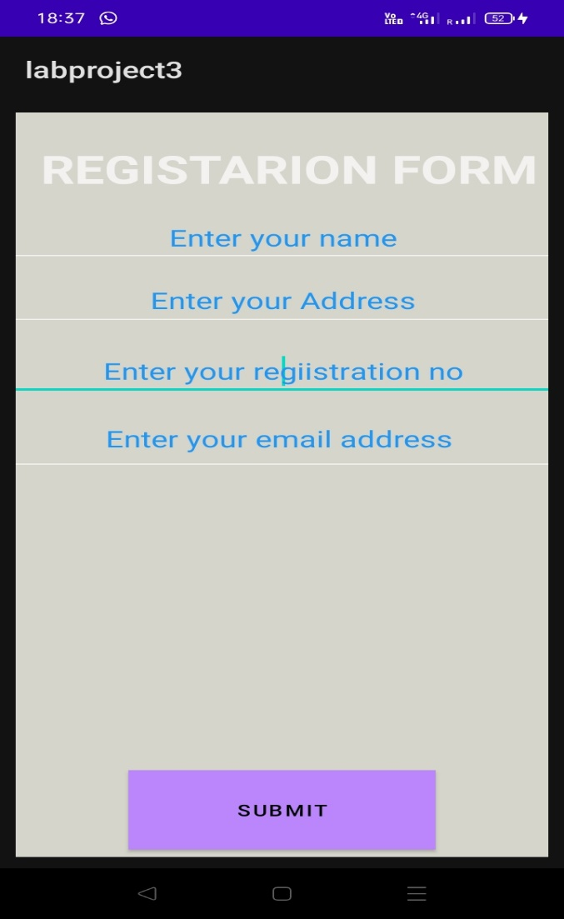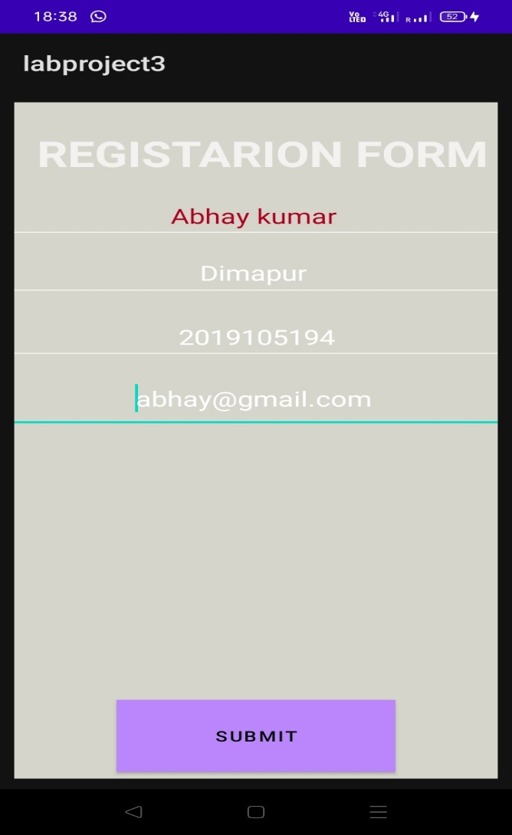

**Output**

**After input**

**Before input**

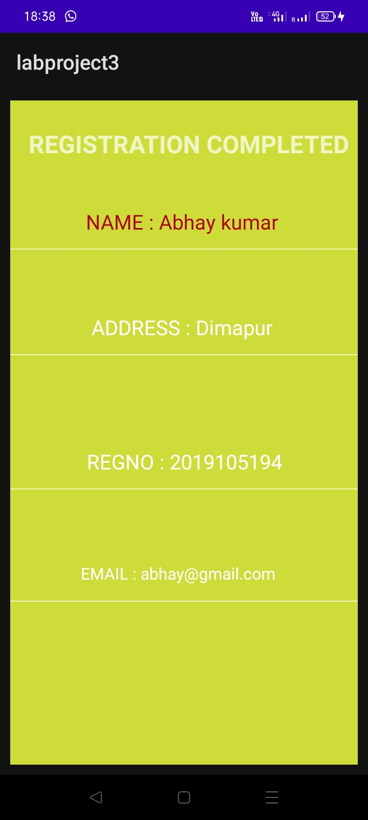

**After submitting**