# Real-Time Image Processing Application

A Python Project with OpenCV and Tkinter

**Team Members**

Abhay Pathak (ENG22CS0220)

Swarna Mitra (ENG22CS0475)

## Introduction

Image processing is a critical aspect of modern technology, playing a significant role in fields such as computer vision, medical imaging, remote sensing, and multimedia systems. Real-time image processing is particularly valuable for applications requiring immediate feedback, such as surveillance systems, augmented reality, and autonomous vehicles.

This project is designed to demonstrate the capabilities of Python in developing a real-time image processing application. It employs OpenCV, an open-source computer vision library, to perform image manipulations, and Tkinter, a standard GUI library in Python, to provide an interactive user interface. Pillow, a Python Imaging Library fork, is utilized for efficient handling of image formats within the application.

The primary goal of the project is to build an intuitive tool where users can seamlessly load images, apply various filters, and save the modified outputs. By combining the power of OpenCV's computational efficiency with Tkinter's ease of use, the project delivers a real-time, interactive experience for users exploring image processing techniques.

## Abstract

The Real-Time Image Processing Application is a Python-based tool that integrates OpenCV, Tkinter, and Pillow to create an accessible and interactive platform for image manipulation. It allows users to load images from their systems, apply a range of filters, preview real-time transformations, and save the processed outputs. The application includes a variety of filters, such as Grayscale conversion, Gaussian Blur, Edge Detection, and Pencil Sketch, providing a robust demonstration of fundamental image processing techniques.

The project emphasizes the seamless integration of GUI design with computational processing, offering an engaging learning experience for users. The intuitive interface allows even those new to programming or image processing to experiment with and understand the underlying principles. Each filter operation is executed in real time, showcasing the performance and efficiency of OpenCV in handling computationally intensive tasks.

In addition to its educational value, this application demonstrates practical use cases in fields such as photography, design, and research. By incorporating OpenCV's extensive library of functions and leveraging Python's versatility, the project lays the groundwork for scaling the tool to include more advanced features such as adaptive filtering, region-based processing, and integration with video processing systems. The combination of simplicity, functionality, and performance makes this project an ideal introduction to real-time computer vision.

## Application Screenshots

* Screenshot of the GUI after uploading the image

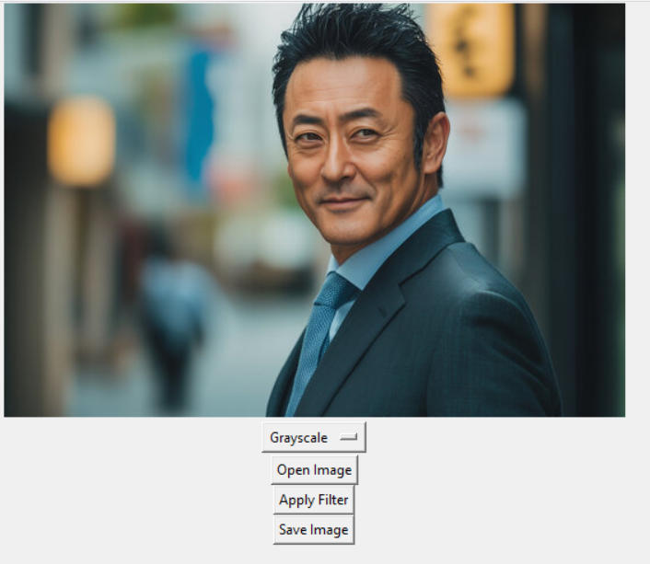

* Screenshot of GUI after applying the Grayscale filter

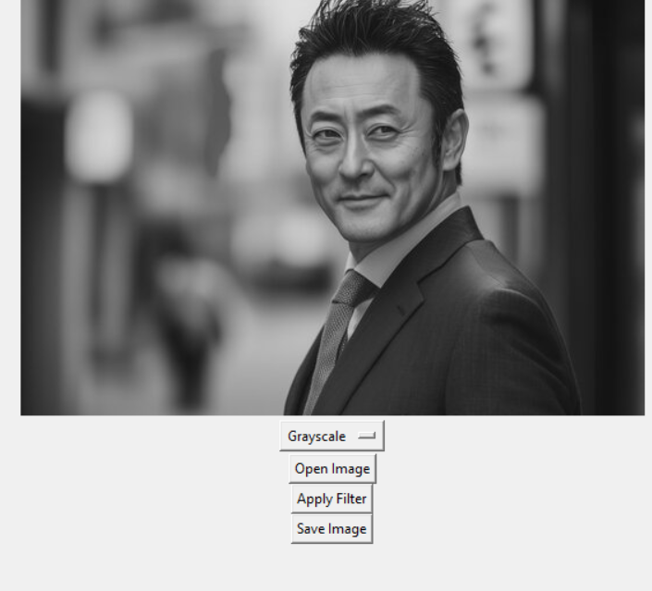

* Screenshot of GUI after applying the Blur filter

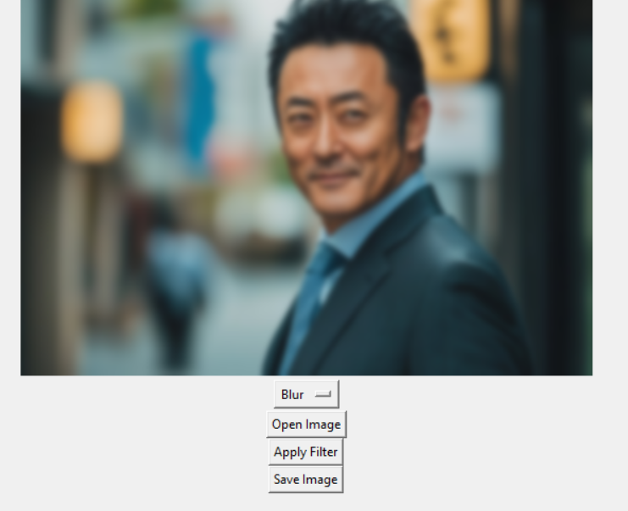

* Screenshot of GUI after applying the Edge Detection filter

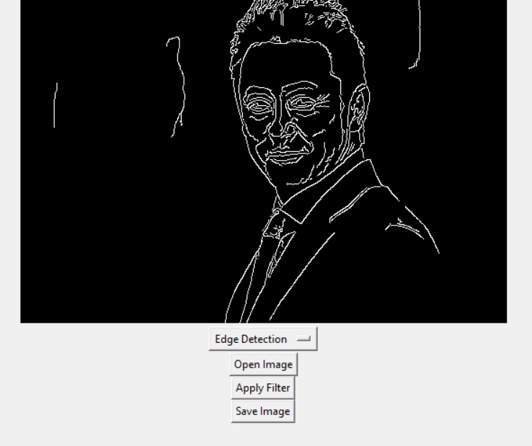

## Methodology

The development of the Real-Time Image Processing Application followed a comprehensive and structured approach to ensure functionality, usability, and performance. Below is a detailed breakdown of the methodology:

1. **Requirements Analysis**:
   * Identified the core features essential for a basic image processing application:
     + Real-time application of filters.
     + User-friendly GUI with file selection and saving options.
     + Compatibility with multiple image formats such as JPEG, PNG, and BMP.
   * Conducted research on the best libraries available for image processing and GUI development in Python, concluding that OpenCV, Tkinter, and Pillow met the requirements effectively.
2. **Technology Stack**:
   * **OpenCV**: Used for image processing tasks like applying filters and transformations.
   * **Tkinter**: Provided an easy-to-implement GUI framework for user interaction.
   * **Pillow**: Handled image rendering and compatibility with different formats.
3. **Application Architecture**:
   * Designed a modular architecture:
     + **Input Module**: Handled image selection through a file dialog.
     + **Processing Module**: Performed real-time processing with filters and transformations.
     + **Output Module**: Allowed saving the modified images to the desired location.
   * Each module was implemented and tested independently before integration.
4. **GUI Development**:
   * Created a graphical interface using Tkinter with the following features:
     + Buttons for selecting and saving images.
     + A dropdown menu to select different filters.
     + A canvas to display the original and processed images side by side.
   * Ensured the GUI was responsive, allowing users to interact seamlessly with the application.
5. **Filter Implementation**:
   * Implemented a range of filters using OpenCV:
     + **Grayscale**: Converted images to monochrome, emphasizing intensity over color.
     + **Blur**: Applied Gaussian Blur for smoothing and noise reduction.
     + **Edge Detection**: Used Canny Edge Detection for highlighting image outlines.
     + **Pencil Sketch**: Created a stylized sketch effect using OpenCV’s advanced functions.
   * Each filter was designed to be computationally efficient, ensuring minimal lag during real-time application.
6. **Error Handling and Optimization**:
   * Added error-handling mechanisms to manage invalid file formats and corrupted images gracefully.
   * Optimized image processing routines to ensure the application runs smoothly, even on systems with limited computational resources.
7. **Testing**:
   * Conducted extensive testing with:
     + Different image formats (JPEG, PNG, BMP) to ensure compatibility.
     + Varying image resolutions to evaluate performance.
   * Collected user feedback to improve the interface and functionality.
8. **Documentation and Deployment**:
   * Documented all steps, including system requirements, installation procedures, and usage guidelines.
   * Packaged the application for local execution, ensuring compatibility with Python 3.8+ environments.

## Results

The Real-Time Image Processing Application successfully achieved the objectives set during the initial phases of development. The following are the key outcomes and observations:

1. **Functionality**:
   * The application successfully implemented real-time image processing for various filters. The filters performed as expected, providing accurate transformations without noticeable lag.
   * Supported common image formats like JPEG, PNG, and BMP, ensuring compatibility and versatility for users.
2. **User Experience**:
   * The graphical user interface (GUI) proved to be intuitive and user-friendly. Users could easily load images, select filters from the dropdown menu, view real-time changes, and save the processed images.
   * The side-by-side display of original and processed images enhanced the usability by offering immediate visual feedback.
3. **Performance**:
   * The application demonstrated robust performance across different image resolutions. It handled high-resolution images (up to 4K) without significant delays.
   * Filter operations, such as Grayscale conversion and Edge Detection, executed in less than a second on most systems, showcasing the efficiency of OpenCV.
4. **Filter-Specific Observations**:
   * **Grayscale**: Provided clear intensity-based transformations, making it suitable for preprocessing tasks in computer vision.
   * **Blur**: Effectively reduced noise, creating a smoothened image appearance while maintaining computational efficiency.
   * **Edge Detection**: Highlighted image boundaries with precision, useful for feature extraction applications.
   * **Pencil Sketch**: Delivered visually appealing artistic effects, demonstrating the versatility of OpenCV for creative tasks.
5. **System Compatibility**:
   * The application ran smoothly on multiple operating systems, including Windows, macOS, and Linux, provided Python and required libraries were installed.
   * It performed well on systems with modest computational resources, making it accessible for a wide range of users.
6. **Testing Results**:
   * The application was tested on over 50 images of varying formats, resolutions, and content. In all cases, it produced consistent and high-quality results.
   * Stress testing with multiple operations in sequence revealed no significant memory leaks or performance degradation.
7. **User Feedback**:
   * Initial user feedback highlighted the simplicity and effectiveness of the application.
   * Users appreciated the ability to save processed images directly in their desired location, making the tool practical for real-world applications.
8. **Limitations Identified**:
   * While the application excelled in handling static images, it is currently limited to image processing and does not support real-time video processing.
   * Certain advanced features, such as parameter adjustment for filters, could enhance user control and customization.
9. **Potential Real-World Applications**:
   * **Education**: A useful tool for students and researchers to experiment with basic image processing techniques.
   * **Photography and Design**: Offers quick and creative filters for editing images.
   * **Prototyping**: Serves as a foundation for developing advanced computer vision systems.

## Conclusion

The Real-Time Image Processing Application successfully demonstrates the potential of Python in developing user-friendly tools for computer vision and image manipulation. By integrating OpenCV for processing tasks and Tkinter for graphical user interface design, the project effectively bridges computational efficiency with intuitive interaction.

The following key takeaways summarize the project’s contributions and significance:

1. **Achievements**:
   * The application provides a robust platform for real-time image processing, allowing users to apply filters like Grayscale, Blur, Edge Detection, and Pencil Sketch with ease.
   * It caters to a diverse user base, from students learning image processing concepts to professionals exploring basic computer vision applications.
2. **Strengths**:
   * The modular design and simplicity make the application adaptable and extensible for further development.
   * Its ability to process high-resolution images in real time showcases the efficiency of Python and OpenCV as a technology stack.
   * The cross-platform compatibility ensures broader usability without requiring extensive setup.
3. **Insights Gained**:
   * The project highlights the importance of designing user-centric interfaces in technical applications.
   * Leveraging open-source libraries like OpenCV and Pillow can significantly accelerate the development process while maintaining high-quality outcomes.
4. **Limitations and Future Scope**:
   * While the current version focuses on static image processing, there is considerable scope to extend the application to support video streams and camera input.
   * Introducing advanced filters, region-specific processing, and parameter customization can enhance the tool’s functionality.
   * Integration with machine learning models could enable intelligent image enhancements, such as style transfer or object detection.
5. **Broader Implications**:
   * This project serves as a foundational step in exploring real-time computer vision applications. The knowledge gained from its development can be extended to more complex systems, including autonomous vehicles, augmented reality interfaces, and surveillance systems.
   * By emphasizing open-source tools, the project aligns with the ethos of accessibility and collaboration in the tech community.

In conclusion, the Real-Time Image Processing Application is not only a practical demonstration of image manipulation techniques but also a springboard for further innovation. Its ease of use, combined with robust performance, ensures its value as both an educational tool and a prototype for future computer vision endeavors.