Setting Hyperledger Fabric v1.3 on Ubuntu 18.04 on a localhost server.

Enable virtualization from BIOS

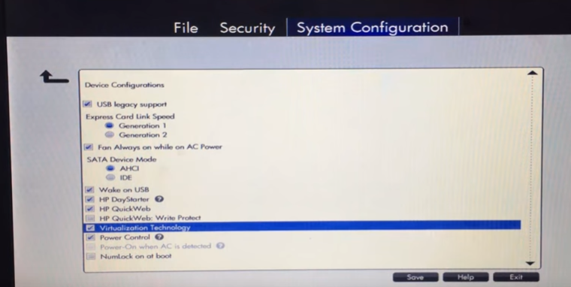

Windows Feature disable Hyper-V

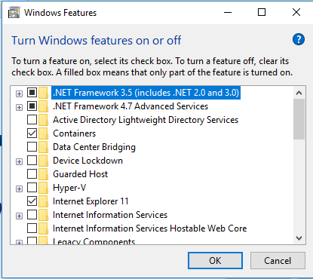

Now Docker for Windows will not work

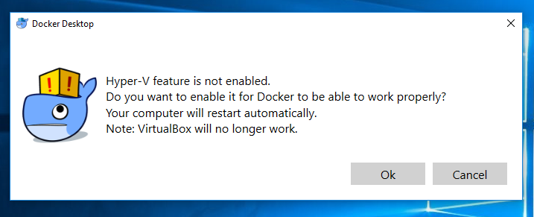

But we will get Linux-64 bit

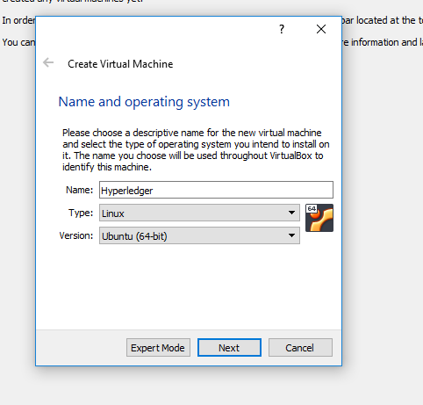

For the rest of the setup, use the following options:

* 2 GHz dual core processor or better
* 2 GB system memory
* 25 GB of free hard drive space
* Either a DVD drive or a USB port for the media installer.

Create Partition

<https://askubuntu.com/questions/343268/how-to-use-manual-partitioning-during-installation>

Network Proxy

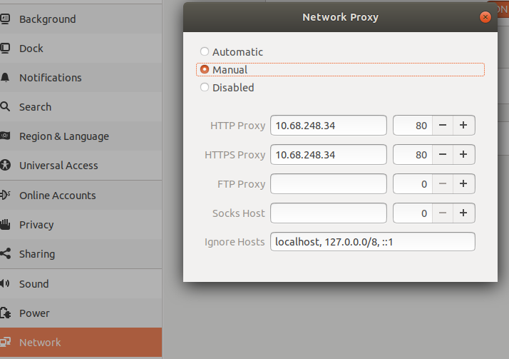

**Go Language v1.10.x**

<https://medium.com/@mychewcents/installing-hyperledger-fabric-v1-0-on-ubuntu-16-04-part-i-18043bde92bb>



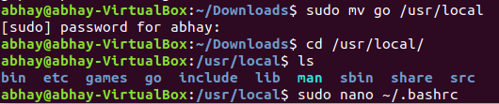

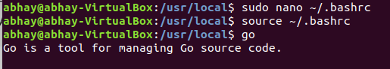

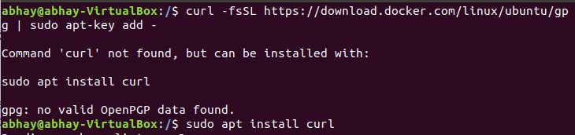

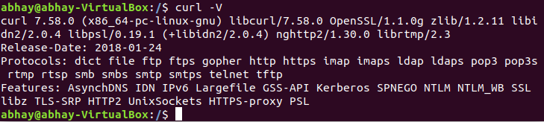



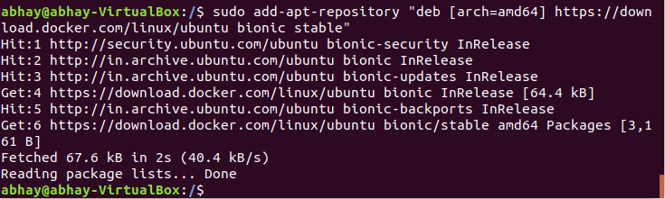

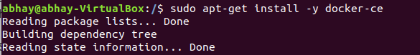

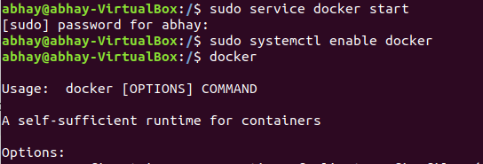

 the second part of docker-ce is the docker-compose function

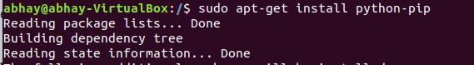

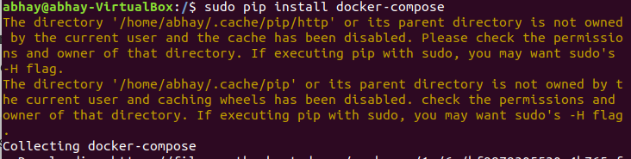



<https://medium.com/@mychewcents/installing-hyperledger-fabric-v1-0-on-ubuntu-16-04-part-ii-ad64148c38fc>

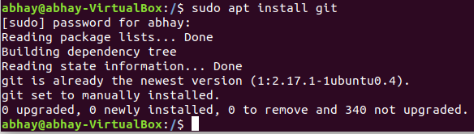

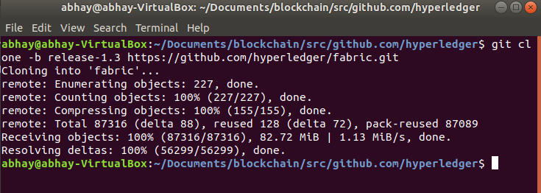

Below command nor required jump to make release

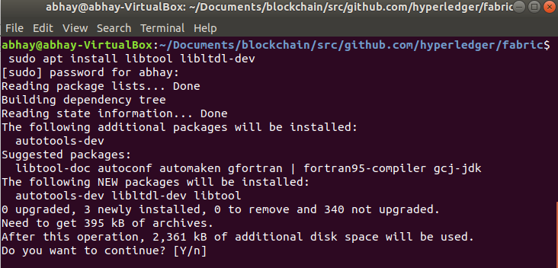

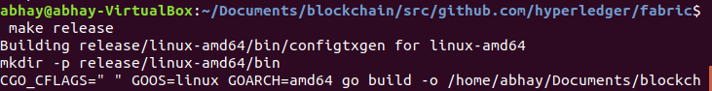

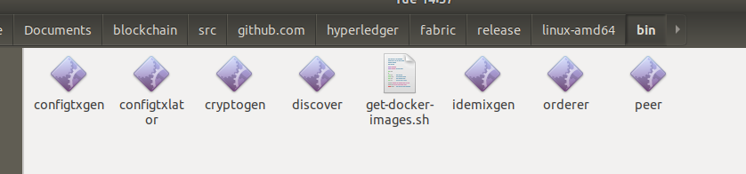

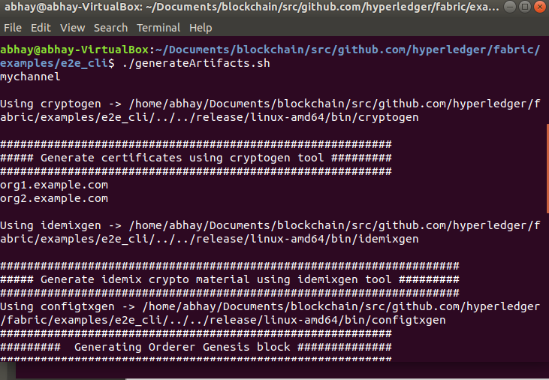

Error -:

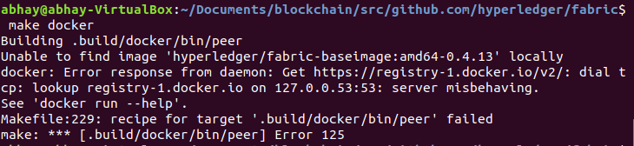

Solution -:

Follow this link <https://github.com/docker/for-mac/issues/1317>

If you are behind a proxy, please use the following link:  
<https://docs.docker.com/engine/admin/systemd/#httphttps-proxy>

Below command is after disabling proxy

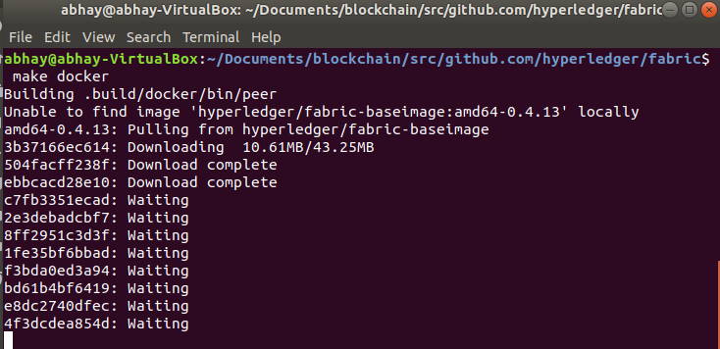

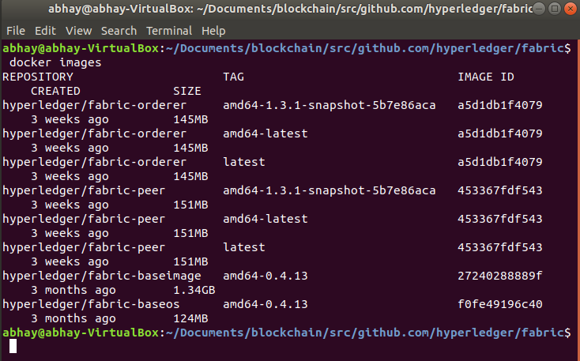

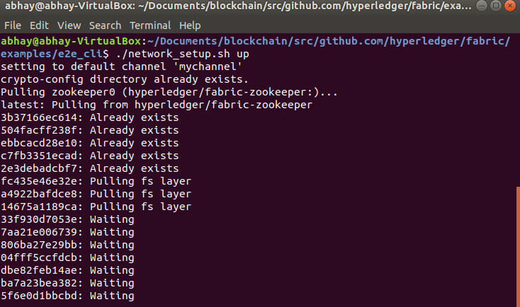

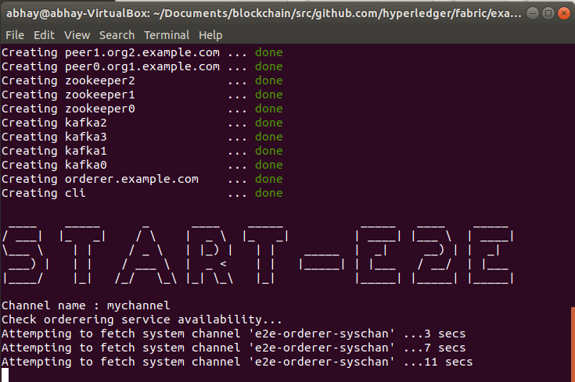

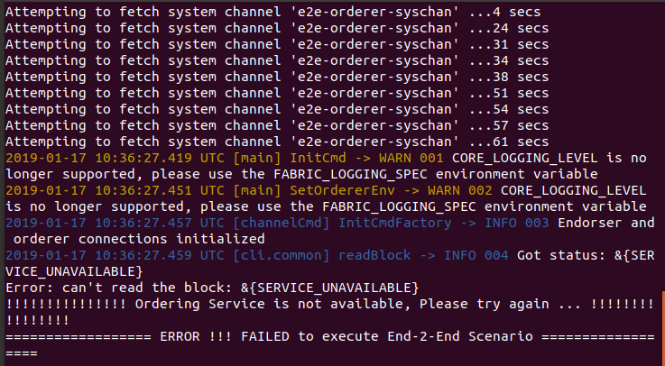

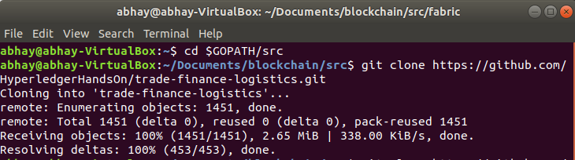

Pending -:

npm install -- global grpc