Few Questions answered by Corda team(Joel, Nick).

Question:- As Notary is the Consensus mechanism in Corda. Is Notary stores all the transaction information which private between Parties?

Answer: No. Notary only stores “Transaction hash and Its index” which is enough to decide the Input transaction is “Consumed or Unconsumed”.

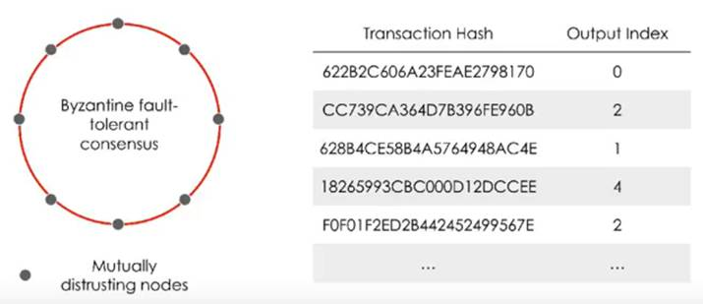

Question: Can network have multiple Notaries?

Answer: Yes. Network can have multiple Notaries. However input and Output transaction/state must be from same Notary.

Question: is Notary single point of failure in Corda network?

Answer: No. Notary Pool can have more nodes and may choose to run a high-speed, high-trust algorithm such as RAFT, a low-speed, low-trust algorithm such as BFT, or any other consensus algorithm it chooses.

Question: Can we change Status Notary?

# Answer: Yes, We can change it using “NotaryChangeFlow”. This is required since all input states to a transaction must point to the same notary.

Question: Can we have two responder flow/flowSession for same Party in flow?

Answer: No. In current version only one responder flow per party is allowed. In future Corda is planning to support more than one.

Question: How mapping calling and responder flow mapping works?

Answer: We need to provide annotation in responder flow - “@initiated(caller_flow.class)”.

Question: Scenario is, One State(StateA) is private to PartyA, other State (StateB) is private to PartyB. Can PartyA get some required data from PartyB’s state.(If PartyB agrees on this.)?

Answer: Yes. It can be possible through Flow Session responder flow. However in this scenario Counterparty must be agree on sharing/sending the State content.

