Blockchain for Business

Hyperledger blockchains are generally permissioned blockchains, which means that the parties that join the network are authenticated and authorized to participate on the network.

Hyperledger’s main goal is to create enterprise grade, open source, distributed ledger frameworks and code bases to support business use cases.

Advantages of Using a Permissioned Blockchain over a Permissionless Blockchain

If you look at permissionless blockchains, like the Bitcoin blockchain or the Ethereum blockchain, anyone can join the network, as well as write and read transactions. The actors in the system are not known, which means there could be some malicious actors within the network.

Hyperledger reduces these security risks and ensures that only the parties that want to transact are the ones that are part of the transaction and, rather than displaying the record of the transactions to the whole network, they remain visible only to the parties involved.

So, Hyperledger provides all the capabilities of the blockchain architecture –

* data privacy,
* information sharing,
* immutability,

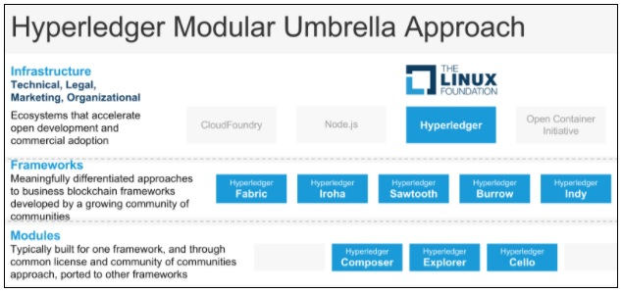

The Hyperledger frameworks are used to build blockchains and distributed ledgers. The Hyperledger modules, are auxiliary softwares used for things like deploying and maintaining blockchains, examining the data on the ledgers, as well as tools to design, prototype, and extend blockchain networks.

Key Hyperledger consensus protocols are

* Apache Kafka in Hyperledger Fabric,
* PoET in Hyperledger Sawtooth,
* RBFT in Hyperledger Indy,
* Tendermint in Hyperledger Burrow, and
* Yet Another Consensus (YAC) in Hyperledger Iroha.

Hyperledger vs. Other Permissioned Ledgers

Quorum is a permissioned implementation of Ethereum, which supports data privacy.

Quorum achieves this data privacy through allowing data visibility on need-to-know basis by a voting-based consensus algorithm.

Interestingly, Quorum was created and open sourced by JPMorgan.

Comparing Hyperledger with Bitcoin and Ethereum

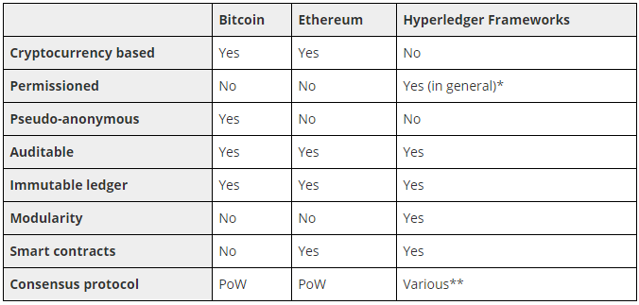

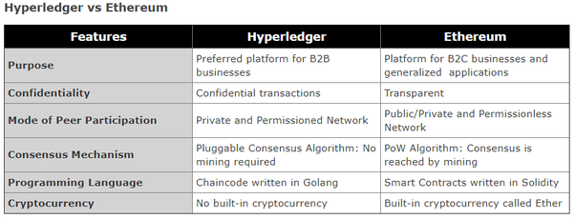

Components of Hyperledger Frameworks

Hyperledger business blockchain frameworks includes

* An append-only distributed **ledger**
* A **consensus algorithm** for agreeing to changes in the ledger
* **Privacy** of transactions through permissioned access
* **Smart contracts** to process transaction requests.

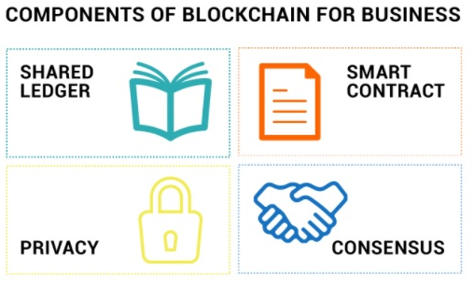

Hyperledger Sawtooth v1.0

Sawtooth is designed so that you can grow the size of the network, you can actually change the consensus mechanism on the fly...

I think this is a unique characteristic of Sawtooth amongst all of the other ledgers...

You can submit as a transaction and then have a policy within your network to accept that new consensus, and then, your network can move from say a ([Practical Byzantine Fault Tolerance](http://pmg.csail.mit.edu/papers/osdi99.pdf)) PBFT-style consensus to something like PoET, or some sort of random leader election consensus...

Hyperledger Fabric v1.0

If you have a large blockchain network and you want to share data with only certain parties, you can create a private channel with just those participants. It is the most distinctive thing about Fabric right now.

Hyperledger Composer

[Hyperledger Composer](https://www.hyperledger.org/projects/composer) provides a suite of tools for building blockchain business networks. These tools allow you to:

* Model your business blockchain network
* Generate REST APIs for interacting with your blockchain network
* Generate a skeleton Angular application.

Built in Javascript, Hyperledger Composer provides an easy-to-use set of components that developers can quickly learn and implement. The project was contributed by Oxchains and IBM.

Composer allows developers to very quickly and easily model out the key components of their business use case,

The [benefits](https://www.hyperledger.org/wp-content/uploads/2017/05/Hyperledger-Composer-Overview.pdf) of Hyperledger Composer are:

* **Faster creation of blockchain applications**, eliminating the massive effort required to build blockchain applications from scratch
* **Reduced risk** with well-tested, efficient design that aligns understanding across business and technical analysts
* **Greater flexibility** as the higher-level abstractions make it far simpler to iterate.

Composer runtime running on the Hyperledger fabric.