**Corda : Distributed Ledger Technology**

* Used by businesses, such as financial institutions
* Keep a shared ledger of transactions
* No need to know about each and every transactions
* A Corda network is made up of nodes running Corda and CorDapps
* Communication between nodes is point-to-point, no global broadcasts.
* The network is permissioned, with access controlled by a doorman

**Corda Network : Detailed Overview**

A Corda Network includes

1. Doorman -: Provide access to eligible nodes with a root-authority-signed TLS certificate.
2. Network Map Service -: Publishes IP addresses through which all nodes can be reached
3. Corda Nodes (2 or more) -: Regular nodes communicate with other nodes, notaries & oracle
4. Notary Nodes (1 or more) -: Attest uniqueness and validity of ledger updates.
5. Oracle Services (0 or more)-: Link ledger to outside world.

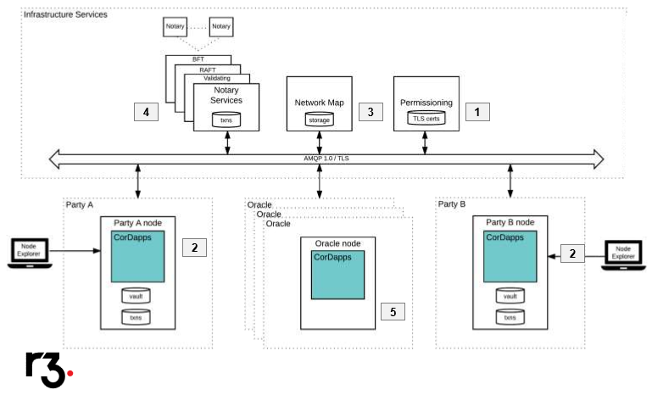

**Corda Setup (Windows)**

* Open Gitbash and clone corda tutorial

git clone https://github.com/corda/cordapp-tutorial

* Open project in Intellij IDEA and run the project (Run Example Cordapp-Kotlin)
* In Gitbash go to the root of tutorial CordApp and run below command

./gradlew.bat deployNodes

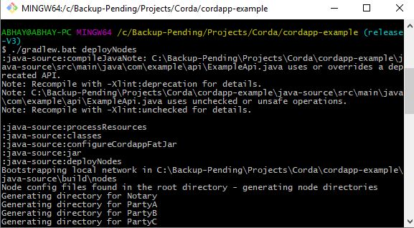

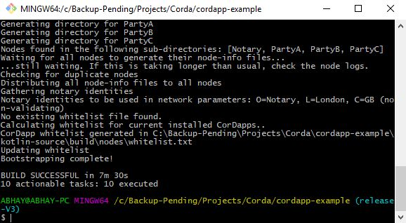

* Once the nodes are deployed run them by executing below command.

Kotlin-source/build/nodes/runnodes

C:\Backup-Pending\Projects\Corda\Stuffs\RunNodes.JPG

* Above command wil start 8 terminal windows (4 nodes + 4 web servers)
* Test that nodes are running correctly by opening a browser and navigating to URL as shown below.

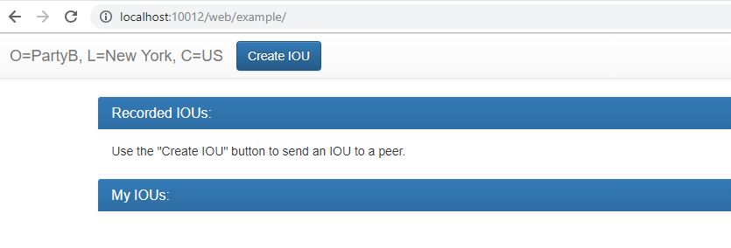

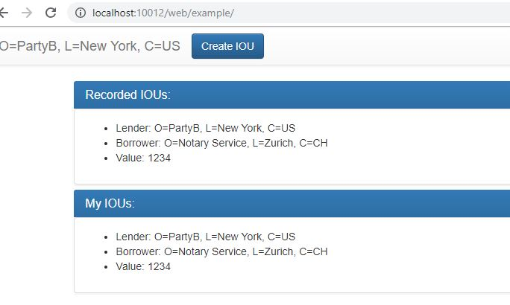

**Possible Errors**

Proxy error -:

Go to Intellij IDEA (File -> Settings) and set the proxy as shown below

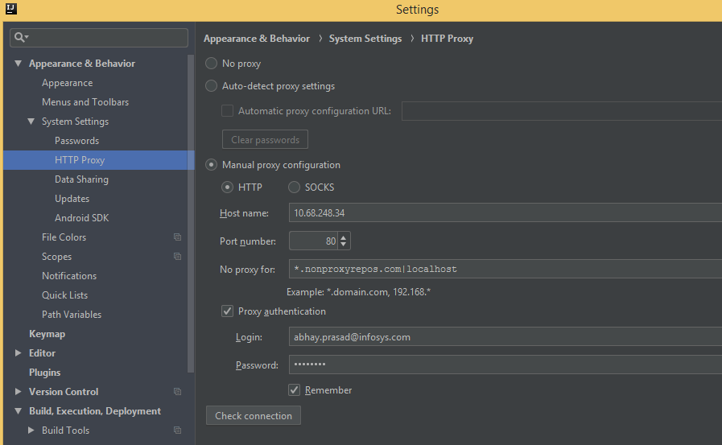

[Automatic library version update for Gradle projects is currently unsupported. Please update your build.gradle manually](https://stackoverflow.com/questions/44574740/automatic-library-version-update-for-gradle-projects-is-currently-unsupported-p)

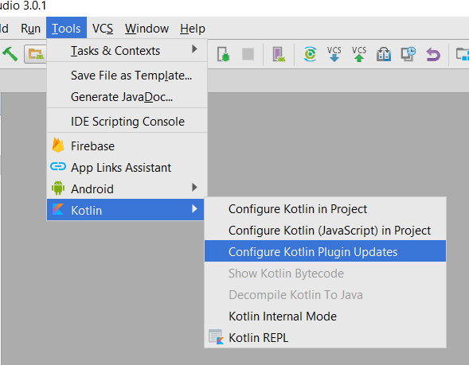

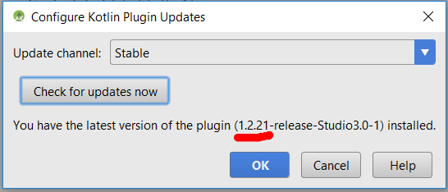

kotlin unresolved reference core as shown below

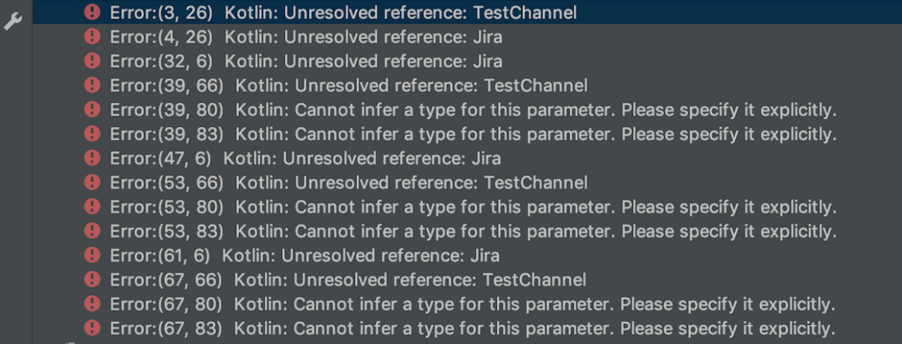

Make sure Kotlin compiler Target JVM version is set correctly as shown below

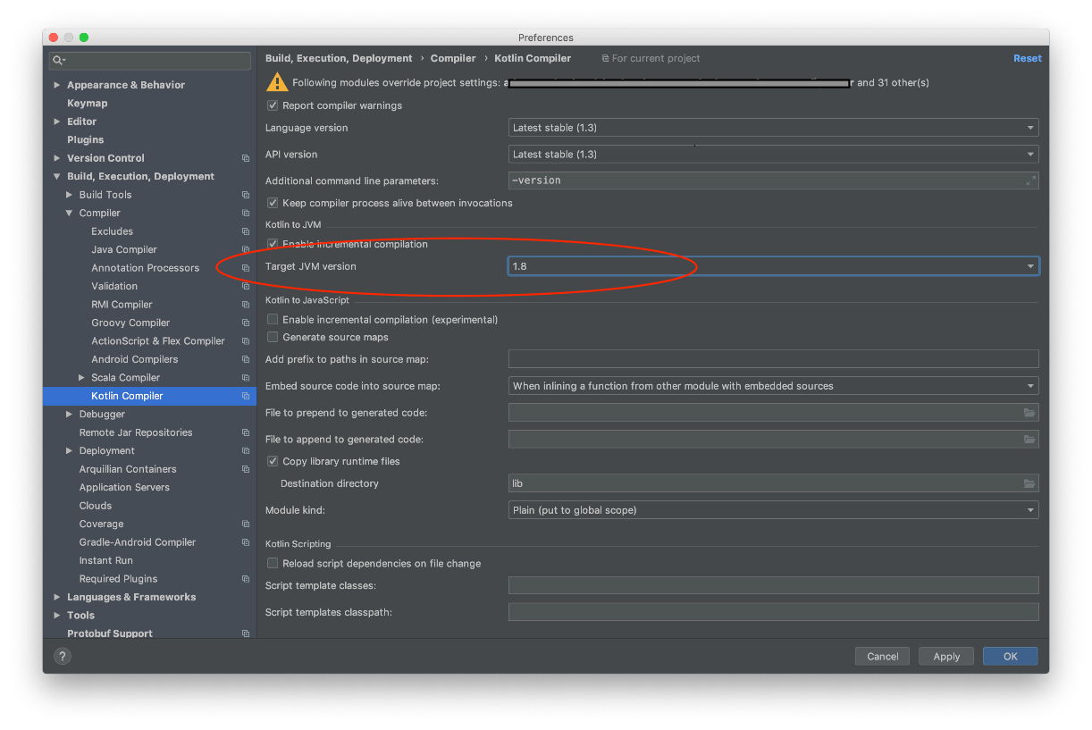

And Java Compiler project bytecode version is 8

