Proxy error -: File -> Settings

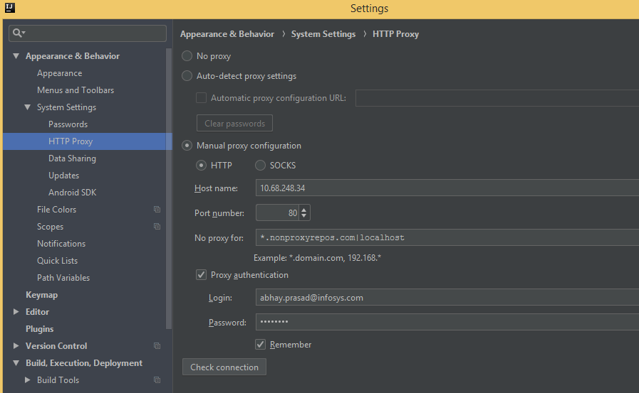

[Automatic library version update for Gradle projects is currently unsupported. Please update your build.gradle manually](https://stackoverflow.com/questions/44574740/automatic-library-version-update-for-gradle-projects-is-currently-unsupported-p)

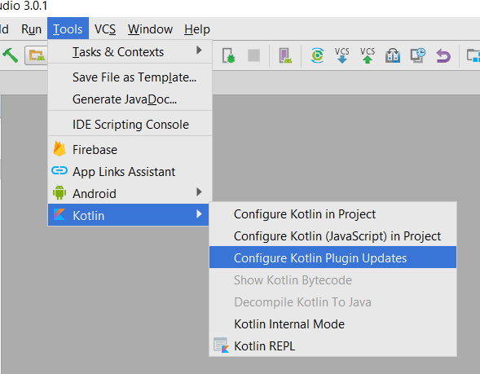

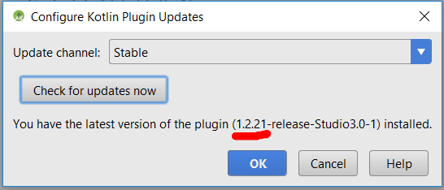

kotlin unresolved reference core

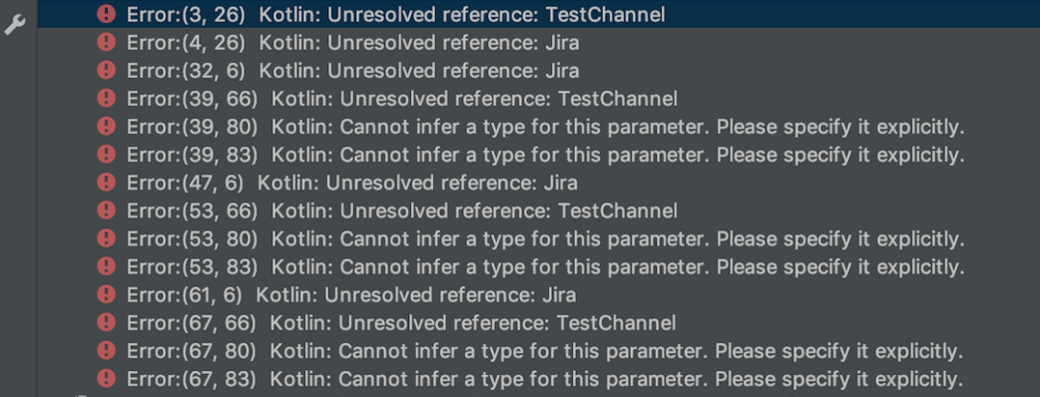

My project (at time of writing this) is a gradle 4.10.2 kotlin 1.3 project in IntelliJ (IntelliJ IDEA 2018.2.5 (Ultimate Edition) Build #IU-182.4892.20, built on October 16, 2018)

For starters though, I invalidated caches and restarted. Then ran a gradle clean build. After rebuilding the project still no joy. I went into the project settings and noticed the compiler versions were not set to java 8, I set the Compiler/Kotlin/Target JVM Version and Compiler/Java/Project Byte Code to 1.8/8 (see below), then ran some tests in the IDE and we are back in business! References resolved in my case.

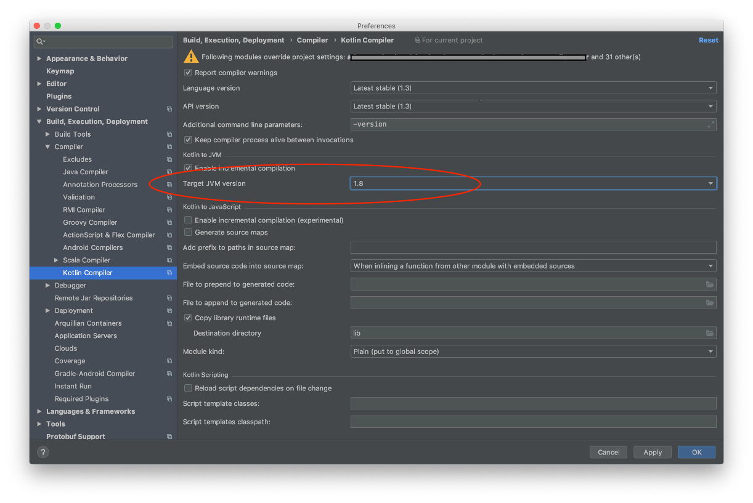

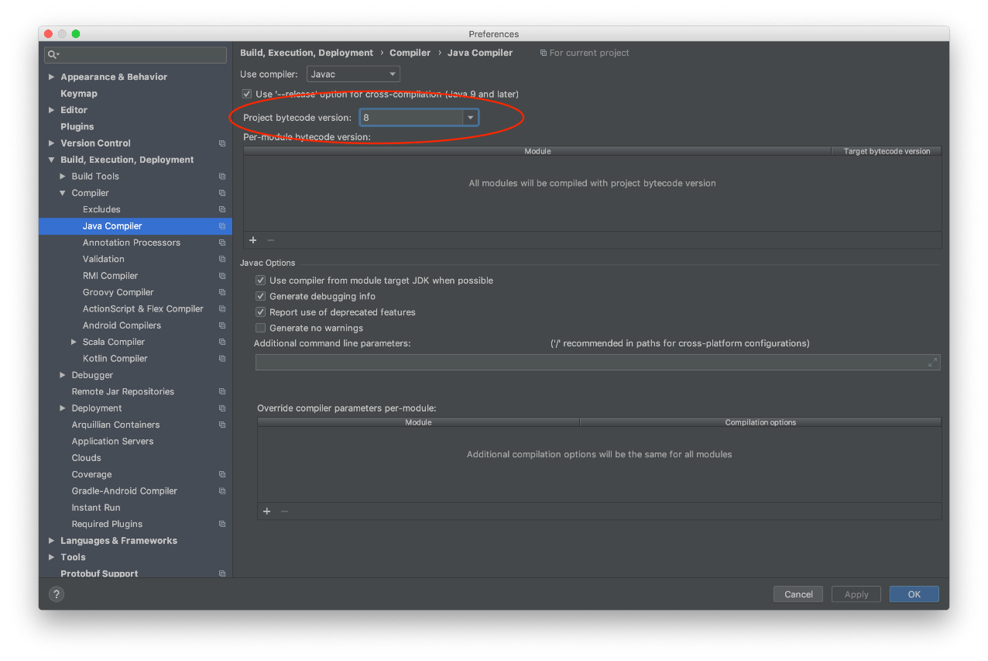

Import latest JDK

