Course Two

Go Beyond the Numbers: Translate Data into Insights


Instructions
Use this PACE strategy document to record decisions and reflections as you work through this end-of-course project. You can use this document as a guide to consider your responses and reflections at different stages of the data analytical process. Additionally, the PACE strategy documents can be used as a resource when working on future projects.

Course Project Recap
Regardless of which track you have chosen to complete, your goals for this project are:
- Complete the questions in the Course 2 PACE strategy document
- Answer the questions in the Jupyter notebook project file
- Clean your data, perform exploratory data analysis (EDA)
- Create data visualizations
- Create an executive summary to share your results

Relevant Interview Questions
Completing the end-of-course project will help you respond to these types of questions that are often asked during the interview process:
- How would you explain the difference between qualitative and quantitative data sources?
- Describe the difference between structured and unstructured data.
- Why is it important to do exploratory data analysis?
- How would you perform EDA on a given dataset?
- How do you create or alter a visualization based on different audiences?
- How do you avoid bias and ensure accessibility in a data visualization?
- How does data visualization inform your EDA?
Reference Guide
This project has six tasks; the visual below identifies how the stages of PACE are incorporated across those tasks.
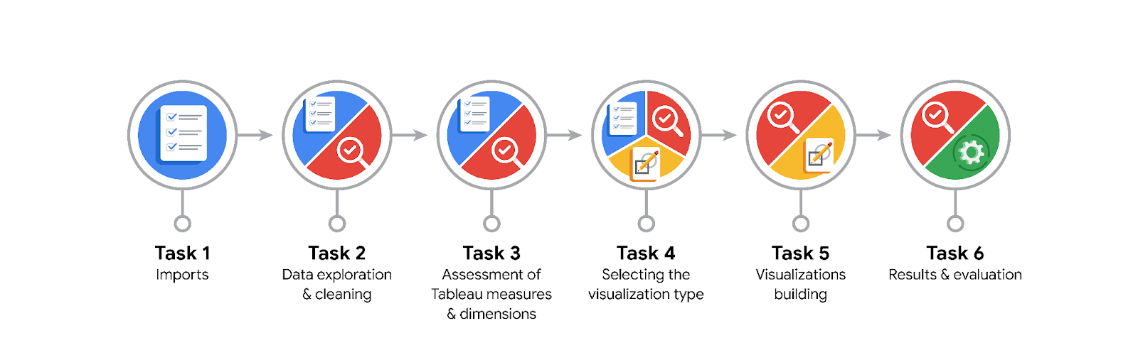
Data Project Questions & Considerations

PACE: Plan Stage
- What are the data columns and variables and which ones are most relevant to your deliverable?
Sessions, drives, total_sessions, driven_km_drives, duration_minutes_drives, activity_days, driving_days

- What units are your variables in?
Mainly all variables are in integer format

- What are your initial presumptions about the data that can inform your EDA, knowing you will need to confirm or deny with your future findings?
- Users who churned averaged ~3 more drives in the last month than retained users, even though retained users used the app over twice as many days as churned users in the same period. Median data shows that churned user drove ~200 km more and 2.5 hours more during last month than the median retained user. The median user who churned, drove 698 km each day last month, which is almost 240% more than median retained users. Also the ratio of number of drives per day also were the same. This data suggests that they are someone who drives a lot. (Eg. Truck Drivers)

- Is there any missing or incomplete data?
- The “label” column had 700 missing rows.

- Are all pieces of this dataset in the same format?
Yeah all the main columns are in integers, and then a column named devices are of “string” datatype

- Which EDA practices will be required to begin this project?
Initially try to find out the data descriptive statistics, and find out any anomalies, then create columns that are required through the process of feature engineering, and plot relevant plots like, boxplot, histogram, pie charts, bar charts etc.

PACE: Analyze Stage
- What steps need to be taken to perform EDA in the most effective way to achieve the project goal?
Mainly through the EDA and visualization process, try to visualize and compare, find median and skewness of all the columns to check how the data is distributed, we could gain possible insight from that

- Do you need to add more data using the EDA practice of joining? What type of structuring needs to be done to this dataset, such as filtering, sorting, etc.?
Yes, based on the pattern observed that:
Users who churned averaged ~3 more drives in the last month than retained users, even though retained users used the app over twice as many days as churned users in the same period. Median data shows that churned user drove ~200 km more and 2.5 hours more during last month than the median retained user. The median user who churned, drove 698 km each day last month, which is almost 240% more than median retained users. Also the ratio of number of drives per day also were the same.
So more amount of data related to this pattern needs to be collected

- What initial assumptions do you have about the types of visualizations that might best be suited for the intended audience?
Box plots(to check outliers), then pie charts to check device usage ratio, histogram for frequency of variables

PACE: Construct Stage
- What data visualizations, machine learning algorithms, or other data outputs will need to be built in order to complete the project goals?
Using the seaborn and matplotlib libraries, we can plot the histogram pie charts, box plots, to check how the data is distributed, it could possibly help in understanding how the data is distributed

- What processes need to be performed in order to build the necessary data visualizations?
Look at the columns we want to analyse, then import necessary libraries to visualise the data as mentioned earlier

- Which variables are most applicable for the visualizations in this data project?
All the columns that are of int dataype seems important, so visualizing all those columns could help

- Going back to the Plan stage, how do you plan to deal with the missing data (if any)?
Lets see if we can develop some algorithms to find out the missing data(as the missing data is of the “label” column that is of churned or retained users), we can learn more about those missing values also.

PACE: Execute Stage
- What key insights emerged from your EDA and visualizations(s)?
  - The sessions variable is a right-skewed distribution with half of the observations having 56 or fewer sessions. However, as indicated by the boxplot, some users have more than 700.
  - The drives information follows a distribution similar to the sessions variable. It is right-skewed, approximately log-normal, with a median of 48. However, some drivers had over 400 drives in the last month.
  - The total_sessions is a right-skewed distribution. The median total number of sessions is 159.6. This is interesting information because, if the median number of sessions in the last month was 48 and the median total sessions was ~160, then it seems that a large proportion of a user's total drives might have taken place in the last month. This is something you can examine more closely later.
  - The total user tenure (i.e., number of days since onboarding) is a uniform distribution with values ranging from near-zero to ~3,500 (~9.5 years).
  - The number of drives driven in the last month per user is a right-skewed distribution with half the users driving under 3,495 kilometers. As discovered in the analysis from the previous course, the users in this dataset drive a lot. The longest distance driven in the month was over half the circumference of the earth.
  - The duration_minutes_drives variable has a heavily skewed right tail. Half of the users drove less than ~1,478 minutes (~25 hours), but some users clocked over 250 hours over the month.
  - Within the last month, users opened the app a median of 16 times. The box plot reveals a centered distribution. The histogram shows a nearly uniform distribution of ~500 people opening the app on each count of days. However, there are ~250 people who didn't open the app at all and ~250 people who opened the app every day of the month.
  - This distribution is noteworthy because it does not mirror the sessions distribution, which you might think would be closely correlated with activity_days.
  - The number of days users drove each month is almost uniform, and it largely correlates with the number of days they opened the app that month, except the driving_days distribution tails off on the right.
  - However, there were almost twice as many users (~1,000 vs. ~550) who did not drive at all during the month. This might seem counterintuitive when considered together with the information from activity_days. That variable had ~500 users opening the app on each of most of the day counts, but there were only ~250 users who did not open the app at all during the month and ~250 users who opened the app every day. Flag this for further investigation later.
  - There are nearly twice as many iPhone users as Android users represented in this data.
  - The proportion of churned users to retained users is consistent between device types.
  - The churn rate tends to increase as the mean daily distance driven increases, confirming what was found in the previous course. It would be worth investigating further the reasons for long-distance users to discontinue using the app.
  - The churn rate is highest for people who didn't use Waze much during the last month. The more times they used the app, the less likely they were to churn. While 40% of the users who didn't use the app at all last month churned, nobody who used the app 30 days churned.
  - Half of the people in the dataset had 40% or more of their sessions in just the last month, yet the overall median time since onboarding is almost five years.
  - The number of days since onboarding for users with 40% or more of their total sessions occurring in just the last month is a uniform distribution. This is very strange. It's worth asking Waze why so many long-time users suddenly used the app so much in the last month.

- What business and/or organizational recommendations do you propose based on the visualization(s) built?
A pattern from the driving_days vs activity_days suggested that the users who always opened the app did not always drive. They might have used the app just to look at the locations and other details. More research regarding high driving users needs to be done on why they drive more and they are the ones who are churned.

- Given what you know about the data and the visualizations you were using, what other questions could you research for the team?
Main question from the data again goes to the question on why to people who drive more tend to be the users who are churned. Also maybe data needs to be collected of the previous months also, to see whether that pattern is happening all the time

- How might you share these visualizations with different audiences?
Mainly to the business clients the main output from this EDA and visualization would be the pattern of users who drive the most being the users that churn.
Regarding these output to the team, its easier to communicate techincally.

