Course Four

Regression Analysis: Simplifying Complex Data Relationships
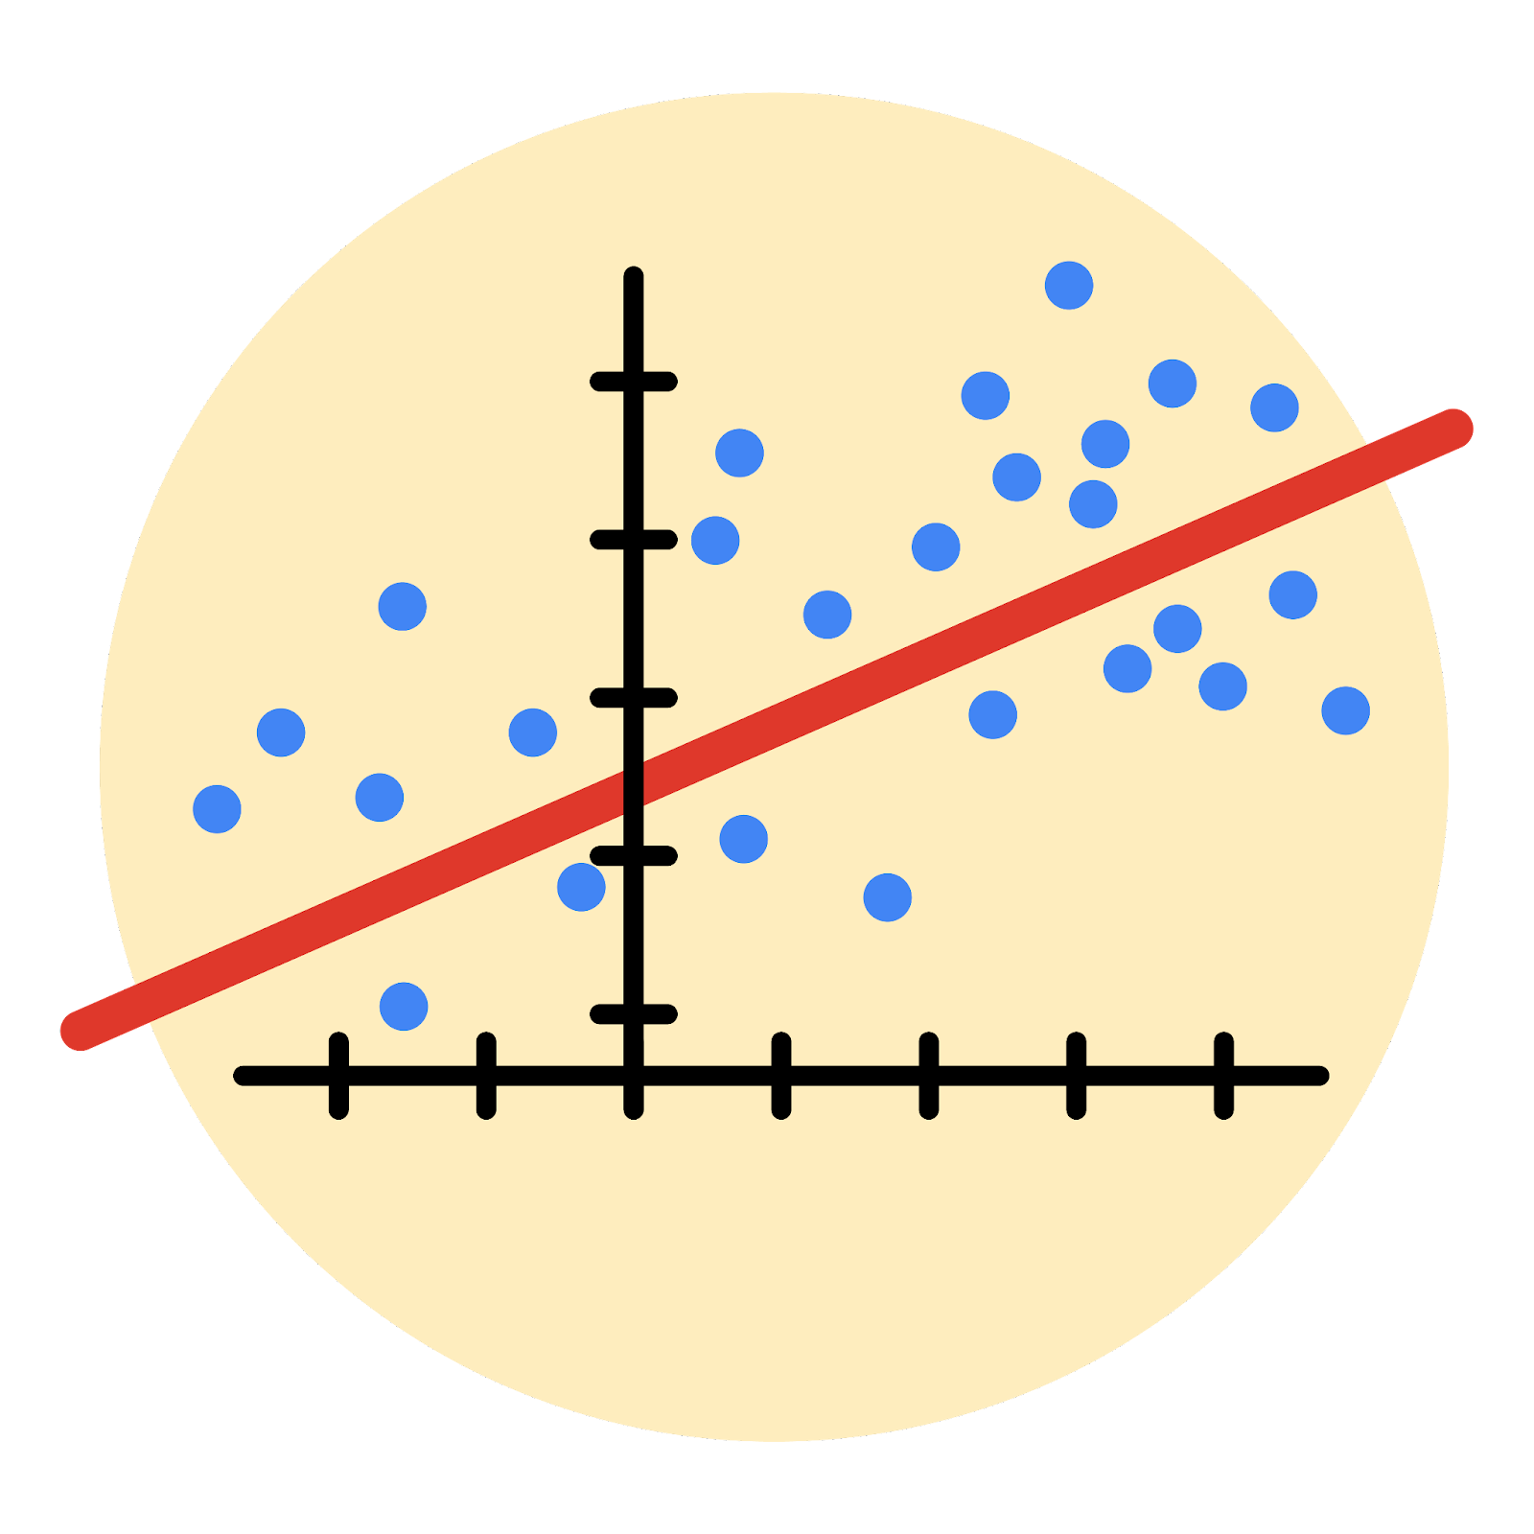

Instructions
Use this PACE strategy document to record decisions and reflections as you work through this end-of-course project. As a reminder, this document is a resource that you can reference in the future, and a guide to help you consider responses and reflections posed at various points throughout projects.

Course Project Recap
Regardless of which track you have chosen to complete, your goals for this project are:
- Complete the questions in the Course 4 PACE strategy document
- Answer the questions in the Jupyter notebook project file
- Build a multiple linear regression model
- Evaluate the model
- Create an executive summary for team members

Relevant Interview Questions
Completing the end-of-course project will empower you to respond to the following interview topics:
- Describe the steps you would take to run a regression-based analysis
- List and describe the critical assumptions of linear regression
- What is the primary difference between R² and adjusted R²?
- How do you interpret a Q-Q plot in a linear regression model?
- What is the bias-variance tradeoff? How does it relate to building a multiple linear regression model? Consider variable selection and adjusted R².
Reference Guide
This project has seven tasks; the visual below identifies how the stages of PACE are incorporated across those tasks.
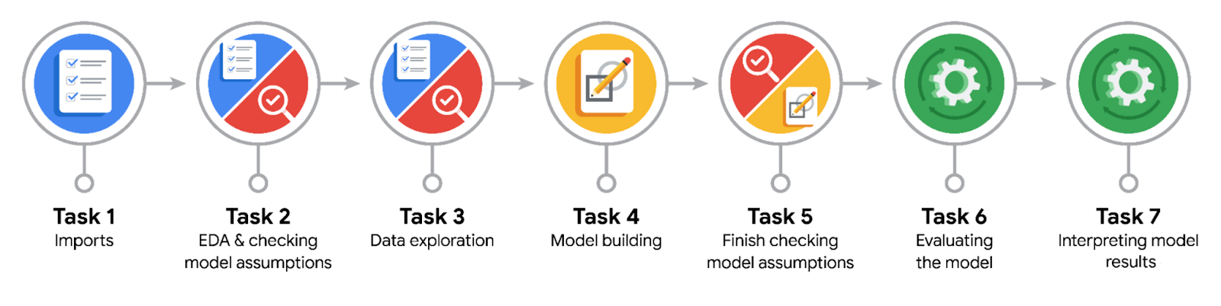

Data Project Questions & Considerations
PACE: Plan Stage
- Who are your external stakeholders for this project?
Operations Manager and the Data Analysis Manager

- What are you trying to solve or accomplish?
Build a binomial logistic regression model, to predict user churn

- What are your initial observations when you explore the data?
There are extreme outliers, which needs to be set a quantile limit, and then there are categorical variables that needs to be labelled
Findings:
Churn Rate for professional drivers is 7.6% while the churn rate for non-professional drivers is 19.9%.
Not professional drivers means, drives who had more than or equal to 60 drives, and drove on 15 or 15+ days in the last month

- What resources do you find yourself using as you complete this stage?
Documentation of various model code and functions

PACE: Analyze Stage
- What are some purposes of EDA before constructing a multiple linear regression model?
Helps us gain an understanding of how the data is distributed, so that in the end the model does not make wrong predictions

- Do you have any ethical considerations at this stage?
Make sure no data is deleted or removed

PACE: Construct Stage
- Do you notice anything odd?
Initially during the EDA process, there were extreme outlier values present, this needed to be set a limit of quantile of 95%

- Can you improve it? Is there anything you would change about the model?

- What resources do you find yourself using as you complete this stage?
Code Documentation

PACE: Execute Stage
- What key insights emerged from your model(s)?
- The efficacy of a binomial logistic regression model is determined by accuracy, precision, and recall scores; in particular, recall is essential to this model as it shows the number of churned users.
- The model has mediocre precision (53% of its positive predictions are correct) but very low recall, with only 9% of churned users identified. This means the model makes a lot of false negative predictions and fails to capture users who will churn.
- Activity_days was by far the most important feature in the model. It had a negative correlation with user churn.
- In previous EDA, user churn rate increased as the values in km_per_driving_day increased. In the model, distance driven per day was the second-least-important variable.

- What business recommendations do you propose based on the models built?
- Due to the model results, our team recommends using the key insights from this project milestone to guide further exploration.
- This model should not be used to make significant business decisions; however, it has valuable insights insofar as it demonstrated a great need for additional data (features) that correlates with user churn, and also a possible need to better define the user profile Waze seeks to target in their aim to increase overall growth by preventing monthly user churn on the app.

- To interpret model results, why is it important to interpret the beta coefficients?
Interpreting beta coefficients is crucial for model interpretation because they quantify the precise relationship between independent and dependent variables, allowing researchers to determine the direction, strength, and relative importance of predictors.

- What potential recommendations would you make?
- Due to the model results, our team recommends using the key insights from this project milestone to guide further exploration.
- This model should not be used to make significant business decisions; however, it has valuable insights insofar as it demonstrated a great need for additional data (features) that correlates with user churn, and also a possible need to better define the user profile Waze seeks to target in their aim to increase overall growth by preventing monthly user churn on the app.

- Do you think your model could be improved? Why or why not? How?
Yes, currently the model is not doing great, so to improve it we would require to add more data

- What business/organizational recommendations would you propose based on the models built?
- Due to the model results, our team recommends using the key insights from this project milestone to guide further exploration.
- This model should not be used to make significant business decisions; however, it has valuable insights insofar as it demonstrated a great need for additional data (features) that correlates with user churn, and also a possible need to better define the user profile Waze seeks to target in their aim to increase overall growth by preventing monthly user churn on the app.

- Given what you know about the data and the models you were using, what other questions could you address for the team?

- Do you have any ethical considerations at this stage?

